**Name:** Shubham Golwal

**Roll No.:** 2020300015

**Batch:** TE COMPS - E

**SUB:** HMI

**Experiment No.:** 8

**Name of the Experiment :** Colors – Design a personal website for any socio technical problem(ie. Carbon Emission).Use statistical graphics for better visualization.

**Implementation:**

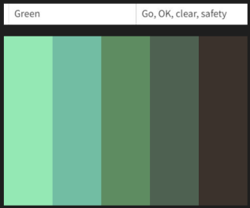

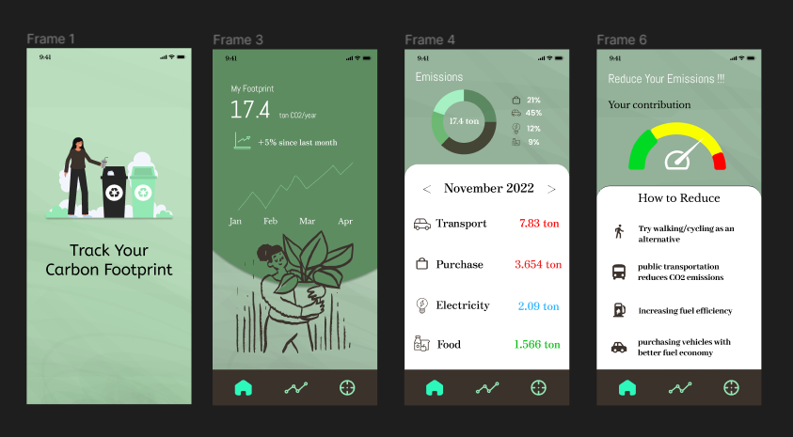

**Conclusion:**

In this experiment, we discovered how to use several colour schemes based on their symbolic meanings and the practicalities of each shade of a given colour for our application based on carbon emissions.

|  |  |  |  |  |  |
| --- | --- | --- | --- | --- | --- |
| Sr.No. | Principles | Poor | Average Good | Very  good | Excellent |
| 1 | Aesthetically pleasing |  |  |  |  |
| 2 | Compatibility |  |  |  |  |
| 3 | Comprehensibility |  |  |  |  |
| 4 | Consistency |  |  |  |  |
| 5 | Control |  |  |  |  |
| 6 | Efficiency |  |  |  |  |
| 7 | Flexibility |  |  |  |  |
| 8  9  10 | Forgiveness  Recovery  Responsiveness |  |  |  |  |