**HMI EXPERIMENT NO. 09**

Shubham Golwal | 2020300015

Ruthik Parab | 2020300050

Dilip Patel | 2020300051

Jai Patel | 2020300052

**Experiment No.: 0**9

**Name of the Experiment:** Design a Map based UI(Web User) for Tiffin with localization feature.

**Implementation:**

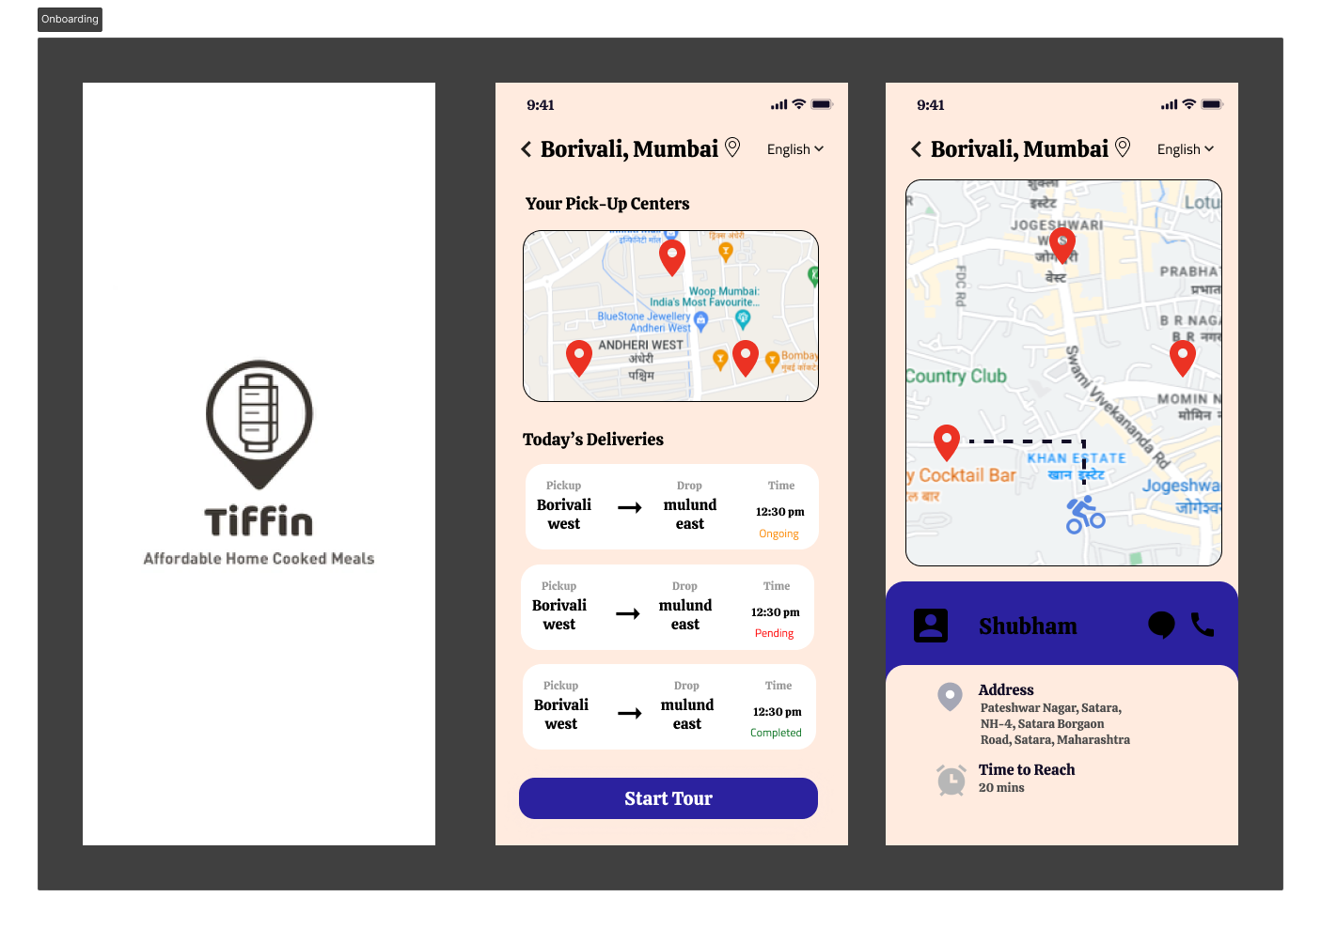

**Conclusion :**

We managed to create a ui interface for Tiffin wallas which includes guidance in the form of tool tips and feedback in the form of status of deliveries.

|  |  |  |  |  |  |
| --- | --- | --- | --- | --- | --- |
| Sr.No. | Principles | Poor | Average Good | Very  good | Excellent |
| 1 | Aesthetically pleasing |  |  |  |  |
| 2 | Compatibility |  |  |  |  |
| 3 | Comprehensibility |  |  |  |  |
| 4 | Consistency |  |  |  |  |
| 5 | Control |  |  |  |  |
| 6 | Efficiency |  |  |  |  |
| 7 | Flexibility |  |  |  |  |
| 8  9  10 | Forgiveness  Recovery  Responsiveness |  |  |  |  |