**Name:** Pranav Nair

**Roll No.:** 2019130042

**Batch:** B

**Course Code :** OECS4

**Experiment No.:** 1

**Name of the Experiment :** To study open source UX tools (Justinmind Prototype, Pidoco, Marvel ,Figma Prototype) and create a simple design for a given problem definition.

**Theory :**

**Justinmind** is a prototyping and wireframing tool for the creation of high-fidelity prototypes of web and mobile apps. It’s known for its ability to render realistic versions of a finished product as well offering collaboration, interaction and design features. Overall, it’s grown into one of the most popular prototyping tools in the industry. Justinmind can be used to simulate webs and mobile apps without any coding, thus allowing non-programmers to be involved in the project.

**Pidoco** is software that lets you quickly create click-through wireframes and fully interactive UX prototypes. Pidoco is a collaborative online wireframing and prototyping tool, which works entirely in your web browser. With Pidoco you can easily create clickable mockups, [wireframes](https://pidoco.com/en/tour/features/wireframes) and [GUI prototypes](https://pidoco.com/en/tour/features/prototypes) without programming. You can share your results with collaborators, reviewers and test users for [real-time editing](https://pidoco.com/en/tour/features/collaboration), discussion and approval. This will help you [design better user interfaces](https://pidoco.com/en/tour/features/usability-tests) (UI) for web, mobile and desktop applications and create solutions that work for the end user.

**Marvel** is a cloud-based platform with mobile support that enables single or multiple users and teams of varying sizes to create app prototypes within a centralized workspace. Rapid prototyping, testing and handoff for modern design teams. Marvel has everything you need to bring ideas to life and transform how you create digital products with your team. Placing the power of design in everyone's hands.

**Figma** is called the collaborative interface design tool. And it stands out for its collaboration feature. It gives users the ability to share a design file with multiple team members and get instant feedback from each other via comments. These days most of the other design tools have also implemented the collaboration feature but Figma is the one that first brought this to the table. Figma also provides a lot of useful resources, plugins, and techniques that make your workflow smoother.

**Procedure :**

Steps to download Figma :

* First, you need to visit the official [Figma website](https://www.figma.com/). There you will see a colorful homepage and an option to sign-up. Though if you have plans to use Figma online version, then you should complete the sign-up process
* To download the Figma desktop app directly, you have to scroll to the bottom of the page and click on the 'Downloads' option, which is placed under the resources section
* On the next page, you will see the Figma desktop download option for various platforms, including macOS and Windows. Choose the link according to your device and soon it will start the downloading process
* Once your file is downloaded, simply install it and run the desktop version. Then it will ask you for your login details. If you don't have an account, you should click on the create account button and create a new Figma account. The good thing is that that it is a completely free account and you could do anything you want without paying any money
* Now you will reach the Figma dashboard where you will be greeted with some Figma designs and samples. If you want to, then you could also install some plugins to make the prototyping more convenient. And that's it, this is the right way to download Figma Desktop app

**Comparative Study of Figma, AdobeXD, Marvel and Justinmind Softwares:**

|  | **Figma** | **AdobeXD** | **Marvel** | **Justinmind** |
| --- | --- | --- | --- | --- |
| **Cost (per year)** | $144 | $120 | $144 | $228 |
| **Platforms** | Supports Mac and Windows | Supports Mac and Windows | Does not support Mac and Windows | Supports Mac and Windows |
| **Specs (Can create design specs)** | Yes | Yes | Yes | Yes |
| **Automatic (Can automatically generate specs)** | Yes | Yes | Yes | Yes |
| **Assets (Can export design assets)** | Yes | Yes | Yes | Yes |
| **Measure (Can measure distance and size)** | Yes | Yes | Yes | Yes |
| **Style Guide (Can automatically generate style guides)** | No | Yes | No | No |
| **Layers** | Yes | No | No | No |
| **Comments** | Yes | Yes | No | No |
| **Revisions** | No | No | No | No |

**Output:**

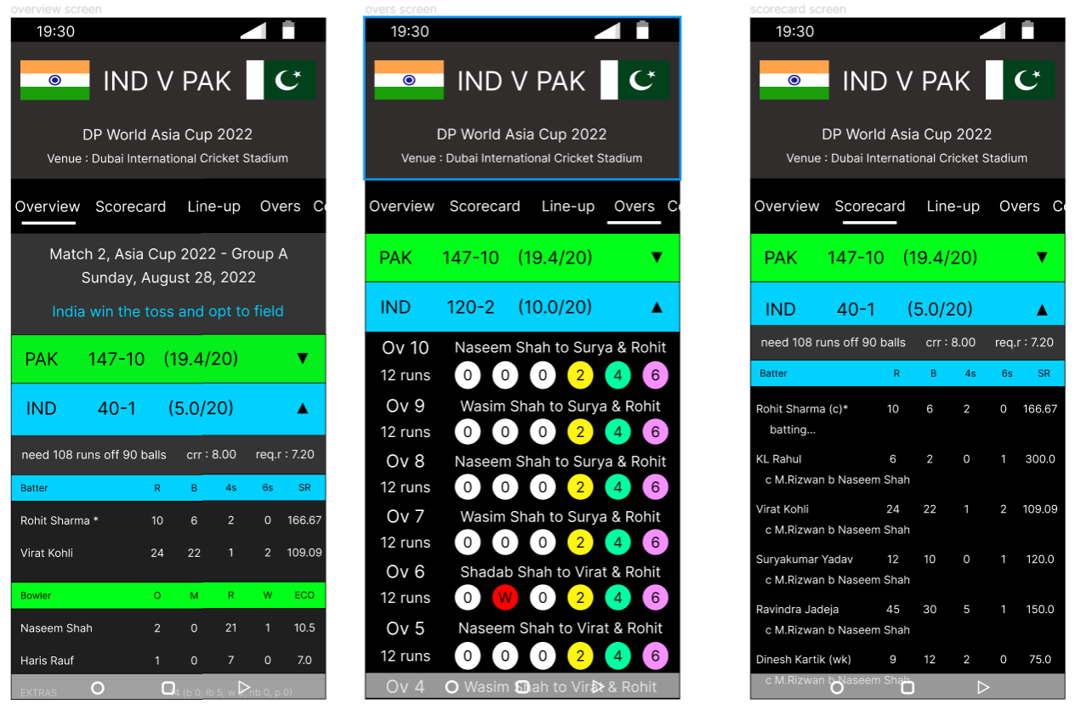

**Conclusion :** After completing the comparative study, I understood the different features each tool has to offer and decided to use Figma. Using figma, I have thus designed the ui for a live cricket score board as shown in the above images