**HMI EXPERIMENT NO. 10**

Shubham Golwal

Ruthik Patel

Dilip Patel

Jai Patel

**Experiment No.:** 10

**Name of the Experiment :** Screen Complexity

**Aim**: To calculate screen complexity of existing Graphical User Interface and redesign the interface to minimize the screen complexity.

**Theory**:

The size, local density, grouping, and alignment of design elements are key factors that contribute to the complexity of a GUI design, affecting its usability. To calculate the overall complexity of a screen, we use a weighted average of these factors, based on their relative importance. While aesthetics and user-friendliness are important considerations in website design, it is also crucial to minimize complexity. Poor alignment can lead to a cluttered or confusing interface, undermining user confidence.

To calculate screen complexity, we first identify the number of fields, vertical and horizontal alignment points in the screen. We then determine the common values for vertical and horizontal alignment. Using the provided formula, we can calculate the complexity of the screen based on the vertical and horizontal alignment points, and sum the resulting complexities to arrive at the final screen complexity.

**Implementation:**

**Old frame :**

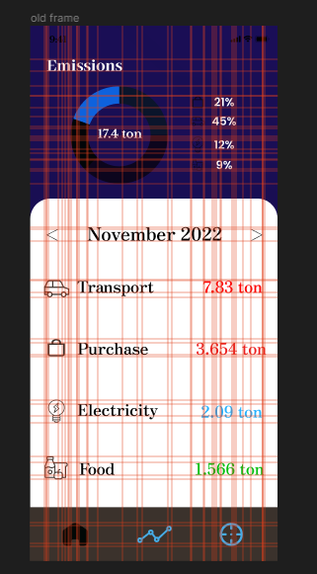

number of elements : 22

number of vertical alignment points : 11

number of horizontal alignment points : 12

common vertical

6*1/22

2*2/22

3*4/22

common horizontal

5*1/22

4*2/22

3*3/22

Screen Complexity By Vertical:

C1 = -22 * { 6 * (1/22) * log2(2/22) + 2 * (2/22) * log2(2/22) + 3 * (4/22) * log2(4/22)}

C1 = -22 * {-1.21 -0.628 -1.34}

C1 = ~70 bits

Screen Complexity By Horizontal:

C2 = -22 * { 5 * (1/22) * log2(1/22) + 4 * (2/22) * log2(2/22) + 3 * (3/22) * log2(3/22) }

C2 = -22 * {-1.01 -1.26 -1.17}

C2 = 76 bits

C = C1 + C2 = 70 + 76 = 146 bits

**Modified Frame:**

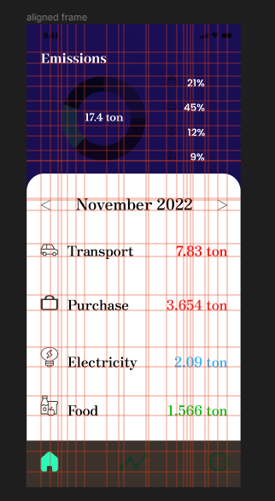

number of elements : 22

number of vertical alignment points : 8

number of horizontal alignment points : 8

common vertical

4*1/22

3*4/22

1*6/22

common horizontal

1*4/22

3*2/22

4*3/22

Screen Complexity By Vertical:

C1 = -22 * { 4 * (1/22) * log2(1/22) + 3 * (4/22) * log2(4/22) + 1 * (6/22) * log2(6/22)}

C1 = -22 * {-0.18 -0.51 -1.34}

C1 = ~45 bits

Screen Complexity By Horizontal:

C2 = -22 * { 1 * (4/22) * log2(4/22) + 3 * (2/22) * log2(2/22) + 4 * (3/22) * log2(3/22) }

C2 = -22 * {-0.45 -0.94 -1.57}

C2 = 65 bits

C = C1 + C2 = 45 + 65 = 110 bits

**Conclusion:**

For this particular experiment, we focused on the user interface (UI) screen of the reduced CO2 project. Our objective was to determine the complexity of a specific screen by analyzing its design elements. By adjusting the alignment of the various elements and merging some of them together, we were able to reduce the overall complexity of the screen..

|  |  |  |  |  |  |
| --- | --- | --- | --- | --- | --- |
| Sr.No. | Principles | Poor | Average Good | Very  good | Excellent |
| 1 | Aesthetically pleasing |  |  |  |  |
| 2 | Compatibility |  |  |  |  |
| 3 | Comprehensibility |  |  |  |  |
| 4 | Consistency |  |  |  |  |
| 5 | Control |  |  |  |  |
| 6 | Efficiency |  |  |  |  |
| 7 | Flexibility |  |  |  |  |
| 8  9  10 | Forgiveness  Recovery  Responsiveness |  |  |  |  |