**Name:** Pranav Nair

**Roll No.:** 2019130042

**Batch:** B

**Course Code :** OECS4

**Experiment No.:** 2

**Name of the Experiment :** Know your client

**Theory :**

**i. Analysis of customers behavior eg their preferences, interests etc**

**Ans:** There is a growing trend of people paying attention to the country of origin and in order to support local businesses and the economy, many people prefer to buy products made in India. There is increased attention to online sales, e-commerce and m-commerce because of the extended use of smartphones and especially in the last two years as a consequence of the pandemic. The consumers’ confidence in mass retailers is two times lower than their trust in craft products and small businesses. Consumers are generally highly influenced by social media mostly from advertisements, users’ comments and influencers. Handmade products are made with higher attention to detail, thus giving the customers aesthetic feel of the product. Handmade products which are unique, custom made or produced in small batches help people in expressing distinctive differences and give a sense of prestige which is an important motivation in Indian Society. Buying handmade stuff says a lot about this customer. It reflects their self-perception and what they want others to think of them. When they purchase and give a handmade gift, it sends a very special message to the recipient about their taste and generosity, and the importance of the relationship.

**ii. What kind of interfaces will they like and why?**

**Ans:**

1. Personalized product recommendations:- Personalizing your customers' buying journey by recommending products they will find most relevant can help improve their shopping experience.
2. Customized experiences and products:- A personalized shopping experience makes customers feel special and appreciated, which improves their overall shopping experience. Customers who feel special are loyal which translates into higher conversion rates for your e-commerce store. Personalization helps to increase brand awareness and trust.
3. Upgrade to smart, relevant reviews:- reviews similarly contain helpful information about each reviewer—height, period management habits, size purchased—letting buyers hone in on the feedback that is most relevant to them.

**iii. Existing apps - analyze and rate them**

**Ans:** Amazon : They do have a separate section for handmade articles but the similar design of the section does not make it stand out from the general products which does not give the user the feel of handmade products, the efforts of the craftsman cannot be expressed through such design which makes it less preferable for a person to sell their handicraft items on this platform.

CraftMaestro : They only focus on the handcrafted market. This is also evident in how their website has been created. But one of the issues with their design was that it didn't place enough attention on the product's background and lore.

**iv. What will be your choice of screen elements?**

**Ans:** To balance what is missing from the above study of existing apps which are amazon and craftMaestro, we thought of adding elements which would give the user the feel of the handmade products which amazon lacked in, that is by adding a different background elements, etc.

Compared to craftMaestro, a background story for the product and materials used in making it and the story of the maker and his journey and thought process behind making this product will be added to enhance the effect that the product will have on the user.

**v. How will your app be better than the existing ones?**

**Ans:** We narrowed down the reasons why consumers pick handmade goods to five. In order to maximize user experience, we took care to incorporate these elements into our app. These elements are:

Handmade items are advantageous to the environment, the local economy, and the preservation of culture. They also last for a long time and have interesting backstories. We believe that our design will be more effective in bringing out the emotions and efforts of the makers as compared to the other sites.

**Output:**

Figma Link: <https://www.figma.com/file/CGTjoWeTvuWqG6uiOGg4lU/HMI-LAB-1?node-id=0%3A1>

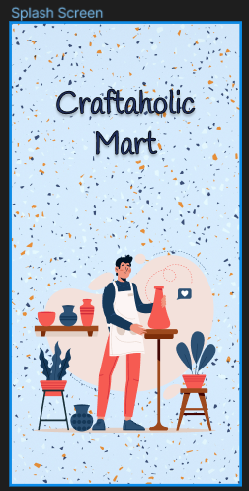 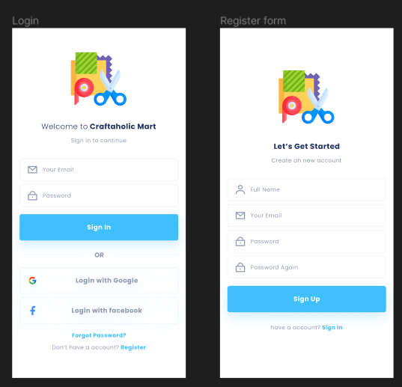

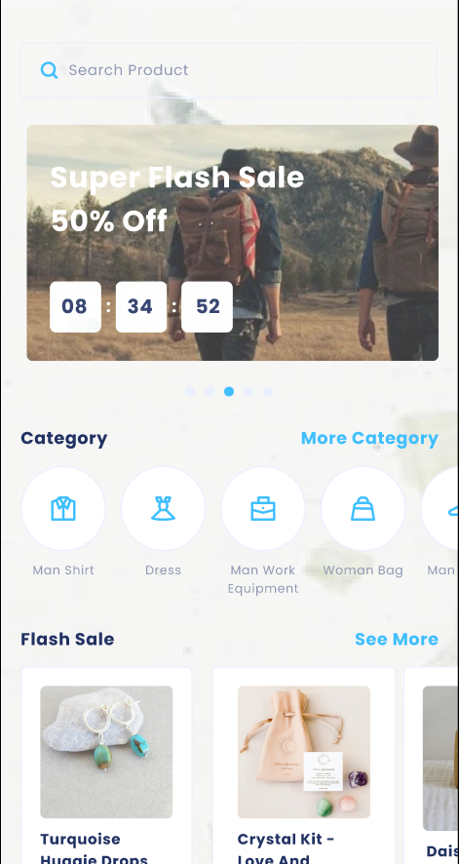 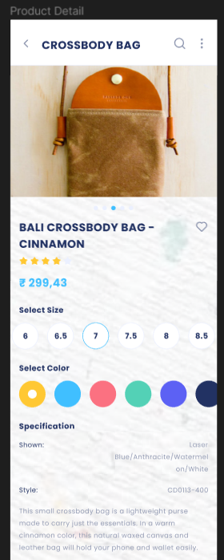

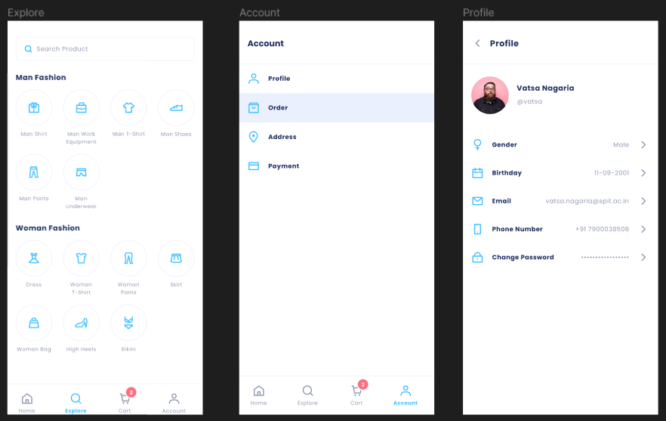

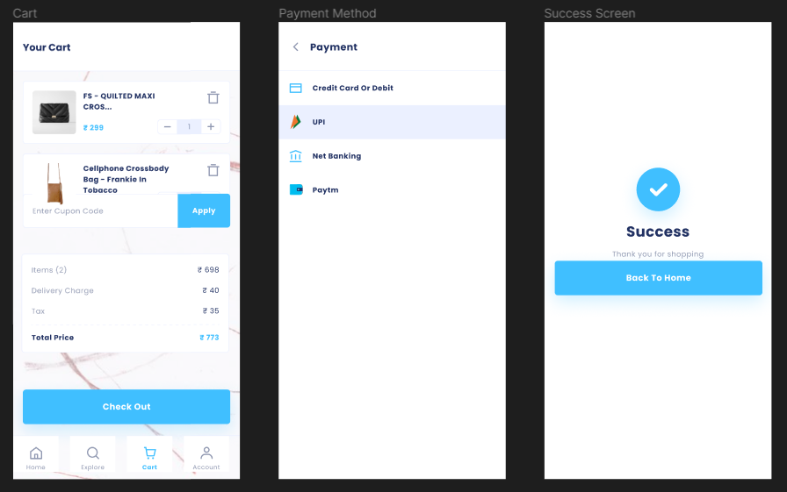

**Conclusion :** I have gained a better understanding of how to use different features of Figma to develop UI Screens through this experiment.