**Name:** Pranav Nair

**Roll No.:** 2019130042

**Batch:** B

**Course Code :** OECS4

**Experiment No.:** 3

**Name of the Experiment : Goal oriented design :** Design an experience for passengers whose train is delayed.

**Theory:**

**How often do you find yourself waiting for a train that has been delayed, or you have missed your train and the next one is after four hours, or waiting for a connecting train?**

**Answer:**

This app must be able to help the passenger to get the details of the delayed train and help the passenger to spend quality time.

Analysis of passenger behavior:

A passenger prefers a variety of options for entertainment if the train is delayed. They would prefer options of food, games, movies, maps regarding the current location of the Train.

Interface preferences of passengers:

The design includes cool user-friendly features with the visual appeal. Clarity is the most important characteristic of user interface design. The content should be sequential so that it does not frustrate the user. Good color combinations and responsive with

feedback option.

Hence we created an app, that will help the passengers to spend leisure time, if their train gets delayed. It satisfies the requirements of the passenger and designed an attractive, responsive and interactive interface so that passengers enjoy their time at the platform during train delayed hours.

**Output:**

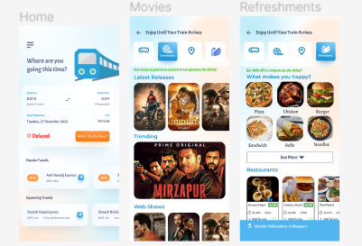

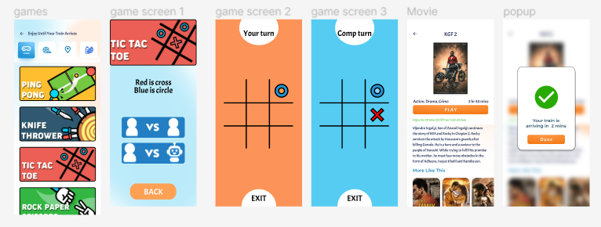

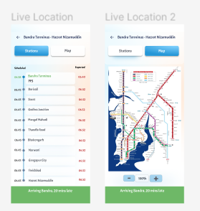

**Conclusion :** In this experiment, we built a ui for an extension to the railway applications, which features to suit the user in times of delay faced by them to keep them engaged by incorporating games, movies, food delivery service and live tracking of the train.