**Name:** Pranav Nair

**Roll No.:** 2019130042

**Batch:** B

**Course Code :** OECS4

**Experiment No.:** 4

**Name of the Experiment : Design Principles -** Understand principles of good UI design by heuristic evaluation.

**Output:**

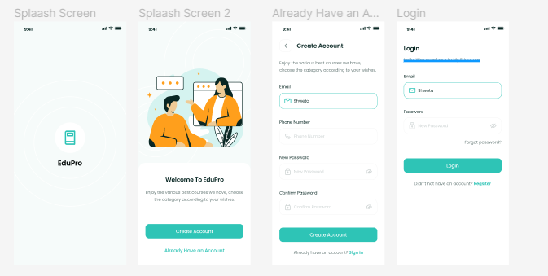



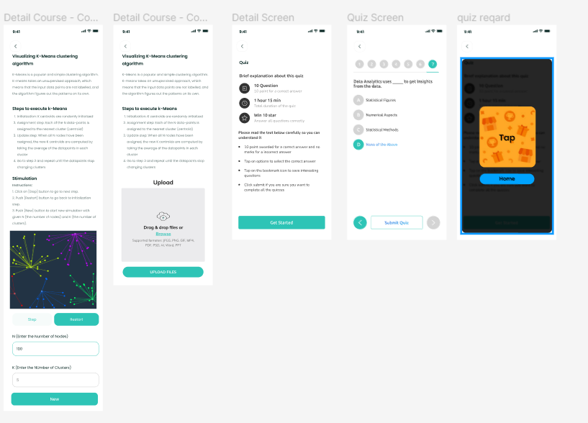

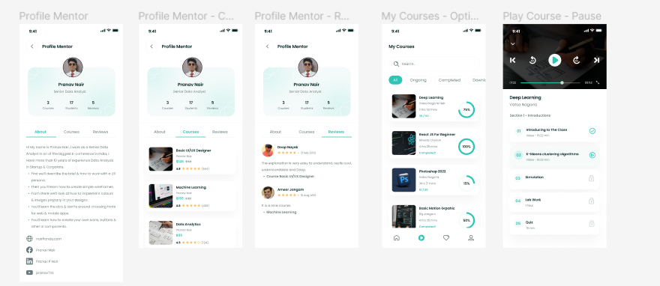

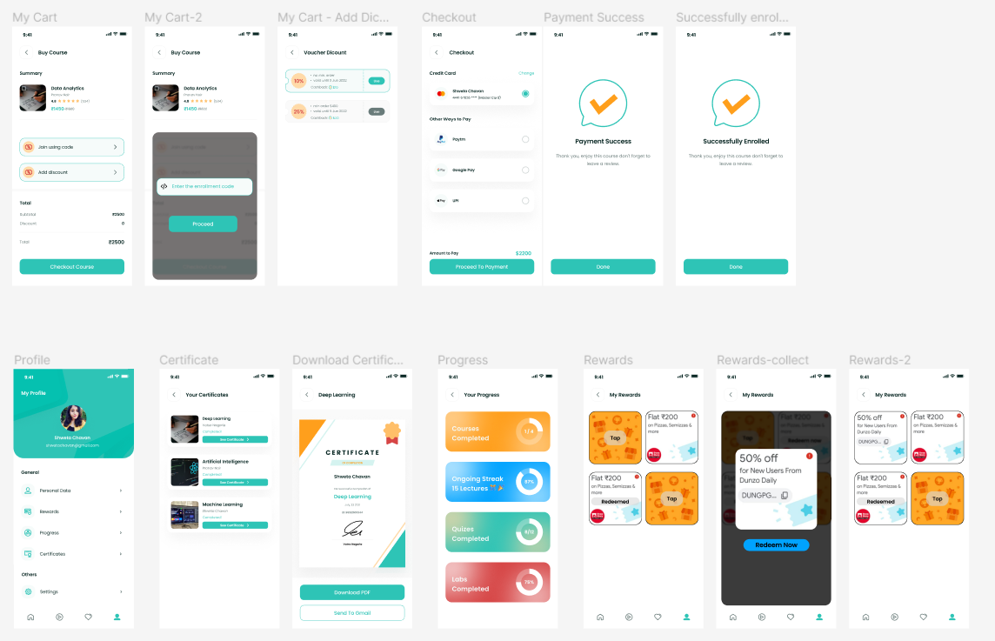

**Conclusion :** In this experiment, we built a ui for a course management app with additional features such as a reward system and simulation section.

| Sr.No. | Principles | Poor | Average | Good | Very  good | Excellent |
| --- | --- | --- | --- | --- | --- | --- |
| 1 | Aesthetically pleasing |  |  |  |  |  |
| 2 | Compatibility |  |  |  |  |  |
| 3 | Comprehensibility |  |  |  |  |  |
| 4 | Consistency |  |  |  |  |  |
| 5 | Control |  |  |  |  |  |
| 6 | Efficiency |  |  |  |  |  |
| 7 | Flexibility |  |  |  |  |  |
| 8 | Forgiveness |  |  |  |  |  |
| 9 | Recovery |  |  |  |  |  |
| 10 | Responsiveness |  |  |  |  |  |