**Name: Pranav Nair**

**Roll No.:** 2019130042

**Batch:** B

**Course Code :** OECS4

**Experiment No.:** 5

**Name of the Experiment :** Menus & Navigation – Redesign of a user interface (Suggest and implement changes in Existing User Interfaces

**Implementation:**



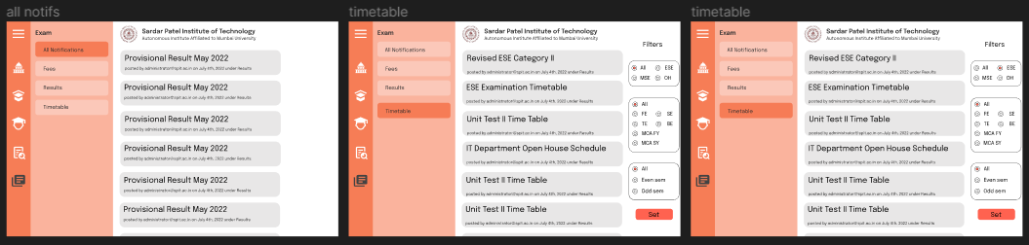

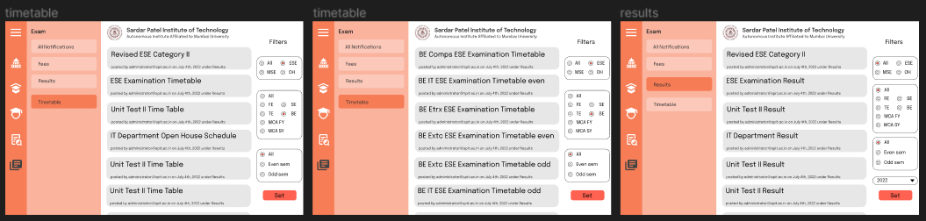

**Conclusion :**

In this Experiment, we built a UI for SPIT website, in which we have applied Collapsible Horizontal and Vertical Navigation & Menu type for better navigation & accessibility of different features of the website.

| Sr.No. | Principles | Poor | Average Good | Very  good | Excellent |
| --- | --- | --- | --- | --- | --- |
| 1 | Aesthetically pleasing |  |  |  |  |
| 2 | Compatibility |  |  |  |  |
| 3 | Comprehensibility |  |  |  |  |
| 4 | Consistency |  |  |  |  |
| 5 | Control |  |  |  |  |
| 6 | Efficiency |  |  |  |  |
| 7 | Flexibility |  |  |  |  |
| 8  9  10 | Forgiveness  Recovery  Responsiveness |  |  |  |  |