**Name:** Pranav Nair

**Roll No.:** 2019130042

**Batch:** B

**Course Code :** OECS4

**Experiment No.:** 7

**Name of the Experiment :** Icons - Design appropriate icons pertaining to a given domain.(ie. Sanitation)

**Implementation:**

* 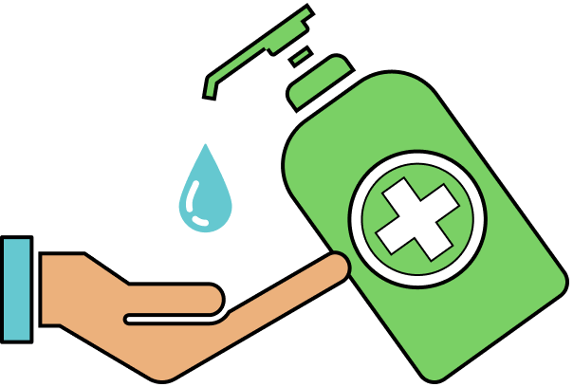**hand sanitization**
* **hygienic washroom**
* **food safety**
* ** housekeeping**
* ** mask**

**Conclusion :**

We created icons for sanitation in this experiment. These icons were created with respect for the viewpoint and comprehension of users.

| Sr.No. | Principles | Poor | Average Good | Very  good | Excellent |
| --- | --- | --- | --- | --- | --- |
| 1 | Aesthetically pleasing |  |  |  |  |
| 2 | Compatibility |  |  |  |  |
| 3 | Comprehensibility |  |  |  |  |
| 4 | Consistency |  |  |  |  |
| 5 | Control |  |  |  |  |
| 6 | Efficiency |  |  |  |  |
| 7 | Flexibility |  |  |  |  |
| 8  9  10 | Forgiveness  Recovery  Responsiveness |  |  |  |  |