**Name:** Pranav Nair

**Roll No.:** 2019130042

**Batch:** B

**Course Code :** OECS4

**Experiment No.:** 9

**Name of the Experiment :** Design a Map based UI(Web User) for Mumbai Dabbawalas with localization feature.

**Implementation:**



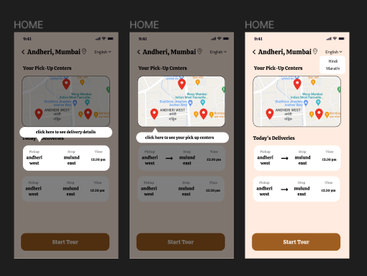

**Conclusion :**

We managed to create a ui interface for mumbai dabba wallas which includes guidance in the form of tool tips and feedback in the form of status of deliveries.

| Sr.No. | Principles | Poor | Average Good | Very  good | Excellent |
| --- | --- | --- | --- | --- | --- |
| 1 | Aesthetically pleasing |  |  |  |  |
| 2 | Compatibility |  |  |  |  |
| 3 | Comprehensibility |  |  |  |  |
| 4 | Consistency |  |  |  |  |
| 5 | Control |  |  |  |  |
| 6 | Efficiency |  |  |  |  |
| 7 | Flexibility |  |  |  |  |
| 8  9  10 | Forgiveness  Recovery  Responsiveness |  |  |  |  |