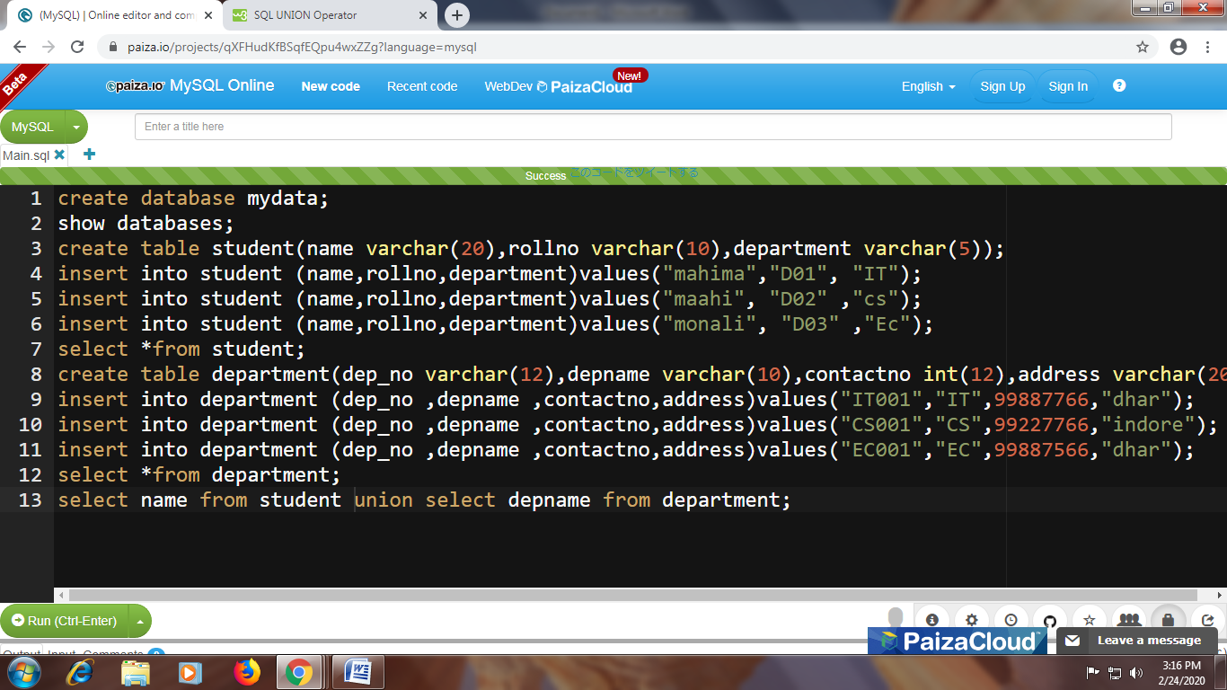
mahima D01 IT
maahi D02 cs
monali D03 Ec
IT001 IT 99887766 dhar
CS001 CS 99227766 indore
EC001 EC 99887566 dhar
mahima
maahi
monali
IT
CS
EC
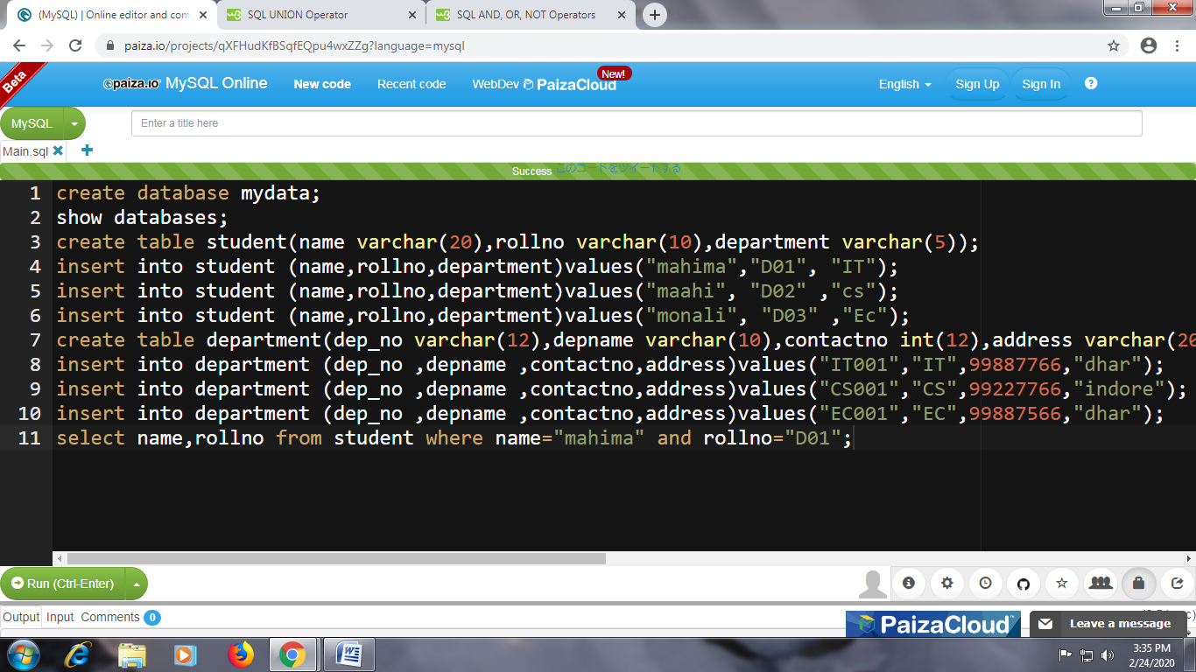

mahima D01

