Student

Management

With

Database

In

Python

* Made by
* Shubham Samal
* Shyresh Dhanawade

Objective of Project:

Along with c , c++ , Java and so on ,now-a-days python is preferred to learn.

Python is a programming language that combines the features of c and Java .

There are various reasons why Python is gaining good popularity in programming community.

Features of Python:

1. Simple
2. Easy to learn
3. Open source
4. High level language , etc.

Due to various facility provided by the python it is easy to create a management system in Python with the help of its features.

Hardware Requirement:

1. Laptop\Personal computer 64 bit , i3 processor or above.

Software Requirement:

1. Pycharm (64bit)
2. Xamp Server(Latest Version)
3. Python 3.8.2 version
4. Mysql package
5. Tkinter

Theory or Working:

1] Home screen of the system

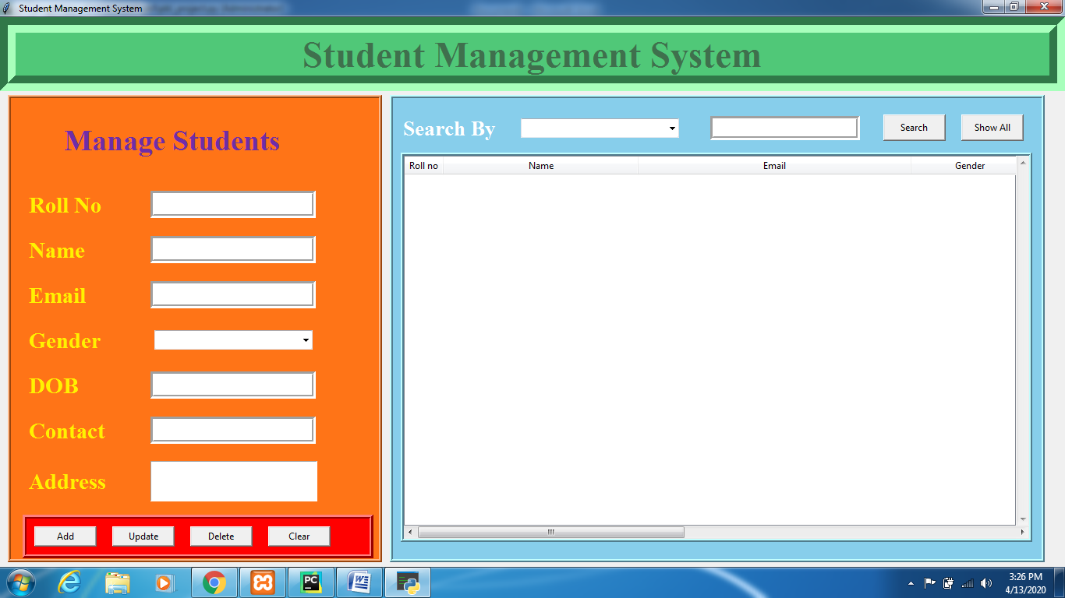

2] Adding details of students

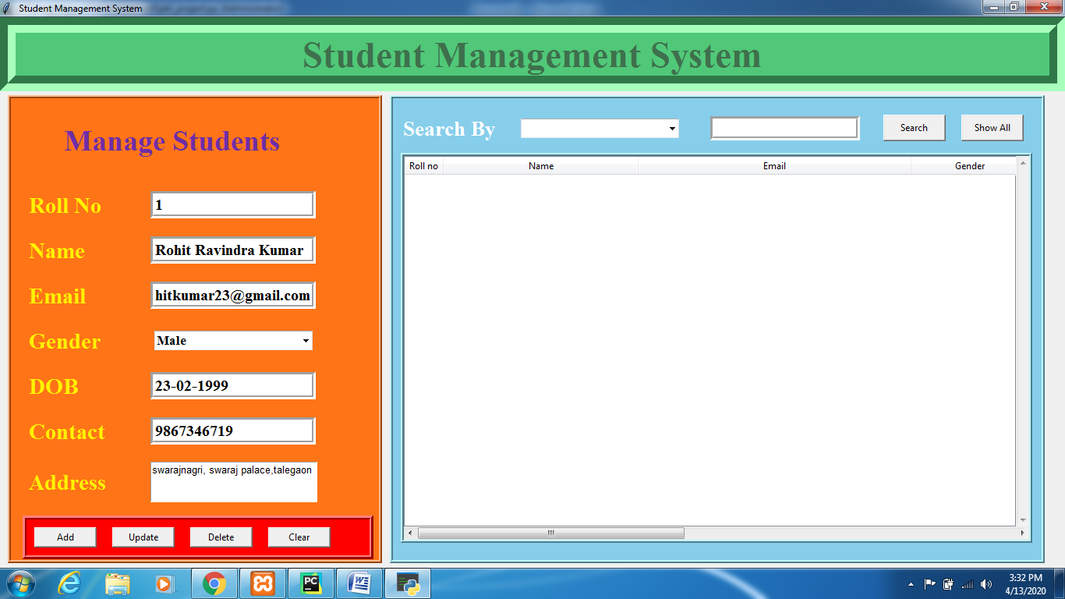

Message of “successfully recoded”

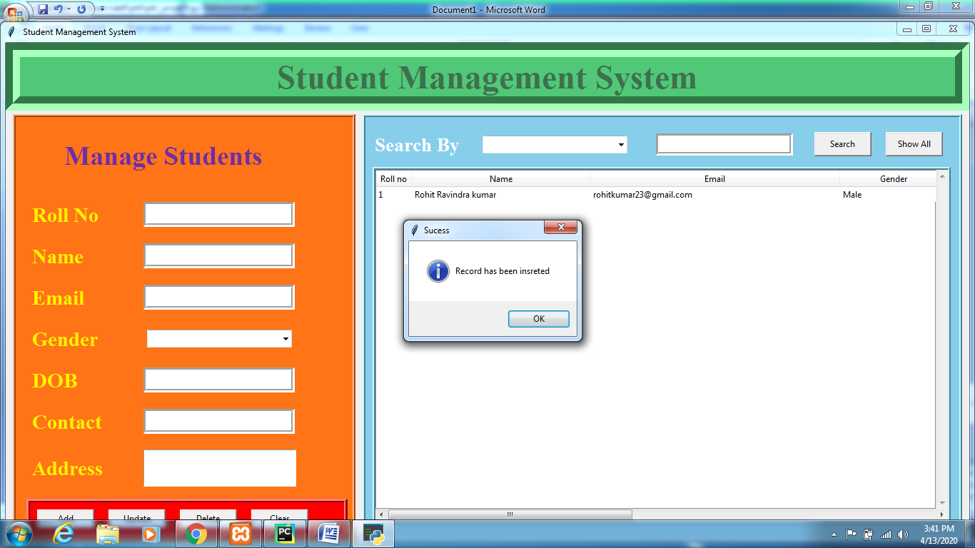

Working of PHPMyAdmin server in Xamp:

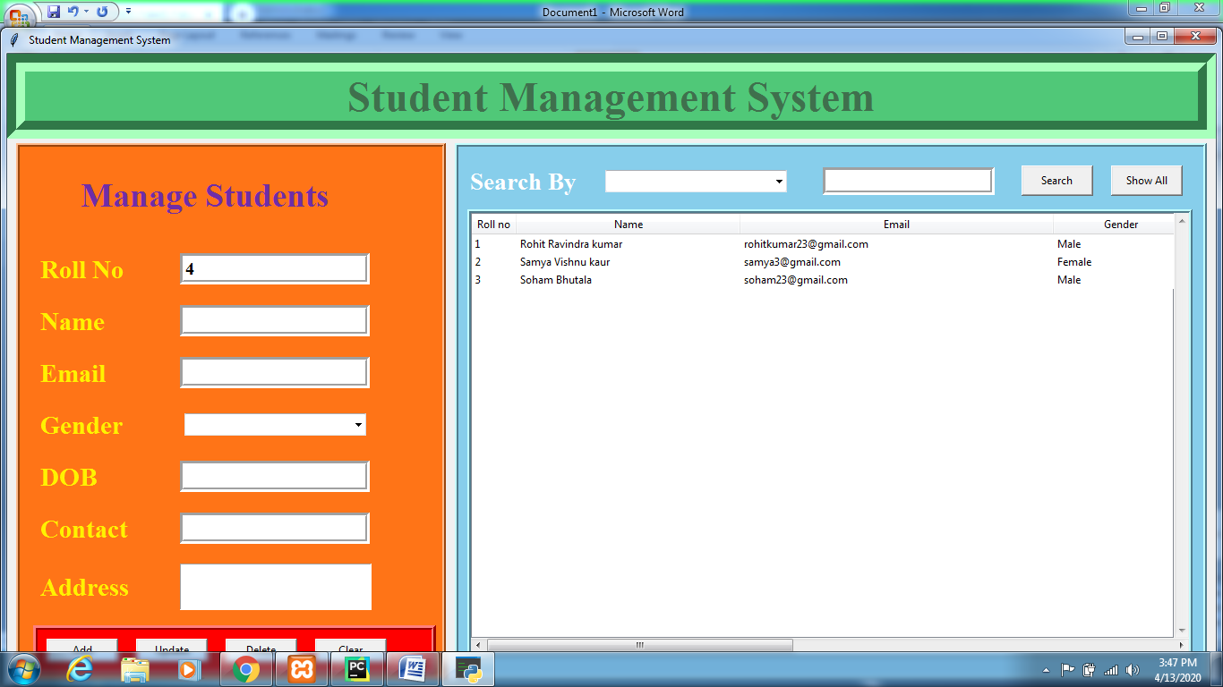

When I add data to the homescreen it stores the data in the xamp

Server along with the folder in desktop, but its easy to find on chrome

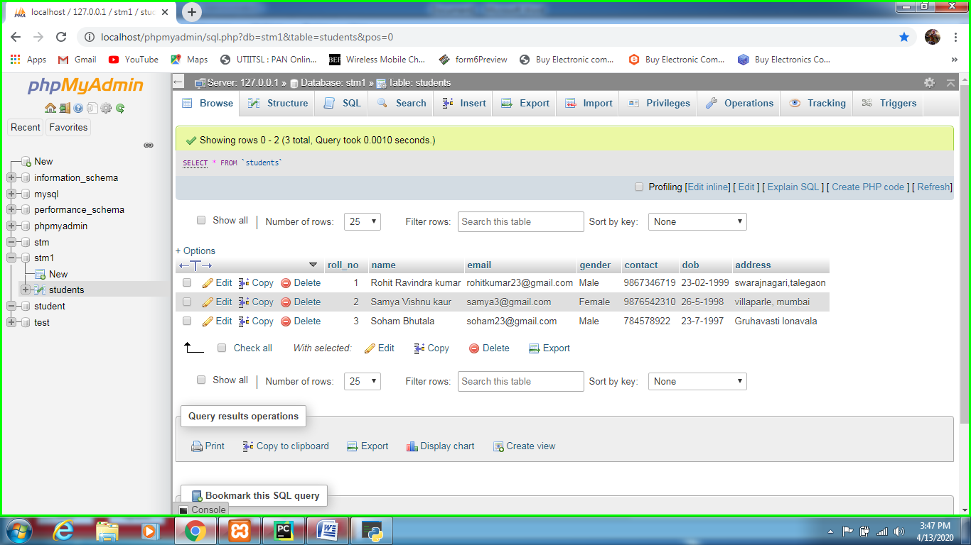

Function of clear button:

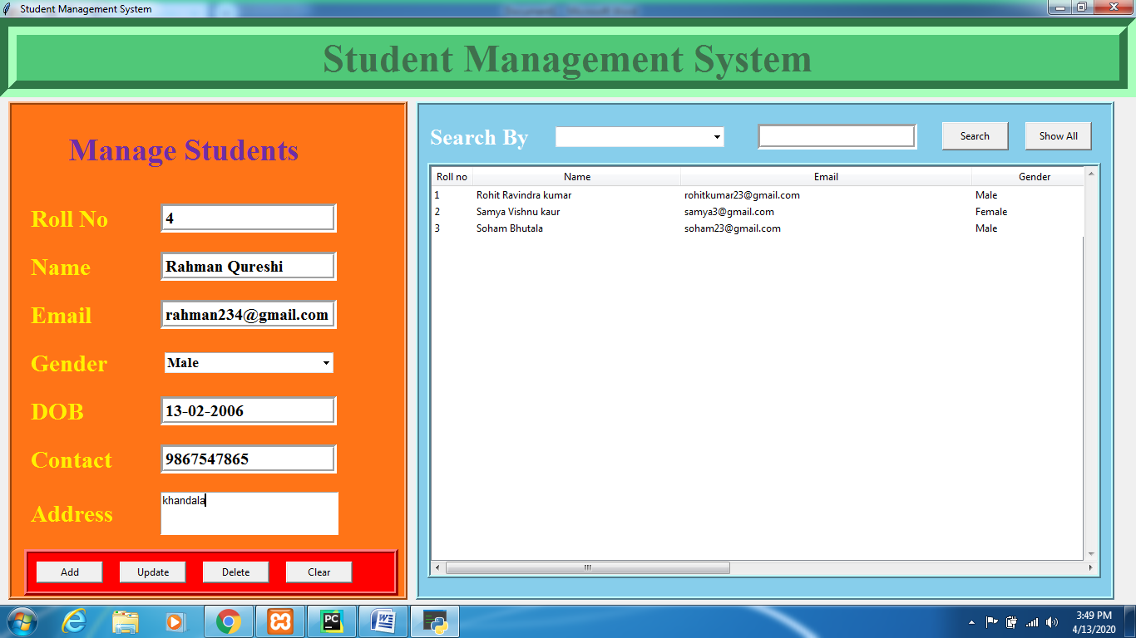

When I entered a data in the input panel , if I want to clear it I can clear it with the clear button

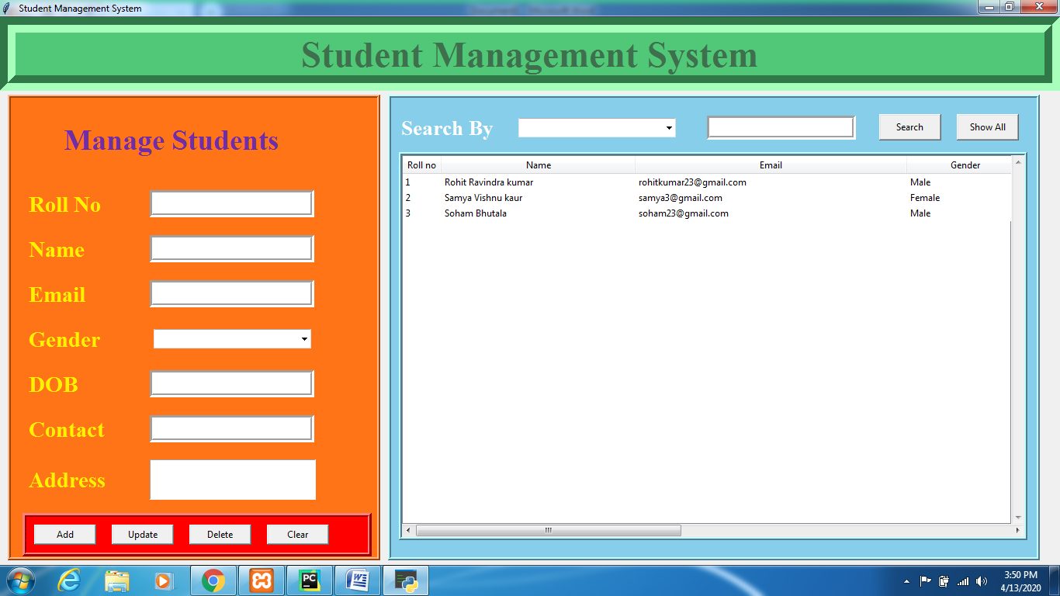

Function of delete button:

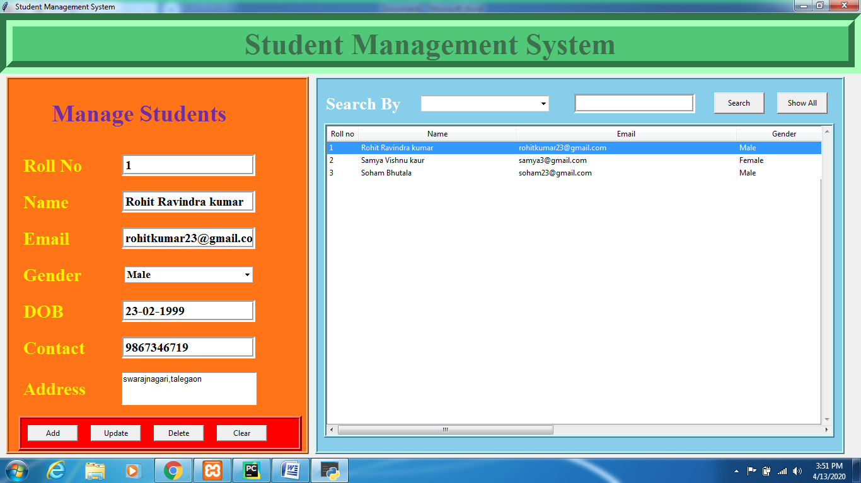

When I select particular row, it is then transformed to the data panel ,as the delete button is executed the data is deleted

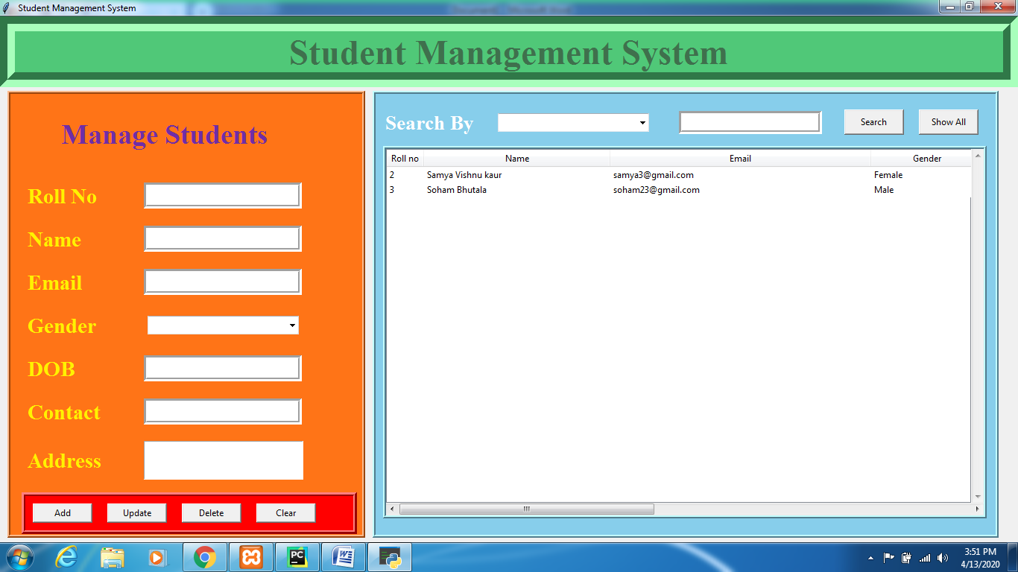

Accordingly the data is also removed from the xamp server

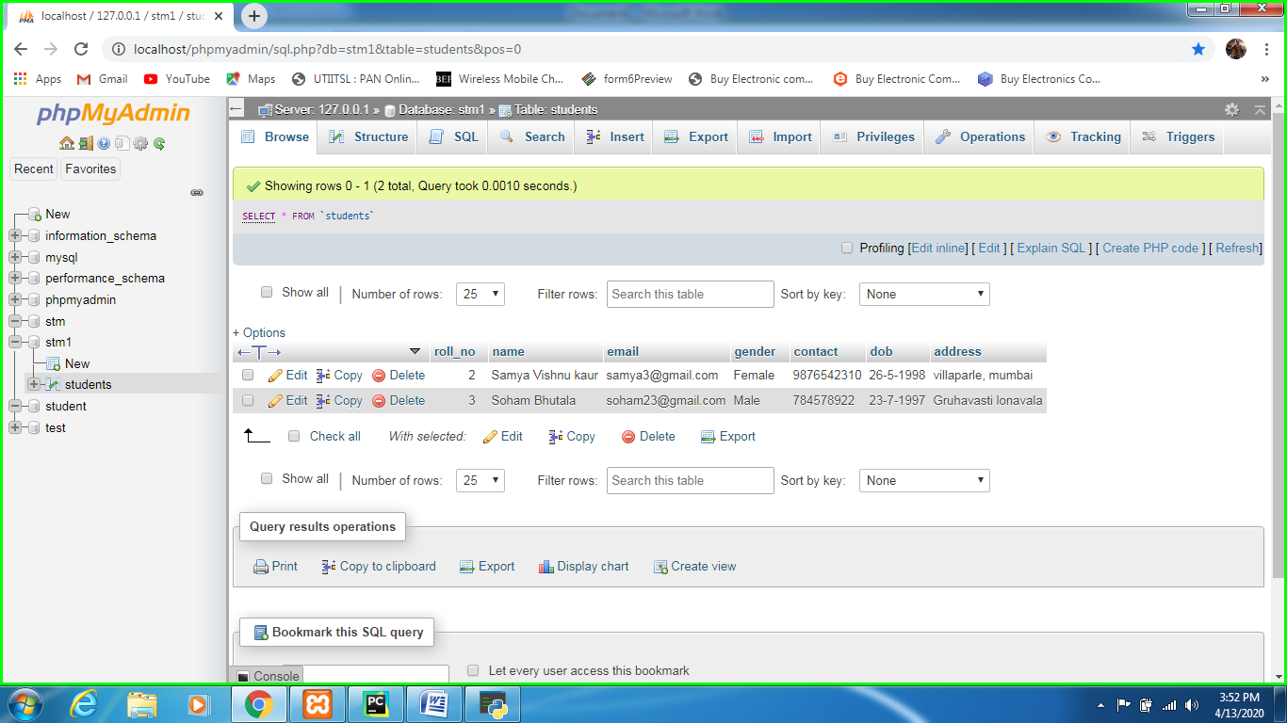

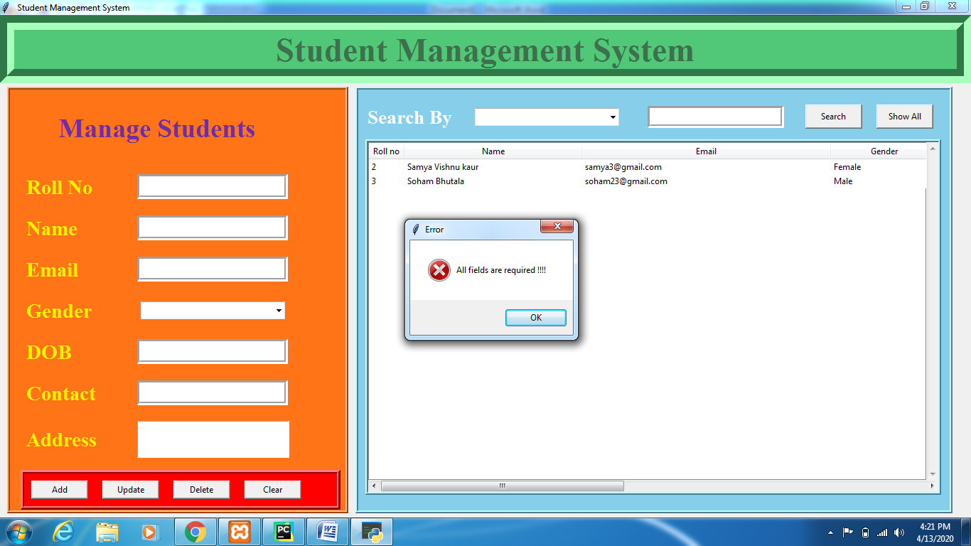

An error is introduced when blank entry is passed

*Conclusion:*

Student management system was created with the help of Xamp server to store database.

The project was coded in Python with the help of its features provided with it