**Fitness Band Prototype Project Report**

**Abstract**

The Fitness Band Prototype presented in this report is designed to offer a comprehensive set of health monitoring and alert features. The band integrates a vibration sensor for detecting epilepsy and panic attacks, a heart rate sensor, a temperature sensor, and an Micro-controller (ESP32) for data processing. This prototype aims to provide a multi-functional wearable solution for users, promoting a proactive approach to health monitoring and emergency alerting.

**PROBLEM STATEMENT:**

Develop a system for Patient Care in the Health Sector

**Solution:**

Our device provides 24/7 monitoring of patients who require continuous assistance. And it will be affordable and easy to use.

Our model is like a fitness band which will monitor heartrate oxygen level and temperature of its user all the time and send alert when there is visible fluctuation. It also has a vibration sensor (specially for mute child to detect high fever, hypothermia, panic attacks and epilepsy patients ) to give allert in time of emergency.

**Keywords:**

Fitness Band, Wearable Health Technology, Epilepsy, Panic Attacks, Heart Rate Monitoring, Alert System, Personal Health Management.

**Components and Features**

We are using Arduino IDE to write the code and integrate the sensors with our micro-controller (ESP32). to monitor the data on phone we are using Blynk app.

**MICRO CONTROLLER**

We are using esp32 as it has built in Wi-Fi module.

Wi-Fi has a range of 100m in ideal condition, which is needed to stay connected to main server.

The library used for connecting esp32 to Blynk:  
1. Wire.h

1. Wifi.h
2. WifiClient.h
3. BlynkSympleEsp32

**Sensors**

HEARTRATE

For Heart rate monitoring we are using “*Max30102*”.

It monitors heart-rate by combining two LEDs , a photodetector, optimized optics, and low-noise analog signal processing to detect heart rate (HR) signals.

This method of pulse detection through light is called Photoplethysmogram3.

Here’s a brief overview of how it works:

LEDs: The MAX30102 has two LEDs – a RED and an IR LED2. These LEDs shine light onto the wrist (or essentially anywhere where the skin isn’t too thick, so both lights can easily penetrate the tissue).

Photodetector: On the other side is a very sensitive photodetector. This photodetector measures the amount of reflected light.

Measurement: By shining a single LED at a time, detecting the amount of light shining back at the detector, and, based on the signature, you can measure blood heart rate.

Signal Processing: The sensor’s onboard signal processing unit analyzes the pattern of light absorption and reflection to determine the heart rate.

I2C Interface: It uses an I2C interface for communication, which is a two-wire serial connection used to transmit data between devices.

Low Power: It’s designed for low power consumption, making it suitable for battery-powered devices. The MAX30102 chip requires two different supply voltages: 1.8V for the IC and 3.3V for the RED and IR LEDs.

(It is advised not to use power supply more than 4.5v)

Libraries used for MAX30102:

1.Max30105.h By Adafruit

2.Heartrate.h By Adafruit

Problem faced during integration of MAX30102:

1.It need power supply between 3.3 to 4.5, although the data sheet says it’s range is -3.3V to 5V It may stop working on 5V.

2.We should carefully connect the Vin and GND pins.

3.We can set the pulse amplitude to control current it is using.

e.g.

 particleSensor.setPulseAmplitudeRed(0x08);

TEMPERATURE

For temperature sensing we are using MLX90614 IR Temperature Sensor:

The MLX90614 is a non-contact infrared temperature sensor that can measure temperatures without physical contact by detecting infrared radiation emitted by an object12.

Here’s a brief overview of how it works:

IR Sensing: The MLX90614 uses infrared rays to measure the temperature of an object. It operates on the principle that all objects emit infrared energy, which is proportional to their temperature.

Dual Temperature Measurement: It generates two temperature measurements: object temperature and ambient temperature. The object temperature is the non-contact measurement from the sensor, while the ambient temperature measures the temperature on the die of the sensor.

Built-In Optical Filter: The sensor includes a built-in optical filter that cuts off visible and near-infrared light, reducing their effect on measurements and providing immunity against ambient light and sunlight.

I2C Interface: Communication with microcontrollers is achieved through the I2C interface, a two-wire serial connection used to transmit data between devices.

Low Power Consumption: The MLX90614 consumes less than 2mA during measurement, allowing implementation in battery-powered devices such as handheld thermal scanners.

Wide Temperature Range: It can measure object temperatures ranging from -70°C to 382.2°C and ambient temperatures from -40°C to 125°C, with a resolution of 0.02°C and standard accuracy of 0.5°C around room temperatures.

Power Requirements: The sensor can be powered using a supply voltage of 3.3 to 5.5V, and it is available in both 3V and 5V versions.

Libraries used for MLX90614:

Adafruit_MLX90614 By Adafruit

Problem faced during integration of MLX90614:

1.The temperature fluctuation was rapid.

Solution: Add a delay and reduce Emissivity to 0.98 the default is 1.00, which was causing the sudden excessive rise of temperature.

e.g.

  float newEmissivity = 0.98; // Set your new emissivity value here

  writeEmissivity(newEmissivity);

  delay(1000);

Vibration

SW420 Vibration Sensor: The SW420 is a cost-effective vibration sensor module that detects vibrations or movements through a mechanical switch and signal processing circuitry.

Here’s a brief overview of how it works:

Vibration Sensing: The core component, the SW420 vibration switch, senses the magnitude of vibration in its environment. It responds to the exposed vibration by changing the state of an electrical contact within the switch.

Signal Processing: The module includes an LM393 voltage comparator, which compares the input vibration signal with a reference threshold set by an onboard potentiometer. This allows for adjustable sensitivity to the vibrations.

Digital Output: When vibrations are detected that exceed the preset threshold, the module outputs a digital signal (logic high). If no vibrations are detected, it remains in its default logic low state.

I2C Interface: While the SW420 primarily provides a digital output, it can be interfaced with microcontrollers, including those using I2C communication, through additional circuitry if needed.

Adjustable Sensitivity: A 10K potentiometer on the module allows for the adjustment of the sensitivity of the sensor, enabling it to be calibrated for different use cases.

Power Requirements: The sensor module operates at a voltage range of 3.3 to 5.0 volts DC and has a current driving capability of 15 mA.

Libraries used for SW420:

No additional libraries required for it.

Problem faced during integration of SW420:

1.We have to set the potentiometer to the desired setting (to set threshold frequency for high signal) manually.

2.Since it is a digital sensor we have to apply count function to get reading how how long the threshold frequency stayed so that the alert can be sent.

Screen

OLED SSD1306 Display: The SSD1306 is a monochrome OLED display module that offers high contrast and wide viewing angles. It is commonly used in various electronics projects and devices due to its crisp display capabilities12.

Here’s a brief overview of how it works:

Display Technology: The SSD1306 operates on Organic Light-Emitting Diode (OLED) technology, which allows each pixel to emit light independently, eliminating the need for a backlight. This results in excellent contrast ratios and deep black levels.

Resolution: It typically comes in a resolution of 128x64 pixels, providing sufficient space for text, symbols, and simple graphics.

Communication Protocol: The display uses the I2C communication protocol, requiring only two pins for data transmission, making it ideal for microcontroller-based projects where pin economy is important.

Power Efficiency: OLED displays are known for their low power consumption, as they only draw power for the lit pixels. This characteristic makes the SSD1306 suitable for battery-powered applications.

Versatility: The SSD1306 can be interfaced with various microcontrollers, including Arduino, and supports both 3.3V and 5V logic levels, making it adaptable to different project requirements.

Applications: Due to its compact size and ease of use, the SSD1306 is often found in wearable devices, portable instruments, and any application where a small, clear display is required1.

Libraries used for SSD1306:

Adafruit_SSD1306 By Adafruit

Adafruit_GFX By Adafruit

Problem faced during integration of SSD1306:

There aren't any particular issue faced using this OLED. Nut we should be careful when connecting the wires, and giving the initializing cursor pointers.

**Flow Chart:**

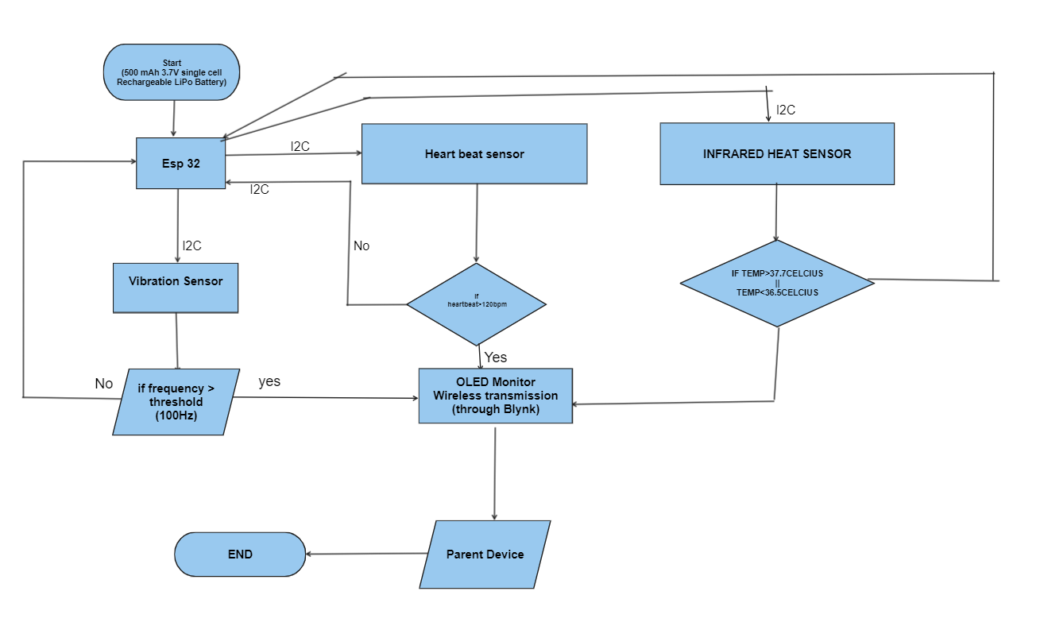

**Block Diagram**

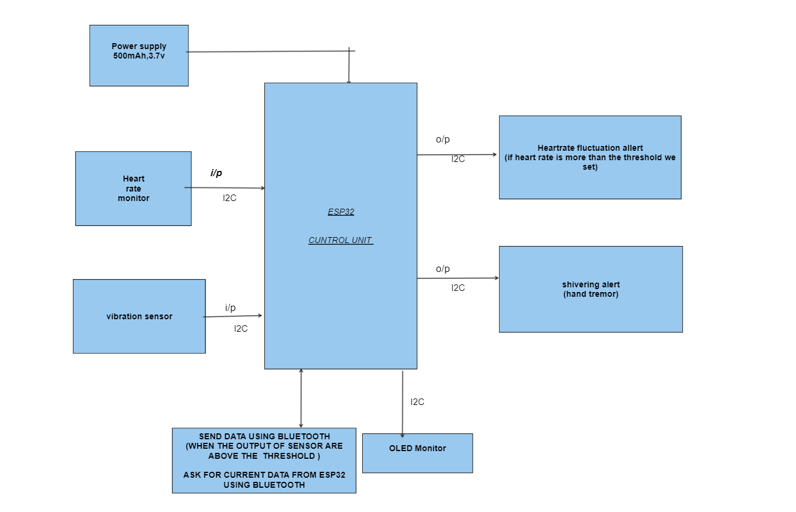

**Circuit Diagram**

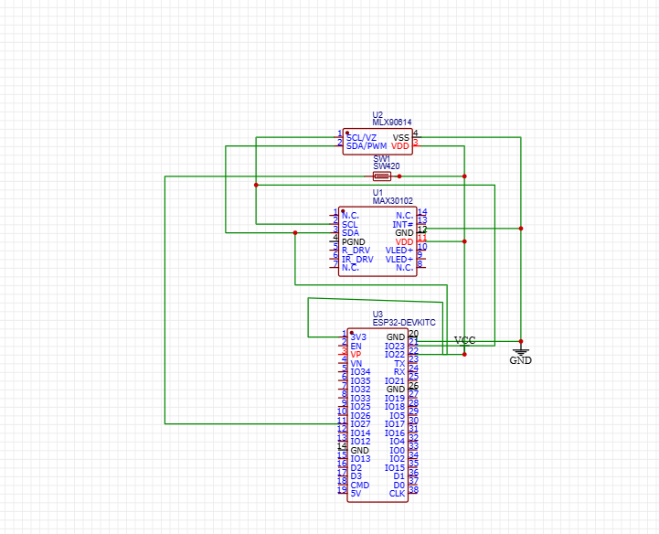

**Conclusion**

The Fitness Band Prototype presented in this project report is a promising development in the field of wearable health technology. It offers users a comprehensive set of health monitoring features, including the detection of epilepsy and panic attacks, heart rate monitoring, and temperature sensing. As the project evolves, it holds the potential to make a significant impact on personal health management and emergency alert systems.