CAPSTONE

# Content:

1. Introduction
2. Entity and Database table
3. Technology
4. Design

# Introduction:

1. User Management.
2. Create Order and place this order
3. Confirm Purchase order via Mail.
4. Confirmed Purchased Order.
5. Create Invoice and show, search
6. Create PO, Search PO, Find PO.
7. Show Total Amount Reports.
8. Multiple Report Generations.
9. Order Payment.
10. Mail Micro Services.
11. Report Micro Service.
12. Item Uploading Micro Service by Console Application.

## Database Tables and Entity:

Database Table

1. Item
2. Invoice Table
3. Order table
4. PO Table
5. USER Table
6. ROLE Table

### View

Total balance View

Entity

1. USER
2. USERROLE
3. InvoiceInfo
4. OrderInfo
5. PurchaseOrderInfo
6. ReportInfo
7. ItemInfo
8. MyMessage
9. MYMessage in Mail Micro Service

## Technology:

1. Java8
2. Spring Boot 2.5.5 and MVC
3. Micro Service.
4. MySQL OR Oracle.
5. SMTP Service.
6. JPA.
7. JDBC.
8. HTML, CSS, Bootstrap.
9. JQUERY, JAVA SCRIPT. 10 Rest Service API. 11 AJAX.

# Design:

1. **Login**

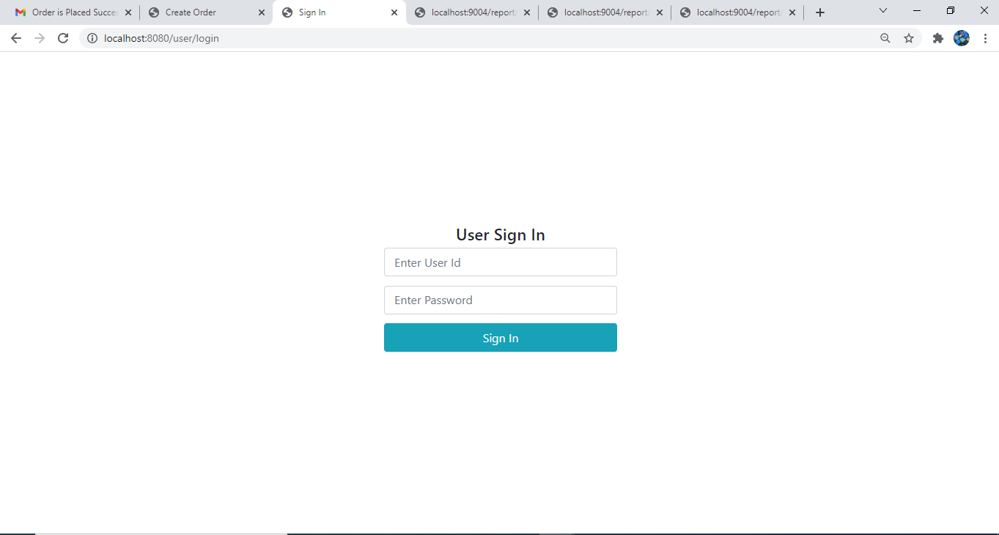

1. Admin and User Dashboard

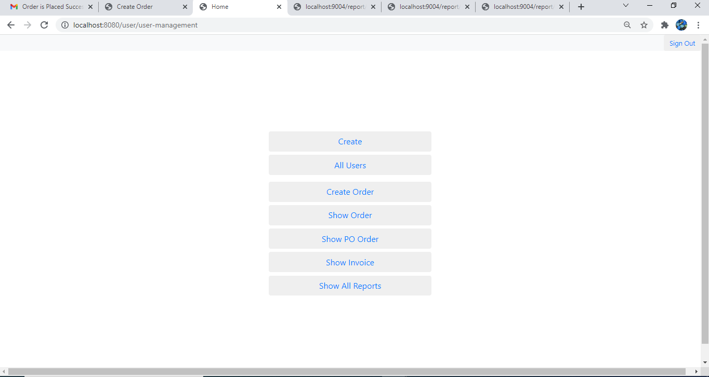

1. Create User

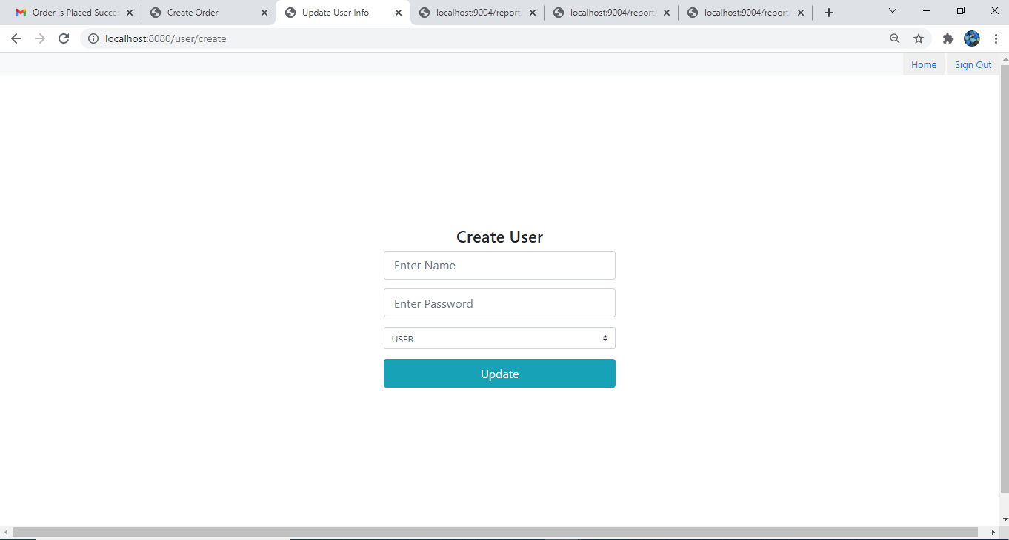

1. View Users

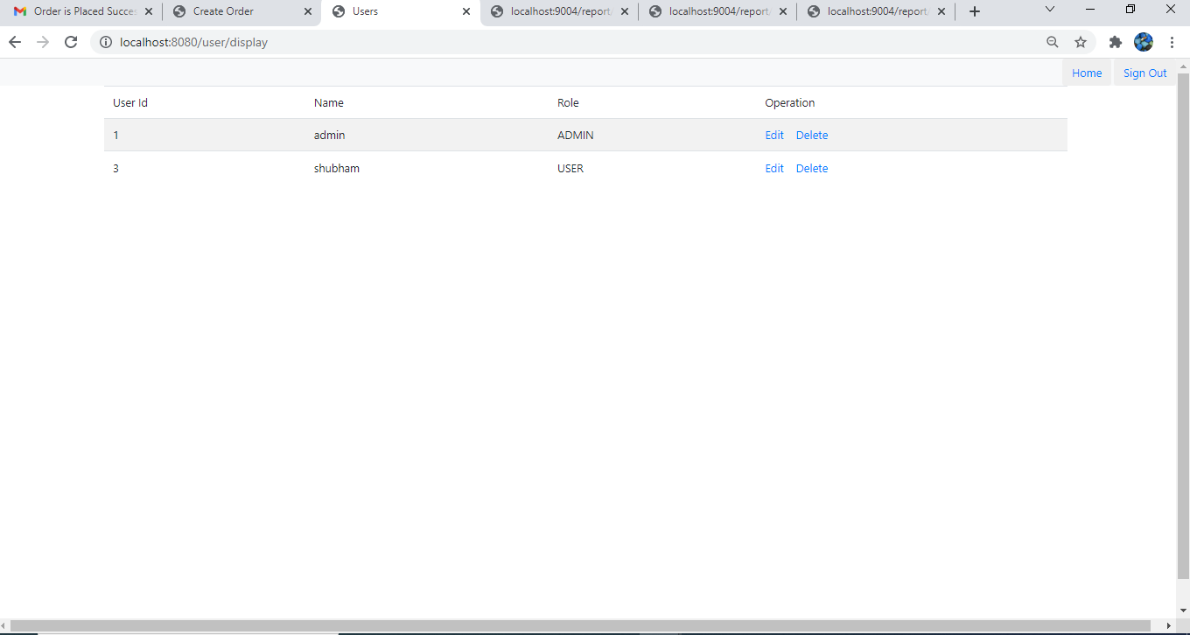

1. Create Order

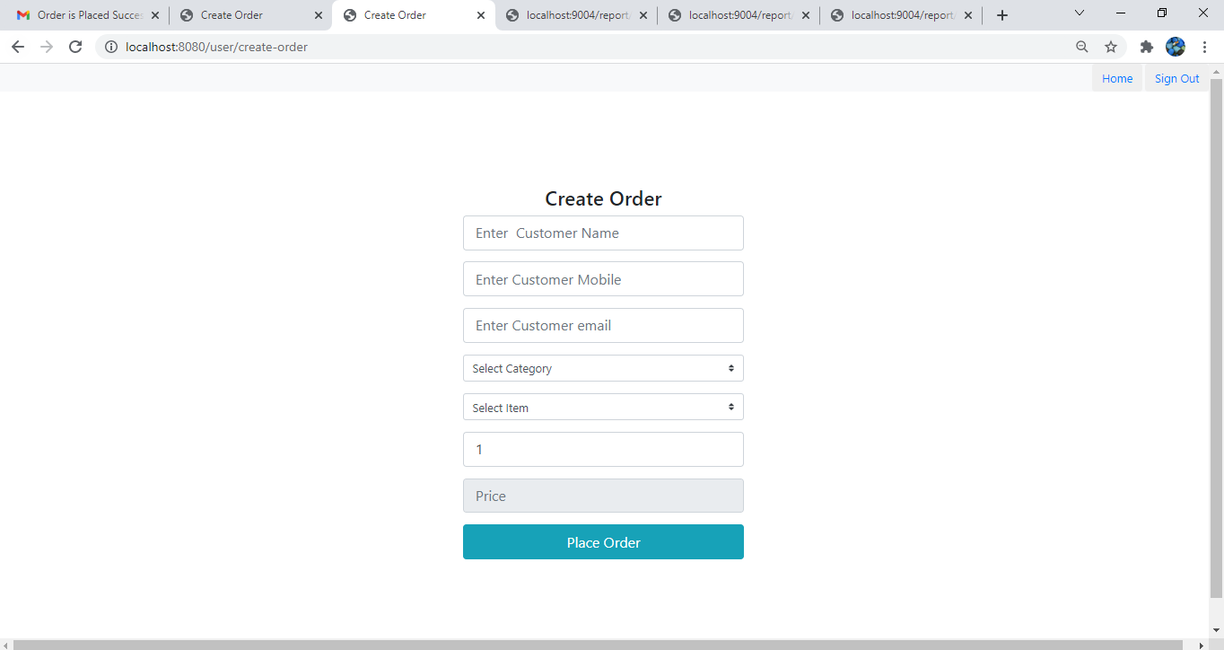

1. Order place Screen

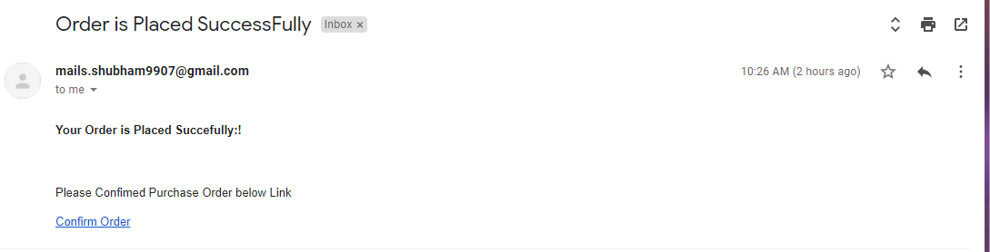

1. View Order

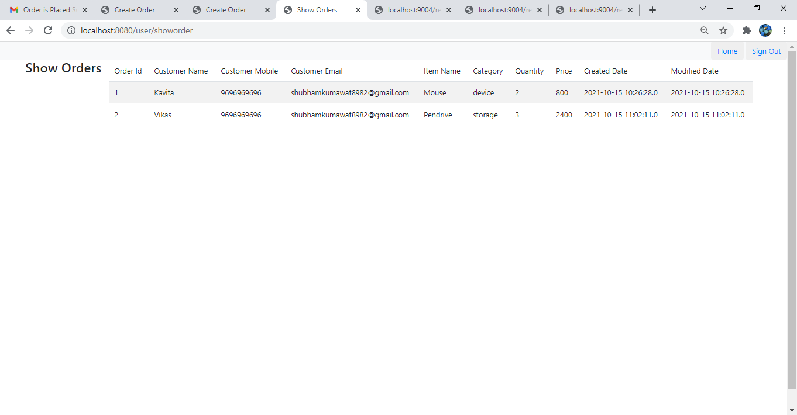

1. Create PO

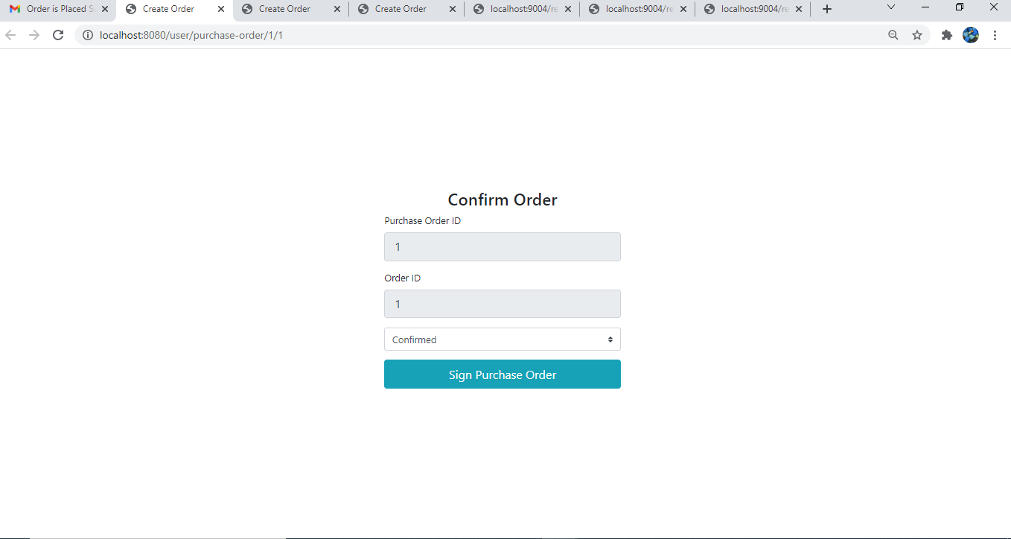

1. Create Invoice



1. Pay Payment

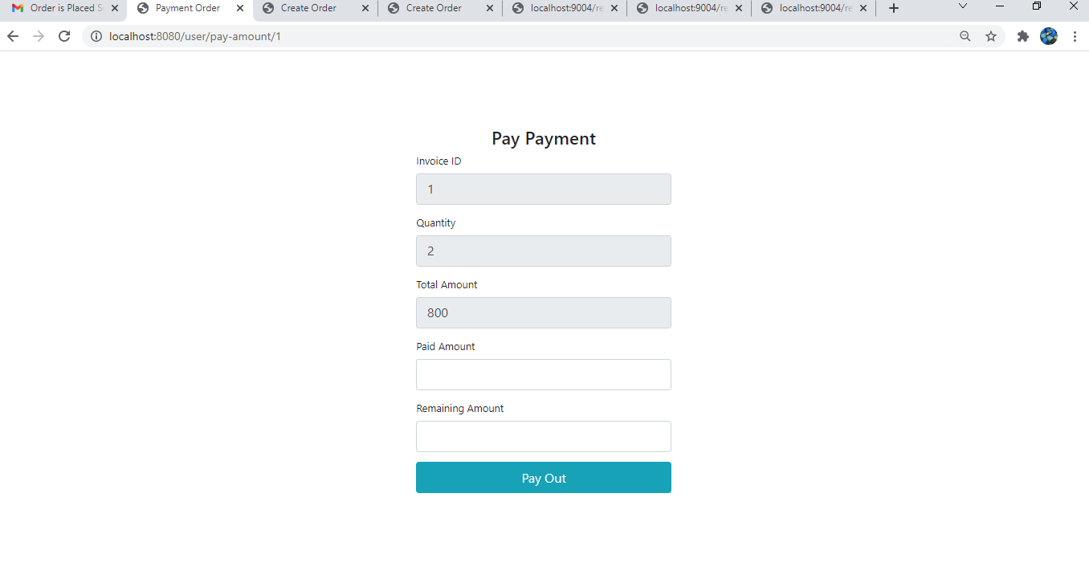

1. Show Order



1. Show Invoice

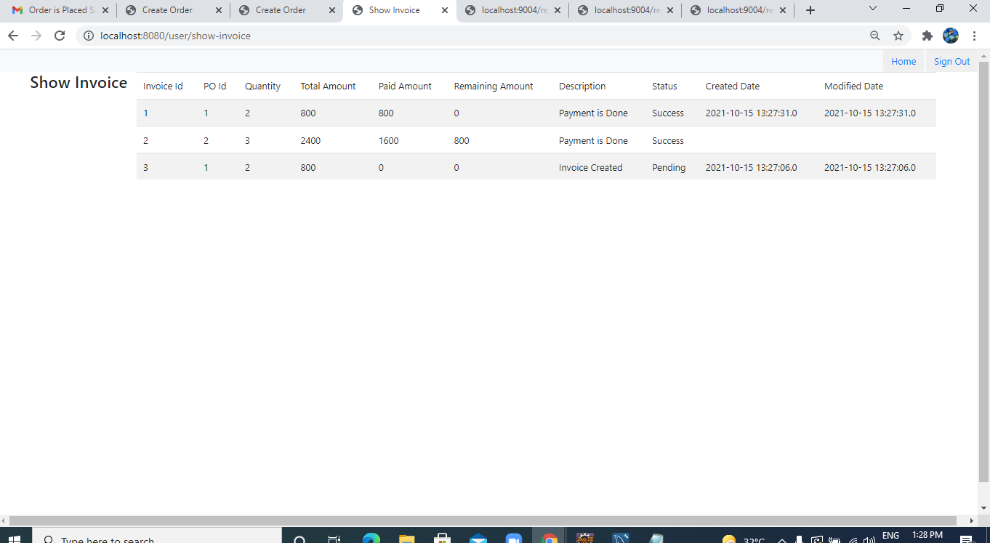

1. Show PO

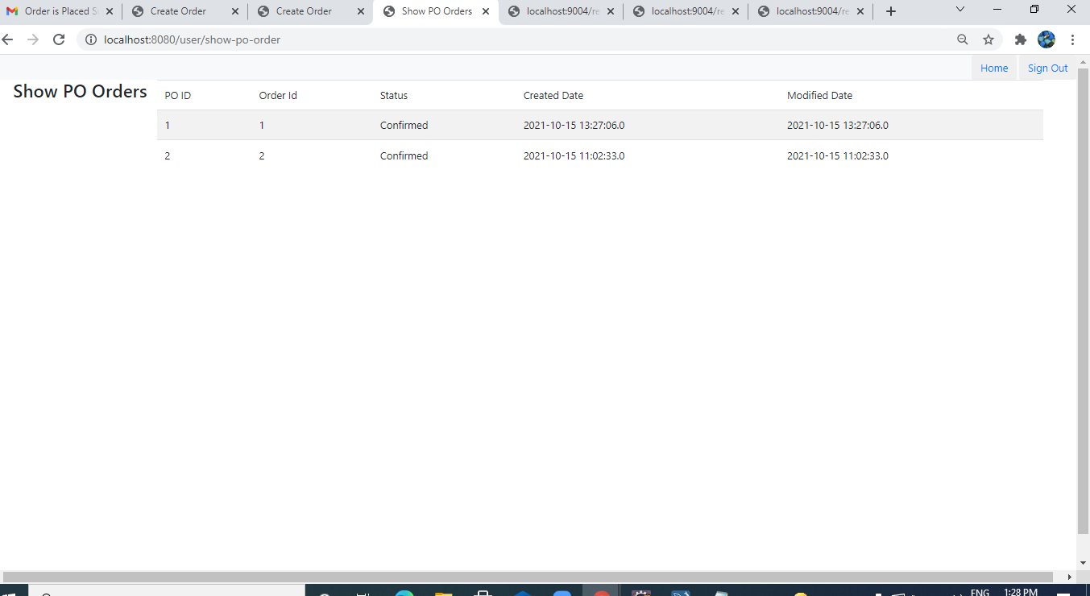

1. Find Invoice By Customer

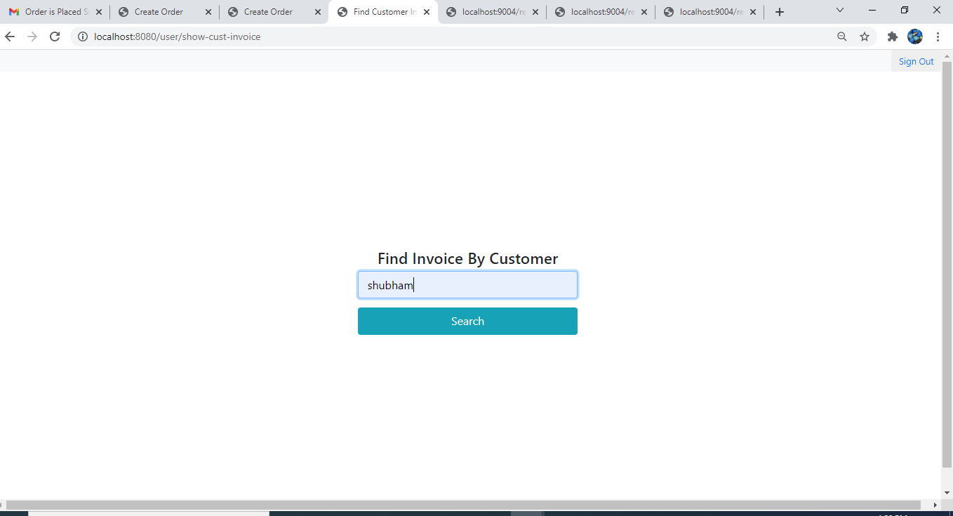

1. Find PO By Customer

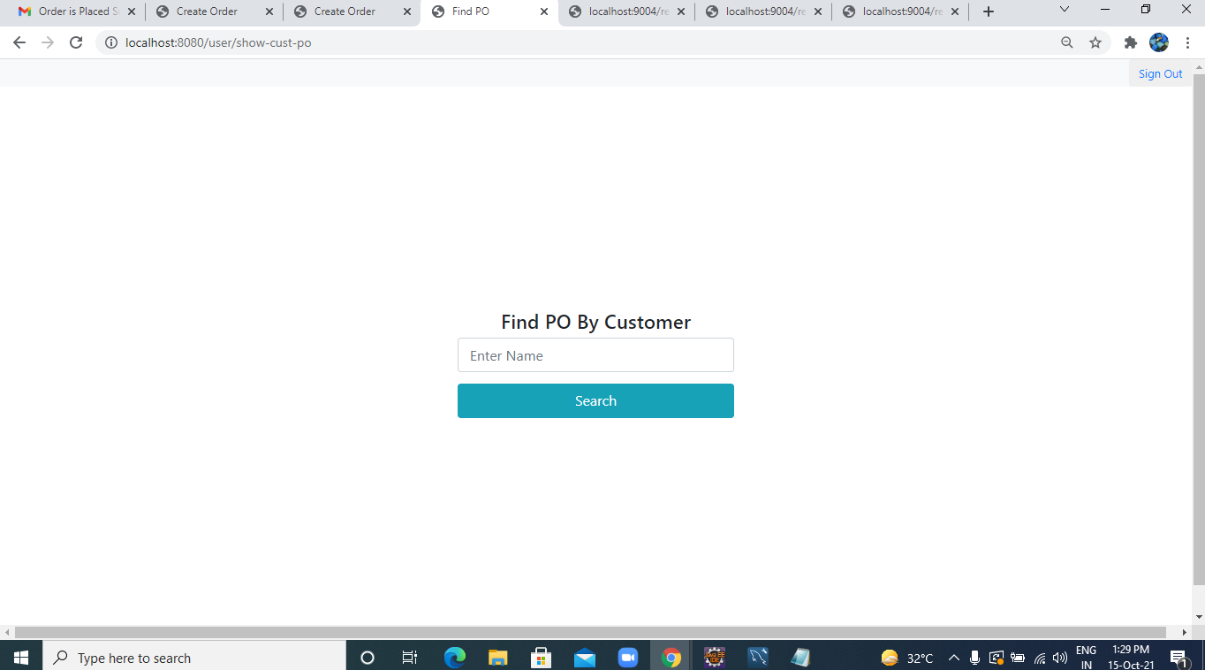

1. Get Total Amount.

