This file contains a simple neural network model for the classification of the dogs and cats images.
The dataset used is open source dataset by kaggle. The link to the dataset is given below.

https://www.kaggle.com/competitions/dogs-vs-cats/data

The zip file for the entire dataset is also provided in the repository. Download and extract the zip file in location of your choice.

While implementing this notebook, take care of the locations of the images on your computer.

There were two models that were tied for the same problem. The number of hidden layers, number of pooling layers and the number of parameters for both the models are same.

For the first model, it was observed that the validation accuracy of the model is not increasing with the model accuracy. This is considered as a over-fitting problem. To overcome this, a dropout layer is added to the second model.

The summary of both the models and the graphs of training accuracy, validation accuracy and the training loss and the validation loss against number of epochs for the model are shown below.

Model: "sequential_1"
_________________________________________________________________
Layer (type) Output Shape Param #
=================================================================
conv2d_1 (Conv2D) (None, 148, 148, 32) 896
_________________________________________________________________
max_pooling2d_1 (MaxPooling2 (None, 74, 74, 32) 0
_________________________________________________________________
conv2d_2 (Conv2D) (None, 72, 72, 64) 18496
_________________________________________________________________
max_pooling2d_2 (MaxPooling2 (None, 36, 36, 64) 0
_________________________________________________________________
conv2d_3 (Conv2D) (None, 34, 34, 128) 73856
_________________________________________________________________
max_pooling2d_3 (MaxPooling2 (None, 17, 17, 128) 0
_________________________________________________________________
conv2d_4 (Conv2D) (None, 15, 15, 128) 147584
_________________________________________________________________
max_pooling2d_4 (MaxPooling2 (None, 7, 7, 128) 0
_________________________________________________________________
flatten_1 (Flatten) (None, 6272) 0
_________________________________________________________________
dense_1 (Dense) (None, 512) 3211776
_________________________________________________________________
dense_2 (Dense) (None, 1) 513
=================================================================
Total params: 3,453,121
Trainable params: 3,453,121
Non-trainable params: 0
_________________________________________________________________

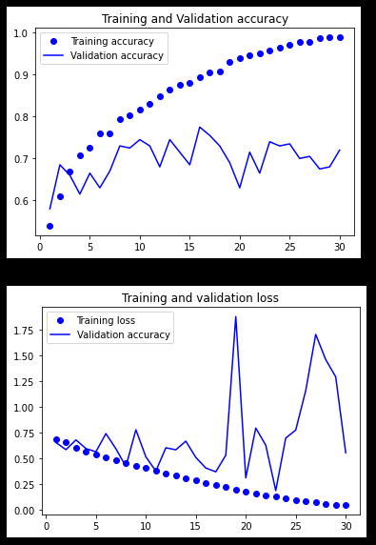
Training and Validation accuracy against number of epochs and Training and Validation loss against number of epochs for sequential model 1

Model: "sequential_2"
_________________________________________________________________
Layer (type) Output Shape Param #
=================================================================
conv2d_5 (Conv2D) (None, 148, 148, 32) 896
_________________________________________________________________
max_pooling2d_5 (MaxPooling2 (None, 74, 74, 32) 0
_________________________________________________________________
conv2d_6 (Conv2D) (None, 72, 72, 64) 18496
_________________________________________________________________
max_pooling2d_6 (MaxPooling2 (None, 36, 36, 64) 0
_________________________________________________________________
conv2d_7 (Conv2D) (None, 34, 34, 128) 73856
_________________________________________________________________
max_pooling2d_7 (MaxPooling2 (None, 17, 17, 128) 0
_________________________________________________________________
conv2d_8 (Conv2D) (None, 15, 15, 128) 147584
_________________________________________________________________
max_pooling2d_8 (MaxPooling2 (None, 7, 7, 128) 0
_________________________________________________________________
flatten_2 (Flatten) (None, 6272) 0
_________________________________________________________________
dropout_1 (Dropout) (None, 6272) 0
_________________________________________________________________
dense_3 (Dense) (None, 512) 3211776
_________________________________________________________________
dense_4 (Dense) (None, 1) 513
=================================================================
Total params: 3,453,121
Trainable params: 3,453,121
Non-trainable params: 0
_________________________________________________________________

Training and Validation accuracy against number of epochs and Training and Validation loss against number of epochs for sequential model 2

