**Assignment 1**

**Modern Portfolio Theory: Portfolio Management**



**Course Code: ECON F412**

**Course Title: Security Analysis & Portfolio Management**

A report by **Group 18**

|  |  |
| --- | --- |
| **Name** | **ID No.** |
| Himanshi Badola Jain | 2020B3AA2159H |
| Yashraj Mehta | 2020B3A72226H |
| Shubham Agrawal | 2020B3A70505H |
| Akash Goel | 2020B3AA2166H |
| Saira Das | 2020B3A31498H |
| Pratyaksha Shukla | 2021A5PS1969H |
| Vedant Bhatt | 2021A4PS3080H |
| Karandeep Singh | 2020A4PS1820H |
| Mathew Thomas | 2021A8PS2955H |

# Instructor In-Charge: **Dr.** **Shreya Biswas**

October 2023

**NOTE:**

**Since the unconstrained optimisation generated portfolios(Domestic and International) with all positive weights, optimisation with short-selling constraints would be redundant in all cases.**

1. **Domestic Portfolio**

**1(a)** The Markowitz Input List composed of annualised expected returns (n*1) and the annualised covariance-variance matrix (n*n) was calculated using returns from April 1, 2022 to March 31, 2023.

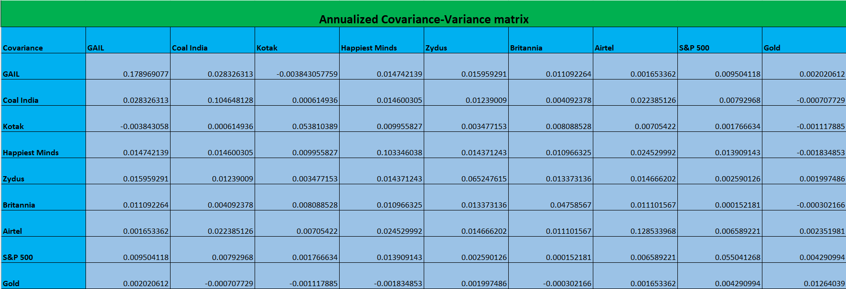

**1(b)** Using Constrained optimisation, the Minimum Variance Portfolio, Tangency Portfolio were generated. Subsequently, the efficient frontier was plotted, illustrating our portfolio's risk-return behaviour.

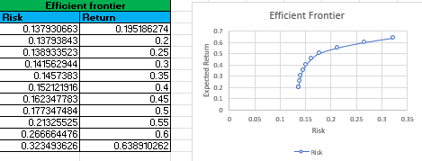

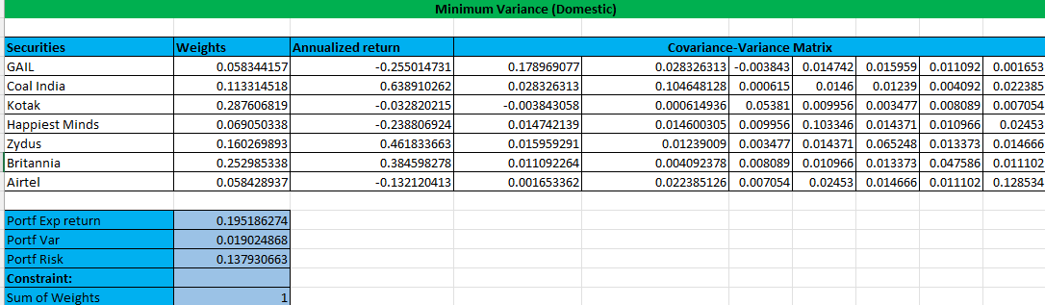

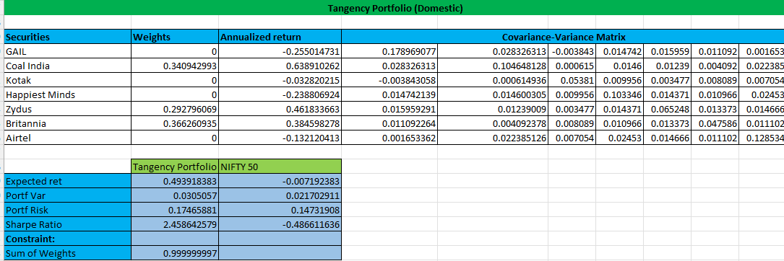

**1(c)** The weights were also calculated using the CAPM Model, and a comparison has been shown with the tangency portfolio. The securities in red have been underweighted, and those in green have been overweighted.

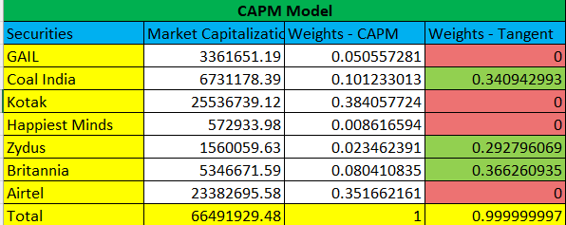

**1(d)** Compared with NIFTY 50 returns for the same period, our tangency portfolio outperforms the passively managed index by a huge margin. Our Portfolio has a Sharpe ratio of 2.46 compared to -0.49, which suggests that it would be more lucrative for a rational investor to choose the given portfolio.

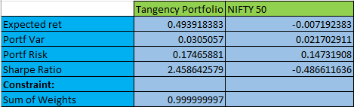

1. **International Portfolio**

**2(a)** For the international portfolio, we added **Gold** Commodity and the index S&P 500 to our portfolio to further diversify and decrease the risk.



**2(b)** A similar computation as the domestic portfolio was followed. We can see that the international portfolio has a much lower risk than the domestic one, further proving our risk diversification hypothesis. Compounded with a lower risk, we can see that the Sharpe ratio is also greater than domestic.

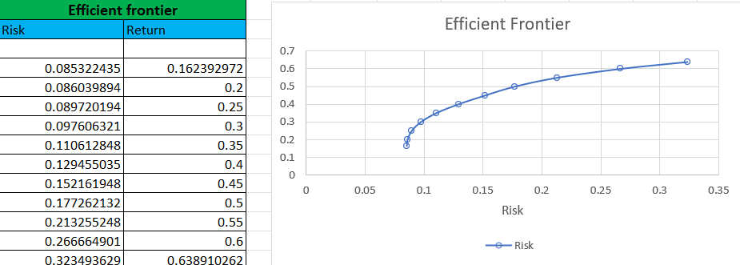

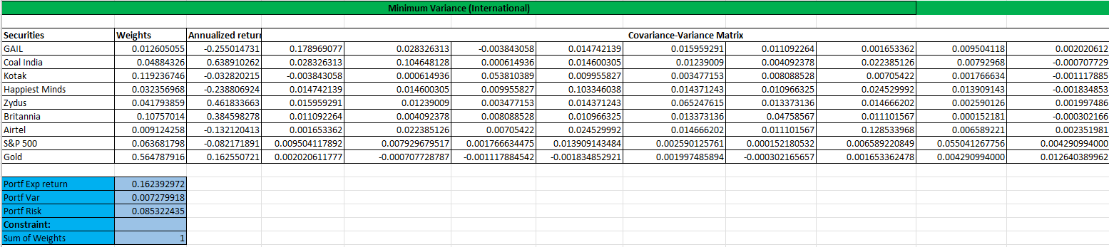

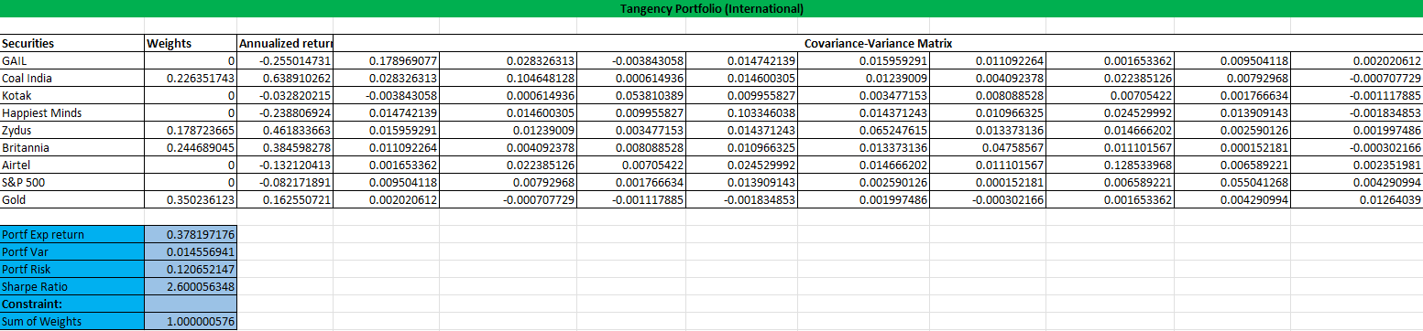

1. **Inferences**
   1. The Domestic Portfolio, consisting of 7 securities, outperformed the passive market index returns, both in terms of risk and return.
   2. The International Portfolio performs better than both the domestic and market index, just with the inclusion of a metal commodity and an international index both in terms of risk and return.
   3. The exact calculation and results have also been shown in the corresponding Excel sheet named [Group18_SAPM](Grp18_SAPM.xlsx)
2. **References**
   1. Security Data sourced from NSE Historical Data:  
      <https://www.nseindia.com/report-detail/eq_security>
   2. Gold Commodity Data sourced from MCX Historical Data:  
      <https://www.mcxindia.com/market-data/historical-data>
   3. S&P 500 Data sourced from Yahoo Finance:  
      <https://finance.yahoo.com/quote/%5EGSPC/history?p=%5EGSPC&guccounter=1>
   4. Indian Treasury Rates sourced from:  
      <https://in.investing.com/rates-bonds/india-1-year-bond-yield-historical-data>