Capstone Project Report on
PLC-Based Smart Forward & Reverse
Submitted in partial fulfillment of the requirements of the Third Year of
Bachelor of Technology In
Electronics and Computer Science
By
Himanshu Chouhan[EU1247043]
Prashant Yadav[EU1247060]
Shubham Agre[EU1247019]
Roshan Jha[EU1247018]

Under the Guidance of

Ms. Hiral Patel
Assistant professor, Department of electronics and computer science,SJCEM



DEPARTMENT OF ELECTRONICS AND COMPUTER SCIENCE ST. JOHN COLLEGE OF ENGINEERING & MANAGEMENT UNIVERSITY OF MUMBAI
2026-2027

Certificate of Approval
This is to certify that, following students of T. Tech in Electronics and Computer Science Department. They have satisfactorily completed the requirements for the courses Programmable Logic Controllers and SCADA prescribed by ST. JOHN COLLEGE OF ENGINEERING AND MANAGEMENT (An Autonomous
College affiliated to University of Mumbai), while working on “PLC-Based Instant Forward–Reverse Motor Control System”
Himanshu Chouhan[EU1247043]
PrashantYadav[EU1247060] Shubham Agre[EU1247019]
Roshan Jha[EU1247018]

Signature:  Name : Ms. Hiral Patel  Ass. Professor | Signature:  Name : Dr. Md. Immadudin HOD

Signature: External Signature:
Name: Dr. Kamal Shah Principal,
St. John College of Engineering and Management.

Declaration

I/we declare that this written submission represents my/our ideas in my/our own words and where others ideas or words have been included, I/we have adequately cited and referenced the original sources. I/we also declare that I/we have adhered to all principles of academic honesty and integrity and have not misrepresented or fabricated or falsified any idea/data/fact/source in my/our submission. I/we understand that any violation of the above will be cause for disciplinary action by the Institute and can also evoke penal action from the sources which have thus not been properly cited or from whom proper permission has not been taken when needed.

Signatures:

Himanshu Chouhan[EU1247043]:
Prashant Yadav[EU1247060]:
Shubham Agre[EU1247019]:
Roshan Jha[EU1247018]:

Date:

ACKNOWLEDGEMENT

We sincerely thank our project guide Ms.Hiral Patel for her guidance and support for carrying out our Project. We thank our HOD Dr. Md. Immadudin for his valuable time and provision of departmental facilities. We thank Principal Dr. Kamal Shah for the infrastructure and maintenance. We also thank lab assistants for their help and practical guidance.

Student name
Himanshu Chouhan[EU1247043]
Prashant Yadav[EU1247060]
Shubham Agre[EU1247019]
Roshan Jha[EU1247018]

Abstract
The Forward–Reverse Motor Control System is designed to control the direction of rotation of an electric motor using a Programmable Logic Controller (PLC). The system allows the motor to rotate in the forward direction by pressing the Forward Start pushbutton and in the reverse direction by pressing the Reverse Start pushbutton. Separate Stop pushbuttons are provided for stopping the forward and reverse operations.
The main objective of this project is to implement reliable motor direction control using a ladder diagram with self-holding contacts and electrical or logical interlocking. The PLC continuously monitors the input signals and controls the corresponding output commands. The self-holding circuit keeps the selected direction active after the Start pushbutton is released, while the Stop pushbutton turns off the active command. Interlocking prevents the forward and reverse commands from being activated simultaneously.
The ladder diagram is developed and tested using Mitsubishi MELSOFT GX Works3 and GX Simulator. The system uses four digital inputs, X0, X1, X2, and X3, and two digital outputs, Y0 and Y1. The forward and reverse outputs are mutually interlocked to prevent an immediate change of direction while the motor is running. This project demonstrates the practical application of PLC programming in industrial motor control, automation, and machine safety.
Keywords: PLC, Ladder Diagram, Forward–Reverse Control, Motor Control, Self-Holding, Interlocking, GX Works3.

Index

Chapter No. | Topic | Page No.
CHAPTER 1 | OVERVIEW | 7-8
1.1 | Introduction
1.2 | Background
1.3 | Importance of the Project
1.4 | Perspective of Stakeholders and Customers
1.5 | Objectives and Scope of the Project
CHAPTER 2 | LITERATURE SURVEY & PROPOSED | 9-10
2.1 | WORK
2.2 | Introduction
2.3 | Literature Survey Table
2.4 | Problem Definition
2.5 | Feasibility Study
 | Methodology Used
CHAPTER 3 | ANALYSIS AND PLANNING | 11
3.1 | Introduction
3.2 | Project Planning
CHAPTER 4 | DESIGN & IMPLEMENTATION | 12-13
4.1 | Data Flow Diagram (DFD)
4.2 | Block Diagram
4.3 | Flow Chart
4.4 | UML & PLC Ladder Diagram
CHAPTER 5 | RESULTS & DISCUSSION | 14-15
5.1 | Actual Results
5.2 | Future Scope
CHAPTER 6 | CONCLUSION | 16
 | REFERENCES

CHAPTER 1: OVERVIEW

1.1 Introduction
A Programmable Logic Controller (PLC) is an industrial digital controller used to automate machines and electrical systems.
Motor direction control is an important application of PLCs in industries such as manufacturing, material handling, conveyors, and machine tools.
In this project, a PLC is used to control the forward and reverse operation of a motor using pushbuttons.
The Forward Start pushbutton activates the forward command, while the Reverse Start pushbutton activates the reverse command.
Separate Stop pushbuttons are used to stop the motor operation in each direction.
A ladder diagram is developed using normally open contacts, normally closed interlocking contacts, self-holding contacts, and output coils.
The PLC logic ensures that forward and reverse commands cannot remain active simultaneously.
The system is designed and simulated using Mitsubishi MELSOFT GX Works3 and GX Simulator.

1.2 Background
In conventional motor control circuits, contactors, pushbuttons, and auxiliary contacts are commonly used to control motor direction.
A forward–reverse starter changes the motor's direction by changing the phase sequence of a three-phase motor through suitable contactor wiring.
PLC-based control performs the same logical control function using programmed instructions.
The PLC receives signals from the Start and Stop pushbuttons and processes them according to the ladder program.
Self-holding contacts maintain the selected command even after the Start pushbutton is released.
Interlocking contacts prevent the forward command from being enabled while the reverse command is active, and vice versa.
This approach simplifies control logic, improves flexibility, and makes the system easier to modify and troubleshoot.

1.3 Importance of the Project
- Directional control: Allows a motor to operate in forward and reverse directions.
- Improved safety: Prevents forward and reverse commands from being active together.
- Self-holding operation: Maintains the selected command after releasing the Start pushbutton.
- Easy stopping: Provides separate Stop pushbuttons for forward and reverse operations.
- Industrial application: Demonstrates a basic PLC control method used in automated machinery.
- Easy troubleshooting: Input and output statuses can be monitored in PLC simulation software.

1.4 Perspective of Stakeholders and Customers
- Industrial operators: Can control motor direction using simple pushbuttons.
- Maintenance technicians: Can monitor PLC inputs and outputs to identify faults.
- Automation engineers: Can modify the ladder logic according to machine requirements.
- Manufacturing industries: Can use similar control principles in conveyors, lifting mechanisms, and machine tools.
- Students: Can understand PLC inputs, outputs, interlocking, and self-holding through practical simulation.

1.5 Objectives and Scope of the Project

Objectives
- To construct a PLC ladder diagram for forward and reverse motor control.
- To control motor direction using separate Forward Start and Reverse Start pushbuttons.
- To provide separate Stop pushbuttons for forward and reverse operations.
- To implement self-holding contacts for maintaining the selected direction command.
- To implement mutual interlocking between forward and reverse outputs.
- To simulate and verify the program using Mitsubishi GX Works3 and GX Simulator.

Scope
The project covers the development and simulation of a PLC-based forward–reverse motor control system. It includes input/output assignment, ladder logic programming, self-holding circuits, mutual interlocking, and functional testing.
The current scope is limited to the PLC control logic. Actual motor power wiring, overload protection, and contactor installation require a suitable electrical design and appropriate safety measures.

CHAPTER 2: LITERATURE SURVEY & PROPOSED WORK

2.1 Introduction
PLC-based motor control is widely used in industrial automation to control the operation of electrical motors.
Forward–reverse control is required in applications where a machine needs to move in two opposite directions.
Traditional relay-based systems use auxiliary contacts and contactors to provide self-holding and interlocking.
PLC-based systems implement these functions through ladder logic, making the control system easier to modify and monitor.
The proposed project uses Mitsubishi PLC programming software to develop and simulate a forward–reverse control circuit.

2.2 Literature Survey
The following table summarizes relevant technologies and concepts used in the project. These are background references, not claims that specific papers were reviewed.
Sr. No. | Technology / Reference | Application | Relevance to Project
1 | PLC-based control systems | Industrial automation | Provides the basic control architecture.
2 | Ladder logic programming | Implementation of control circuits | Used to create the forward and reverse rungs.
3 | Self-holding circuits | Maintaining an output command | Keeps the selected direction active.
4 | Electrical interlocking | Preventing simultaneous contactor operation | Prevents forward and reverse commands from being active together.
5 | Mitsubishi GX Works3 | PLC programming and monitoring | Used to develop and test the ladder program.

2.3 Problem Definition
In a motor control system, incorrect activation of forward and reverse commands can cause electrical faults, mechanical stress, and damage to the motor or connected equipment.
A control circuit is therefore required to operate the motor in either direction while preventing simultaneous forward and reverse commands.
The system must satisfy the following requirements:
- The motor should start in the forward direction when the Forward Start pushbutton is pressed.
- The motor should stop when the Forward Stop pushbutton is operated.
- The motor should start in the reverse direction when the Reverse Start pushbutton is pressed.
- The motor should stop when the Reverse Stop pushbutton is operated.
- The selected command should remain active through a self-holding contact.
- The reverse command must not activate while the forward command is running, and vice versa.
- A direction change must require the existing command to stop before the opposite direction is activated.

2.4 Feasibility Study
Technical feasibility: The control system can be implemented using a PLC with digital inputs and outputs and standard ladder logic instructions.
Operational feasibility: The operator can control the motor using four pushbuttons, making the system straightforward to operate.
Economic feasibility: PLC simulation allows the control logic to be tested before connecting actual motor-control hardware, reducing initial testing costs.
Safety feasibility: Mutual interlocking helps prevent conflicting commands. For a physical motor installation, electrical and mechanical interlocking, overload protection, and a suitable motor starter are also required.

2.5 Methodology Used
The project follows these steps:
- Requirement analysis: Identify the required forward, reverse, and stop operations.
- I/O assignment: Assign PLC inputs X0–X3 and outputs Y0–Y1.
- Ladder diagram design: Develop separate rungs for forward and reverse operation.
- Self-holding implementation: Add auxiliary contacts to maintain the active command.
- Interlocking implementation: Add normally closed logic contacts of the opposite output.
- Simulation: Run the ladder program using GX Works3 and GX Simulator.
- Testing: Verify forward operation, reverse operation, stopping, and direction-change interlocking.

CHAPTER 3: ANALYSIS AND PLANNING

3.1 Introduction
The analysis and planning stage identifies the control requirements and defines the PLC logic needed to operate the motor safely.
The system is divided into input devices, PLC processing logic, and output commands.
The input devices provide the operator's commands, while the PLC processes these signals according to the ladder program.
The outputs represent the forward and reverse motor-control commands.
The program is tested in simulation before any physical motor connection is made.

3.2 Project Planning
Phase | Activity | Expected Deliverable
Phase 1 | Requirement analysis | List of operating conditions
Phase 2 | I/O assignment | PLC input/output table
Phase 3 | Ladder diagram design | Two control rungs
Phase 4 | PLC programming | Ladder program in GX Works3
Phase 5 | Simulation | Verified input/output operation
Phase 6 | Testing and documentation | Results and final report

3.3 Hardware and Software Requirements
Sr. No. | Component / Software | Purpose
1 | Mitsubishi PLC or compatible simulator | Executes the ladder logic
2 | Pushbuttons | Provide Start and Stop commands
3 | Motor contactors | Switch the motor power circuit
4 | Forward–reverse motor | Demonstrates directional operation
5 | Overload protection | Protects against motor overload
6 | MELSOFT GX Works3 | Creates and edits the PLC program
7 | GX Simulator | Tests the program without a physical motor
Note: The supplied practice images show the ladder program in GX Works3 and the GX Simulator interface. The report does not assume that an actual motor has been connected or tested.

CHAPTER 4: DESIGN AND IMPLEMENTATION

4.1 Aim and Ladder Construction
Construct a PLC ladder diagram for forward-reverse motor control with separate Start and Stop pushbuttons for each direction. The motor runs forward when the Forward Start button is pressed and reverses when the Reverse Start button is pressed. Reversal is blocked while the motor is running. Each rung uses a self-holding contact so the command stays on after the Start button is released, and normally closed interlocks prevent both outputs from energising together.

4.2 I/O Assignment and Block Diagram
Address | Type | Description
X0 | Input | Stop Forward
X1 | Input | Start Forward
X2 | Input | Stop Reverse
X3 | Input | Start Reverse
Y0 | Output | Forward Command
Y1 | Output | Reverse Command
The pushbuttons feed the PLC, which runs the ladder logic and energises Y0 or Y1. Those outputs drive interlocked forward and reverse contactors with overload protection, which switch the motor’s direction. In the simulation, Y0 and Y1 show control commands only, not actual motor rotation.

4.3 Working Principle and Flow Chart
The PLC scans its inputs continuously. Pressing X1 turns on Y0 if X0 is healthy and Y1 is off. Y0 then holds itself on through its parallel seal-in contact. Pressing X0 opens the circuit and turns Y0 off. The reverse direction works the same way using X3, X2, and Y1. Each direction’s normally closed interlock blocks the other, so the active command must stop before the opposite one can start.
The basic two-rung circuit does not by itself stop a held opposite Start button from causing an immediate reversal once the running direction stops. To prevent this, add an edge-detection or restart interlock, or require the new Start button to be released and pressed again.

4.4 PLC Ladder Diagram and Program Logic
- Rung 1, Forward control: X0 (Stop FWD) in series with Y1 (normally closed reverse interlock), then X1 (Start FWD) in parallel with a Y0 seal-in contact, driving coil Y0.
- Rung 2, Reverse control: X2 (Stop REV) in series with Y0 (normally closed forward interlock), then X3 (Start REV) in parallel with a Y1 seal-in contact, driving coil Y1.
- Boolean equations: Y0 = X0 ∧ ¬Y1 ∧ (X1 ∨ Y0) and Y1 = X2 ∧ ¬Y0 ∧ (X3 ∨ Y1).

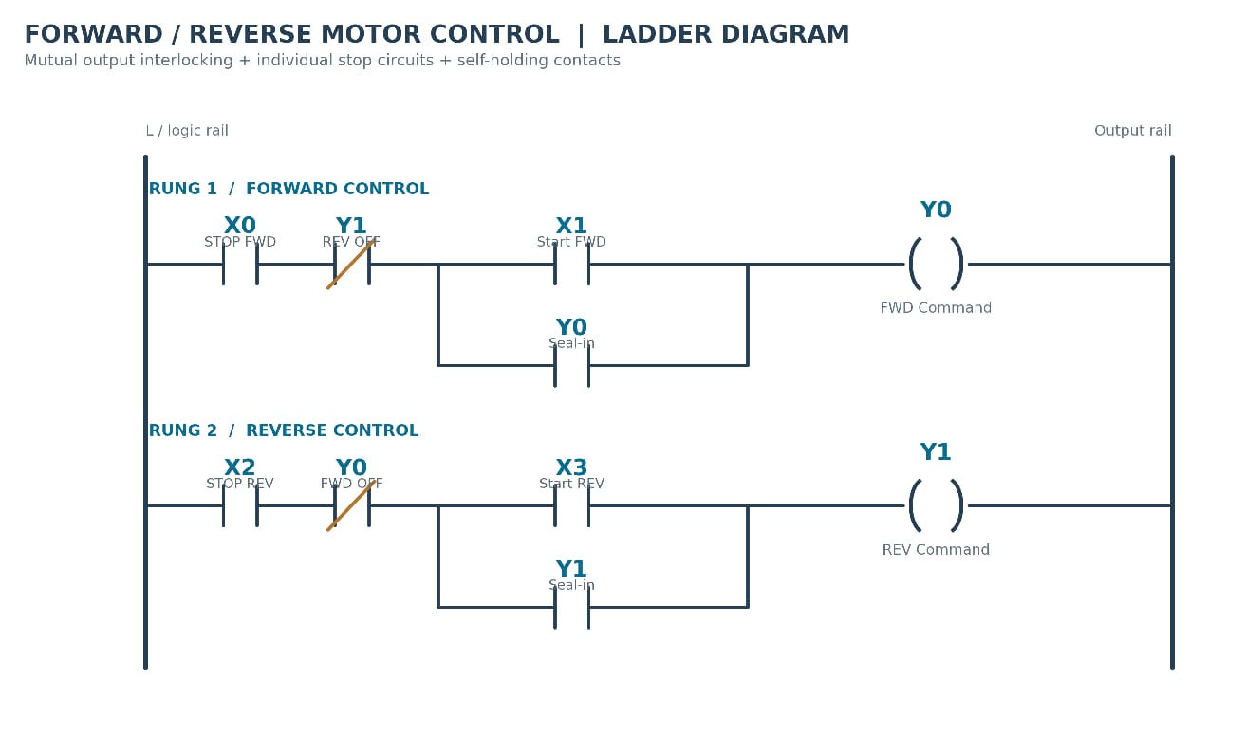

CHAPTER 5: RESULTS AND DISCUSSION

5.1 Expected Results
- The ladder diagram is intended to provide the following behavior during simulation.
Sr. No. | Test Condition | Expected Output
1 | Forward Start pressed with all required conditions satisfied | Y0 ON
2 | Forward Start released after successful activation | Y0 remains ON
3 | Forward Stop operated | Y0 OFF
4 | Reverse Start pressed when forward is inactive | Y1 ON
5 | Reverse Start released after successful activation | Y1 remains ON
6 | Reverse Stop operated | Y1 OFF
7 | Reverse Start pressed while Y0 is active | Y1 remains OFF
8 | Forward Start pressed while Y1 is active | Y0 remains OFF
9 | Both direction commands checked during operation | Y0 and Y1 must not be ON simultaneously
These are expected behaviors from the intended control logic. Actual results should be recorded after performing the corresponding simulation tests.

Result
The designed ladder logic demonstrates the principles of forward–reverse motor control, self-holding, and mutual interlocking. The program is intended to ensure that only one direction command is active at a time.
The strict requirement that reversal must not occur while running also requires the opposite Start command to be released and pressed again after stopping, or an equivalent restart interlock. This behavior should be verified separately if it is required for the final submission.
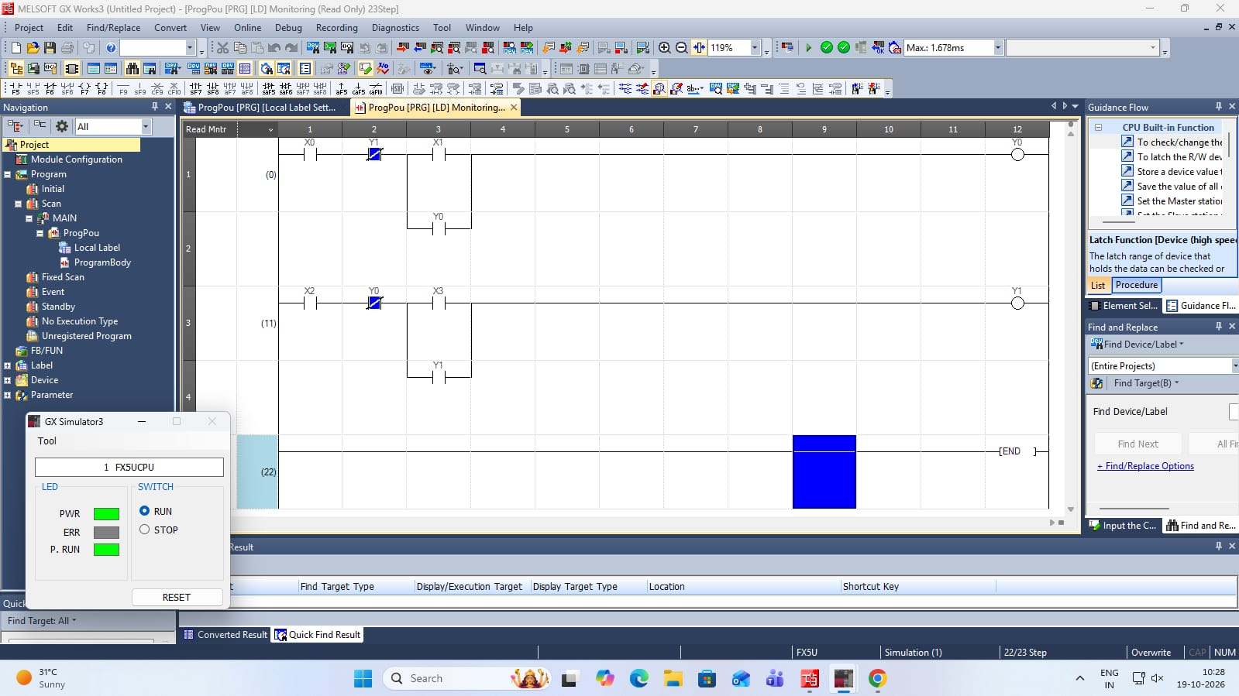

5.2 Future Scope
- Physical motor integration: Connect the PLC to a suitable forward–reverse contactor starter and motor.
- Overload protection: Add overload relay feedback to stop the motor during an overload condition.
- Emergency stop: Include a properly designed safety circuit for emergency stopping.
- Direction-change delay: Introduce a suitable delay before energizing the opposite contactor to allow the motor to stop.
- Status indication: Add indicator lamps to show forward, reverse, and stopped states.
- Fault monitoring: Add fault indication and diagnostics for contactor or overload faults.
- HMI integration: Use a Human–Machine Interface to display motor status and control commands.

CHAPTER 6: CONCLUSION
The PLC-based Forward–Reverse Motor Control System demonstrates the application of ladder logic in industrial motor automation. The system uses four digital inputs and two digital outputs to control the forward and reverse commands of a motor.
The ladder program uses self-holding contacts to maintain the selected command after the Start pushbutton is released. Mutual interlocking prevents the forward and reverse outputs from being activated simultaneously. Separate Stop pushbuttons provide independent stopping control for each direction.
The program can be developed and tested using Mitsubishi MELSOFT GX Works3 and GX Simulator before connecting actual hardware. The project provides practical knowledge of PLC programming, I/O assignment, ladder diagram construction, output monitoring, and interlocking techniques.
Thus, the project establishes the basic control logic required for a forward–reverse motor system. For actual industrial implementation, suitable contactors, overload protection, electrical interlocking, and appropriate safety measures must be included.

REFERENCES
- W. Bolton, Programmable Logic Controllers, 6th ed. Oxford, U.K.: Newnes (Elsevier), 2015. (Ladder logic, self-holding circuits, interlocking)
- F. D. Petruzella, Programmable Logic Controllers, 5th ed. New York, NY, USA: McGraw-Hill Education, 2016. (Motor starters, forward-reverse circuits)
- J. R. Hackworth and F. D. Hackworth Jr., Programmable Logic Controllers: Programming Methods and Applications. Upper Saddle River, NJ, USA: Prentice Hall, 2003. (Programming methods)
- IEC 61131-3, Programmable Controllers, Part 3: Programming Languages, 3rd ed. Geneva, Switzerland: IEC, 2013. (Ladder diagram language)
- IEC 60947-4-1, Low-Voltage Switchgear and Controlgear, Part 4-1: Contactors and Motor-Starters, Electromechanical Contactors and Motor-Starters. Geneva, Switzerland: IEC. (Reversing starters, power-circuit interlocking)
- IEC 60947-5-1, Low-Voltage Switchgear and Controlgear, Part 5-1: Control Circuit Devices and Switching Elements, Electromechanical Control Circuit Devices. Geneva, Switzerland: IEC. (Pushbutton contacts, NO/NC)
- IEC 60204-1, Safety of Machinery, Electrical Equipment of Machines, Part 1: General Requirements. Geneva, Switzerland: IEC. (Stop functions, safety of machine control)
- NFPA 79, Electrical Standard for Industrial Machinery. Quincy, MA, USA: National Fire Protection Association. (Reversing controls, interlocking requirements)
- Mitsubishi Electric Corporation, MELSEC iQ-F FX5 User’s Manual (Hardware). Tokyo, Japan. (FX5U I/O specifications)
- Mitsubishi Electric Corporation, MELSEC iQ-F FX5 Programming Manual (Program Design). Tokyo, Japan. (Instructions and device usage)
- Mitsubishi Electric Corporation, GX Works3 Operating Manual. Tokyo, Japan. (Program creation and GX Simulator use)

