Mongodb

mongodb is a nosql document oriented database it stores data in json like document (bson, a binary form of json) making it easy to scale and handle large volumes of unstructured data.

mongodb structure

mongodb stores data in collection and documents
a collection is a group of mongodb documents
a document is a set of key-value pairs

basic shell commands

show dbs // list all databases
use school // create or switch to a databases
show collections // list all collection in the current db
db.dropDatabase() // drop current database

________________________________________________________________

Ways to Access MongoDB Database

There are multiple ways to access and manage a MongoDB database:

Graphical Interface (MongoDB Compass)
MongoDB Compass is a GUI tool used to visually explore and manage MongoDB databases. It allows us to
view collections, insert documents, run queries, and analyze data without using commands.

Command Line (mongosh)
mongosh is the MongoDB Shell that allows us to interact with the database using commands. It is mainly
used for developers to perform operations like creating databases, collections, inserting data, and
querying directly from the terminal.

Cloud-Based (MongoDB Atlas)
MongoDB Atlas is a cloud service that allows us to create, host, and manage MongoDB databases online.
It provides features like scalability, security, and backups, and can be accessed through a web
interface or by connecting from applications.
________________________________________________________________

use database_name
eg- use bank_db

db.createcollection("employees")
// database can only be seen by show dbs if it has some collection like now we have created
// employees collection so now show dbs will reflect bank_db

DROP

db.collection_name.drop() // to drop a particular collection
db.dropDatabase() // to drop entire database

CRUD OPERATIONS
{CREATE,READ,UPDATE,DELETE}

CREATE - insertOne(),insertMany()
READ - find(),findOne()
UPDATE - updateOne(),updateMany()
DELETE - deleteOne(),deleteMany()

Creating database car_dealership

Create database by inserting collections using insertOne(),insertMany()

inserting using insertOne

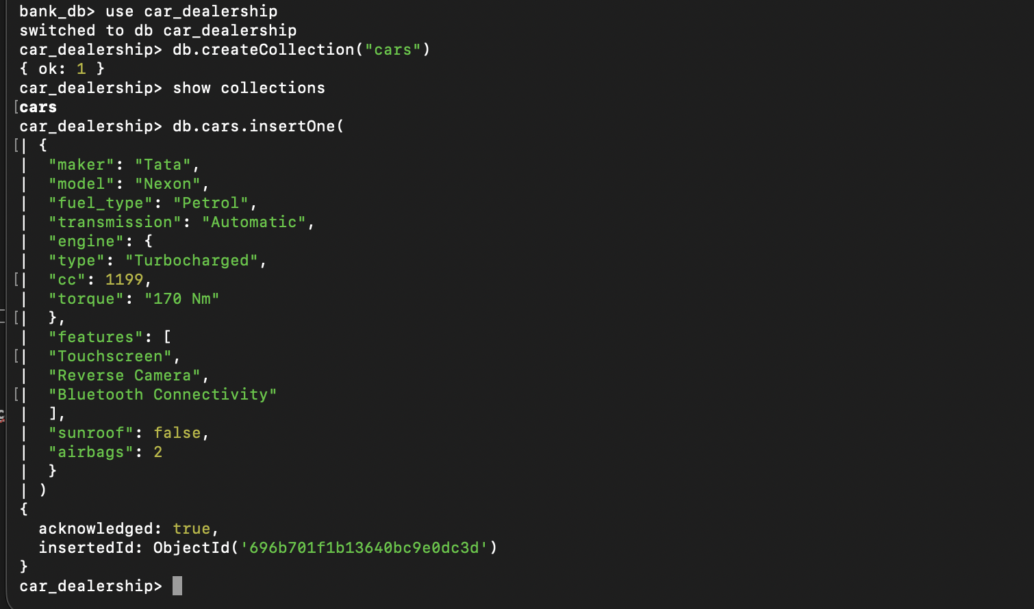
The command db.cars.insertOne() is used to insert a single document into the cars collection.
In this example, one car record is added with multiple fields such as:
- Basic details (maker, model, fuel type, transmission)
- A nested document for engine specifications
- An array for features
- Boolean and numeric fields (sunroof, airbags)
MongoDB returns an ObjectId after insertion, which uniquely identifies the document and confirms that the data has been stored successfully.

Inserting using insertMany [ {}, {}, {}]
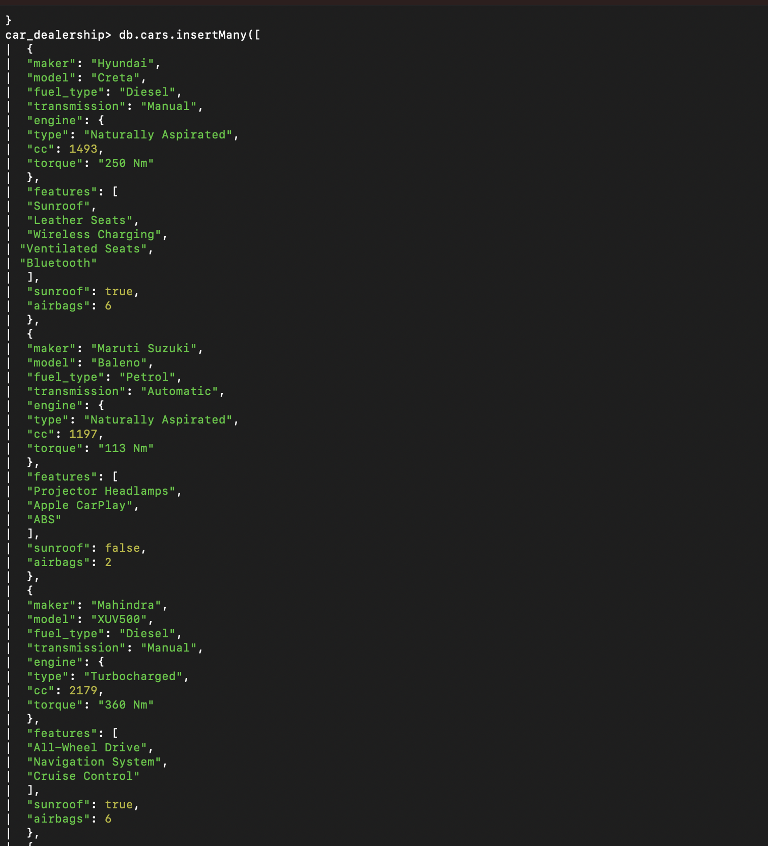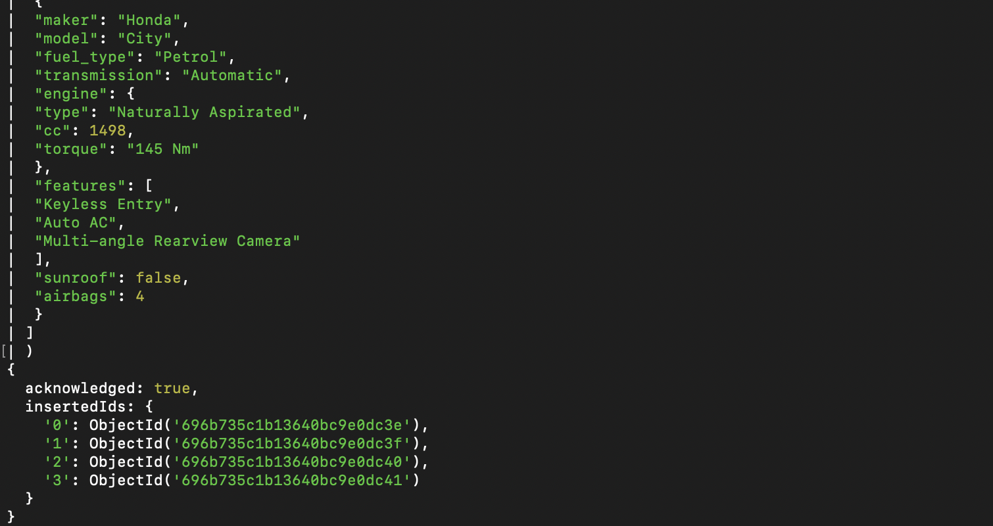
The command db.cars.insertMany() is used to insert a multiple document into the cars collection.
Reading from database car_dealership
Using find(),findOne()

find()
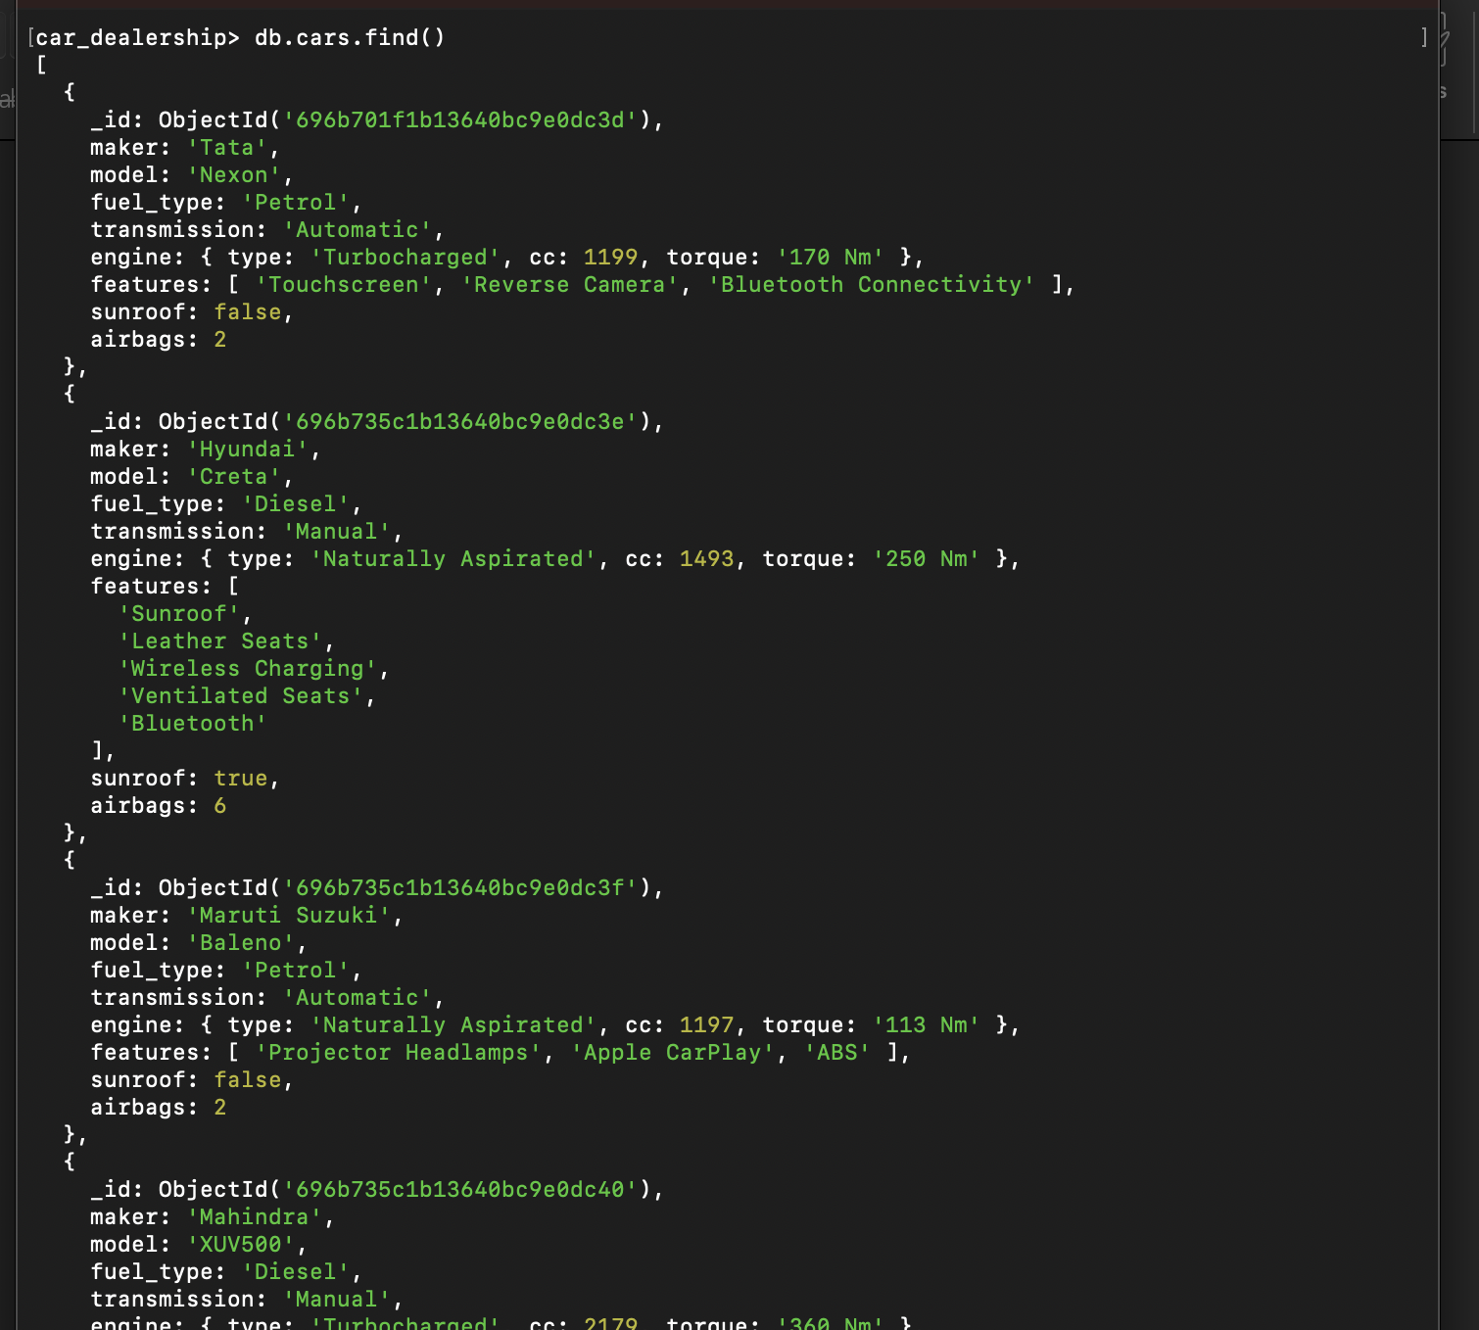
The command db.cars.find() is used to read all documents from the cars collection.
It returns a list of all car records stored in the database, where each document contains:
- Unique _id
- Car details (maker, model, fuel type, transmission)
- Nested engine information
- Feature lists, and other fields like sunroof and airbags
This command is useful when we want to view multiple records or the entire collection at once.

findOne()
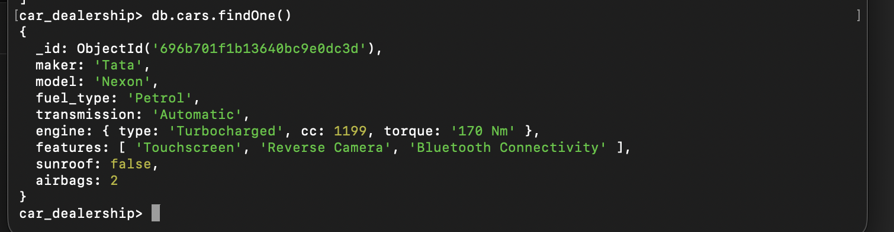
The command db.cars.findOne() is used to read a single document from the cars collection in the car_dealership database.
It returns the first matching document in a readable JSON-like format, including:
- The automatically generated _id
- All stored fields such as maker, model, fuel type, transmission
- Nested objects (engine details)
- Arrays (features list)
This command is useful when we want to quickly view one record from the collection.
Projection
Projection is used to control which fields are returned in the query result. It helps to display only required data, reduce unnecessary information, and make the output clean and efficient.
db.collection.find(query, projection)
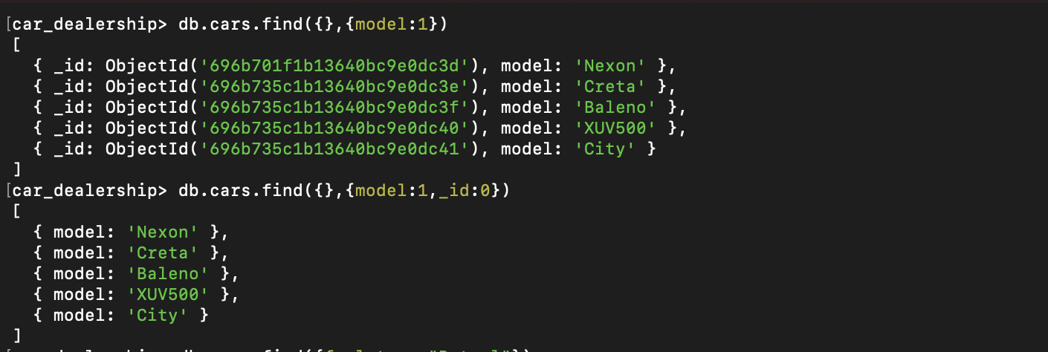
1.db.cars.find({}, { model: 1 }) //Returns only the model field (along with _id by default).

2.db.cars.find({}, { model: 1, _id: 0 }). // Returns only the model field and excludes _id.

Pretty()
The pretty() method is used along with find() to format the output in a more readable way.
db.cars.find().pretty()
It does not change the data, it only displays the documents in a well-structured and indented format, making large records easier to understand

Filtering by Field
MongoDB allows us to filter documents based on specific field values. Filtering helps in retrieving only relevant data from the collection.
db.cars.find({ fuel_type: "Diesel" })
This command returns only those car records whose fuel_type is Diesel, ignoring all others.

Filtering by Nested Field
MongoDB also allows filtering using fields inside embedded documents.
db.cars.find({ "engine.type": "Turbocharged" })
This command returns only those car records whose engine type is Turbocharged
Dot notation is used to access and filter nested fields in MongoDB.
Eg-
