A Data frame is a two-dimensional data structure, i.e., data is aligned in a tabular fashion in rows and columns.

Features of DataFrame

* Potentially columns are of different types
* Size – Mutable
* Labeled axes (rows and columns)
* Can Perform Arithmetic operations on rows and columns

Structure

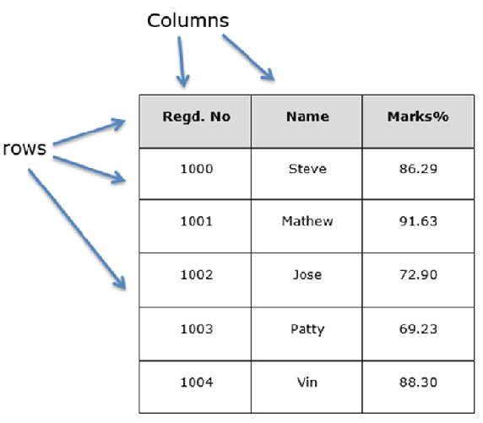

**These are the attributes of the** **dataframe:**

* index
* columns
* axes
* dtypes
* size
* shape
* ndim
* empty
* T
* values