

Assignment: Group Project
Course: Labour Economics (MBA-HR)

Topic:
Labour Supply of Married Women in Urban India
SUBMITTED TO:
Prof. Swarn Rajan

SUBMITTED BY:
Group 13:
Bhut Shubham Kishorbhai (H77-25)
Abantika Karmakar (H74-25)
Farzana Ehsaan (H14-25)
Shivam Bhardwaj (H64-25)
Botta Navaneeth (H65-25)
Teella Bharath Kalyan (H86-25)

INTRODUCTION AND BACKGROUND:
Labour supply reflects choices over labour market participation and hours of work, shaped by wages, income, and preferences through the work–leisure trade-off. In urban India, married women display a persistent paradox: despite rising education, urbanization, and economic growth, labour force participation remains low. Classical and neo-classical models frame labour supply as a household-level utility-maximizing decision, where the husband’s earnings act as non-labour income. Consequently, women’s labour supply depends not only on wages but also on household income, preferences, and social constraints.

CORE ECONOMIC QUESTION(s)
- Why does labour force participation among married women in urban India remain low, and how do wages, household income, and preferences jointly shape this decision?

RELEVANT LABOUR ECONOMIC CONCEPTS
1. Labour Supply Theory (Work–Leisure Choice)
• Labour supply reflects time allocation between paid work and leisure based on wages and preferences, including unpaid household work.
2. Substitution Effect
• Higher wages increase the incentive to work by raising the relative return to labour.
3. Income Effect
• Higher household income reduces labour supply; in urban India, husband’s income often leads to withdrawal.
4. Household Decision-Making Models
• Labour supply decisions are made at the household level, with husband’s earnings acting as non-labour income.
5. Opportunity Cost of Time
• Domestic and childcare responsibilities raise the cost of market work, discouraging participation.

DATA DESCRIPTION AND SOURCES

Data Description and Macro Findings
Data Source and Sample Construction
• Data are drawn from the Periodic Labour Force Survey (PLFS) 2023–24.
• From ~400,000 observations, urban married women were filtered, yielding ~40,000 individuals.
• From over 480 variables, 30 relevant socio-economic and labour market parameters were retained.

Part A: Data Cleaning and Methodological Adjustments
• A small number of negative incomes from self-employment losses were recoded as zero to allow logarithmic transformations.
• Variables such as caste and religion were converted from numerical codes to categorical variables to avoid misinterpretation.

Part B: Descriptive Statistical Insights
Discouraged Worker Effect
• Only 1.7% are unemployed, while 71% report domestic duties, highlighting non-participation as the key issue.
Income Distribution
• Wages are highly right-skewed (skewness = 22.5), showing high variation in wages.
Technical Education Gap
• Despite high general education, limited technical training constrains employment outcomes.

  Social Group | Count | Share of Population (%) | Participation Rate (%)
  Scheduled Tribe (ST) | 3152 | 7.9 | 43.8
  Scheduled Caste (SC) | 5978 | 14.9 | 28.8
  OBC | 17057 | 42.6 | 24.5
  General/Others | 13896 | 34.7 | 21.6
  Education | Participation Rate (%) | Median Monthly Wage (₹)
  Post-Grad+ | 40.038536 | 35000.0
  Low/Illiterate | 28.998399 | 5000.0
  Graduate/Tech | 24.060275 | 15000.0
  Middle/Secondary | 23.755622 | 6500.0
Table: Social Group Breakdown Table: Economic Profile by Education Level

Key Macro Insights:
• Labour force participation among married urban women varies across social groups and education levels, showing that labour supply is driven by household income, social norms, and preferences rather than wages alone.
• Scheduled Tribe women show the highest participation, reflecting necessity-driven labour supply and a weak income effect.
• OBC and General-category women display low participation due to higher household incomes, stronger norms, and higher reservation wages.
• Education exhibits a non-linear pattern: participation is higher at low and high education levels but lowest at intermediate levels despite moderate wages.
• Overall, the results support the U-shaped female labour supply hypothesis, underscoring the role of non-wage factors.

In-Depth Labour Supply Patterns with Visual Analysis:

1. Education, Wages, and Earnings Dispersion

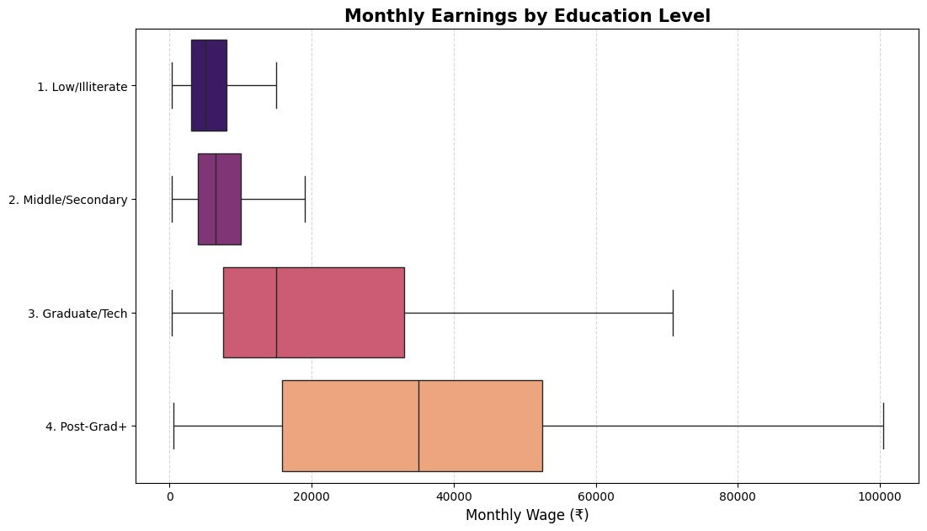
- Higher education sharply raises median wages and dispersion. Post-graduates benefit from superior job quality, while low-educated women face compressed, low-return wages.

2. Age–Lifecycle and Workforce Participation
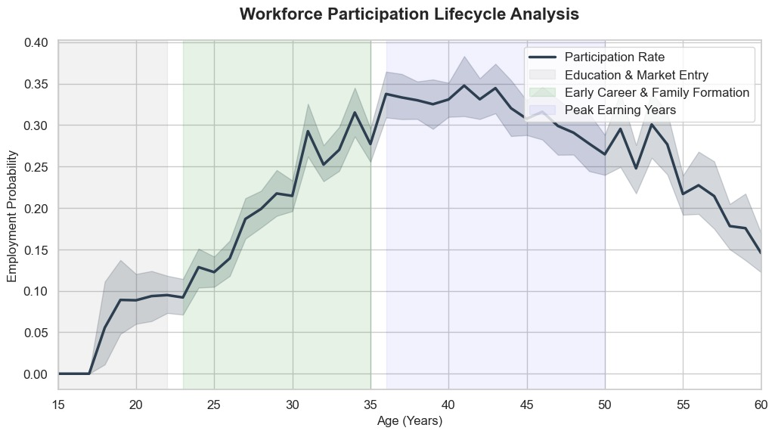
- Participation rises after education, dips during marriage and childbearing years, stabilizes in mid-life, and declines steadily after age 50.

3. Spousal Income and Labour Supply Elasticity

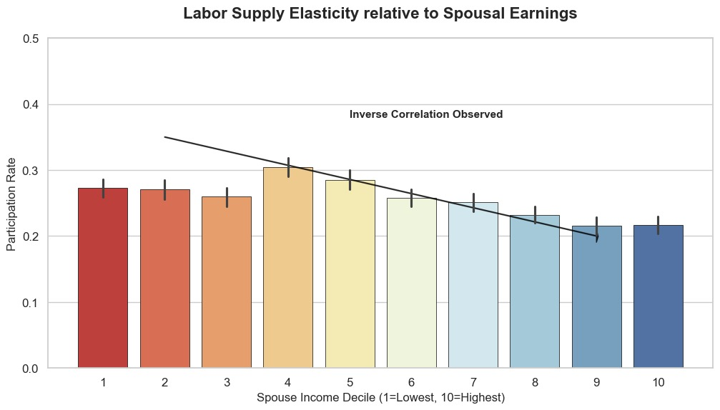
- Participation declines with rising spousal income, confirming a dominant income effect and reduced economic necessity in higher-income households.

4. Household Size and Employment Probability

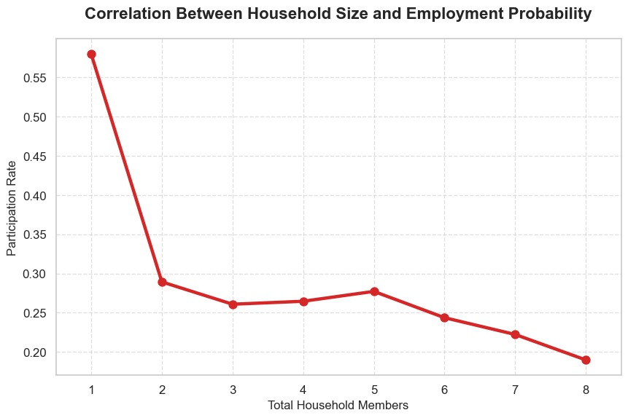
- Larger households reduce women’s employment likelihood, reflecting higher domestic workloads and childcare responsibilities.

5. Wage Growth Trajectories by Education
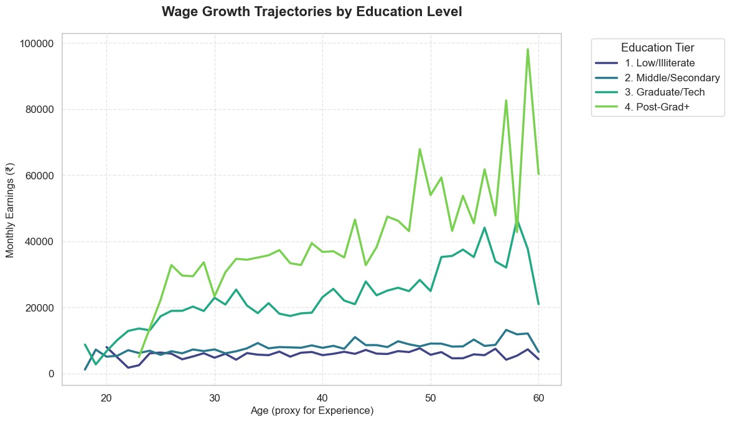
- Graduate and post-graduate women experience steep wage growth with age, while low-educated women see stagnant earnings across the lifecycle.

6. Spousal Wage Correlation
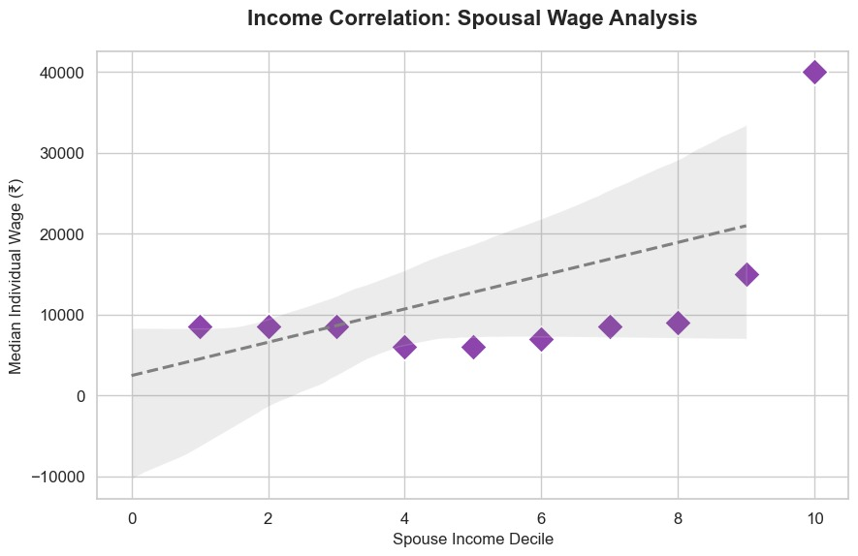
- Positive assortative matching is evident: higher-earning husbands are associated with higher-earning wives, with greater dispersion at upper income levels.

Machine Learning Evidence on Employment and Wage Determination:
Two machine learning models were applied: (i) Random Forest Classification for employment participation prediction and (ii) Random Forest Regression for wage determination.

Employability Prediction Results:
Class | Precision | Recall | F1-Score | Support
0 | 0.75 | 0.99 | 0.85 | 5962
1 | 0.50 | 0.04 | 0.08 | 2055
Accuracy |  |  | 0.74 | 8017
Macro Avg | 0.63 | 0.51 | 0.47 | 8017
Weighted Avg | 0.69 | 0.74 | 0.65 | 8017

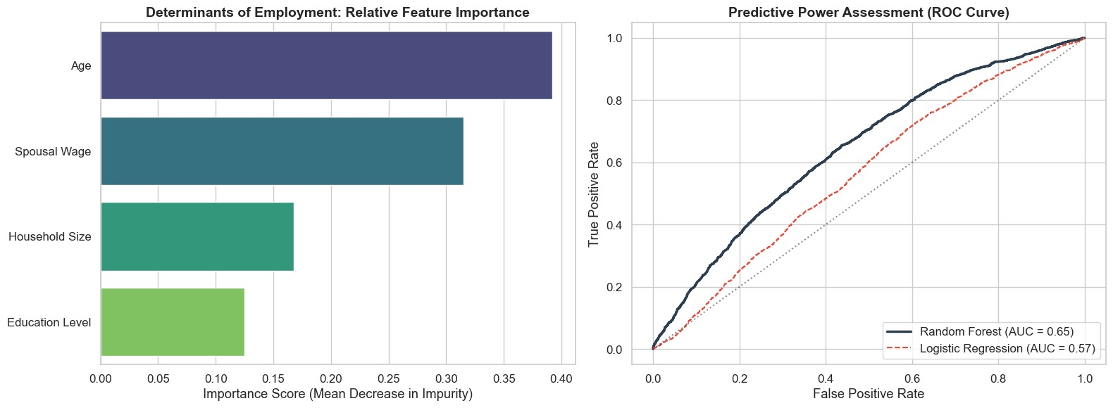

Key Insights:
• Age is the strongest predictor of participation, reflecting life-cycle effects linked to marriage, childbirth, and caregiving.
• Spousal wage has a strong negative effect on participation, confirming the dominance of the income effect in married women’s labour supply.
• Household size reduces labour force participation by increasing unpaid domestic and care responsibilities.
• Education has limited predictive power, indicating that higher qualifications do not automatically translate into labour market entry.

Wage Prediction Results:
- Model R² (Explained Variance): 0.4107
- RMSE (Avg Error in ₹): ₹14771.64
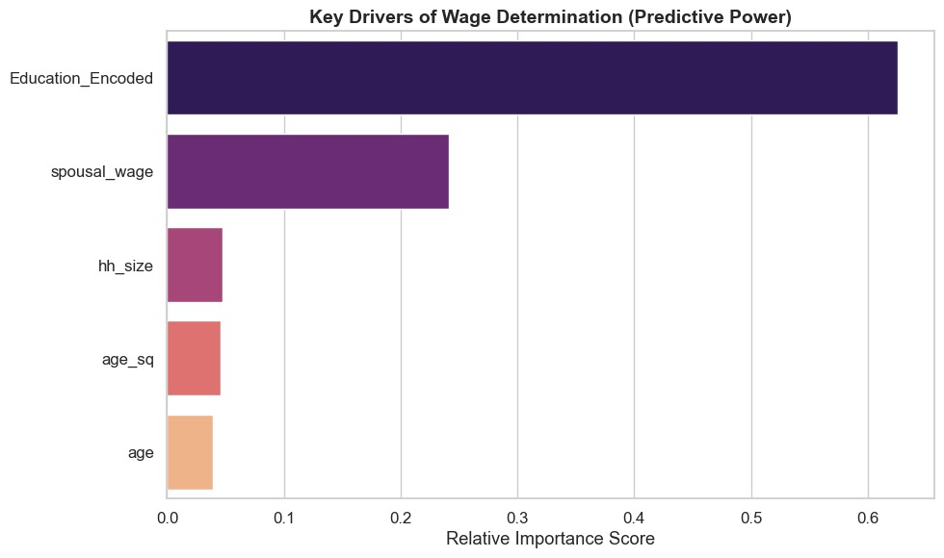

Key Insights:
• Education is the primary determinant of wages, highlighting the central role of human capital in earnings.
• Spousal wage positively influences women’s wages, consistent with assortative matching within households.
• Household size and age have minimal effects on wages, indicating that family responsibilities affect participation decisions more than wage outcomes.
• The divergence between education’s strong wage effect and weak participation effect reveals a clear participation–wage mismatch among married urban women.

CONCLUSION
• Labour supply decisions of married women in urban India are driven primarily by household income, life-cycle constraints, and social norms rather than wages alone.
• Education strongly increases wages but has a limited effect on labour force participation, revealing a persistent participation–wage mismatch.
• Income effects arising from spousal earnings significantly reduce women’s labour supply, especially during prime working ages.
• Household size and childcare responsibilities raise the opportunity cost of market work, further discouraging participation.
• The evidence points to non-linear and context-dependent labour supply behaviour, underscoring the limits of purely market-based explanations.

POLICY AND MANAGERIAL IMPLICATIONS
• Invest in care infrastructure: Affordable childcare and eldercare are critical to lowering opportunity costs and enabling labour market participation.
• Enable flexible urban employment: Flexible hours, remote work, and safe transport can significantly improve retention of married women.
• Target mid-education women: Graduates and secondary-educated women show low participation despite moderate wages, warranting focused re-skilling and job-matching.
• Improve job quality: Formal, stable employment with social security can attract women from middle-income households and sustain participation.

Appendix
- Interactive Dashboard: https://plfsanalysis.streamlit.app/
- PLFS Datasource: https://microdata.gov.in/NADA/index.php/catalog/213
- All the code involving Data Processing, Analysis and Machine Learning models: https://github.com/ShubhamBhut/PLFS-Analysis---LE-Assignment

