CodeRank Project:

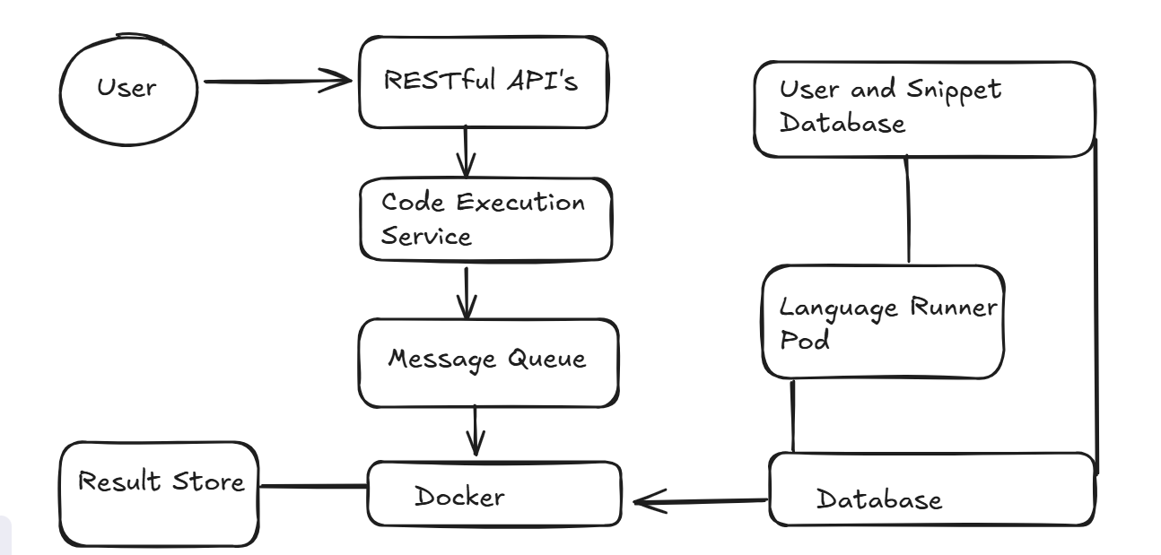

1. Users
Users interact with the platform to submit code snippets for execution.
And communicate through a RESTful API.

2. RESTful API
Act as entry point for user requests.
Handles HTTP requests (e.g., code submission, fetching results).
Passes the request to the Code Execution Service.

- View list of problems
GET/problemsList

- View a problem
GET/problem/problemId

- Submit Solution
POST/problems/problemId-> Submission
{
Code,
language
}

- Get Leaderborad
GET/ leanderborad

#Entities
1.User
2.Probelm
3.Submission
4.Leaderboard

3. Code Execution Service
Core service responsible for managing code execution tasks.
It validates the request and sends execution jobs to the Message Queue.
4. Message Queue
Ensures asynchronous and reliable processing of code execution tasks.
Decouples the request handling from actual execution.
Send tasks to Docker containers for execution.

5. Docker
Provides isolated environments for running user code securely.
Each execution happens inside a container to prevent interference and ensure security.
After execution, results are sent to the Result Store.

6. Result Store
Stores the output of executed code.
Users can retrieve results from here via the API.

7. User & Snippet Database
Stores user information and code snippets.
Connected to the API for user authentication and snippet management.

8. Language Runner Pods
Specialized pods for different programming languages (C++, Java, Python).
They interact with Docker and the database to execute code in the correct language environment.

9. Database
Central storage for execution metadata, logs, and other persistent data.
Supports both the Language Runner Pods and Docker.

