Assignment 3
5-transistor OTA with a single-ended output with the following specifications:
1. Gain > 25 dB
2. Unity gain bandwidth > 500 MHz with 1pF load capacitance
Plots of OTA
- DC currents & voltages at different nodes for an input common mode voltage of 0.8V.
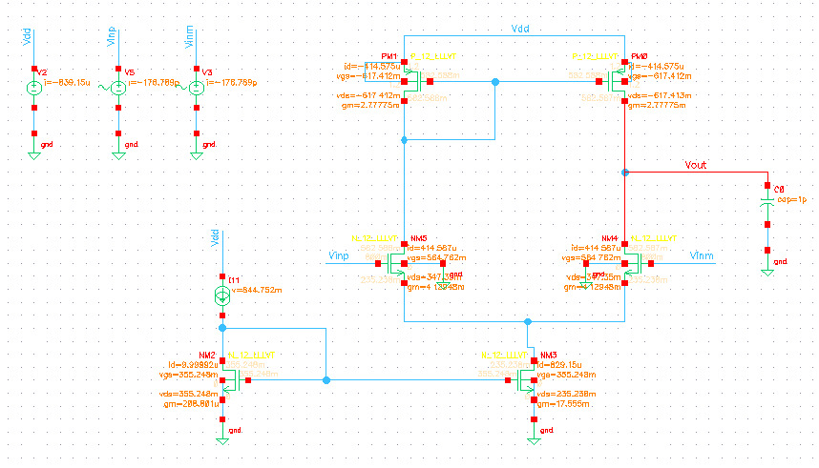

- Ac differential gain and phase
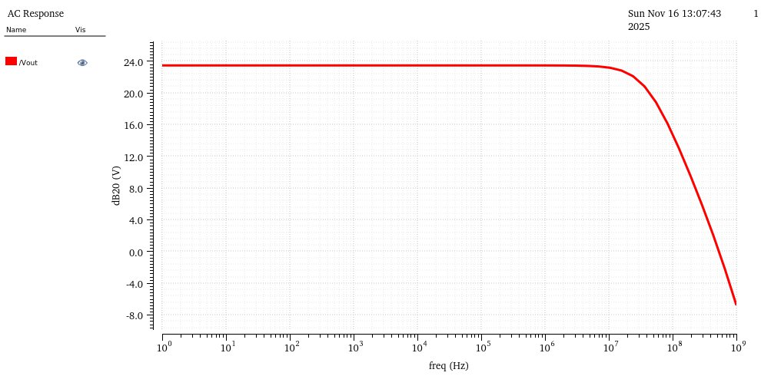
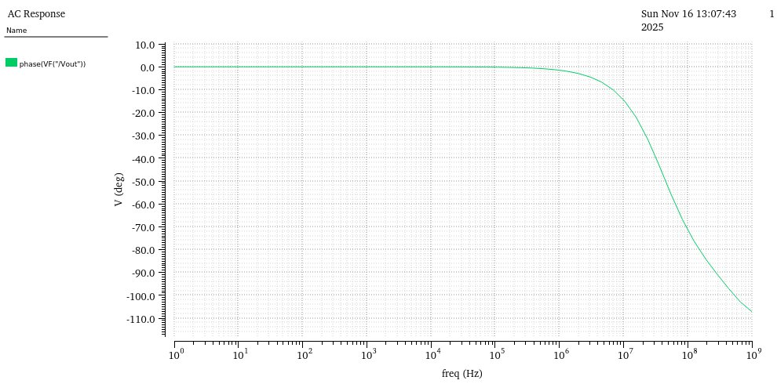

- Ac common mode gain

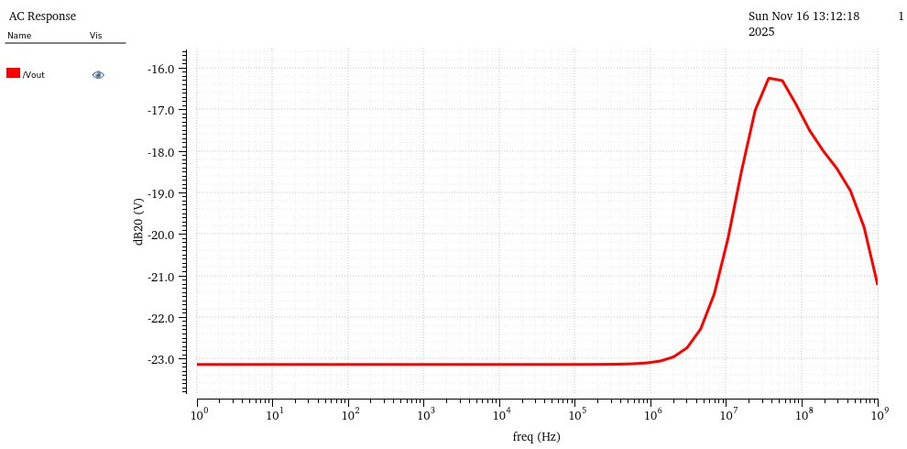

- CMRR vs frequency

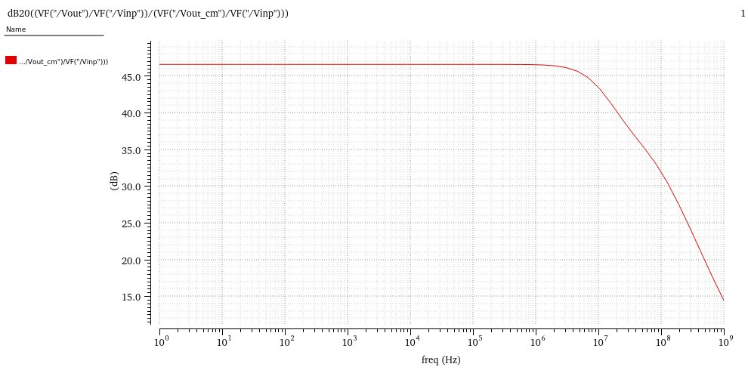

- Input referred noise of the OTA across frequency

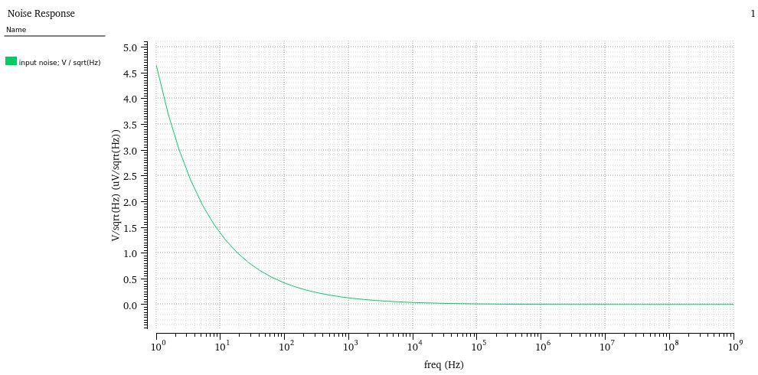

- PSRR

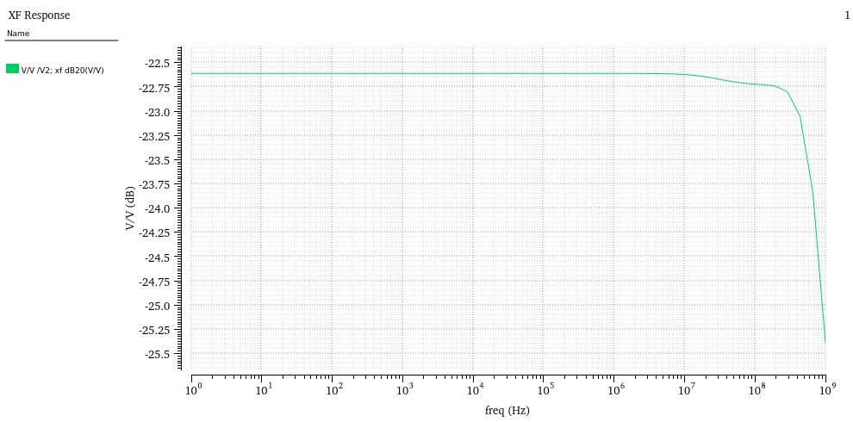
- Opamp in unity gain feedback with step input of amplitude 0.4V with a DC common mode voltage.
The time domain response.
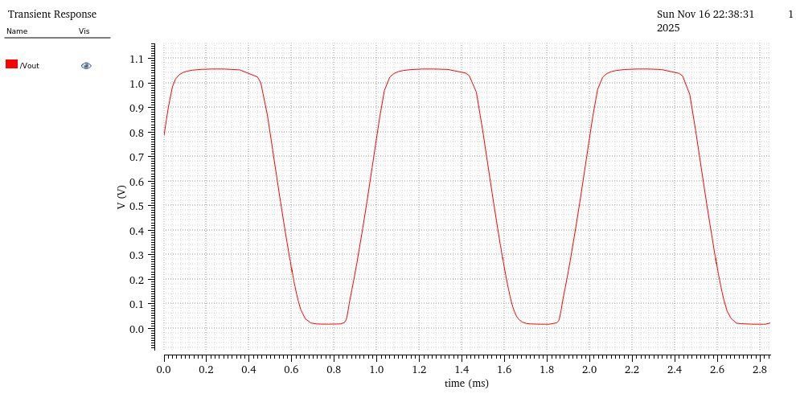

- DC & AC behaviour of OTA across PVT: tt, ss and ff corners for temperatures: -40◦, 27◦ and +120◦.

