**WEB SCRAPPING**

**Q. Store Top 50 movies – Sno. Name of the Movies Year Time Rating!!**

**Website - https://www.imdb.com/search/title/?groups=top_250&sort=user_rating")**

**> mov<-read_html("https://www.imdb.com/search/title/?groups=top_250&sort=user_rating")**

**> mov %>% html_nodes(".runtime , .ratings-imdb-rating strong , .unbold , .lister-item-header a") %>% html_text2()->movlist**



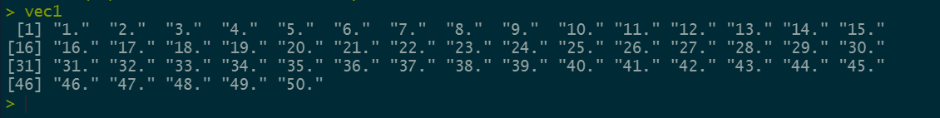



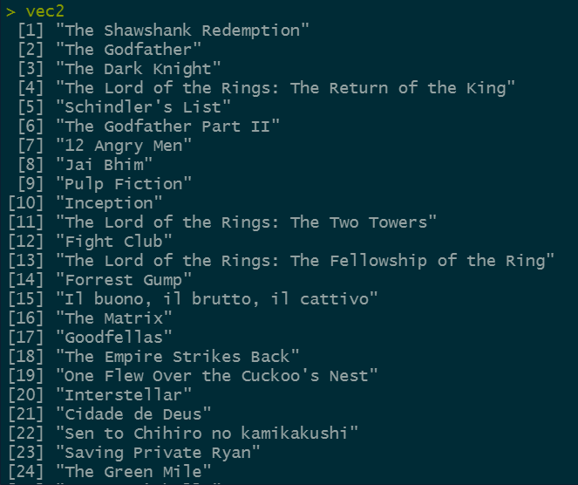



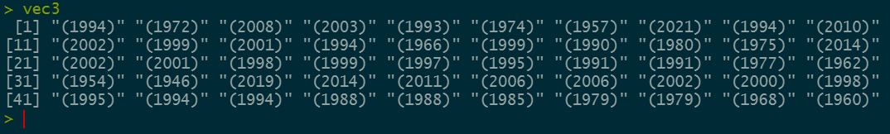



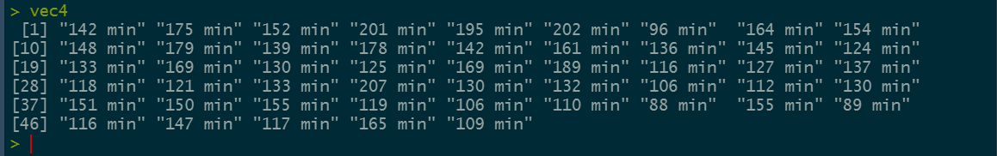



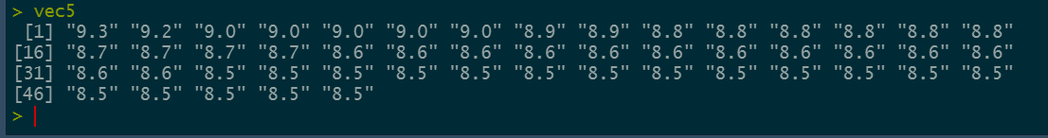

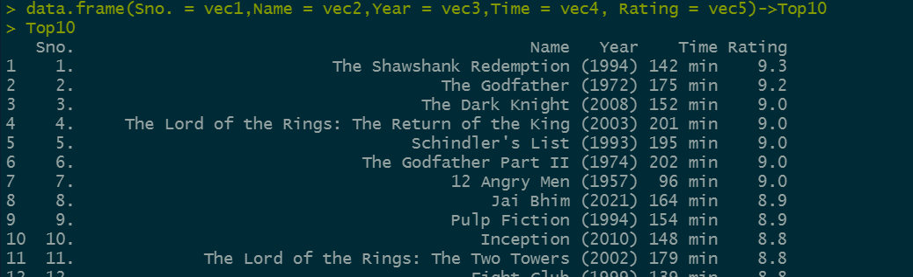

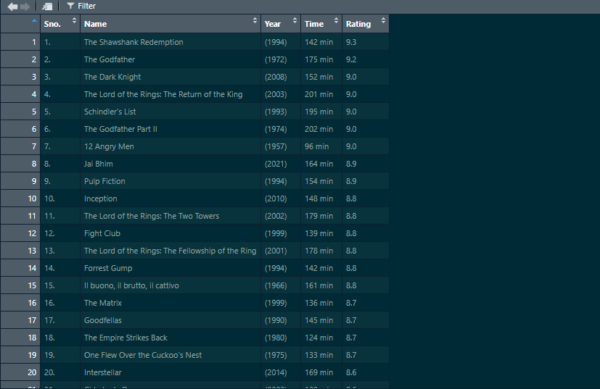

1. Out of first 11, which movie has highest rating.

> ggplot(data = top11,aes(y=Name,x=Rating))+geom_boxplot()

