**WEB SCRAPPING**

**Q. Store Top 50 movies – Sno. Name of the Movies Year Time Rating!!**

**Website - https://en.wikipedia.org/wiki/Universities_and_colleges_of_West_Bengal**

**> uni<-read_html("****https://en.wikipedia.org/wiki/Universities_and_colleges_of_West_Bengal");**

**> uni %>% html_nodes("td+ td:nth-child(2) , .jquery-tablesorter:nth-child(45) td:nth-child(5) , td~ td+ td > a , td:nth-child(1) a , td:nth-child(1) .mw-redirect") %>% html_text2()->abc**

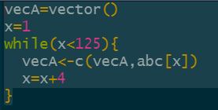

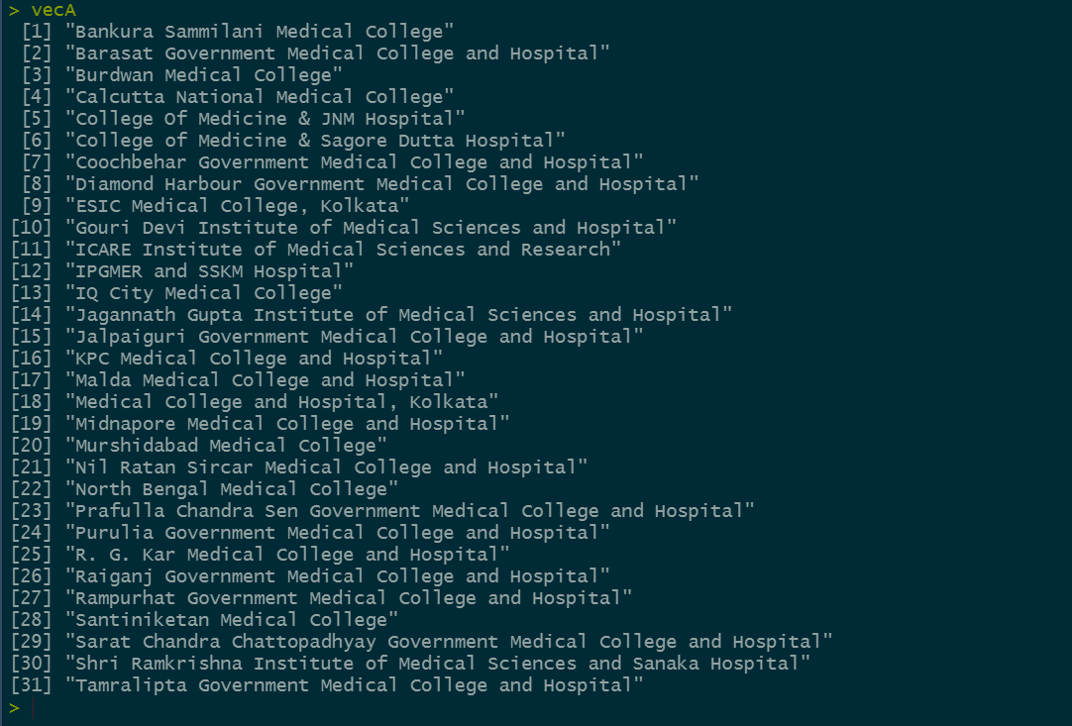

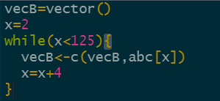

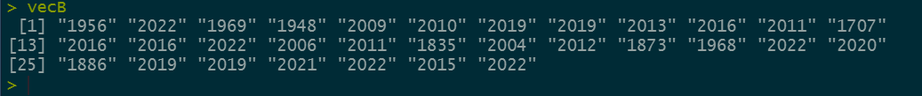

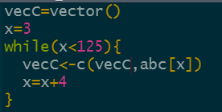

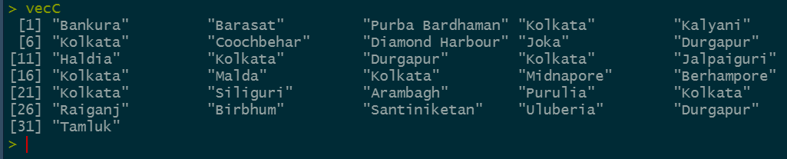

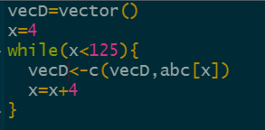

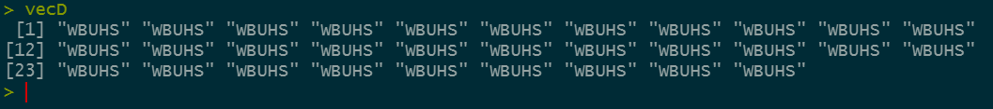



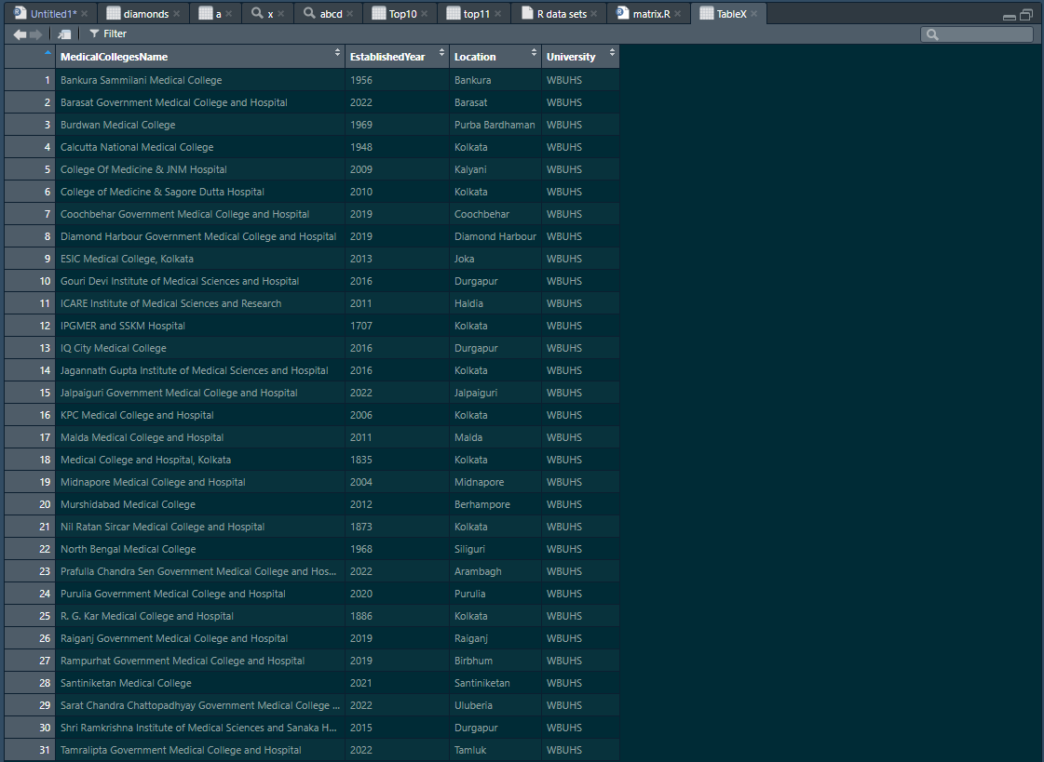

1. Out of first 11, which movie has highest rating.

> ggplot(data = TableX,aes(y=Location,fill=Location))+geom_bar()

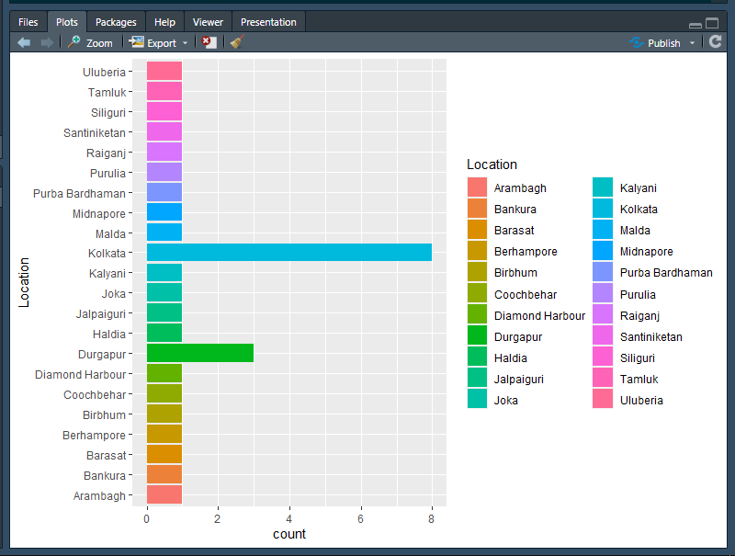

>ggplot(data = TableX,aes(y=University))+geom_bar()

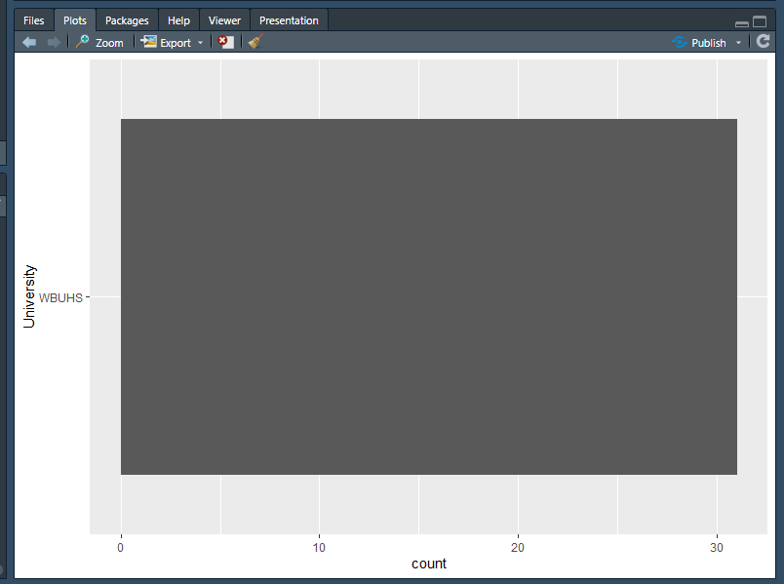

> ggplot(data = TableX,aes(y=EstablishedYear,fill=EstablishedYear))+geom_bar()

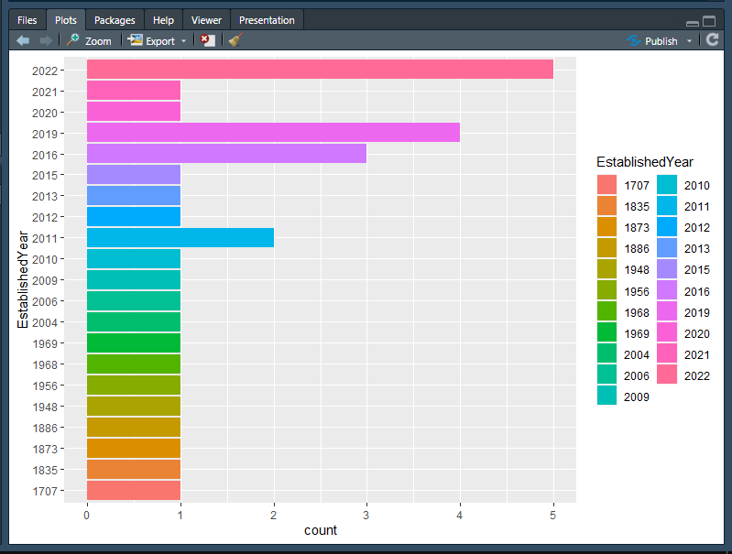

> ggplot(data = TableX,aes(y=Location,x=University,col=Location))+geom_boxplot()

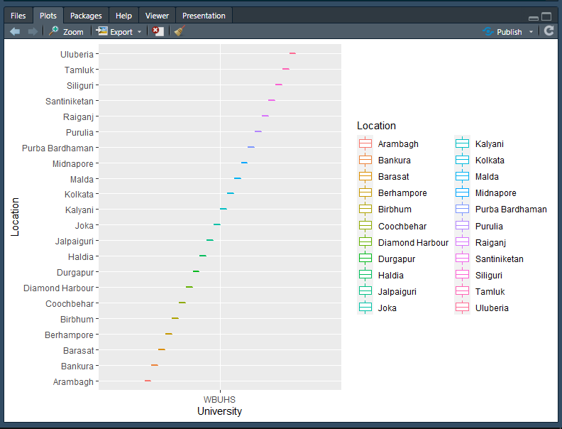

> ggplot(data = TableX, aes(x = "", y = EstablishedYear, fill = Location)) + geom_bar(stat = "identity") +coord_polar("y")

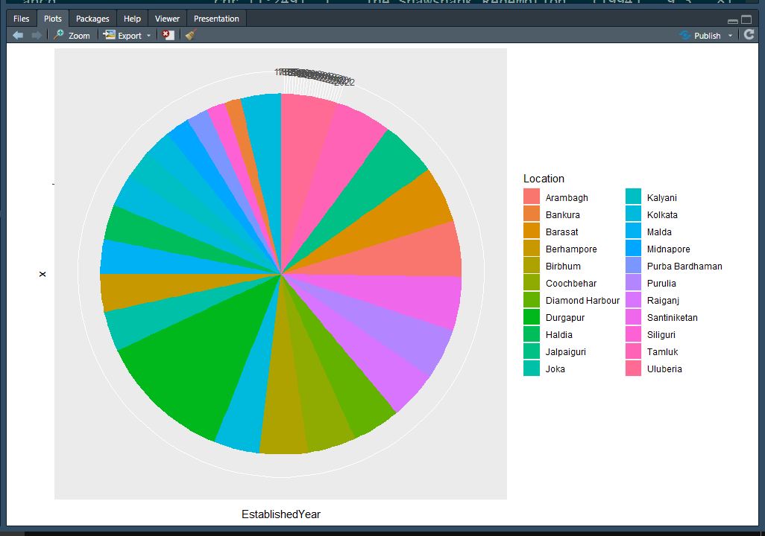

> ggplot(data = TableX, aes(x = "", y = Location, fill = EstablishedYear)) +

+ geom_bar(stat = "identity",color = "black") + labs(title = "Percentage of Medical Colleges on that given Year")+

+ coord_polar("y")+theme_void()

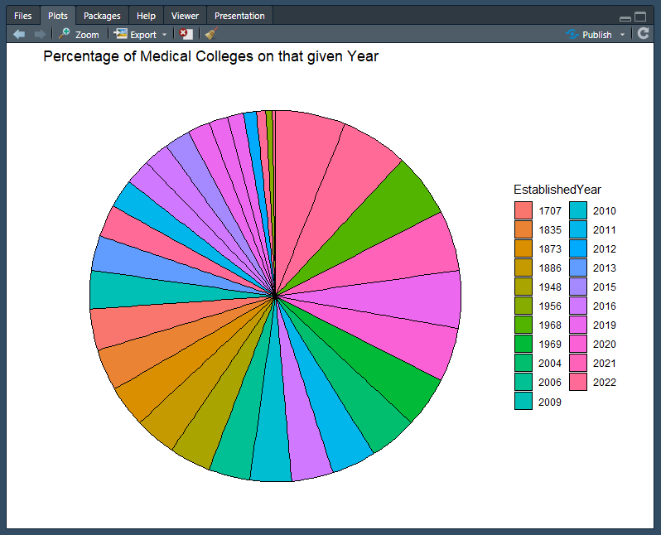

> ggplot(data = TableX, aes(x = "", y = EstablishedYear, fill = Location)) +

+ geom_bar(stat = "identity",color = "black") + labs(title = "Percentage of Medical Colleges on that given Location")+

+ coord_polar("y")+theme_void()

