Proposed API design structure, depicting different entities and possible channels of communication.

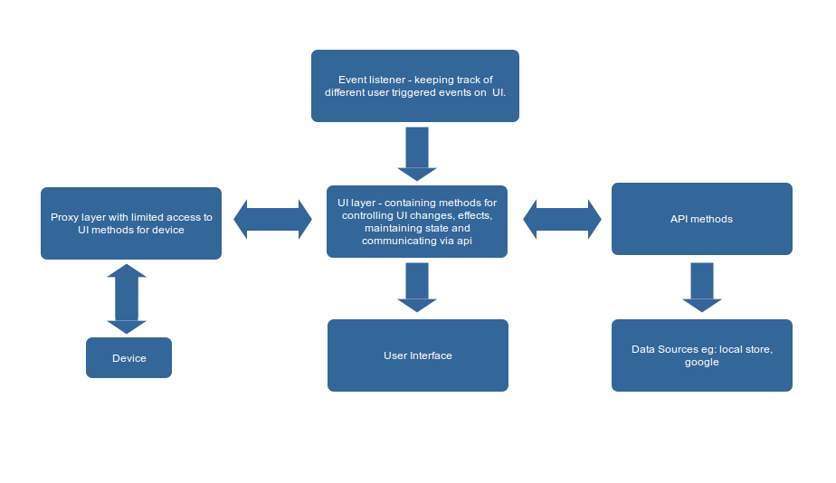
Response to Review by Jimmy

From what I am reading of your Screen Methods and Private Methods comprise
the “API” we are defining. Is this correct?

=> Yes, this is what we are targeting.

--

Are the “Screen Methods” doing any drawing, navigation, etc of html for the UI
or are they only calling into the other api “Private” methods?

=> Screen methods were initially intended to perform/trigger different UI functionality which is part of a particular action and call private methods for data communication and processing.

For example:

Device initialize method will call:
loadScheduledMeetings

Which will call API method getMeetings and render ui via a method like uiDisplayMeetings (not covered in specs), on initiating a call from ui an API call will be made connectMeeting.

I believe we can make methods / functions that would perform UI level functionality by prefixing 'ui' to them.

--

We are wondering if it would be better for there to be at least one “Private” method that
the “Screen Methods” must call into.

=> I believe that we should limit the API / 'private' methods to only perform data communication and processing.

--

For example: Here are a couple of “Screen Methods” that do not have a corresponding
”Private” method:

muteMeetingMember()

pinMeetingMember()

For muteMeetingMember(), i do see that you call a “Private” method: canMuteMember().

Does this do two functions at once? see if one can mute the member and then
do the mute? Is it possible to break it into two ”Private” API calls?

canMuteMember()

muteMember() // this one is not the same as the “screen” muteMeetingMember()

=> This part got missed out and yes we need to have a API method muteMember, pinMember that actually mutes / pins a member. Functions like canMuteMember will be responsible to check and confirm that if a user can be muted eg: is any other member already muted.
--
Hopefully it turns out that both the SCREEN methods and the PRIVATE methods
are both part of the “API” then that is better for us to control the UI via (IOC-
inversion of control).

=> UI can be controlled by device via the proxy layer.

--

Member types: currently we only have three types: user, room, phone

=> How do we derive that which user can be muted or pinned to the display.
Or should we assume that all users and rooms can be muted or pinned.
And phone can only be muted but not pinned.

--

2) UpdateMeeting: currently we are just “ending” phone calls but you can leave

it as “updateMeeting” with a status parameter “ended”

=> Does this means that we end a meeting once a phone call

closeMeeting method calls API level method: updateMeeting({status: 'ended'});

Do you mean something else?

--

3) Proposed api method muteMember and current canMuteMember: For mic status we have no

way to keep track of state for mute for others. The mute icon on a meeting

member should not track state (ie: switch to a different icon). It just mutes the

participant and should not keep track of if you muted someone thus not sure

if you need if_muted in your JSON structure for a Member. For muting yourself

you can just pass null into your muteMember() to make it assume you want

to mute yourself instead of another member.

=> I am not clear on the concern here. Are you suggesting that we should not track who is muted and we wont need to unmute a member?

--

This is_pinned in your JSON structure for Member would need to be tracked by your code. Remember, only one can be pinned.

Yes this will be hooked on to elements representing members:
<div id='member_card' onClick='pinMeetingMember({member_id: 1})'>John</div>

--

getMeetingMembers . I have a need for clarification here. Is this method for

obtaining the current “participants” in the meeting or is it to get a list of all

those who said they will attend a scheduled meeting in the Calendar? I believe

the intention is for a list of all the participants in the current meeting which means

you cannot obtain a list of members for anything other than the current meeting

so not sure you need a meeting_id parameter as we can only return a participant

list for a meeting the Brown is currently in. We also have a url (served on the cloud) for the icon

of the member if it’s type of “user”. So expect to add icon to your meeting structure

for a member.

=> If we make the meeting_id as a global parameter that is assigned on connecting to a meeting then we do not need to pass meeting id around.

--

6) updateCameraSettingForMember. We only can affect video feed for Brown or mute the

Brown’s camera. Does this function also mute the Camera? We cannot video mute other

members camera. This is also not a toggle, need to pass in boolean (is that your display

param?) What is x =1 y=1 for? Maybe the method should be named muteCamera(display bool).

=> x=1 y=1 was to indicate parameters for video feed crop selection. Will add muteCamera to hide camera feed.

---

What about exception handling?

