

Thapar Institute of Engineering and technology

**Object Oriented Programming using c++**

ASSIGNMENT – I

Name: - Shubham Gupta

Class: - MCA-I ‘B’

Roll No: - 202101044

**Q1.** Write a program to print “HELLO WORLD” on screen.

* #include<iostream>

using *namespace* std;

*int* main(){

    cout<<"HELLO WORLD";

    return 0;

}

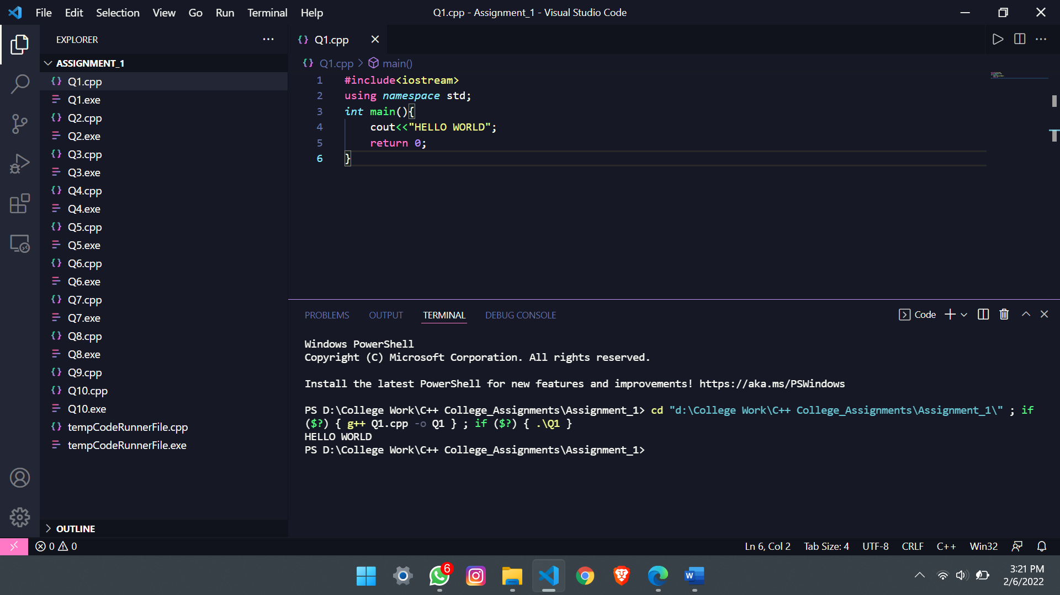

**Q2.** Write a program to display the following output using a single cout statement.

Subject Marks

Mathematics 95

Computer 80

Chemistry 75

Physics 80

* #include<iostream>

using *namespace* std;

*int* main(){

cout<<"Subject\t\tMarks"<<endl<<"Mathematics\t95"<<endl<<"Computer\t80"<<endl<<"Chemistry\t75"<<endl<<"Physics\t\t80";

return 0;

}

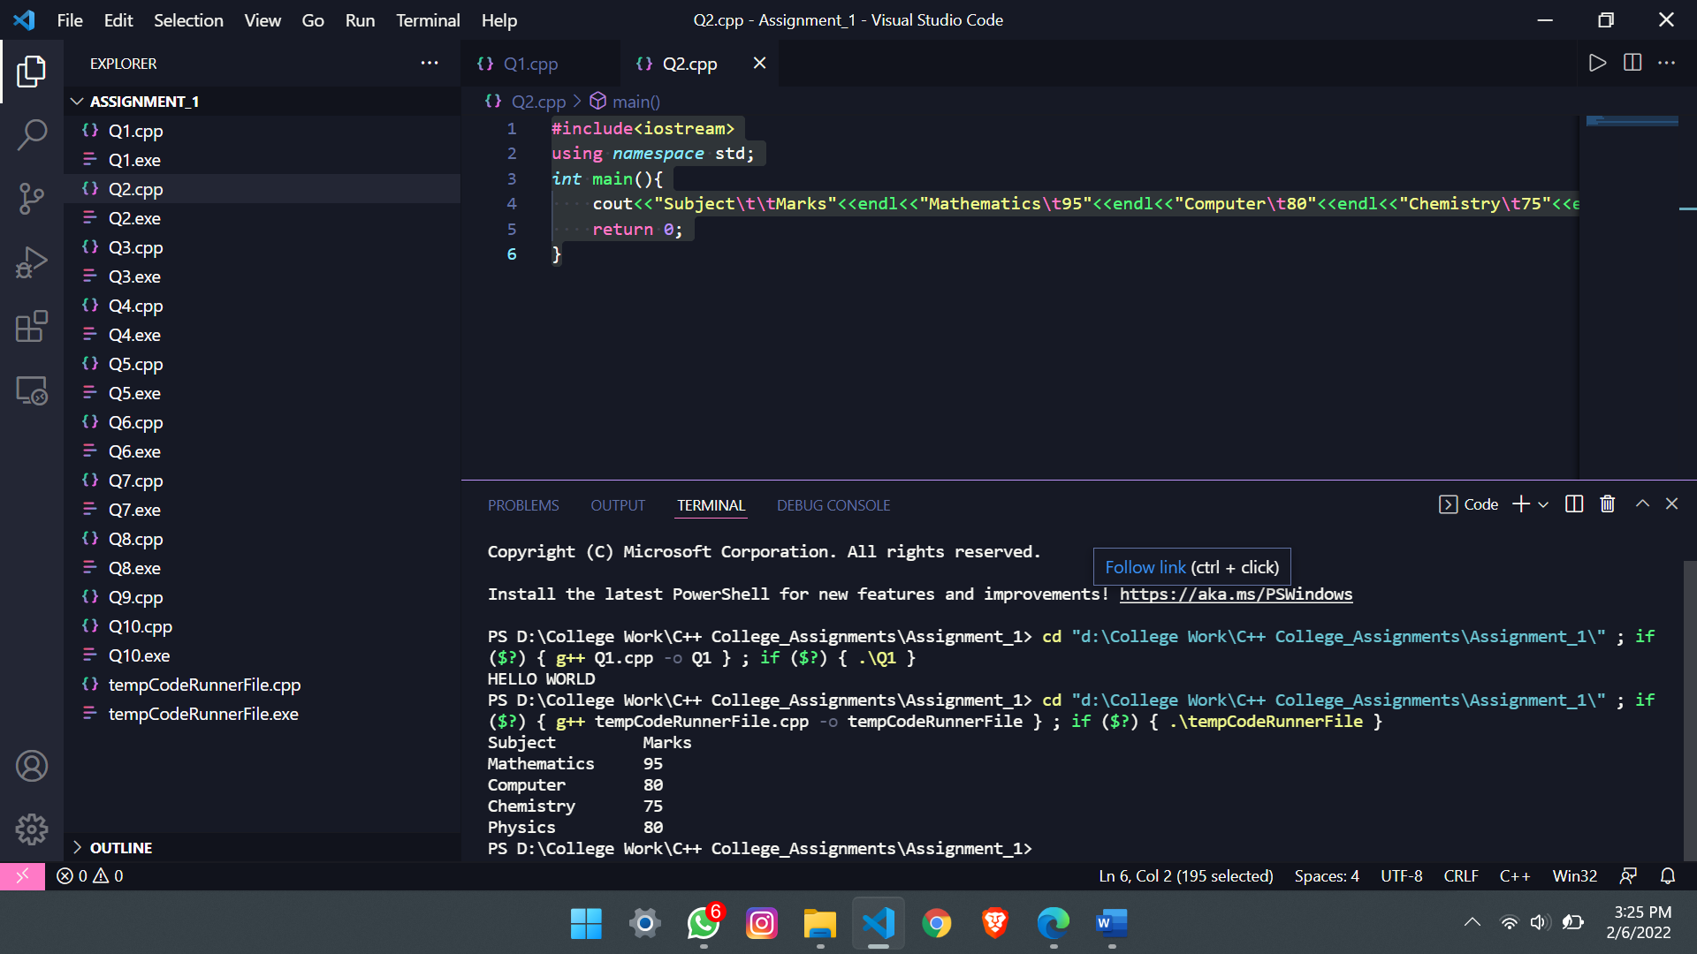

**Q3.** Write a program which accept two integer numbers and print their sum.

* #include<iostream>

using *namespace* std;

*int* main(){

*int* a, b;

    cout<<"Enter two number : ";

    cin>>a>>b;

*int* c = a+b;

    cout<<"Sum of a and b is : "<<c;

    return 0;

}

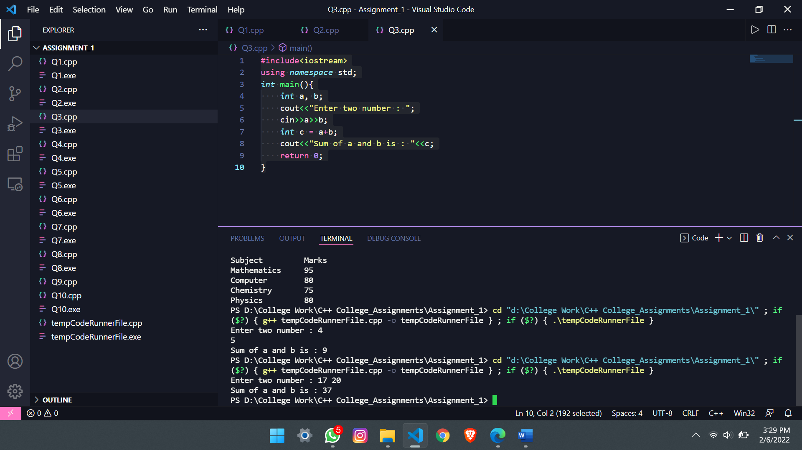

**Q4.** Write a program which accept temperature in Fahrenheit and print it in celcius.

🡪 #include<iostream>

using *namespace* std;

*int* main(){

*int* temp_c, temp_f;

    cout<<"Enter temprature in Fahrenheit : ";

    cin>>temp_f;

    temp_c = ((temp_f - 32)*5)/9;

    cout<<"Temprature in celcius is : "<<temp_c<<" degree";

    return 0;

}

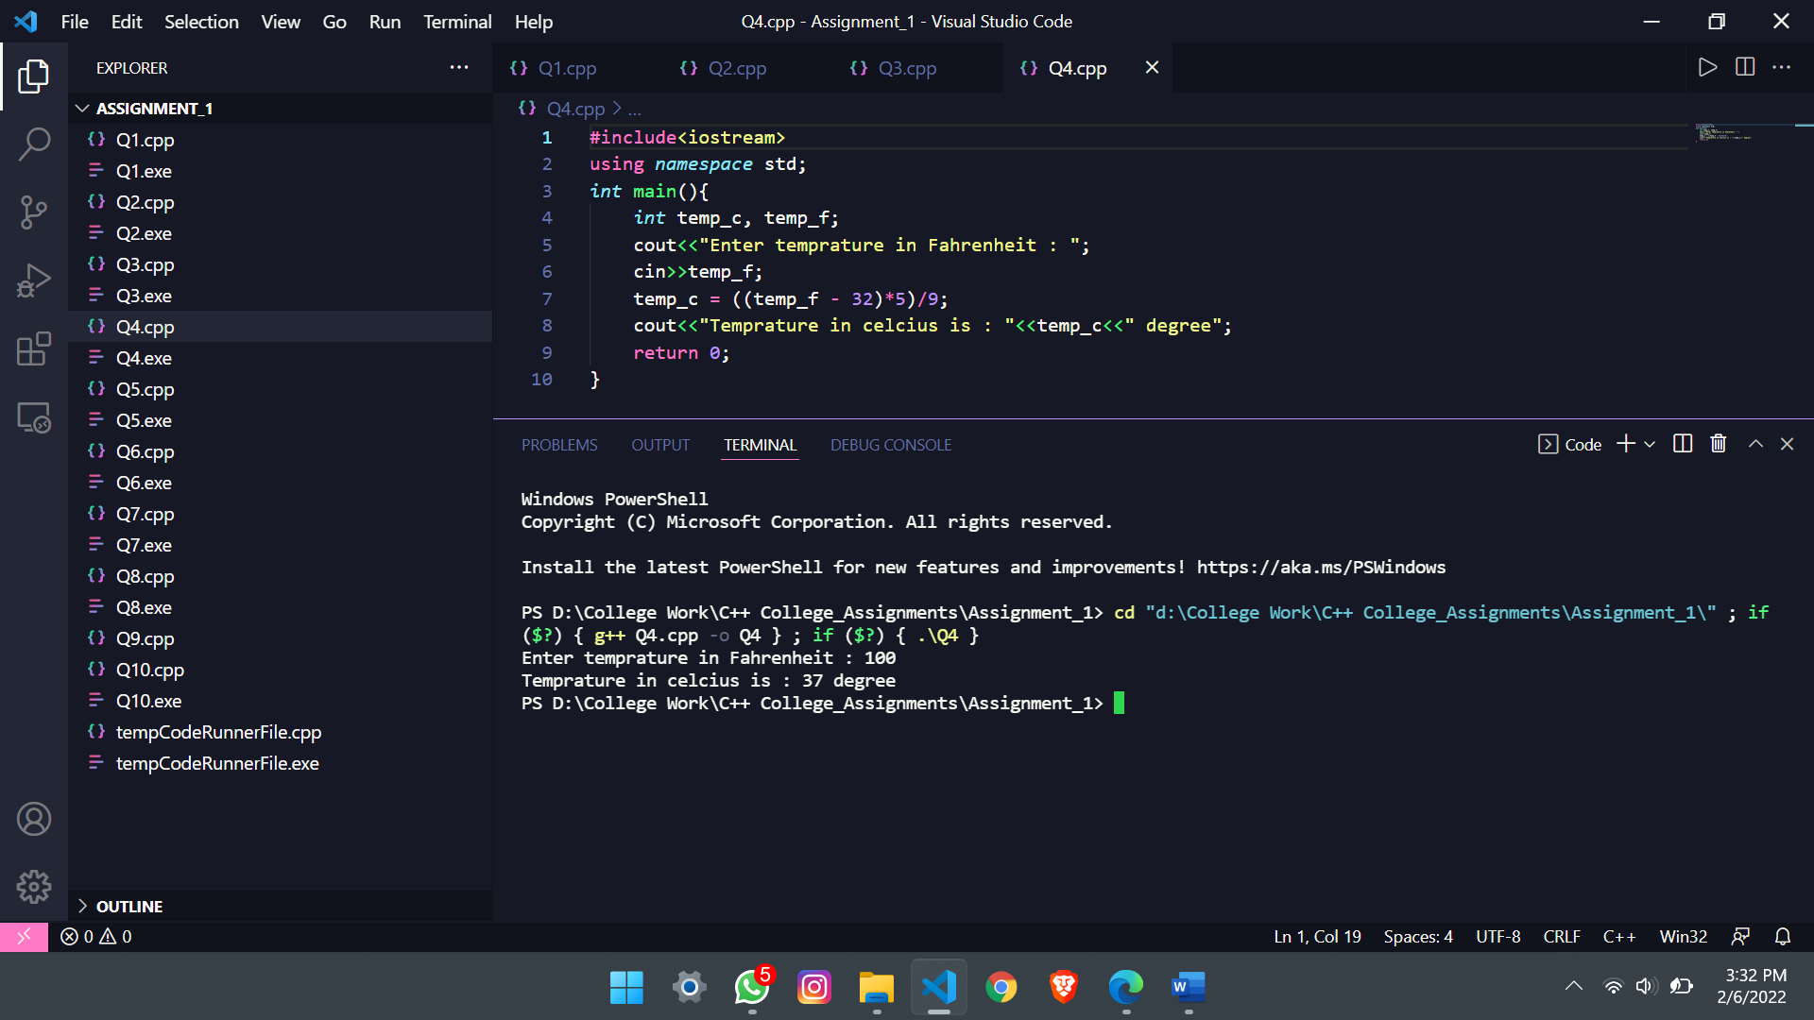

**Q5.** Write a program which accept principal , rate and time from user and print the simple interest.

🡪 #include<iostream>

using *namespace* std;

*int* main(){

*int* SI, P, R, T;

cout<<"Enter the value of Principal, Rate and time respectively in order to find Simple interest : ";

    cin>>P>>R>>T;

    SI = (P*R*T)/100;

    cout<<"The value of Simple Interset is : "<<SI;

  return 0;

}

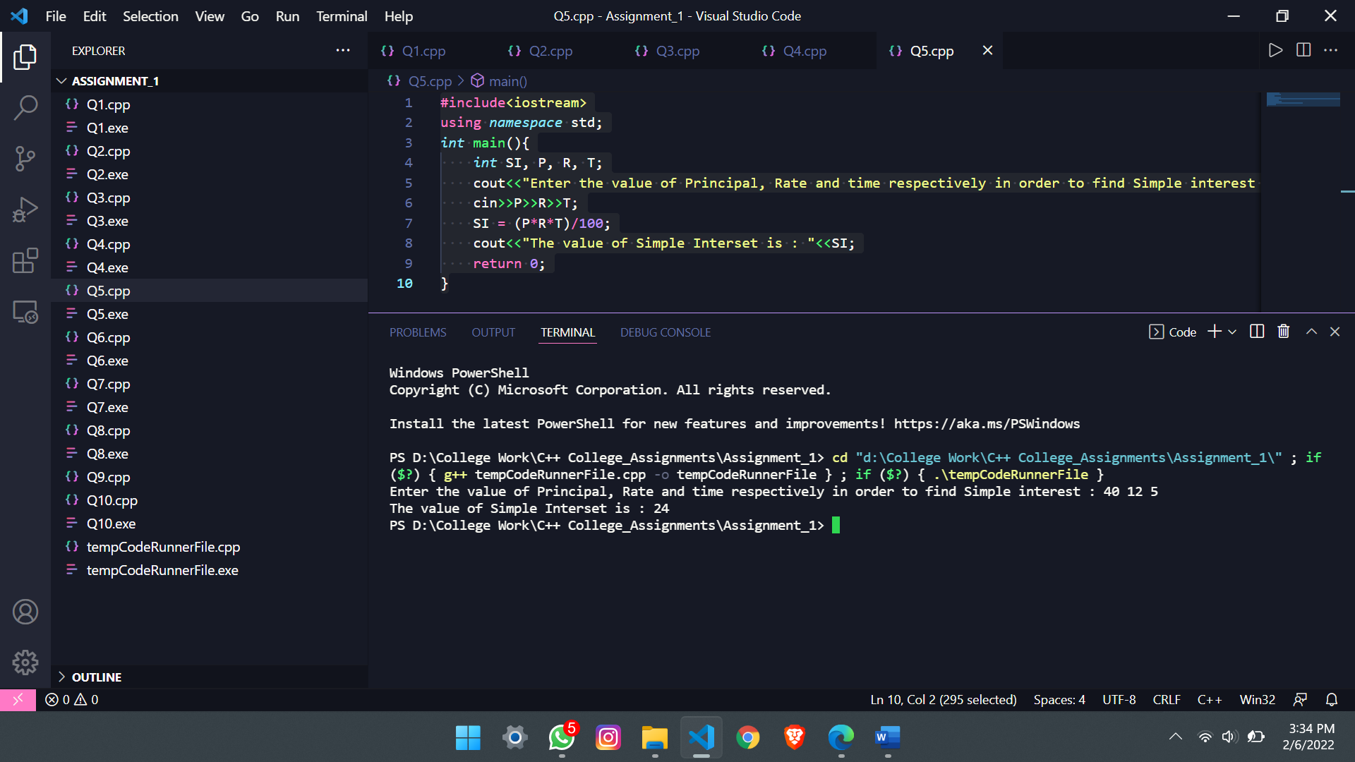

**Q6.** Write a program which accepts a charater and display it’s ASCII value.

🡪 #include<iostream>

// #include<ctype.h>

using *namespace* std;

*int* main(){

*char* a;

    // char c = '\t';

    cout<<"Enter a character in order to find its ASCII value : ";

    cin>>a;

    cout<<"The ASCII value of the inputed character is : "<<*int*(a);

    return 0;

}

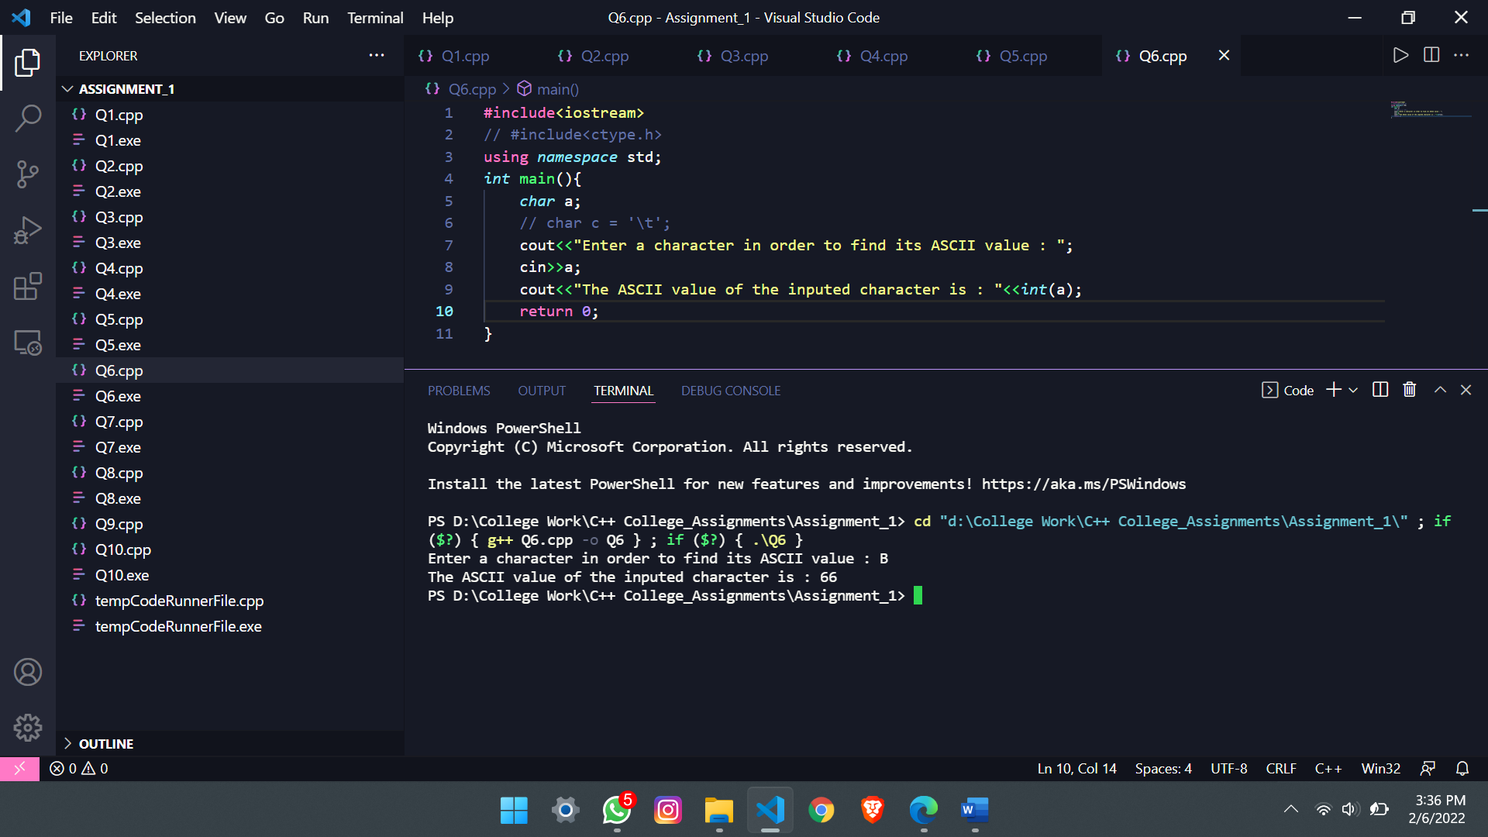

**Q7.** Write a program to swap the values of two variables.

🡪 #include<iostream>

using *namespace* std;

*int* main(){

*int* n1,n2,temp;

  cout<<"Enter two numbers n1 and n2 : ";

    cin>>n1>>n2;

    temp = n1;

    n1 = n2;

    n2 = temp;

    cout<<"Swapped Numners are : "<<n1<<" "<<n2;

    return 0;

}

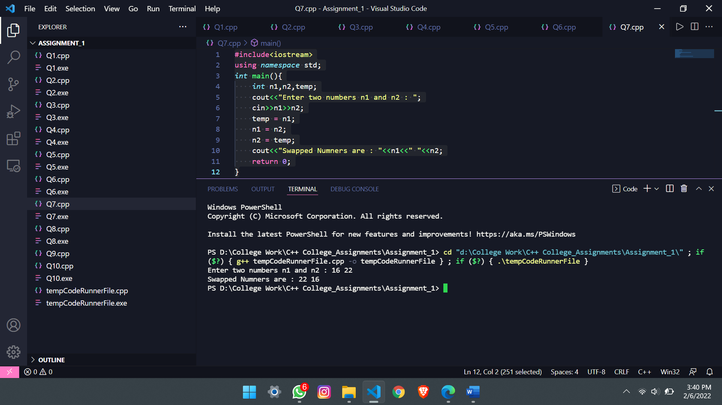

**Q8.** Write a program to calculate area of circle.

🡪 #include<iostream>

using *namespace* std;

#define PI 3.14

*int* main(){

*float* r;

    cout<<"Enter radius of the circle : ";

    cin>>r;

*float* area = PI*r*r;

    cout<<"The area of the circle is : "<<area;

    return 0;

}

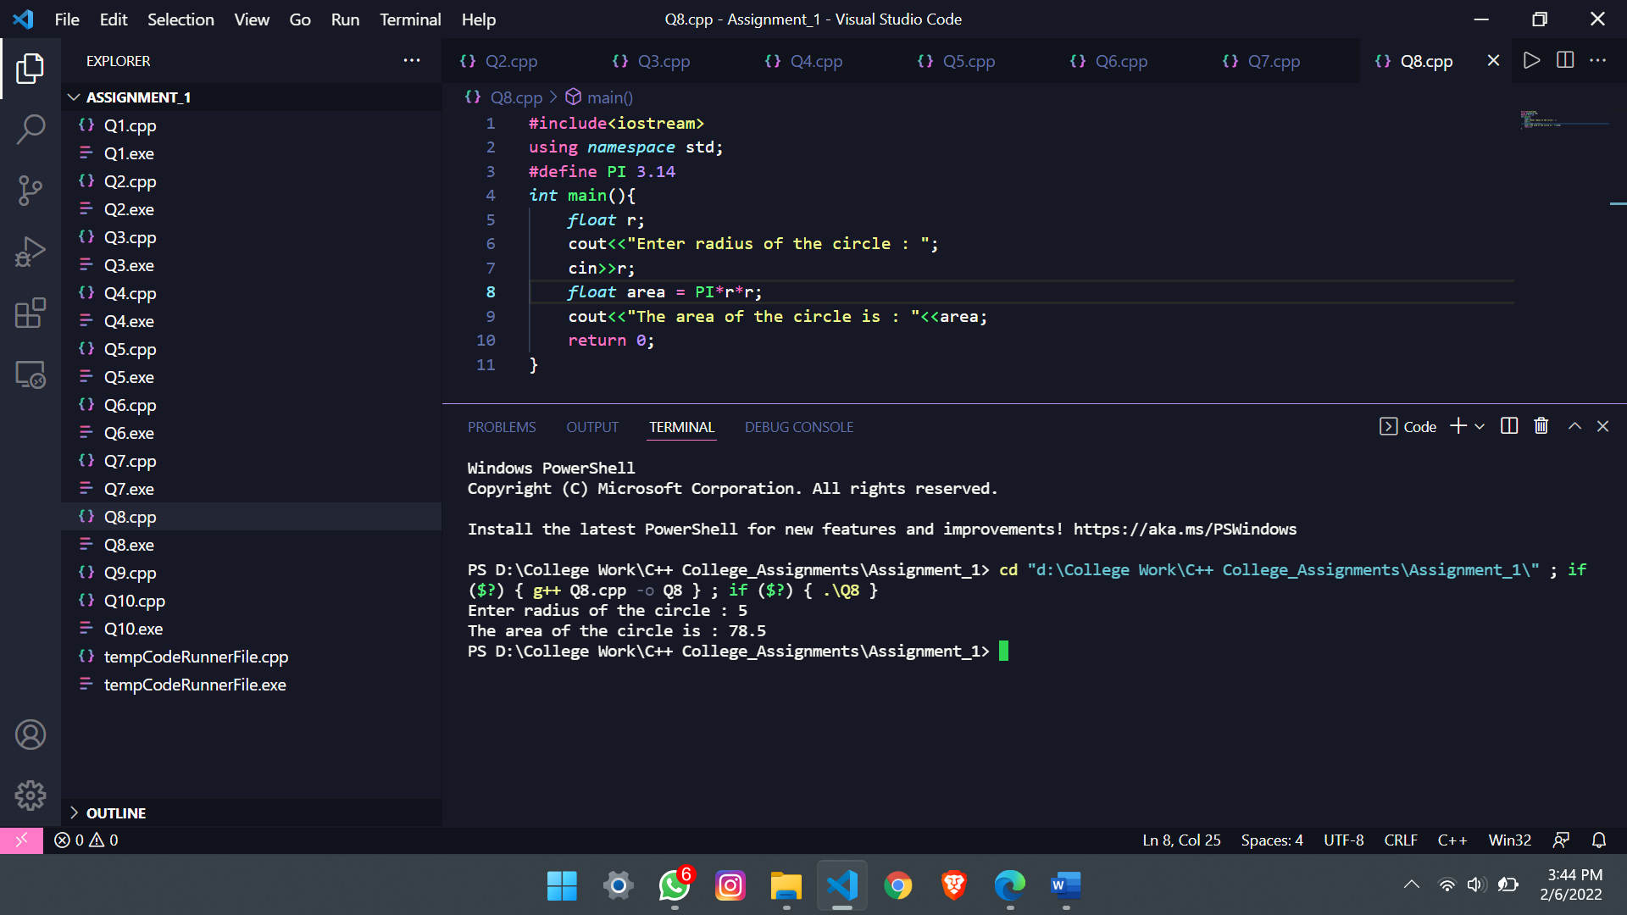

**Q9.** Write a program to swap value of two variables without using third variable.

🡪#include<iostream>

using *namespace* std;

*int* main(){

*int* n1,n2;

    cout<<"Enter two numbers n1 and n2 : ";

    cin>>n1>>n2;

    n1 = n1+n2;

    n2 = n1-n2;

    n1 = n1-n2;

    cout<<"Swapped Numners are : "<<n1<<" "<<n2;

    return 0;

}

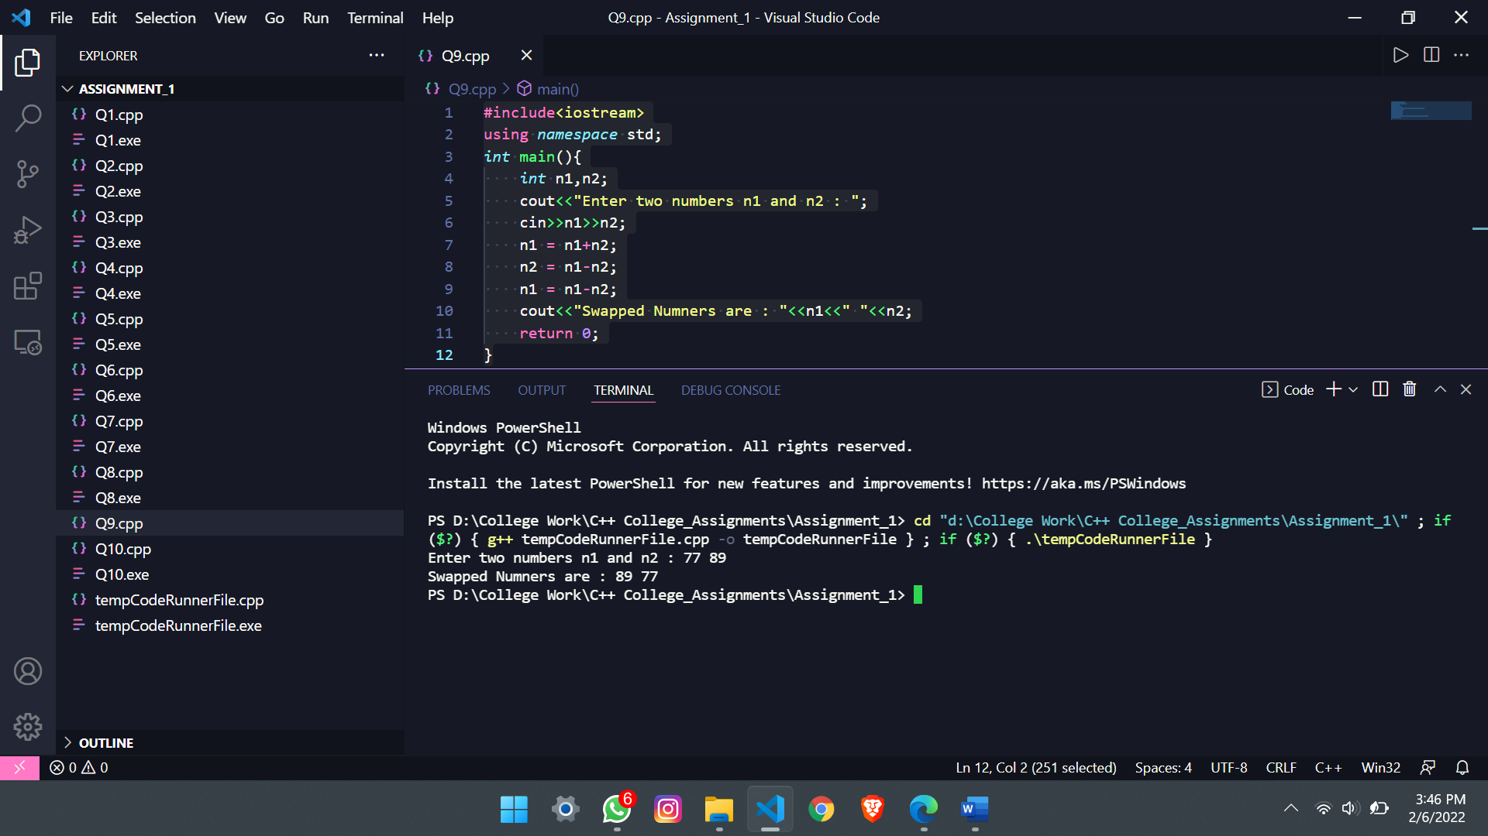

**Q10.** Write a program to check whether the given number is even or odd(using ?: ternary operator)

🡪 #include<iostream>

using *namespace* std;

*int* main(){

*int* num;

    cout<<"Enter a number : ";

    cin>>num;

    num%2 == 0?cout<<"Number is even":cout<<"Number is odd";

    return 0;

}

