Review 1 — Problem Definition, Reconnaissance & Threat Model
Member 1: Shubham Kumar (23BCI0017)
Member 2: Agamya Verma (23BCI0037)

1. Scenario Number & Problem Statement
Scenario 5: Blogging Platform with a Framework & CVE Audit
Problem Statement: The blogging platform exhibits multiple severe security vulnerabilities across its application stack, including Broken Access Control, Cross-Site Scripting (XSS), and vulnerable dependencies. This project aims to identify, exploit, and remediate these flaws to ensure data confidentiality, integrity, and availability. We perform a comprehensive security audit involving reconnaissance, threat modeling, exploitation of vulnerabilities, and implementation of robust defense mechanisms to protect sensitive user data and administrative functionalities.
Team Role Split-: Shubham: Frontend and Backend | Agamya: Exploit, Defence, Report

2. Architecture Diagram
The following architecture diagram outlines the hardened state of the application, explicitly marking trust boundaries and authentication flows.
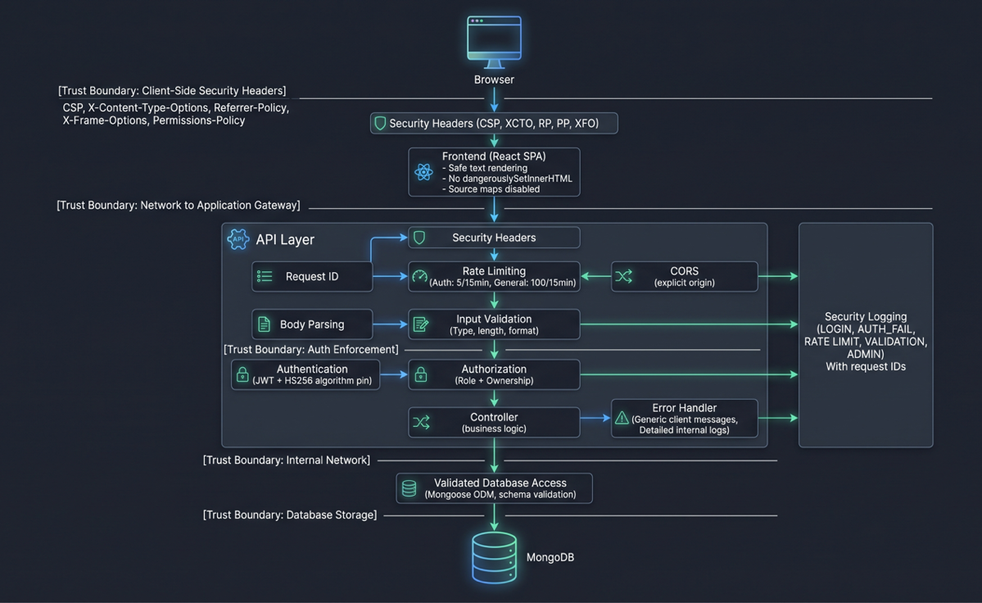

3. Attack-Surface Inventory

Method | Path | Parameters | Auth Required (Y/N) | Data Sensitivity
GET | /api/admin/users | None | Y | HIGH
GET | /api/admin/stats | None | Y | HIGH
DELETE | /api/admin/posts/:id | id | Y | HIGH
DELETE | /api/admin/comments/:id | id | Y | HIGH
DELETE | /api/admin/users/:id | id | Y | HIGH
GET | /api/posts/ | None | N | MEDIUM
GET | /api/posts/search | query (query string) | N | MEDIUM
GET | /api/posts/:id | id | N | MEDIUM
POST | /api/posts/ | body (title, content) | Y | MEDIUM
PUT | /api/posts/:id | id, body | Y | MEDIUM
DELETE | /api/posts/:id | id | Y | MEDIUM
GET | /api/comments/:postId | postId | N | LOW-MEDIUM
POST | /api/comments/:postId | postId, body (text) | Y | LOW-MEDIUM
DELETE | /api/comments/:commentId | commentId | Y | LOW-MEDIUM
POST | /api/auth/register | body (email, password, etc) | N | HIGH
POST | /api/auth/login | body (email, password) | N | HIGH
POST | /api/auth/logout | None | N | LOW
POST | /api/auth/refresh | Cookie (refreshToken) | N | HIGH
GET | /api/auth/profile | None | Y | HIGH

4. Literature / CVE Survey
- CVE-2022-23541 — jsonwebtoken Algorithm Confusion: Source: NIST NVD (Link) When jwt.verify() is called without specifying allowed algorithms, it enables an attacker to forge tokens by exploiting algorithm confusion. Our backend originally suffered from this by not restricting the signing algorithm, allowing asymmetric-signed tokens to bypass the HS256 requirement.
- CVE-2024-43796 — Express XSS in res.redirect(): Source: NIST NVD (Link) This vulnerability highlights that response.redirect() in older versions of Express generates an HTML body containing the redirect URL as a clickable link. If the URL contains an XSS payload, it can be reflected in the HTML response.
- OWASP Top 10:2021-A01 - Broken Access Control: Source: OWASP (Link) The application’s initial state lacked role verification on administrative endpoints and ownership checks on post modification (V-07), directly mapping to this category. We mitigated this by enforcing role-based middleware (/api/admin/*) and ownership matching for CRUD operations.
- OWASP Top 10:2021-A03 - Injection (Cross-Site Scripting): Source: OWASP (Link) The frontend originally used dangerouslySetInnerHTML for rendering blog content without sanitization (V-04). This allowed stored XSS attacks, compromising user sessions and data integrity.
- CWE-209: Generation of Error Message Containing Sensitive Information: Source: MITRE (Link) Prior to hardening, the server returned verbose error responses including stack traces and database structure details (V-06). This aided attacker reconnaissance and fingerprinting, leading us to implement a generic error handler that logs detailed errors internally while presenting sanitized messages to clients.

