Java is:-

* **Statically typed language: -** where type of each variable is already known at compile time. Once a variable is declared with a certain datatype it can’t hold value other than that type. Example: - C, C++, Java.

Data Types in Java:-

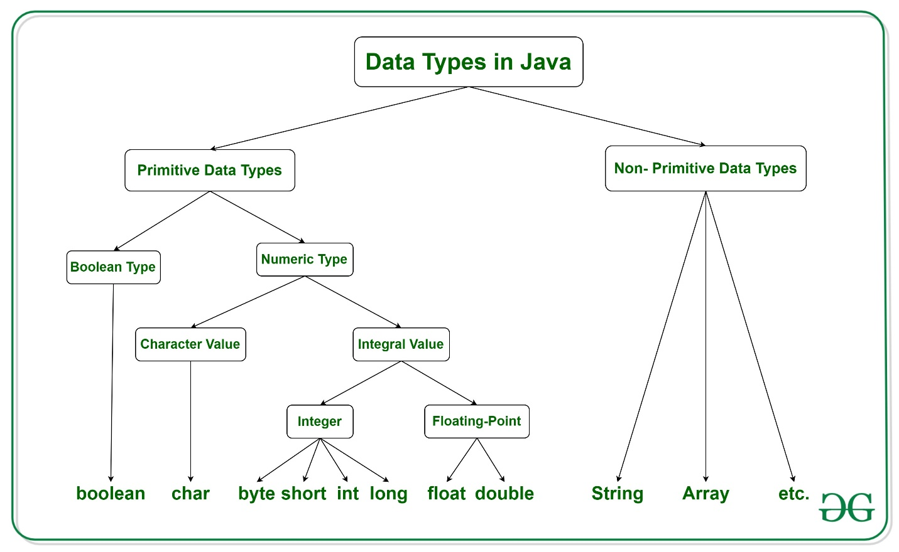

Java has two categories of data:

* **Primitive Data Type:** such as Boolean, char, int, short, byte, long, float and double
* **Non-Primitive Data Type or Object Data type:** such as String, Array, etc.

There are **8 primitive data types**:

1. Boolean
2. Byte
3. Short
4. Int
5. Long
6. Float
7. Double
8. Char

There are **Non-primitive data types**:

1. String
2. Class
3. Object
4. Interface
5. Array