**MySQL**

DBMS: -

* A collection of programs which enables users to access database, manipulate data, and represent data.

Various Types of DBMS: -

* Relational DBMS

What is MySQL?

* A RDBMS which
  + Open Source software
  + Provides multi-user access
  + Supports-multi storage engines
  + Works on many platforms

Features of MySQL: -

* High Performance
* Ease of Management
* Secure Data Protection
* Low Total Cost of Ownership
* Robust Transactional Support
* High Availability
* Open Source & 24*7 Support
* Comprehensive Application Development
* Scalability & Flexibility

SQL Command Categories: -

* DDL (Data Definition Language): -
  + Consists of commands that can be used to define the database schema.
  + Example: - Create, Drop, Alter, Truncate, Rename.
* DML (Data Manipulation Language): -
  + Commands that deals with the manipulation of data present in database.
  + Example: - Select, insert, update, delete.
* DCL (Data Control Language): -
  + Commands which mainly deals with the rights, permissions and other controls of the database system.
  + Example: - Grant, Invoke
* TCL (Transaction Control Language): -
  + Include commands which mainly deal with the transaction of database.
  + Example: - Commit, Rollback, Savepoint, Settransaction.

Data Modelling: - Means how to design database.

Two ways of Data Modelling are: -

* Either Normalize the whole database.
* Or use Entity-Relation Diagram.

ER Diagram: -

* Diagram in which we represent real world object as entity and then we understand the relationship between them.
* How one entity is dependent on other entity?
* What attributes do they have?
* We can get the answers of all these questions with the help of ER Diagram.

For Example: -

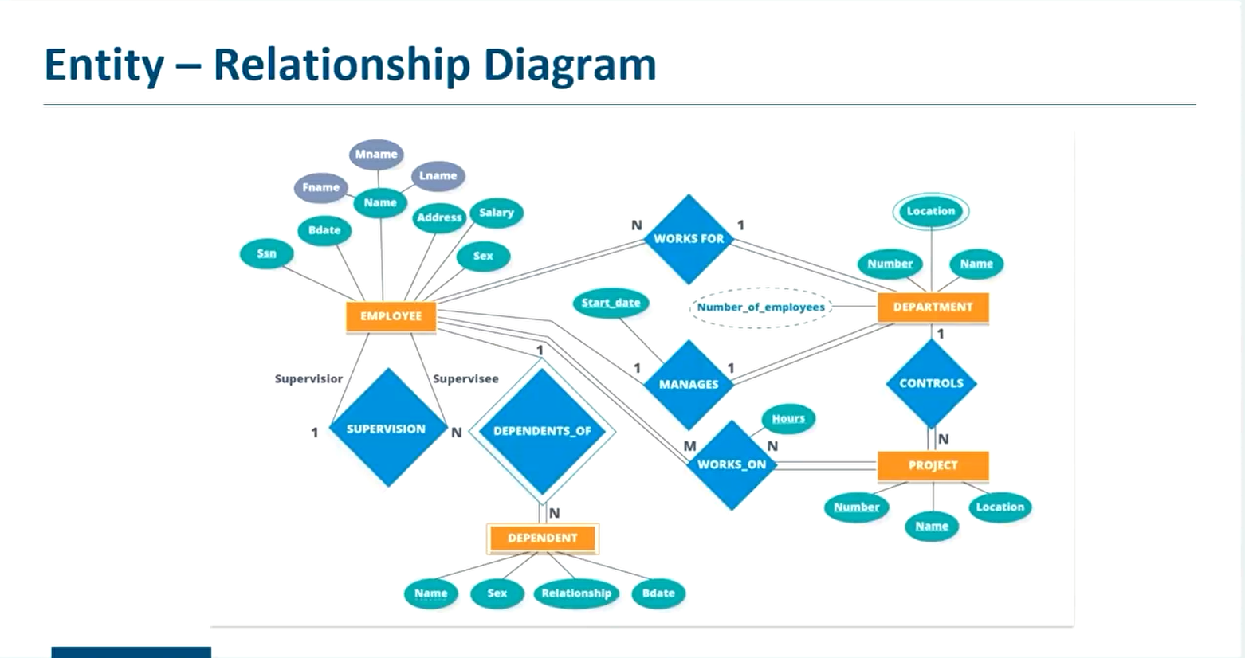

* This is the Company’s ER Diagram in which Employee, Department and Project are the Strong Entities.
* Whole ER Diagram will be based on these entities.

Employee Entity: -

* Attributes: -
  + SSN, Bdate, name( fname, mname, lname), address, salary, sex.

Department Entity: -

* Attributes: -
  + Number, Location, name

Project Entity: -

* Attributes: -
  + Number, name, location

Relationship: -

* Works For (Many to One Relationship from Employee to Department)
  + Many Employee works for One Department
* Manages ( One to One Relationship from Employee to Department)
  + Only One Employee manages Only One Department
* Works On ( Many to Many Relationship from Employee to Project )
  + Many Employee works on a project & one Employee can works on many project.
* Supervision ( One to Many Relationship from Employee to Employee)
  + One Employee supervision on Many Employees.
* Dependents of [week Relation] (insurance) ( One to Many Relation from Employee to Dependent Entity)
  + One Employee can have many dependents.
* And so on.

Cardinality Ratio: -

Participation: -

Attributes: -

Types of Attributes: -

* Composite vs Simple
* Single vs Multivalued
* Stored vs Derived
* Complex Attributes

Different Keys: -

* Candidate Key
* Super Key
* Primary Key
* Alternate Key
* Foreign Key

Normalization: -

* A technique that organizes tables in such a way that redundancy and dependency of data is reduced.