Java is:-

* High Level
* Object-oriented
* Secure
* Java was developed by *Sun Microsystems* (which is now the subsidiary of Oracle) in the year 1995. *James Gosling* is known as the father of Java.

**Applications**:-

Approximately 3 billion devices run java. There are many devices where java is currently used. Some of them are:-

* Desktop Applications such as acrobat reader, media player, antivirus, etc.
* Web Applications such as irctc.co.in, javatpoint.com, etc.
* Enterprise Applications such as banking applications.
* Mobile Applications
* Games etc.

**Features of Java:-**

* Simple
* Object-Oriented
* Portable
* Platform independent
* Secured
* Robust
* Architecture neutral
* Interpreted
* High Performance
* Multithreaded
* Distributed
* Dynamic

**Difference between C++ and Java:-**

**Compilation Flow:-**

**At compile time**

* At compile time, java file is compiled by java compiler (it does not interact with OS) and converts the java code into bytecode.

**At runtime**

* **Classloader:** is the subsystem of JVM that is used to load class files.
* **Bytecode Verifier:** checks the code fragments for illegal code that can violate access right to objects.
* **Interpreter:** read bytecode stream then execute the instructions.

**What is JVM, JRE, JDK and difference between them.**

**Types of Variables:-**

* Local Variables
* Instance Variables
* Static Variables

**Data Types in Java**:-

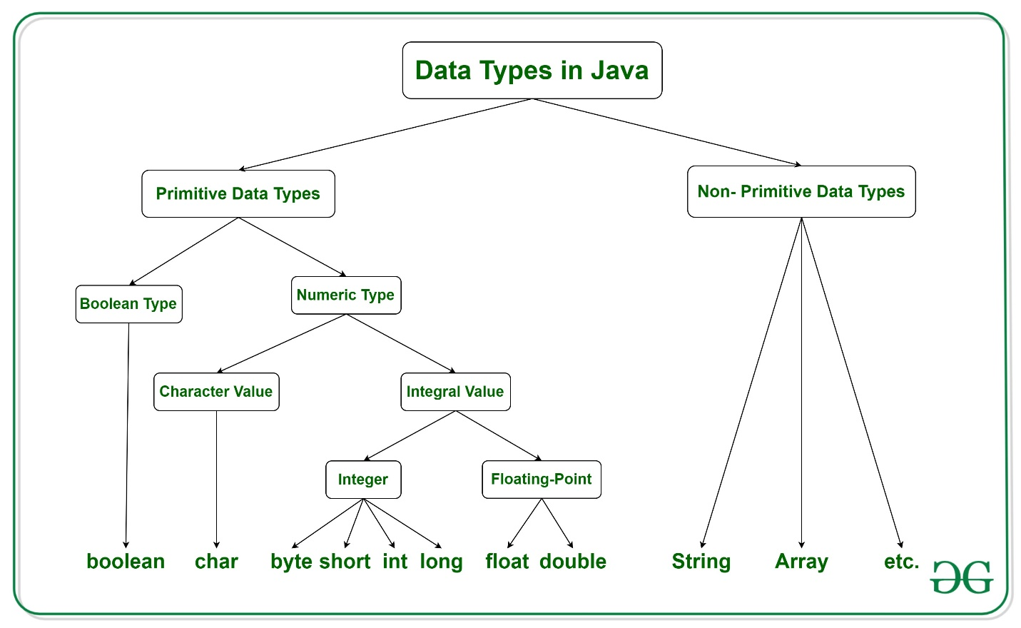

Java has two categories of data:

* **Primitive Data Type:** such as Boolean, char, int, short, byte, long, float and double
* **Non-Primitive Data Type or Object Data type:** such as String, Array, etc.

There are **8 primitive data types**:

1. Boolean
2. Byte
3. Short
4. Int
5. Long
6. Float
7. Double
8. Char

There are **Non-primitive data types**:

1. String
2. Class
3. Object
4. Interface
5. Array

**Operators:-**

* Unary Operator, (++, --, !, ~)
* Arithmetic Operator,
* Shift Operator,
* Relational Operator,
* Bitwise Operator,
* Logical Operator,
* Ternary Operator and
* Assignment Operator