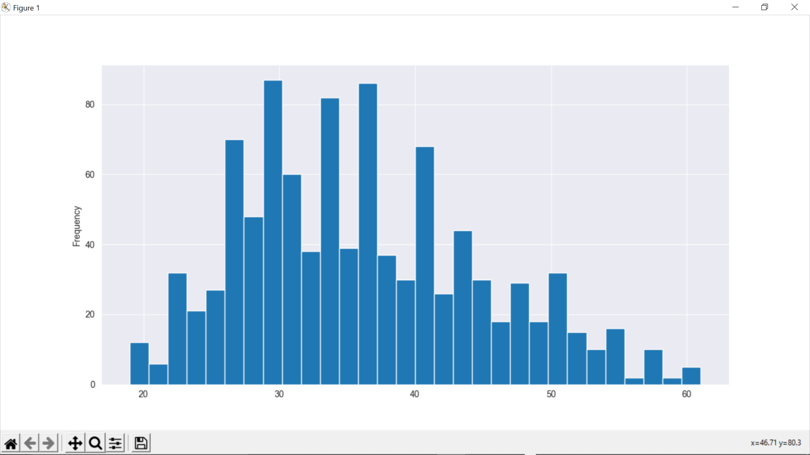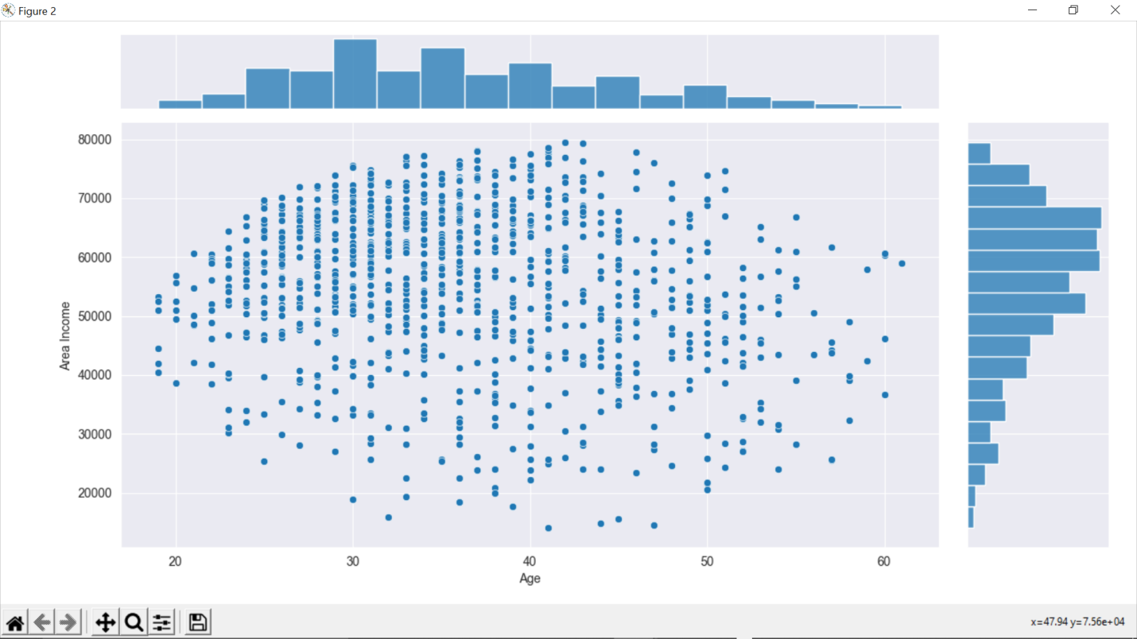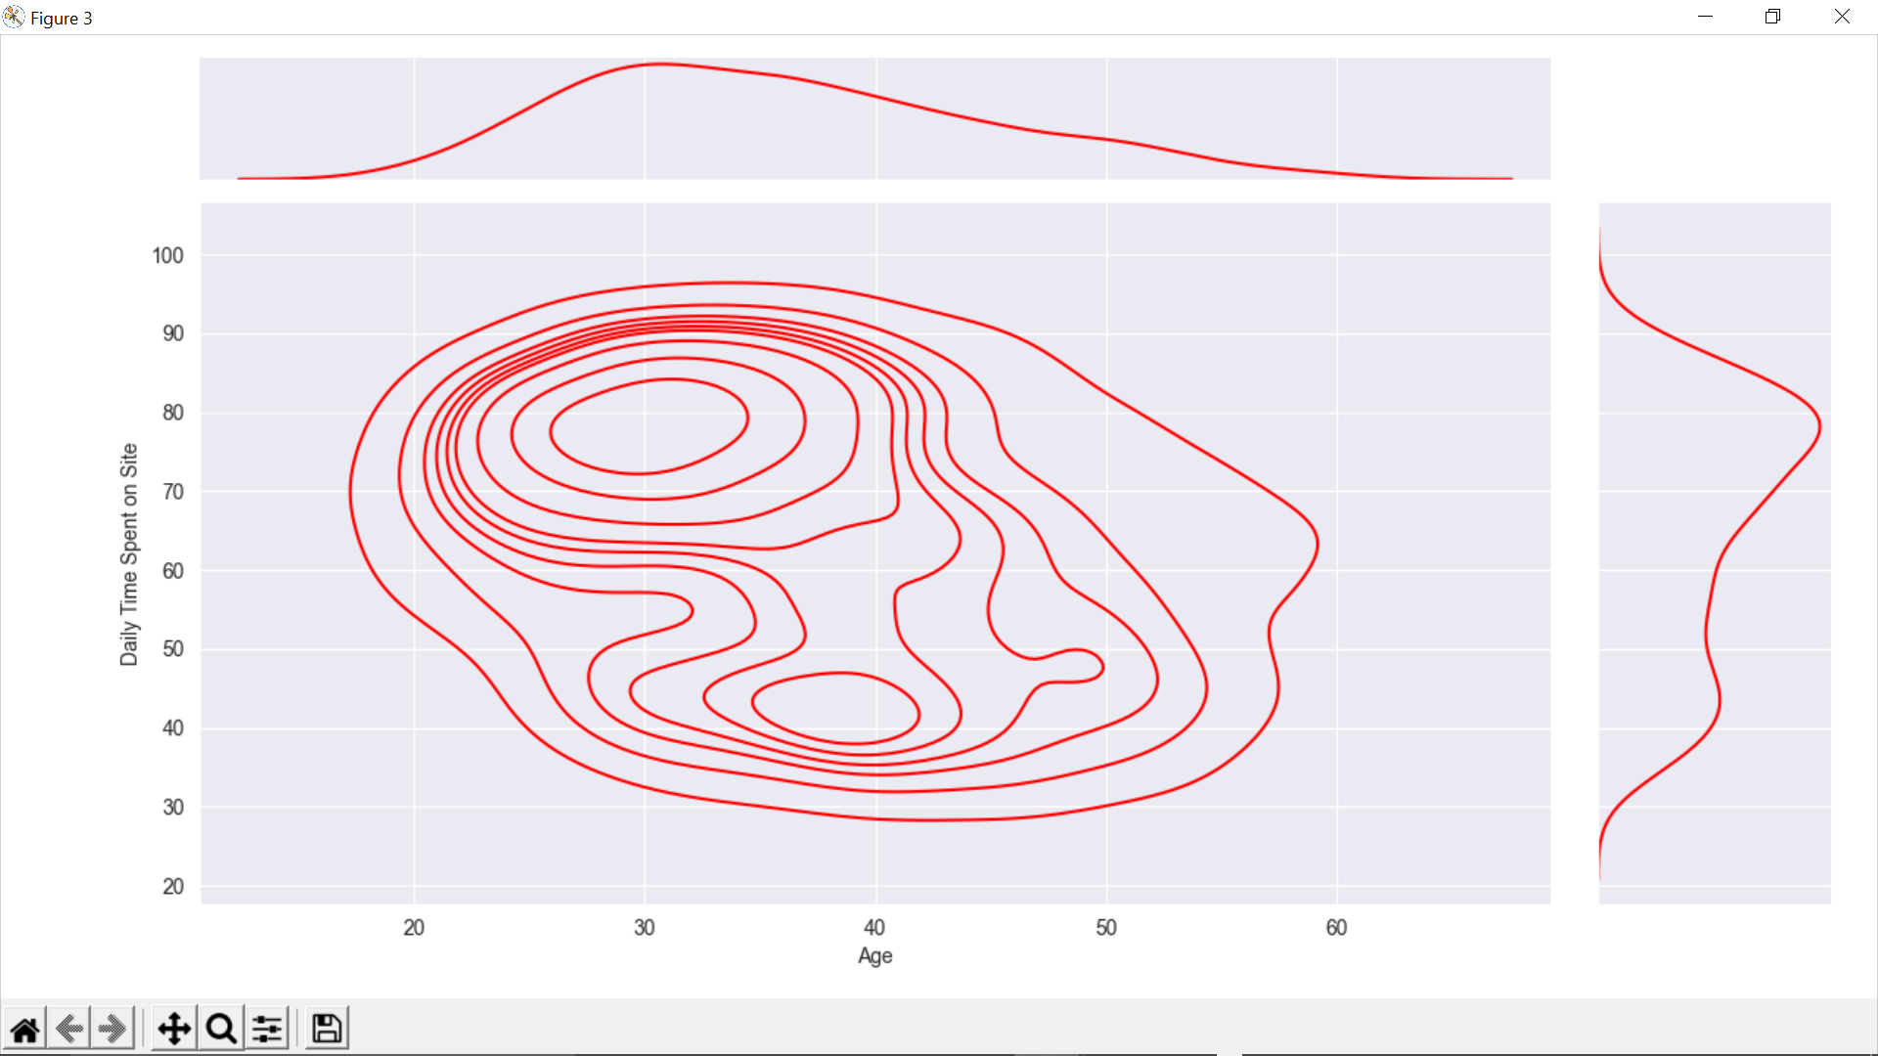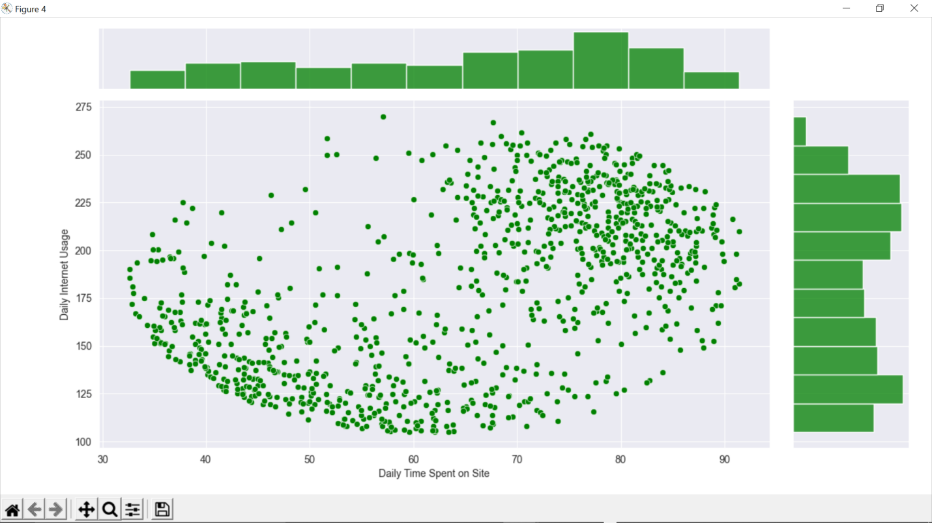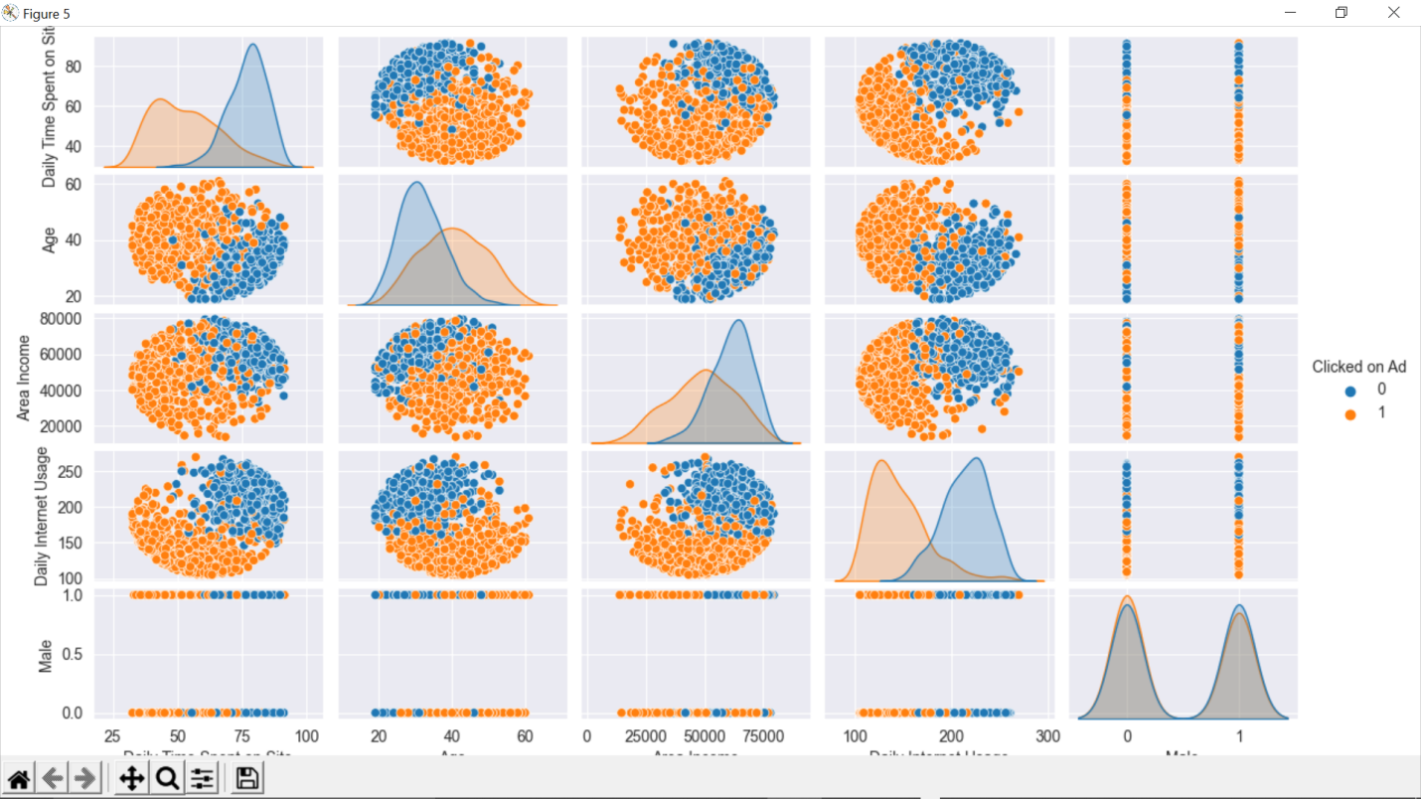

OUTPUT:-

this is the classification report:-

precision recall f1-score support

0 0.91 0.95 0.93 157

1 0.94 0.90 0.92 143

accuracy 0.93 300

macro avg 0.93 0.93 0.93 300

weighted avg 0.93 0.93 0.93 300

this is the confusion matrix:-

[[149 8]

[ 14 129]]