Data analysis

Steps
- Import the dump file in SQL workbench.
- Check all the tables in the dump file.

- There are some useless and messy data in the tables perform data cleaning to remove them.
- In Transactions table “currency ” column has 2 types of currency convert it accordingly into INR.

- There are total 150283 Sales transaction table.
- There are total of 38 customer.
- There are total of 279 products.

-TRANSACTION TABLE:-
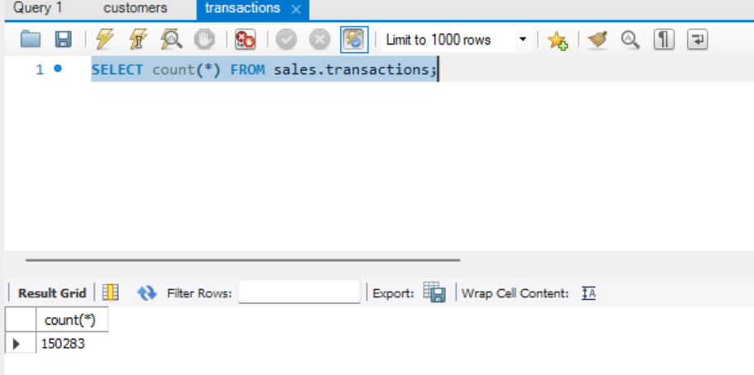

- Get the total transactions performed in Chennai.
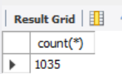
( To get the dump of this data export the table SQL file into CSV)

- Get all the records of ”Mark001” that have “USD”currency
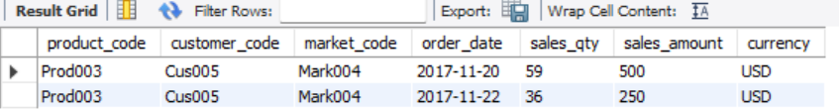
There are only 2 sales in Chennai with USD currency.

- Perform INNER JOIN to Show Transactions in 2020 JOIN BY date table.

CODE FOR INNER JOIN:-
SELECT sales.transactions.*, sales.date.* FROM sales.transactions INNER JOIN sales.date ON sales.transactions.order_date=sales.date.date
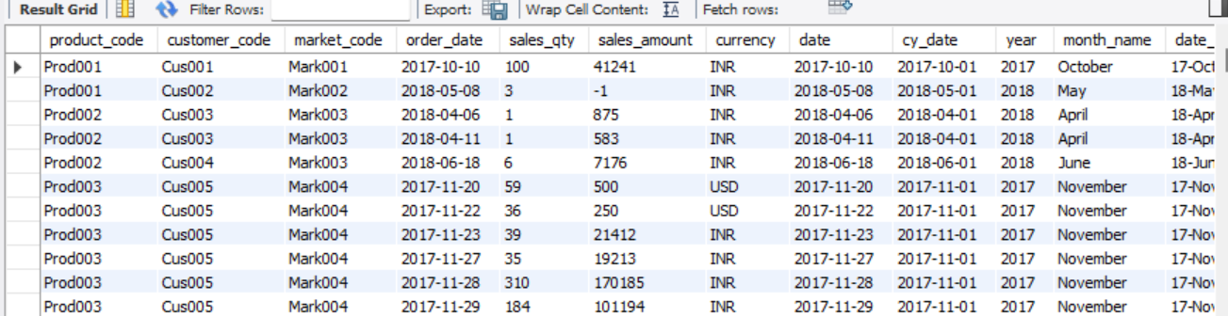

- Get the total revenue in year 2020.
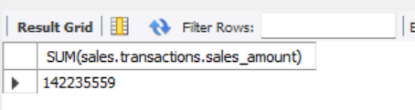
- Revenue in year 2019.
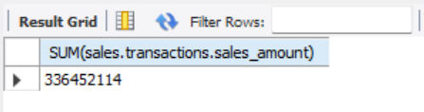
NOTE:- sales have declined in year 2020.

CODE:-
SELECT SUM(sales.transactions.sales_amount) FROM sales.transactions
INNER JOIN sales.date ON sales.transactions.order_date=sales.date.date
WHERE sales.date.year=2020;

- Get the total revenue in Chennai in year 2020 .
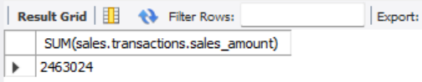

- Get the count of distinct products sold in Chennai
