

**MCP 401**

**GROUP - 4B**

**FOOTSTEP POWER GENERATION**

**ROHAN (2022ME11323)**

**SHUBHAM KURRE (2022ME11325)**

**KUNAL (2022ME11319)**

**TABLE OF CONTENTS**

1. **Introduction**
2. **Need and Importance**
3. **Main Concepts Explained**  
   3.1 Piezoelectric Effect  
   3.2 Footstep Energy
4. **Flow Diagram of the System**
5. **Footstep Platform**  
   5.1 Components of Platform  
   5.2 Diagram of Platform
6. **Electrical Circuit**
7. **Arduino Code(with explanation)**
8. **Design Calculations**  
   7.1 Force Calculations  
   7.2 Platform Dimensions  
   7.3 Material Selection (Plywood)  
   7.4 PZT Disc Calculations
9. **Manufacturing Details**
10. **Final Measurable and Outcome**
11. **Bill of Materials**
12. **References**

**NTRODUCTION**

Footstep power generation is an innovative method of harvesting energy from human motion, specifically by capturing the mechanical pressure exerted while walking and converting it into usable electrical energy. In this project, piezoelectric discs are embedded within a specially designed platform that deforms slightly under each step. The pressure on the discs generates an electrical charge due to the piezoelectric effect, which is then collected and passed through an electrical circuit for storage. This stored energy can be used to power a small device, such as an LED lamp, demonstrating a sustainable and eco-friendly approach to energy generation that makes use of otherwise wasted mechanical energy.

To make the system more interactive and informative, the platform is integrated with an Arduino microcontroller. The Arduino is programmed to measure the voltage generated by the piezoelectric discs and count the number of footsteps applied to the platform. These readings are then displayed on an electronic display, allowing users to see both the instantaneous voltage produced and the cumulative step count. This combination of energy harvesting, storage, and real-time monitoring highlights the practical applications of piezoelectric technology in low-power electronics.

**NEED/IMPORTANCE**

Footstep power generation harnesses the mechanical energy produced by human motion—normally lost as heat or vibration—and converts it into usable electricity via piezoelectric or kinetic systems. This approach promotes sustainable energy practices, particularly in high-traffic environments where even small per-step outputs accumulate meaningfully. For instance, a 2024 study demonstrated that a single piezoelectric floor tile costing around $10.2 could generate up to 249.6 milliwatts, enough to light a couple of LEDs

Globally, footstep power systems have been put on trial in diverse settings, reflecting both their adaptability and innovative potential. In Tokyo’s Shibuya station, piezoelectric mats power holiday light displays and LED boards, drawing on the immense footfall in the area. In Rio de Janeiro’s Morro da Mineira favela, Pavegen tiles under a football pitch help floodlight the field with energy generated by players’ footsteps—up to 7 W per step—demonstrating community-driven power generation. Studies in Pakistan similarly explore piezoelectric transducers beneath urban crosswalks and universities to power LEDs or mobile charging stations, aiming to address energy shortages through localized, footstep-derived electricity.

**MAIN CONCEPTS EXPLAINED**

* **Piezoelectric Effect -** The piezoelectric effect is a property of certain crystalline materials (like Lead Zirconate Titanate – PZT, quartz, PVDF) that allows them to generate an electric charge when mechanical stressis applied.This is because the atomic lattice of these materials has a non-centrosymmetric structure – when deformed, the positive and negative charge centres shift relative to each other, creating a voltage across the material.  
  Key point: Mechanical → Electrical energy conversion is direct, no moving electromagnetic parts like in dynamos.
* **Footstep Energy -**When a person walks, each step transfers kinetic + potential energy to the ground.  
  This energy is usually dissipated as heat and sound, but we can harvest part of it.  
  A normal step from a 70 kg person can exert ~900N force momentarily. If this force causes even a small deformation (1–2 mm), it represents ~1–2 J of mechanical energy per step.

**FLOW DIAGRAM OF THE SYSTEM**

Footstep Applied  
↓  
Mechanical Pressure on Platform  
↓  
Piezoelectric Discs  
↓  
Generation of AC Voltage  
↓  
Rectifier Circuit (AC to DC)  
↓  
Voltage Regulation  
↓  
Energy Storage (Battery)  
↓  
Arduino for Data Acquisition  
(Voltage, Current, Step Count)  
↓  
Display Module (LCD/OLED)  
↓  
Powering Load (LEDs, Small Devices)

**FOOTSTEP PLATFORM**

Our first major component is the footstep platform. This is the base on which we will set foot. The platform consists of the following major components-

* **Plywood platform –** This is the upper platform on which the person will step foot. Dimensions will be 330 mm x 330 mm x 12 mm.
* **EVA Foam –** There will be two layers of EVA (Ethylene-Vinyl Acetate) foam sheets, one above and one below the piezoelectric discs, for padding purposes. They will protect the piezoelectric discs from breaking when footstep is placed on the platform. Dimensions will be 330 mm x 330 mm x 5 mm for each EVA sheet.
* **Piezoelectric Discs –** These are the voltage generating units of our system. There will be 10 discs arranged beneath the platform connected to the electric circuit, arranged in two rows (5 x 2). Dimensions will be radius of 13.5 mm and thickness of 1mm.
* **Base Plywood Plate-** A plywood base will be placed at the bottom for supporting the entire structure. Dimensions 330 mm x 330 mm x 12 mm.
* **Boundary Wall –** A boundary wall made of plywood bounding the entire assembly. This is to ensure that the platform doesn’t shear under load.The dimensions of the boundary wall include a cutout square of 330 mm x 330 mm from a 380 mm x 380 mm square base and height of 35 mm.

**DIAGRAM OF PLATFORM**

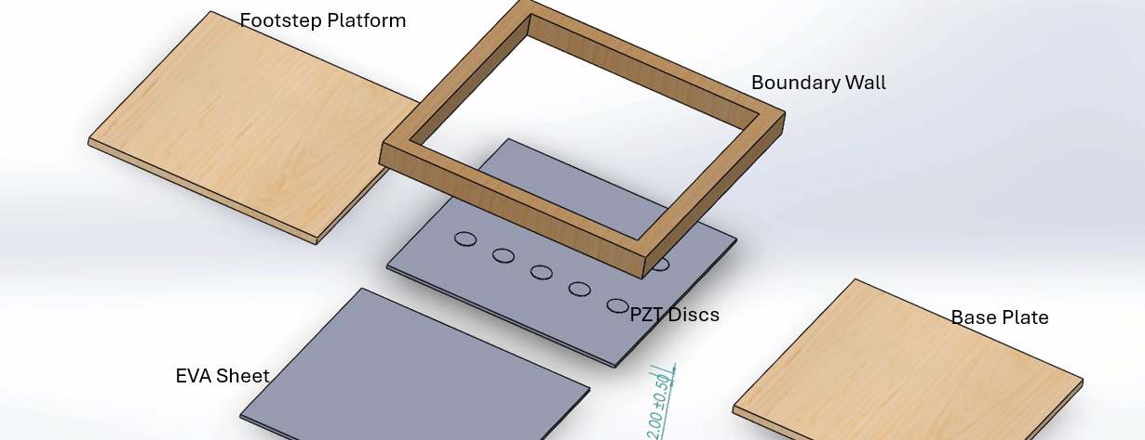

**ELECTRICAL CIRCUIT**

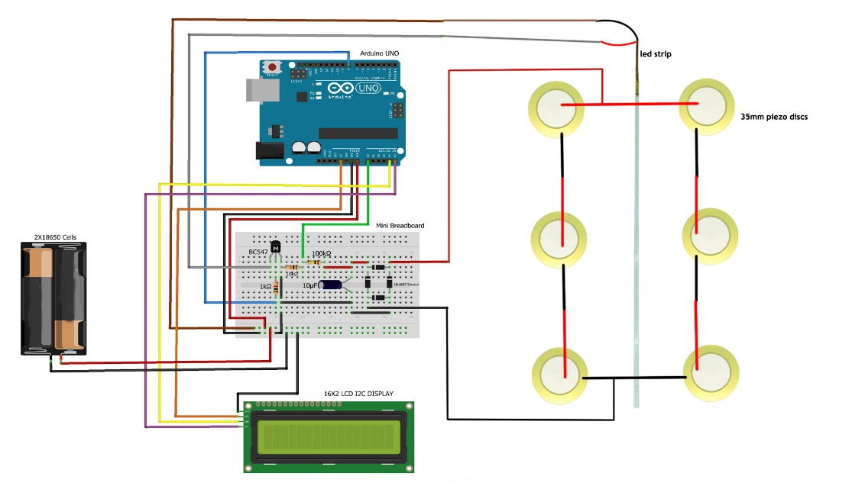

## **USES OF EACH COMPONENT**

* **LED Strip**
  + Acts as a **visual output device**.
  + Provides instant indication when a step is detected.
* **Arduino Uno (Microcontroller)**
  + Receives signals from the piezoelectric sensor.
  + Processes the data to count steps and calculate voltage.
  + Controls other components such as the LED and LCD.
* **Diodes (in Rectifier)**
  + Convert **AC output of piezo** into **DC**.
  + Ensure unidirectional current flow, preventing reverse current.
* **Capacitor**
  + Stores electrical energy temporarily.
  + Smooths out **rectified DC**, reducing noise and fluctuations.
* **Resistors**
  + Limit current flow in the circuit, protecting sensitive components.
  + Protect LEDs, transistor base, and other sensitive parts.
  + Used in **voltage divider circuits** to scale down voltage safely for Arduino inputs.
* **Transistor**
  + Works as an **electronic switch**.
  + Allows Arduino to control larger current loads that it cannot handle directly.
  + Also helps in current amplification when required.

## **CONSEQUENCES IF COMPONENTS ARE MISSING**

* **Diodes:**
  + Arduino would receive **AC signals**, which it cannot interpret properly.
  + May damage input circuits.
* **Capacitor:**
  + Rectified voltage will remain **pulsating and noisy**, leading to unstable readings.
* **Resistors:**
  + Without voltage dividers, Arduino pins may receive **higher than 5V**, causing permanent damage.
  + Without current-limiting resistors, LEDs and transistor base may burn out.
* **Transistor:**
  + Arduino pins alone can supply only **20 mA safely** (40 mA absolute max).
  + Without transistor switching, Arduino cannot control **high-current loads** safely.
  + Risk of damaging the microcontroller if higher current is drawn directly.

**ARDUINO CODE**

**#include <Wire.h> // Include Wire library for I2C communication**

**#include <LiquidCrystal_I2C.h> // Include LCD library for I2C LCD display**

**// -------------------- Variables --------------------**

**int prev = 0, stepCount = 0; // 'prev' stores previous sensor value, 'stepCount' counts steps**

**unsigned long previousMillis = 0; // Stores last time LED was turned OFF**

**const long interval = 1000; // Interval for LED blinking (not fully used here)**

**unsigned long currentMillis; // Current time in milliseconds**

**float v, vout, vin; // Variables for voltage calculations**

**// Initialize the LCD (address = 0x27, 16x2 LCD)**

**LiquidCrystal_I2C lcd(0x27, 16, 2);**

**void setup() {**

**Serial.begin(9600); // Start serial monitor at 9600 baud rate**

**pinMode(8, OUTPUT); // Pin 8 used as LED indicator**

**lcd.init(); // Initialize LCD**

**lcd.backlight(); // Turn on LCD backlight**

**// Startup display message**

**lcd.print("FOOT STEP POWER");**

**lcd.setCursor(0, 1);**

**lcd.print(" GENERATOR");**

**delay(2000); // Show for 2 seconds**

**lcd.clear();**

**// Display initial labels**

**lcd.setCursor(0, 0);**

**lcd.print("STEP COUNT:");**

**lcd.setCursor(0, 1);**

**lcd.print("VOLTAGE:");**

**}**

**void loop() {**

**v = analogRead(A0); // Read analog input from pin A0 (footstep sensor/voltage)**

**currentMillis = millis(); // Get current system time**

**// Step detection logic**

**if (v != 0 && (prev == 0)) { // If current value is non-zero and previous was zero**

**stepCount += 1; // Increment step counter**

**digitalWrite(8, HIGH); // Turn LED ON as indicator**

**lcd.setCursor(12, 0); // Move cursor to position on LCD**

**lcd.print(stepCount); // Print updated step count**

**} else {**

**// If enough time has passed, turn LED OFF**

**if (currentMillis - previousMillis >= 100) {**

**previousMillis = currentMillis;**

**digitalWrite(8, LOW); // Turn LED OFF**

**}**

**}**

**prev = v; // Update previous sensor value**

**// Voltage calculation**

**lcd.setCursor(9, 1); // Move cursor to print voltage**

**vout = (v * 5.00) / 1024.00; // Convert ADC value (0-1023) to actual voltage (0-5V)**

**vin = (vout / 0.040909) * 100; // Custom scaling factor to convert to mV**

**lcd.print(vin); // Display calculated voltage**

**lcd.print("mV "); // Print unit**

**delay(200); // Small delay for stability**

**}**

**DESIGN CALCULATIONS**

**Force calculations:**

* Average mass of adult male: m = 68 kg
* Force exerted by a person standing still: F = m x g = 667.08 N
* During walking, the force can be 1.5 to 2 times the body weight. We will hence consider a factor of 1.5 for design safety : Fdesign = 1.5 x 667 N = 1001 N

**Platform dimensions:**

* A common man’s foot size is approximately 25 cm long.
* Hence, we take the platform dimensions to be 33 cm x 33 cm x 3.5 cm.

**Material Selection (Plywood):**

* Uniform pressure over the platform: q = F/A = 9192 Pa
* Side length of the Plate: a = 0.33 m
* Plate thickness: t = 0.035 m
* Modulus of elasticity of plywood: E = 7.5 Gpa
* Poisson’s Ratio for plywood: v = 0.3
* Flexural Rigidity: D=(E * t^3) / (12 * (1 - ν^2)) =29447 Pa
* Maximum bending stress: σ_max = (6 * q * a^2) / (t^2 * D) = 166.49 Pa
* Maximum deflection: w_max = (q * a^4) / (64 * D) = 0.058 mm
* Maximum bending stress is within limits and deflection is also very small.

**PZT Disc Calculations:**

* Radius (a) = 13.5 mm
* Pressure: q = F/A = 174830 Pa
* Young’s Modulus: E = 60 Gpa
* Flexural Strength: D = 80 Mpa
* Poisson’s Ratio: v = 0.3
* Thickness (t) = 1 mm
* Maximum bending stress: σ = (3*q*a²*(3+ν))/(8*t²) = 39 Mpa
* Deflection: ((5+v)*q*a⁴)/((1+v)*64*D) = 0.0125 microns
* Maximum bending stress is within limits and deflection is also very small.

**MANUFACTURING DETAILS**

The footstep power generation system will be fabricated using two plywood plates of 330 × 330 × 12 mm as the base and top platform, with surface finishing. A boundary frame of inner size 330 × 330 × 35 mm will be cut and joined at the corners. Two EVA foam layers of 330 × 330 × 5 mm will be placed between the plywood plates. 10 piezoelectric discs of 16.5 mm diameter will be sandwiched between the foam layers. The final assembly will follow the sequence: base plate → EVA foam → PZT discs → EVA foam → top plate → boundary frame, with adhesive and screws ensuring rigidity, and a small hole provided on one side of the frame for taking out the wires connected to the external circuit.

**FINAL MEASURABLE AND OUTCOME**

* At the end of the design fabrication, we will be measuring the voltage generated by each footstep in our system.
* The voltage generated will be shown by the display attached to our system along with the number of steps.
* The voltage generated will be taken as input and displayed on the display screen as output through an Arduino code attached with our circuit using an Arduino UNO device.

The voltage calculations are as follows:

* Piezoelectric voltage coefficient: g = 30 mV.m/N
* Thickness: t = 1 mm
* Stress applied: σ = 174830 Pa
* Hence, voltage generated by each footstep: V =σ * g * t = 5.25 V
* Hence, to conclude, we aim to generate somewhere around 3-5 V with each footstep.

**BILL OF MATERIALS**

|  |  |  |  |  |  |
| --- | --- | --- | --- | --- | --- |
| Item No. | Component | Qty | Material | Dimensions | Est. Cost (₹) |
| 1 | Plywood sheet | 1 | Hardwood plywood | 550×550×12 mm | 200 |
| 2 | EVA sheet | 5 | EVA foam | A4 | 300 |
| 3 | PZT discs | 10 | PZT ceramic | 27 mm (dia) | 400 |
| 4 | UNO R3 | 1 | – | – | 350 |
| 5 | Bridge rectifier | 1 | Diodes (1N4007) | – | 20 |
| 6 | Capacitor | 1 | Electrolytic | 10 µF, 25 V | 10 |
| 7 | Resistors | – | – | – | 15 |
| 8 | Bc547 | 1 | Transistor | – | 10 |
| 9 | LED | – | LED | 1W | 20 |
| 10 | Wires | – | – | – | 50 |
| 11 | 18650 Battery | 1 | Li-Ion | 3.7V 2200mAh | 320 |
| 12 | LCD Display with I2C module | 1 | LCD | 16x2 | 250 |

**REFERENCES**

• Lee, S., Kim, J., & Park, H. (2024). Piezoelectric sensors pressed by human footsteps for energy harvesting. Energies, 17(10), 2297. https://doi.org/10.3390/en17102297

• Yousaf, M., Zafar, A., & Raza, H. (2020). Footstep power generation using piezoelectric sensor. In Proceedings of the International Conference on Information and Decision Sciences for Sustainable Development (ICIDSSD 2020) (pp. 1–6). EAI. https://doi.org/10.4108/eai.27-2-2020.2303209

• Shaikh, M. S., & Bhatti, A. A. (2025). Footsteps power generation using piezoelectric energy harvester. Spectrum of Engineering Sciences, 2(1), 54–60. [https://sesjournal.com/index.php/1/article/view/623](https://sesjournal.com/index.php/1/article/view/623?utm_source=chatgpt.com)

• Rani, N., & Kumar, S. (2019). Review on footstep power generation system. Journal of Recent Trends in Electrical Power Systems, 9(1), 45–52. [https://hbrppublication.com/OJS/index.php/JRTEPS/article/view/658](https://hbrppublication.com/OJS/index.php/JRTEPS/article/view/658?utm_source=chatgpt.com)

• Wired. (2006, August 14). Power from the people: Tokyo subway tests piezoelectric flooring. WIRED. [https://www.wired.com/2006/08/power-from-the-people](https://www.wired.com/2006/08/power-from-the-people?utm_source=chatgpt.com)

• Pavegen. (2014). Pavegen kinetic energy tiles. In Wikipedia. [https://en.wikipedia.org/wiki/Pavegen](https://en.wikipedia.org/wiki/Pavegen?utm_source=chatgpt.com)