* git –version -> to check version
* git config --global user.name "Shubham Lekule" -> to add your name to your git
* git config --global user.email "shubhamlekuleofficial@gmail.com" -> to add your mail id
* git config --global user.name -> to see your username
* git config --global user.email -> to see your mail
* git config --global –edit -> new way to add your name and mail, in this case editor will open you need to change in file
* pwd -> to check current directory in git bash
* cd /d(drive name)/GIT eg /d/GIT -> to jump on directory
* mkdir dayOne -> to create new directory
* ls -> to check list of directory in current directory
* cd dayOne/
* ls -a -> to check list of directory with hidden directory
* git status -> to check status to currect git. Is it modified or new or commited n all
* git init-> to initialize git in current directory

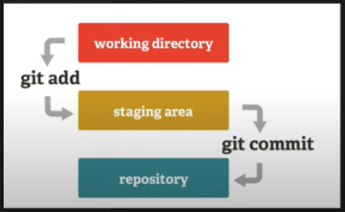

* git add pythonFile.py -> to add file in git, when we use add it only send data to staging area from stagging area we can add to repo. Eg if you modified 4 files in working dir you can add only 3 file in stagging area after that when you commit only that 3 file will commit which you add in stagging area.
* git commit -m(for adding message) "First Commit"-> to commit in repo
* git log-> to check all commits.
* git add . -> to add all file at once in staging area
* git checkout 5a001194e47ce000d816a7d63d097c8cdd37195a -> (to jump on commit)
* git checkout master
* git branch dev -> to create branch
* git branch -> to check list of branch
* git checkout -b shubham/multiply -> to create branch while checkout
* git merge dev-> if we ren this command from master branch then dev branch merge with master branch
* touch .gitignore-> to create .gitignore file(we create this file to hide sensitive data from git). If we add file name in this .gitignore file then git echosystem will not track this file, we can add .gitignore file name into .gitignore file.

GIT HUB

* Go to your profile->Overview->click on add button-> New Repository
* git remote add origin(This name changeable) <https://github.com/ShubhamLekule/LearnGit.git>
* git remote -v -> to see remote location
* git branch -M master
* git push -u origin master -> you have to give ur username and password
* git push -u origin dev -> to add dev branch also
* if we fork same copy created in our git repo
* git clone <https://github.com/ShubhamLekule/First-Contribution.git> -> to clone on local dir

