Installation Java on windows:

* Search java JDK downloads on google.
* Visit oracle downloads URL.
* <https://www.oracle.com/in/java/technologies/downloads/#jdk24-windows>
* Select Windows tab.

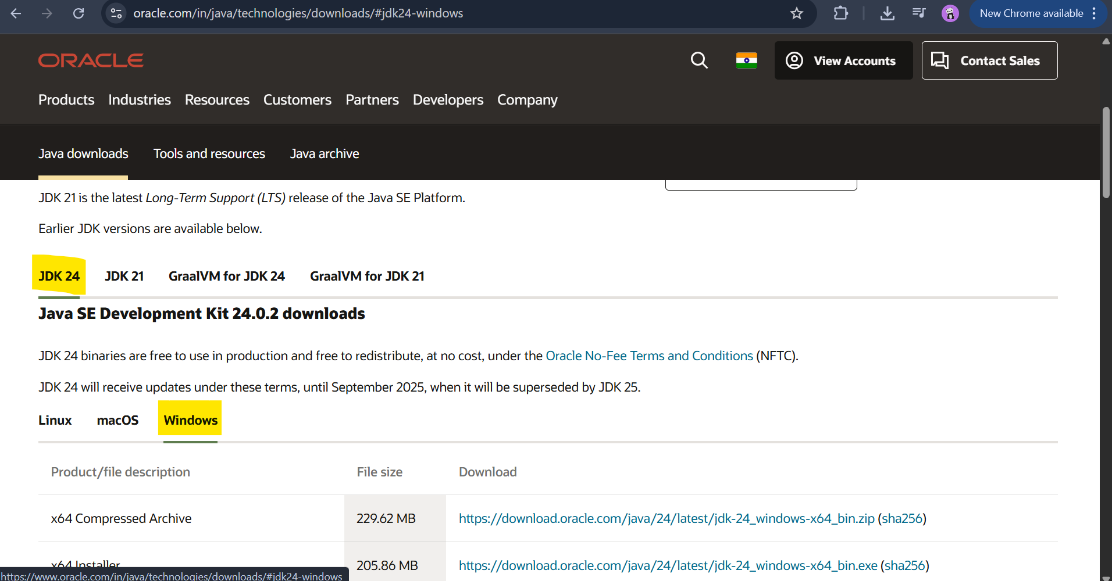

* As of today (25-08-25), JDK 24 is the latest version.
* Click on x64 Installer link.
* <https://download.oracle.com/java/24/latest/jdk-24_windows-x64_bin.exe>

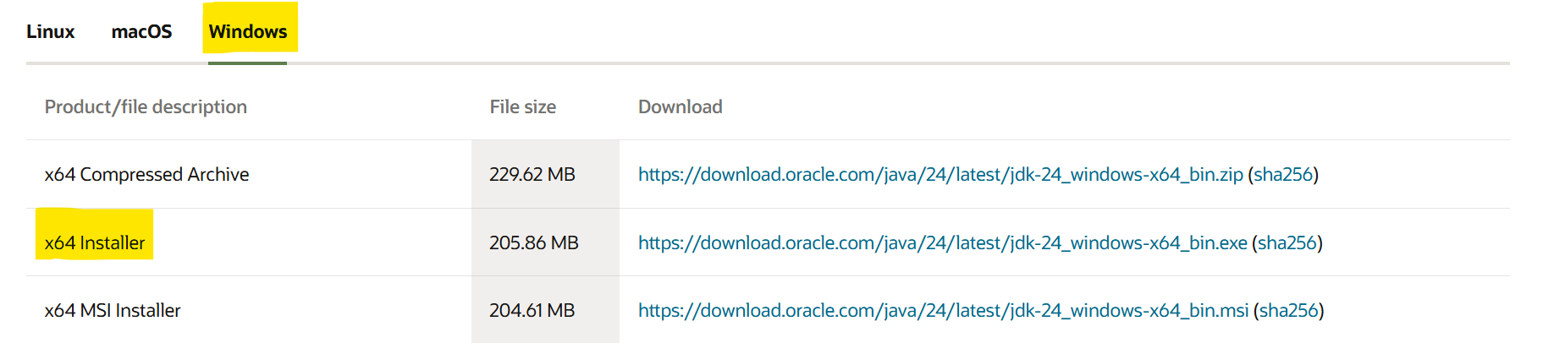

* It will download JDK’s executable(*.exe) file.
* Double click on *.exe.
* It will ask for Account control access to install JDK, click on yes.
* Click next.

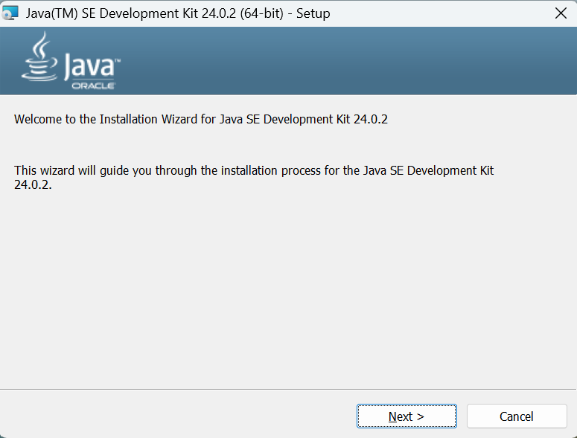

* Verify installation location and click on next.

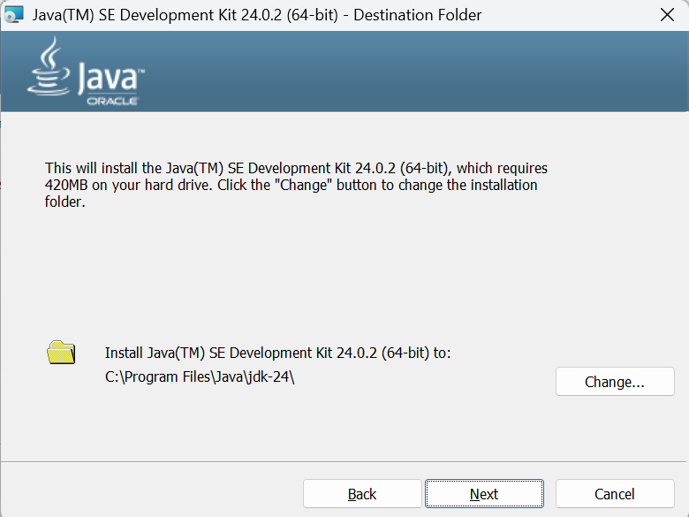

* It will start installation.

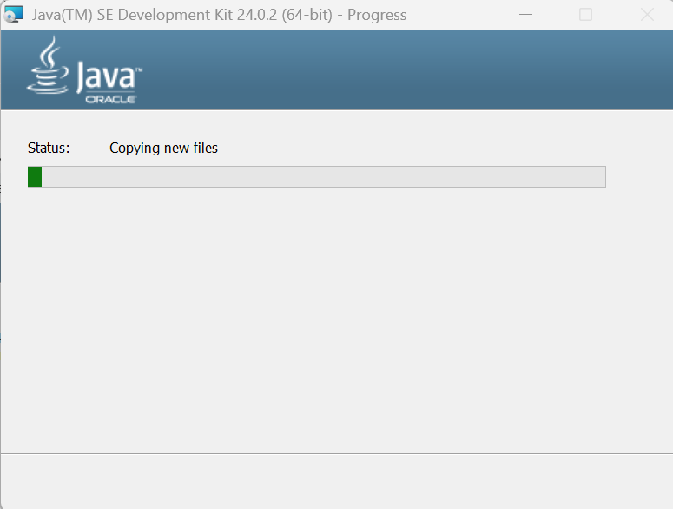

* Once installation done click on close.

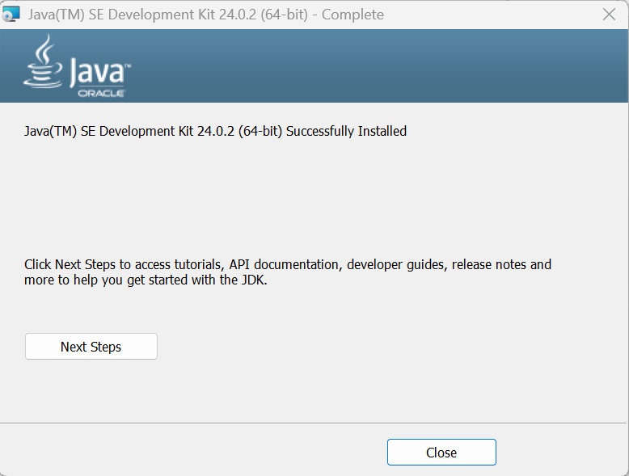

* Now we need to set environment variable for java. Search for Edit the system environment variables in control panel.

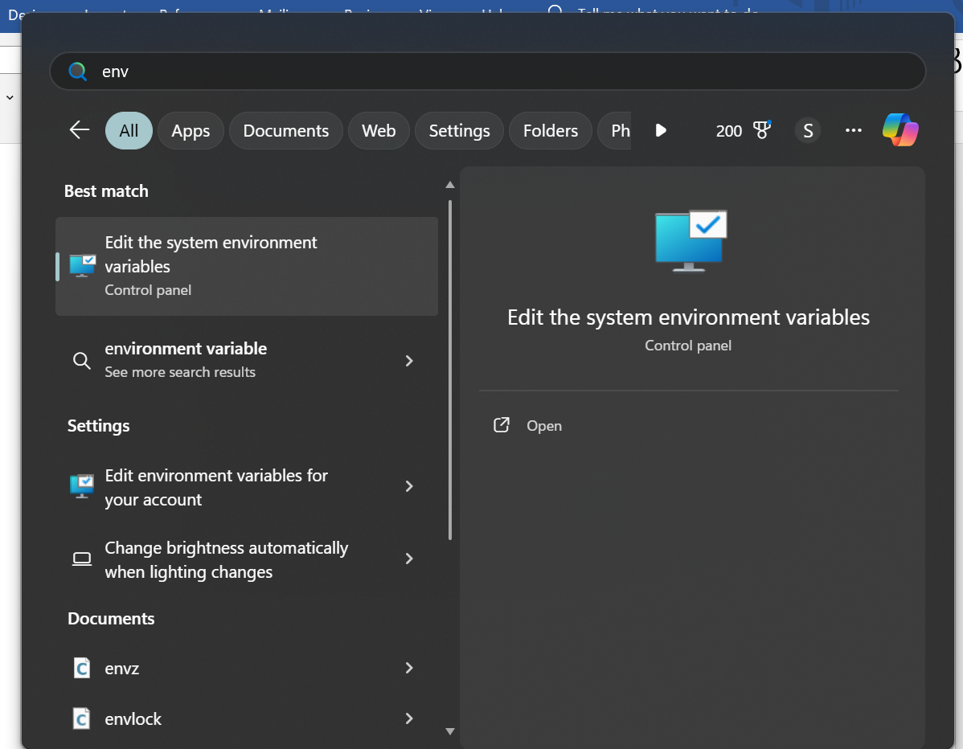

* Click on environment variables.

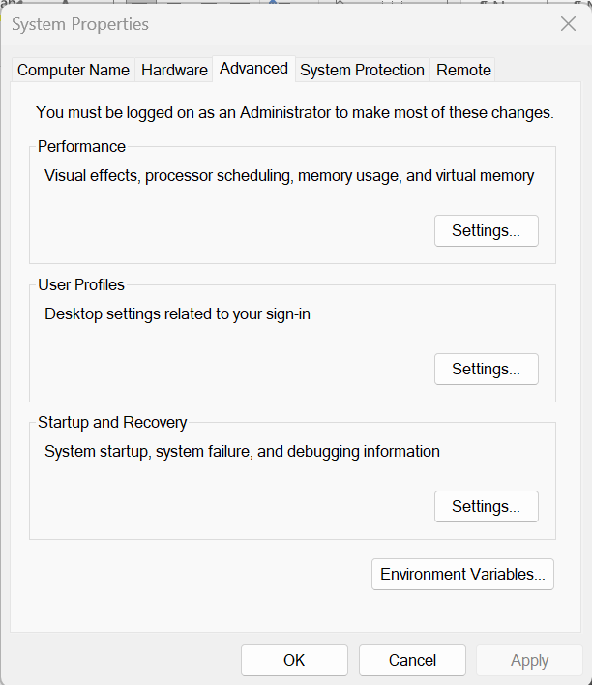

* In system variables add JAVA_HOME and JRE_HOME

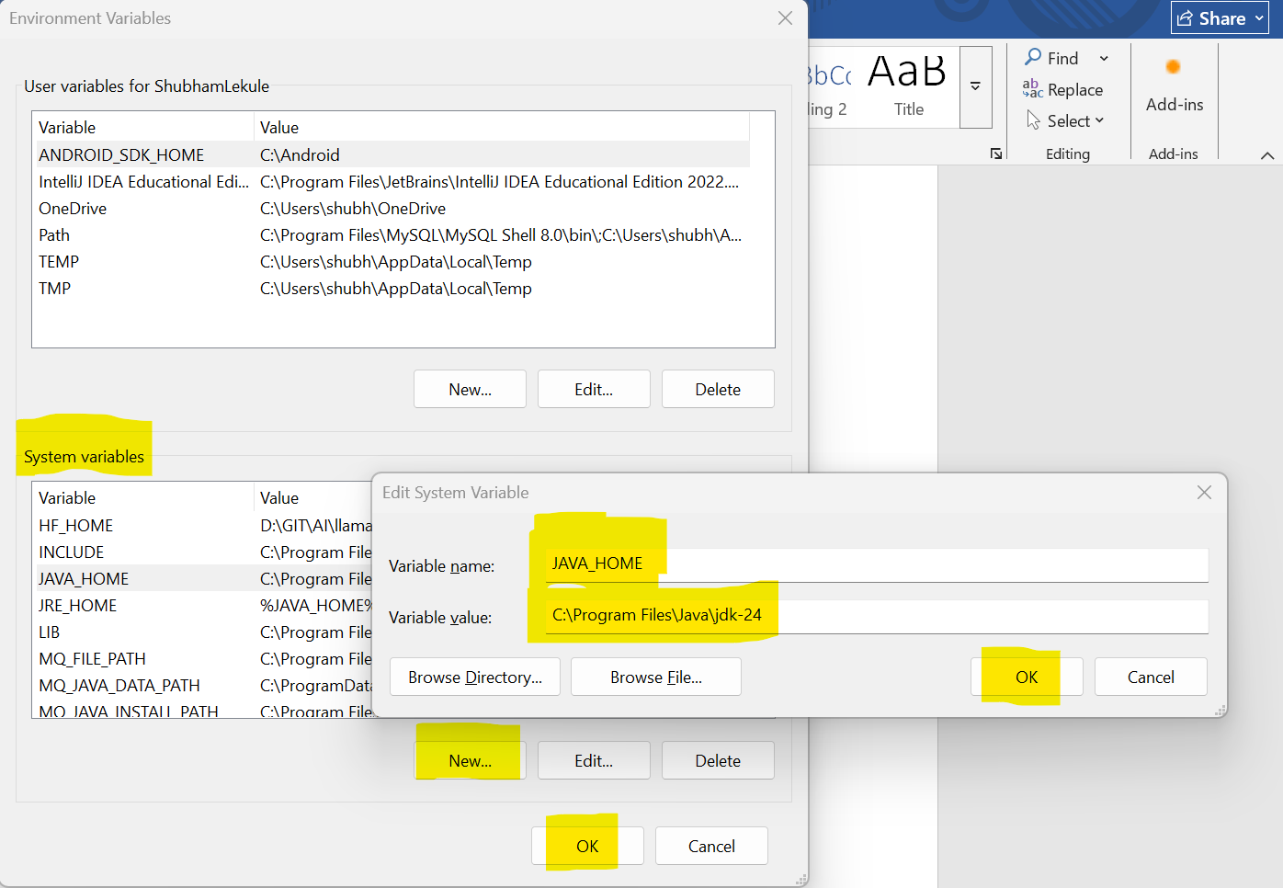

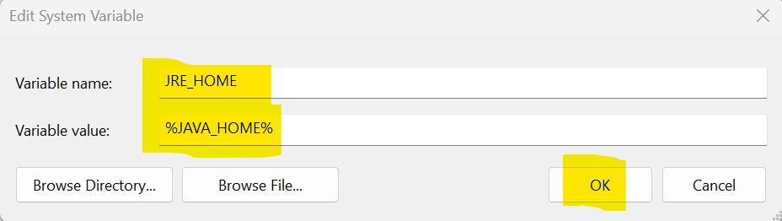

* Click ok.
* Now add JAVA_HOME and JRE_HOME in path.
* In System variables double click on path.

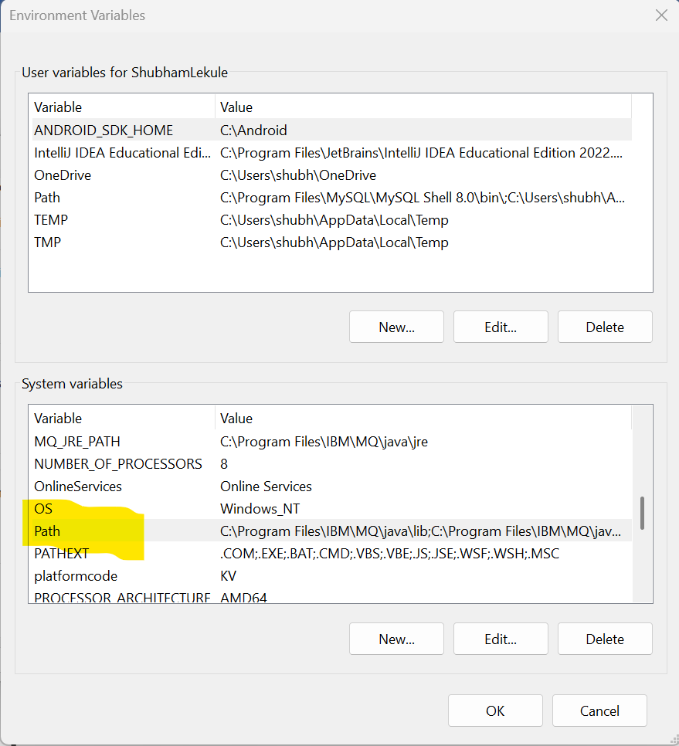

* Add JAVA_HOME and JRE_HOME

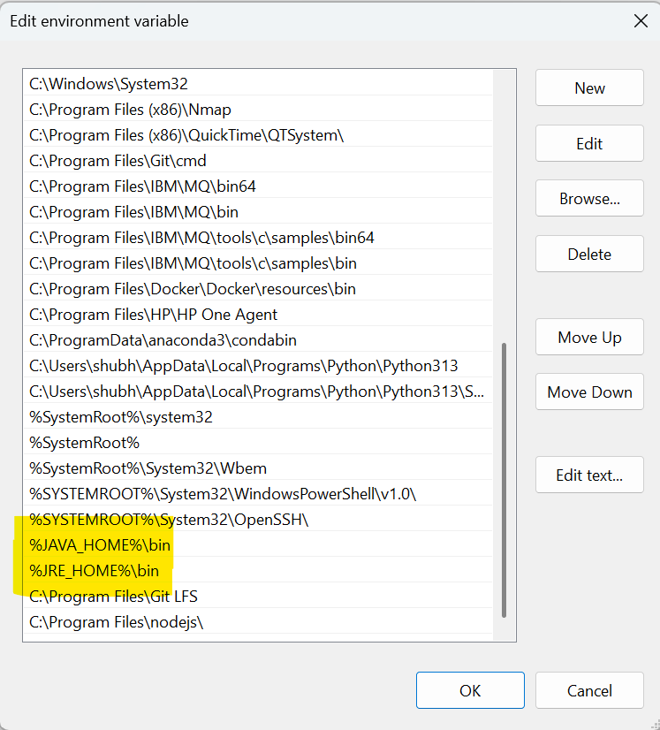

* Click ok.
* Now to verify installation open command prompt and type below command

CMD: java --version

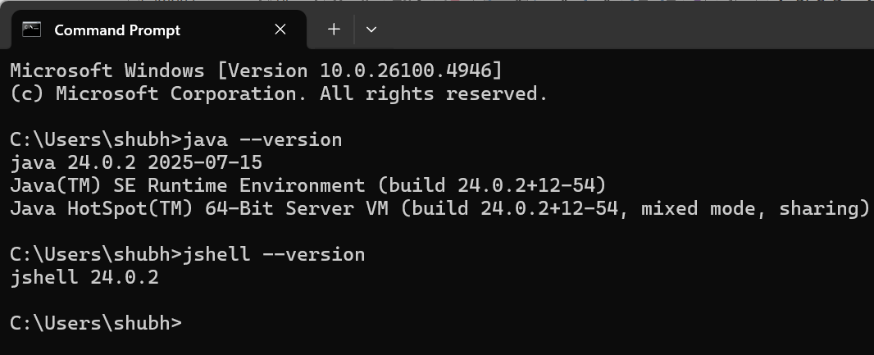

* Installation Done.
* <https://docs.oracle.com/en/java/javase/24/install/installation-guide.pdf>
* <https://docs.oracle.com/en/java/javase/24/install/overview-jdk-installation.html>
* <https://docs.oracle.com/en/java/javase/24/install/toc.htm>
* Java older version list:

<https://docs.oracle.com/en/java/javase/index.html>

* Documentation:

<https://docs.oracle.com/en/java/javase/24/index.html>

<https://docs.oracle.com/en/java/javase/24/docs/api/index.html>