**Q1: PowerBI Products:**

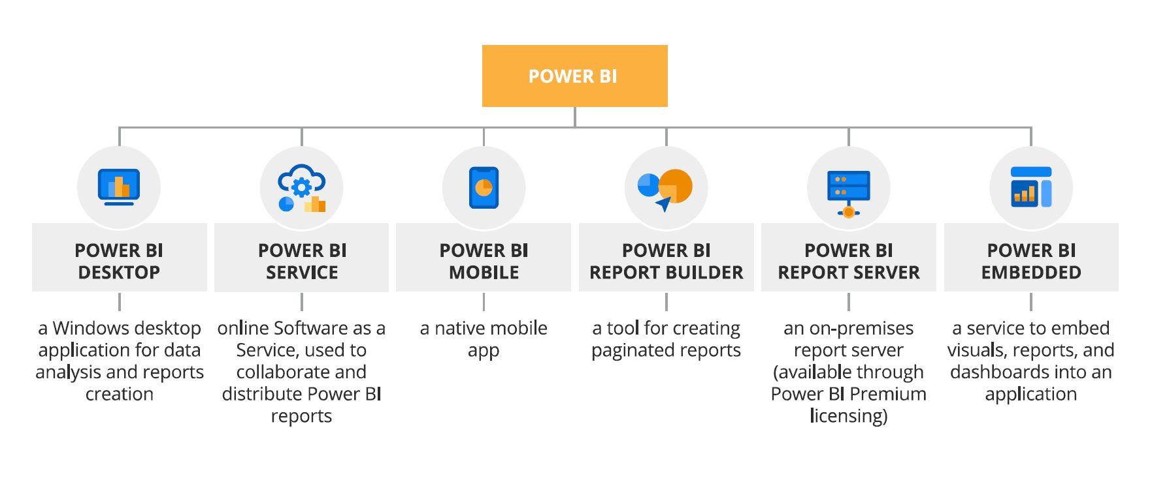

**Q2: What limitations of Excel, Microsoft solved by PowerBi?**

* Excel is used to organize data, transform it and perform mathematical operations and calculations. On the other hand, Power BI was conceived as a business intelligence and [data visualization](https://blog.bismart.com/en/data-visualization-with-power-bi) tool for businesses.
* Excel has limitations in the amount of data it can work with. In contrast, Power BI can handle much larger amounts of data.
* Power BI can connect to a large number of data sources, while Excel's connectivity capacity is limited. Also, unlike Excel, Power BI can be easily used from mobile devices.
* Power BI has faster processing than Excel.
* Power BI dashboards are [more visually appealing, interactive and customizable](https://blog.bismart.com/en/reporting-services-and-highly-visual-and-interactive-reports) than those in Excel.
* Power BI is a more powerful tool than Excel in terms of comparison between tables, reports or data files.
* Power BI is more user friendly and easy to use than Excel.

**Q3: Power Query:**

* Power Query is a data transformation and data preparation engine. Power Query comes with a graphical interface for getting data from sources and a Power Query Editor for applying transformations. Because the engine is available in many products and services, the destination where the data will be stored depends on where Power Query was used. Using Power Query, you can perform the extract, transform, and load (ETL) processing of data.

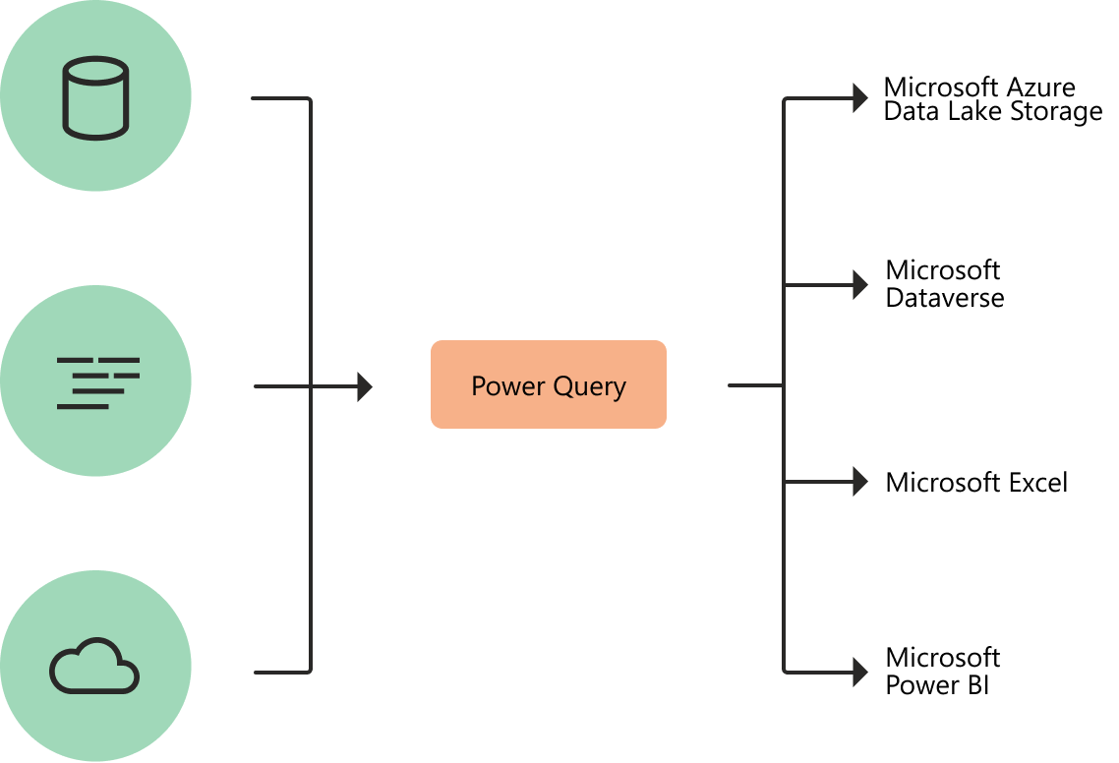

**Q4: PowerMap**

A power map lets you discover insights you might not see in traditional two-dimensional (2-D) tables and charts.

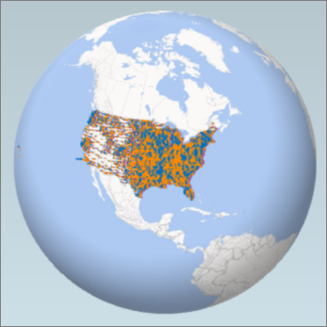

With Power Map, you can plot geographic and temporal data on a 3-D globe or custom map, show it over time, and create visual tours you can share with other people.

**Q6: Updates:**

Reporting

* Conditional formatting for data labels
* New select sensitivity labels dialog
* Data loss prevention
* Metric visual
* Mobile formatting

Modelling:

* DAX editor improvement

Data connectivity

* MariaDB
* Google sheets

Visuals

* New visuals in AppSource