**Q1: Advantages of natural query in powerBI**

* User can add visuals by typing in Q&A section.
* Easy to explore data.
* If you have permission, you can edit dashboard.

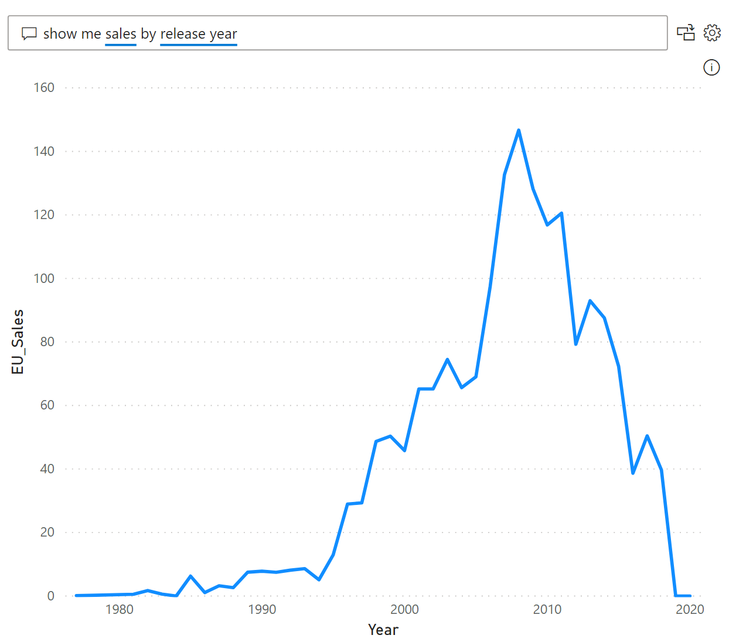

**Q2: WEF:**

The WFE cluster manages the initial connection and authentication to the Power BI service, and once authenticated, the Back-End handles all subsequent user interactions.

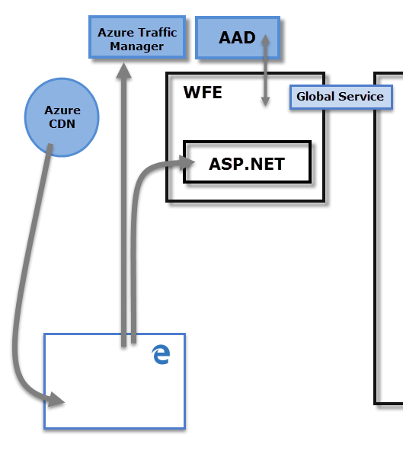

**Q3: BEC**

The Back-End cluster is how authenticated clients interact with the Power BI service. The Back-End cluster manages visualizations, user dashboards, datasets, reports, data storage, data connections, data refresh, and other aspects of interacting with the Power BI service. The Gateway Role acts as a gateway between user requests and the Power BI service. Users do not interact directly with any roles other than the Gateway Role. Azure API Management will eventually handle the Gateway Role.

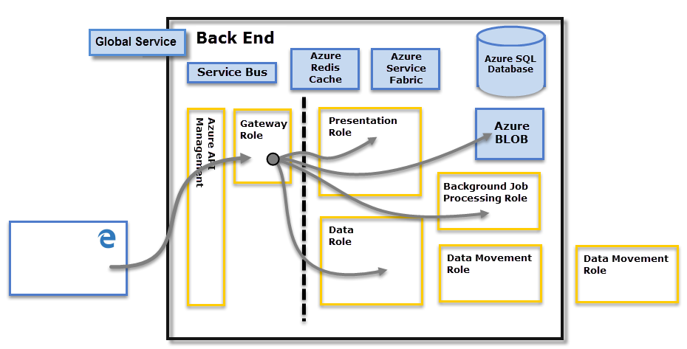

**Q4: ASP.NET**

The ASP.NET component within the WFE cluster parses the token to determine which organization the user belongs to, and then consults the Power BI Global Service. The WFE specifies to the browser which back-end cluster houses the organization's tenant.

**Q5: Microsoft Excel Vs Microsoft PowerBI**

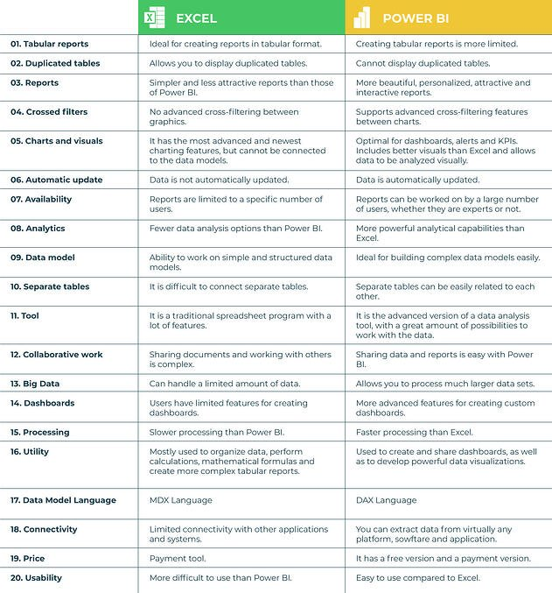

**Q6: Data sources supported by PowerBI:**

* SQL Server database
* Access database
* SQL Server Analysis Services database
* Oracle database
* IBM Db2 database
* IBM Informix database (Beta)
* IBM Netezza
* MySQL database
* PostgreSQL database
* Sybase database
* Teradata database
* SAP HANA database
* SAP Business Warehouse Application Server
* SAP Business Warehouse Message Server
* Amazon Redshift
* Impala
* Google BigQuery
* Vertica
* Snowflake
* Essbase
* Actian (Beta)
* Amazon Athena
* BI Connector

And many more