## Q1: What is DAX?

DAX is a collection of functions, operators, and constants that can be used in a formula, or expression, to calculate and return one or more values. Stated more simply, DAX helps you create new information from data already in your model.

## Q2:

Datasets:

A dataset is a collection of data that you *import* or *connect* to. Power BI lets you connect to and import all sorts of datasets and bring all of it together in one place. Datasets can also source data from dataflow.

Reports:

A Power BI report is one or more pages of visualizations such as line charts, maps, and tree maps. Visualizations are also called visuals. All of the visualizations in a report come from a single dataset. You can create reports from scratch within Power BI, import them with dashboards that colleagues share with you, or Power BI can create them when you connect to datasets from Excel, Power BI Desktop, databases, and SaaS applications. For example, when you connect to a SaaS application, Power BI imports a pre-built report.

Dashboard:

A dashboard is something you create in the Power BI service or something a colleague creates in the Power BI service and shares with you. It is a single canvas that contains zero or more tiles and widgets. Each tile pinned from a report or from [Q&A](https://docs.microsoft.com/en-us/power-bi/consumer/end-user-q-and-a) displays a single [visualization](https://docs.microsoft.com/en-us/power-bi/visuals/power-bi-report-visualizations) that was created from a dataset and pinned to the dashboard. Entire report pages can also be pinned to a dashboard as a single tile. There are many ways to add tiles to your dashboard; too many to be covered in this overview topic. To learn more, see [Dashboard tiles in Power BI](https://docs.microsoft.com/en-us/power-bi/create-reports/service-dashboard-tiles).

**Q3: How to create report**

* Open PowerBI desktop
* Import data
* Create visual according to purpose
* Add multiple sheet and visuals
* We are done with report

**Q4:**

* In Power BI Desktop, select Get data from the Home ribbon tab.
* In the Get Data window, select Online Services from the categories in the left pane.
* Select Google Analytics from the selections in the right pane.
* At the bottom of the window, select Connect.  
  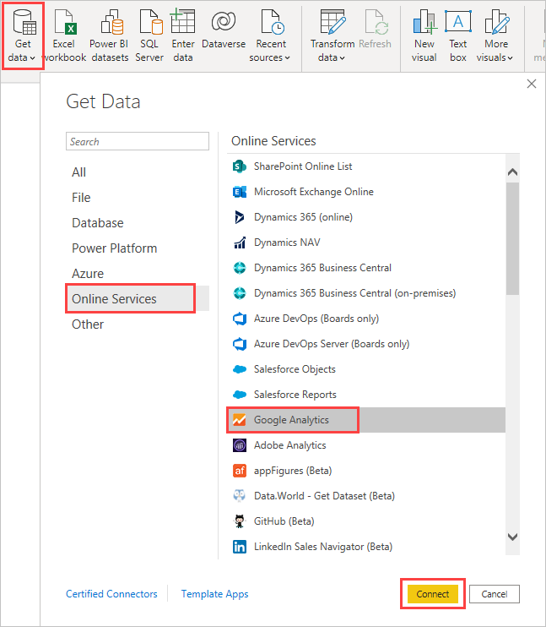
* You're prompted with a dialog that explains that the connector is a Third-Party Service, and warns about how features and availability may change over time, and other clarifications.  
  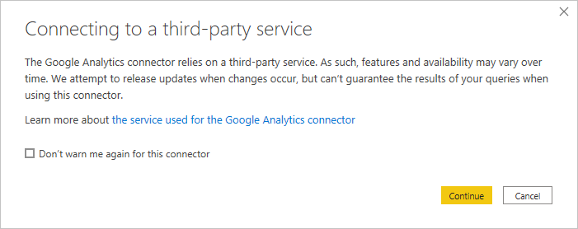
* When you select Continue, you're prompted to sign in to Google Analytics.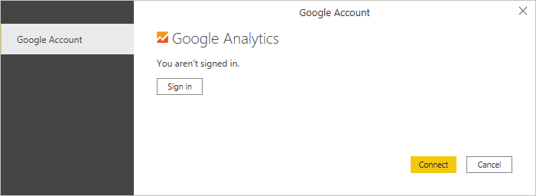
* When you enter your credentials, you're prompted that Power BI would like to have offline access. This is how you use Power BI Desktop to access your Google Analytics data.
* Once you accept, Power BI Desktop shows that you're currently signed in.  
  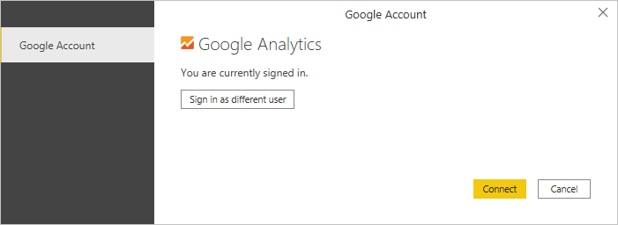
* Select Connect, and your Google Analytics data is connected to Power BI Desktop, and loads the data.  
  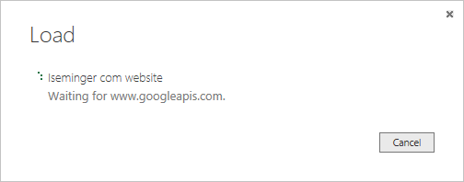

**Q5: Manually import data to Power BI**

* In Power BI, click **Get Data** in the lower left screen.
* Under **Import or Connect to Data** > **Files**, click **Get**.

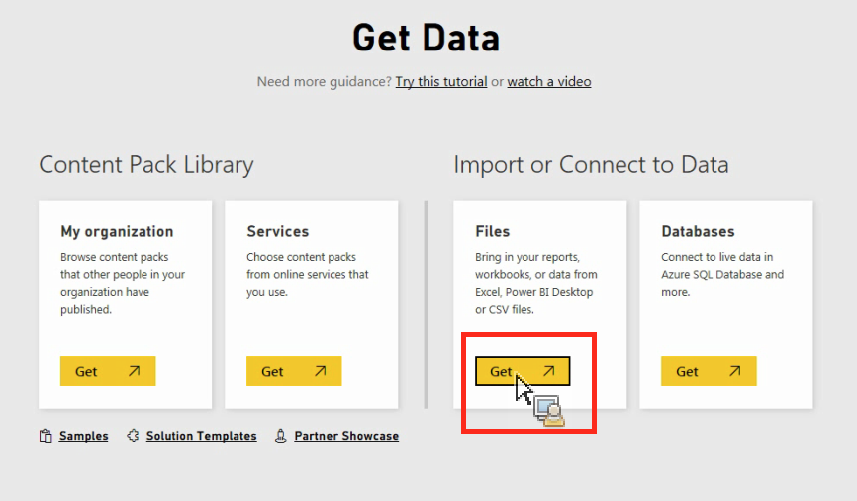

* Click Local File.

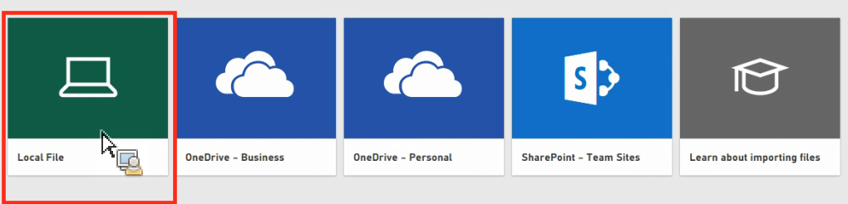

* Choose which file to upload and click **Open**.
* Click **Upload** under **Upload your Excel file to Power BI**.

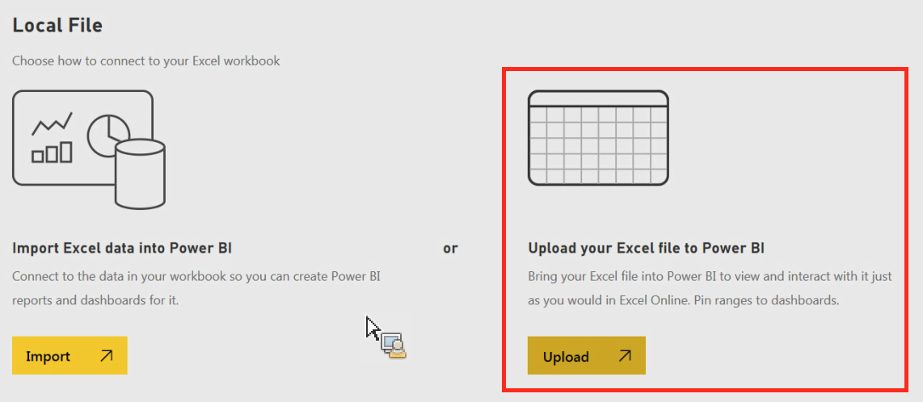

* The message “Your file has been uploaded” should appear.

**Q6: Reading and Editing view**

* There are two modes for interacting with reports in the Power BI service: Editing view and Reading view. If you are a business user, then you are more likely to use Reading view to consume reports created by others. Editing view is used by report designers, who create the reports and share them with you. Reading view is your way to explore and interact with reports created by colleagues
* Even in Reading view, the content isn't static. You can dig in, looking for trends, insights, and other business intelligence. Slice and dice the content, and even ask it questions using your own words. Or, sit back and let your data discover interesting insights for you; send you alerts when data changes, and email reports to you on a schedule you set. All your data, any time, in the cloud or on-premises, from any device.