# Business Problem

In recent years, City and Resort hotel have seen high cancellation rates. Each hotel is now dealing with a number of issues as a result, Including fewer revenues and less than ideal hotel use. Consequently, lowering cancellation rates is both hotels is primary goal in order To increase their revenue and for us to offer through business advice to address their problem.

The analysis for hotel booking cancellation as well as other factors that have no bearing on their business and yearly revenue generation Are the main topic of the report

# Assumptions

1. No unusual occurrences between 2005 and 2017 will have a substantial impact on the data used

2. The information is still current and can be used to analyse a hotels possible plan in an efficient manner

3. There are no unanticipated negative to the hotel employing any advised technique

4. The hotel are not currently using any of the suggested solution

5. The biggest factor affecting the effectiveness of earning income is booking cancellation

6. Clients make reservations the same year they make cancellations

# Research Questions

1. What are the variables that affect the hotel reservations cancellation?

2. How can we make hotels reservations cancellation lower?

3. How will hotels be assisted in making and promotional decisions?

# Hypothesis

1. More cancellations occur when price are higher

2. When there is longer waiting list, customers tend to cancel more frequently

3. The majority of clients are coming from offline travel agents to make their reservations

# Analysis and finding

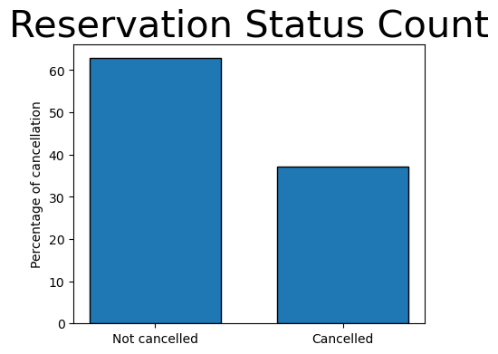

The accompanying bar graph shows the percentage of reservations that are cancelled and those that are not. It is obvious that there are still a significant number of reservations that have not been cancelled. There are still 37% of clients who cancelled their reservation, which has a significant impact on the hotels earnings

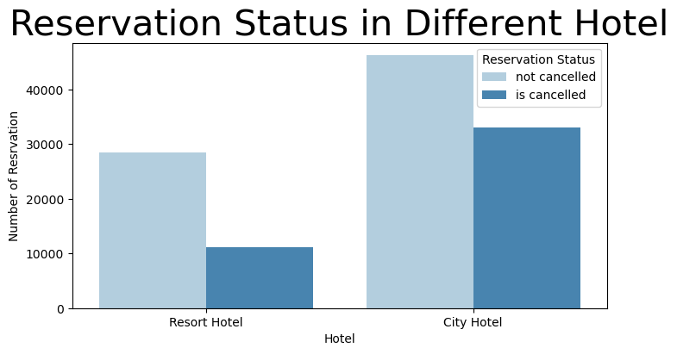

In comparison to resort hotels, the city hotels have more bookings. It’s possible that resort hotels are more expensive than those of city hotels

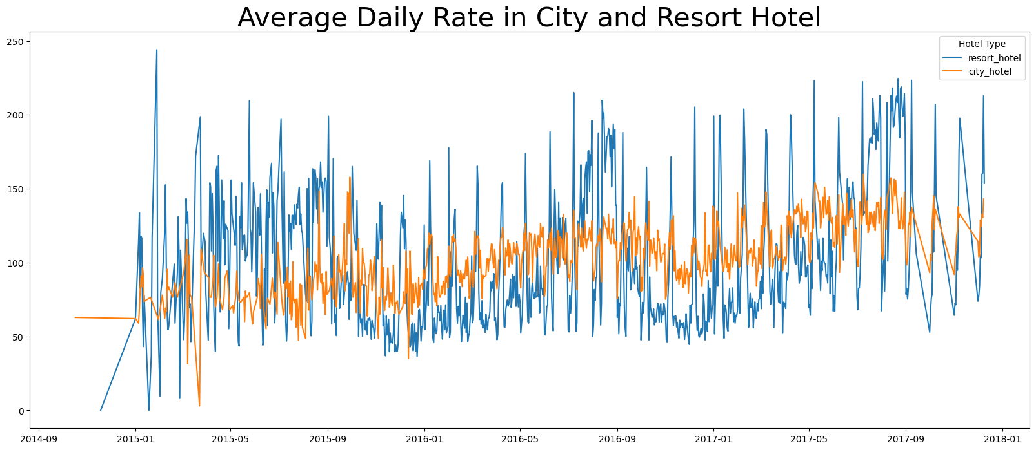

The line graph above shows that, on certain days, the average daily rate for a city hotel is less than that of a resort hotel and on other days, it even less. It goes without saying that weekends and holidays may see a rise in resort hotel rates

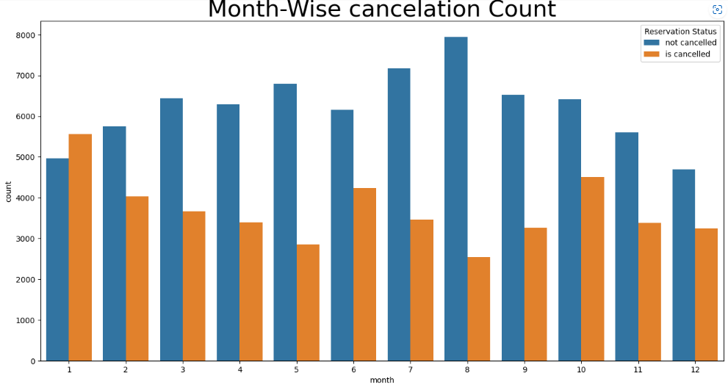

We have developed the grouped bar graph to analyse the months with the highest and lowest reservation levels according to reservation status. As can we see, both the numbers off conformed reservations and the number of cancelled reservations are largest in month of August. Whereas January is the month with the most cancelled reservations.

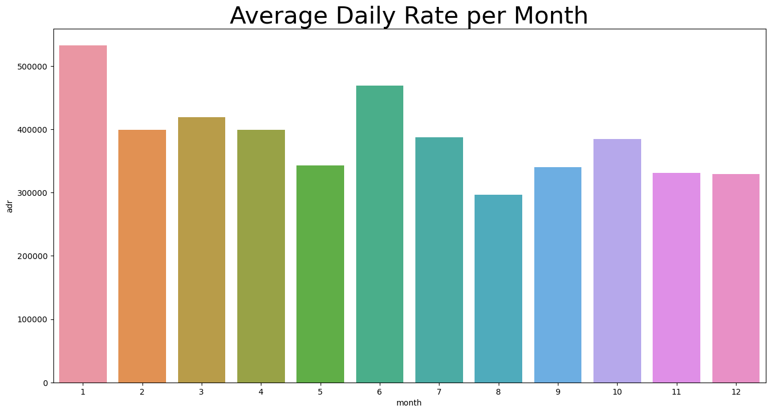

This bar graph demonstrates that cancellations rate is directly proportional to hotel price.

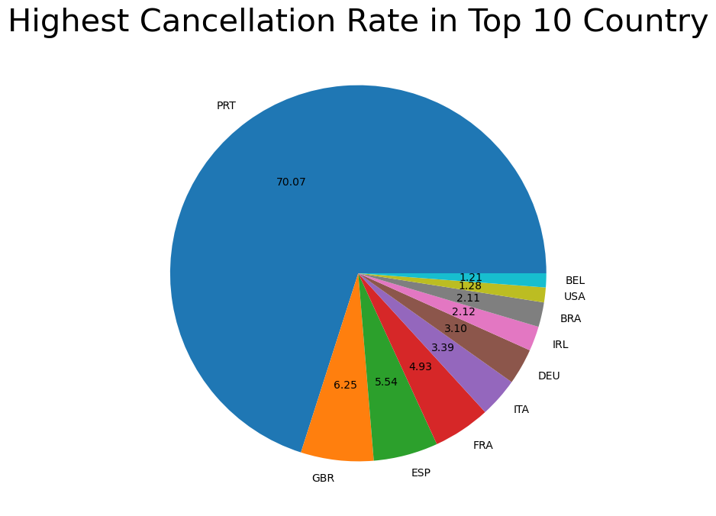

Now, let ‘see which country has the highest reservations cancelled. The top country is Portugal with around 70% cancellation rate

Let see, from which market segment hotels are getting customers.

|  |  |
| --- | --- |
| Market segment | Number of reservation |
| Online TA | 56402 |
| Offline TA/TO | 24159 |
| Groups | 19806 |
| Direct | 12448 |
| Corporate | 5111 |
| Complementary | 734 |
| Aviation | 237 |

|  |  |
| --- | --- |
| Market segment | Percentage of reservation |
| Online TA | 47.43 |
| Offline TA/TO | 20.31 |
| Groups | 16.65 |
| Direct | 10.46 |
| Corporate | 4.29 |
| Complementary | 0.61 |
| Aviation | 0.19 |

Cancellation as per market segment in percentage

|  |  |
| --- | --- |
| Market segment | Cancellation rate in percentage |
| Online TA | 46.96 |
| Groups | 27.39 |
| Offline TA/TO | 18.74 |
| Direct | 4.34 |
| Corporate | 2.21 |
| Complementary | 0.20 |
| Aviation | 0.11 |

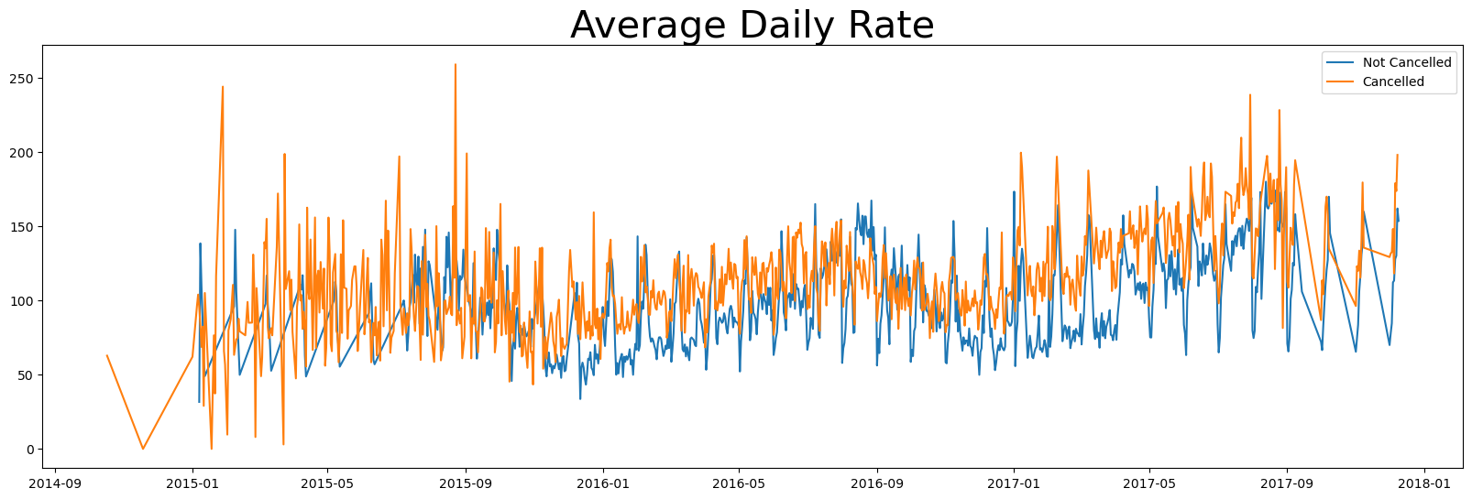

As seen in the graph, reservations are cancelled when the average daily rate is higher then when it is not cancelled. So it is proved that, cancellations rate is directly proportional to hotel price.

# Suggestion

1. Cancellations rate is directly proportional to hotel price. In order to arrest the cancellations of reservations, hotel need to work in pricing strategies and try to lower the specific hotels based on locations. As well as they can provide strategic discount to the customers
2. As per bar graph, cancellation rate is higher at the resort hotels in comparison to city hotel.so hotel may provide strategic discount based on locations, weekends as well as holidays.
3. In month on January, hotel can start their strategic marketing campaign, this month shows highest cancellation rate compare to rest of months
4. There is also need to increase the quality of hotel and services, mainly in Portugal to reduce the cancellation rate