### Practical File

### of

### Problem Solving using Python Programming

### 23CS001

#### Submitted

#### in partial fulfillment for the award of the degree of

## BACHELEOR OF ENGINEERING

***in***

COMPUTER SCIENCE & ENGINEERING



**CHITKARA UNIVERSITY**

**CHANDIGARH-PATIALA NATIONAL HIGHWAY**

**RAJPURA (PATIALA) PUNJAB-140401 (INDIA)**

##### December, 2023

##### **Submitted To: Submitted By:**

##### Faculty name-Dr. Vikas Solanki Name-Shubham

##### Designation- Professor Roll No.2310992449

##### Chitkara University, Punjab Sem 1, Batch-28-B

**INDEX**

|  |  |  |
| --- | --- | --- |
| **Sr. No.** | **Practical Name** | **Teacher Sign** |
| **1.** | **Write a python program to Calculate the Area of a Triangle** |  |
| **2.** | **Write a python program to Swap Two Variables** |  |
| **3.** | **Write a python program to Convert Celsius to Fahrenheit** |  |
| **4.** | **Write a python program to Check if a Number is Odd or Even** |  |
| **5.** | **Write a** [**Python Program to Check if a Number is Positive, Negative or 0**](https://www.programiz.com/python-programming/examples/positive-negative-zero) |  |
| **6.** | **Write a** [**Python Program to Check Armstrong Number**](https://www.programiz.com/python-programming/examples/armstrong-number) |  |
| **7.** | **Write a Python program to check if a given number is Fibonacci number?** |  |
| **8.** | **Write a Python program to print cube sum of first n natural numbers** |  |
| **9.** | **Write a Python program to print all odd numbers in a range.** |  |
| **10.** |  |  |
| **11.** |  |  |
| **12.** |  |  |
| **13.** |  |  |
| **14.** |  |  |
| **15.** |  |  |

**Program 1: ……….title of program……….**

Solution:

side_1 = int(input("Please input first side value : "))

side_2 = int(input("Please input second side value : "))

side_3 = int(input("Please input third side value : "))

S=(side_1+side_2+side_3)/2

area = (S*(S-side_1)*(S-side_2)*(S-side_3))**0.5

print("Area of triangle is : ",area)

**Output:**

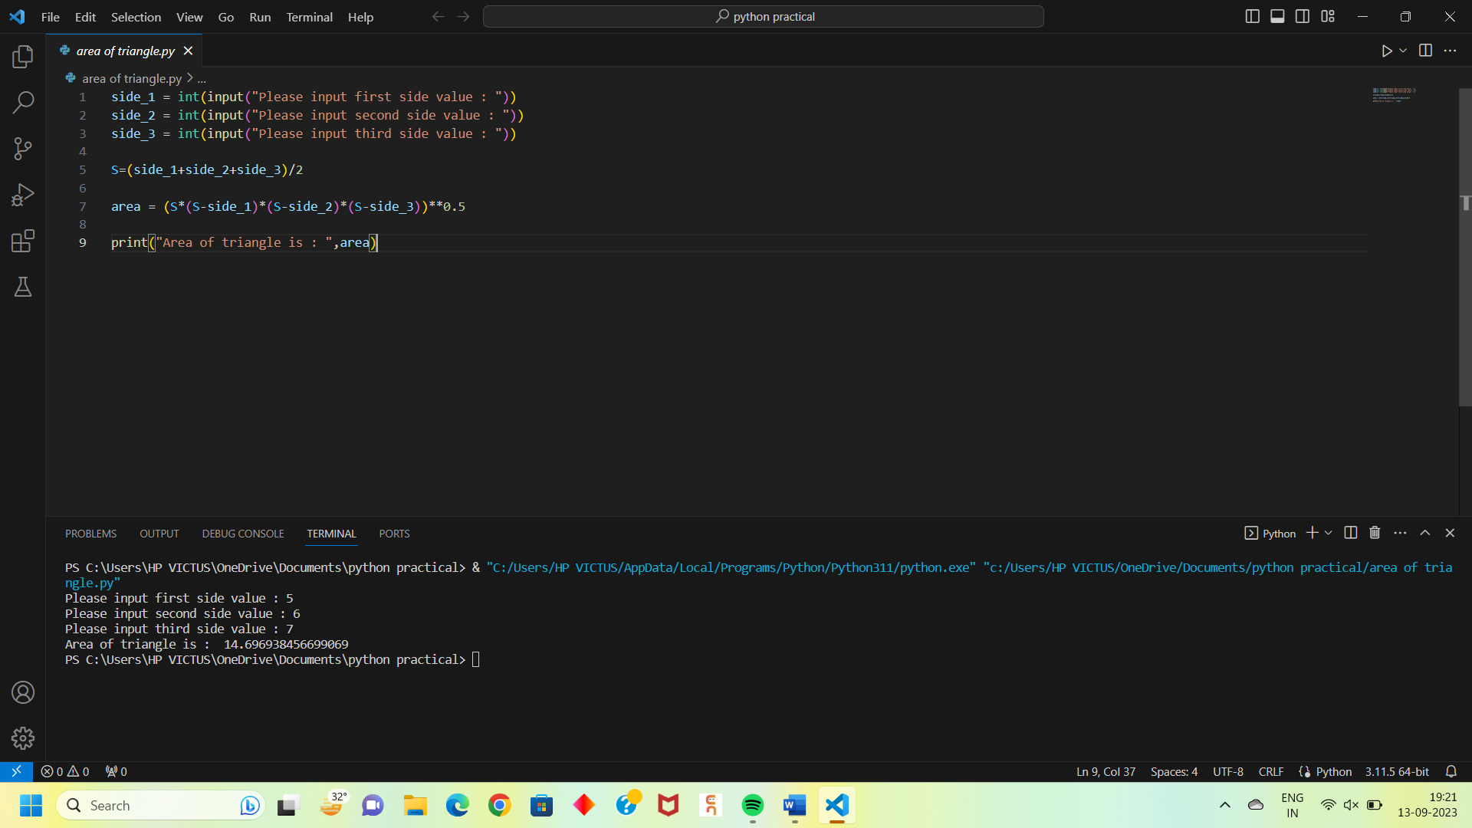

**Program 2: ………………..Title of program………..**

**Solution:**

**x = int(input("Enter the value of x : "))**

**y = int(input("Enter the value of y : "))**

**swap = x**

**x = y**

**y = swap**

**print("The value of x after swaping : ",x)**

**print("The value of y after swaping : ",y)**

**Output:**

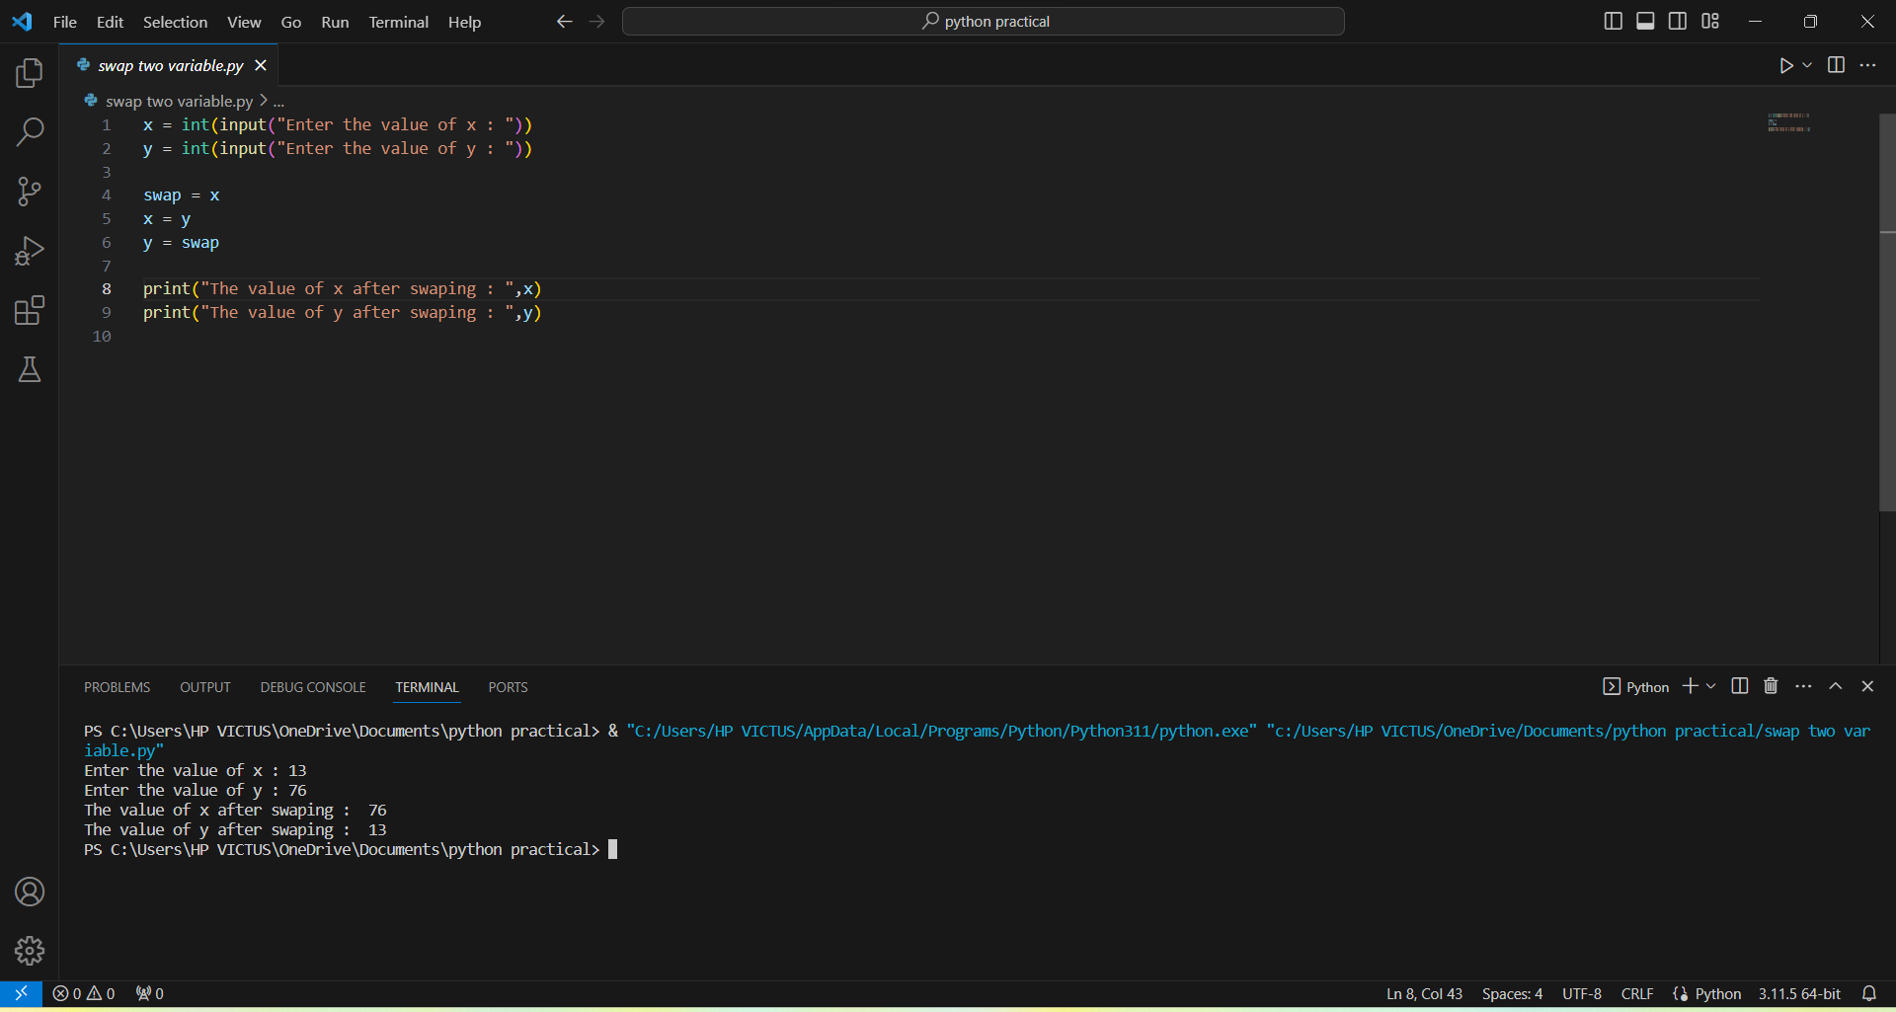

**Program 3: ………………..Title of program………..**

**Solution:**

C = int(input("Enter the temperature in Celcius : "))

F = ((C-32)*5)/9

print("Temperature in Fahrenheit is : ",F)

**Output:**

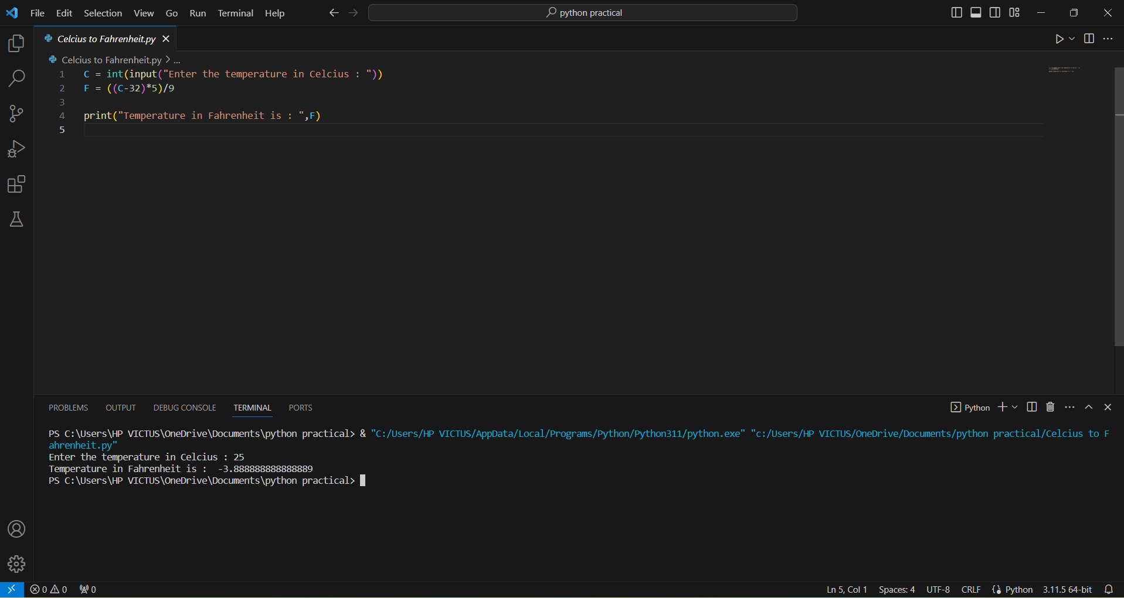

**Program 4: ………………..Title of program………..**

**Solution:**

n = int(input("Enter the number : "))

if n<0 :

print("The number is negative.")

elif n==0 :

print("The number is zero.")

else :

print("The number is positive.")

**Output:**

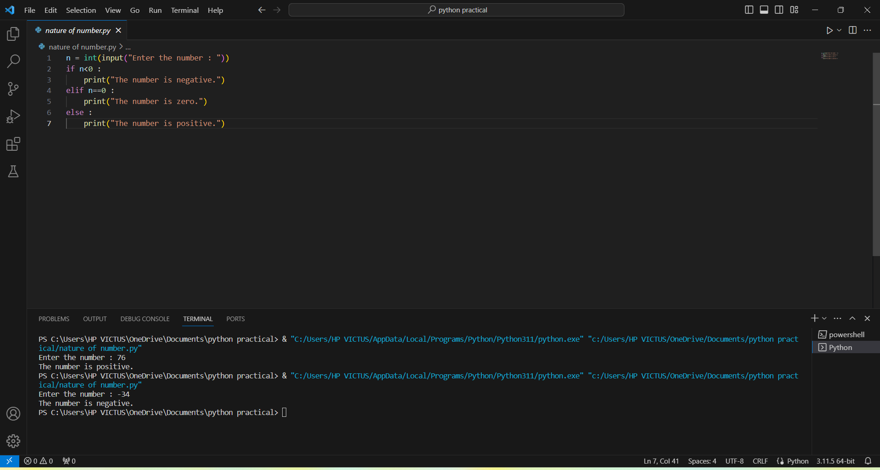

**Program 5: ………………..Title of program………..**

**Solution:**

n=int(input("Enter the number: "))

if n%2 == 0:

print("The number n is even")

else :

print("The number is odd")

**Output:**

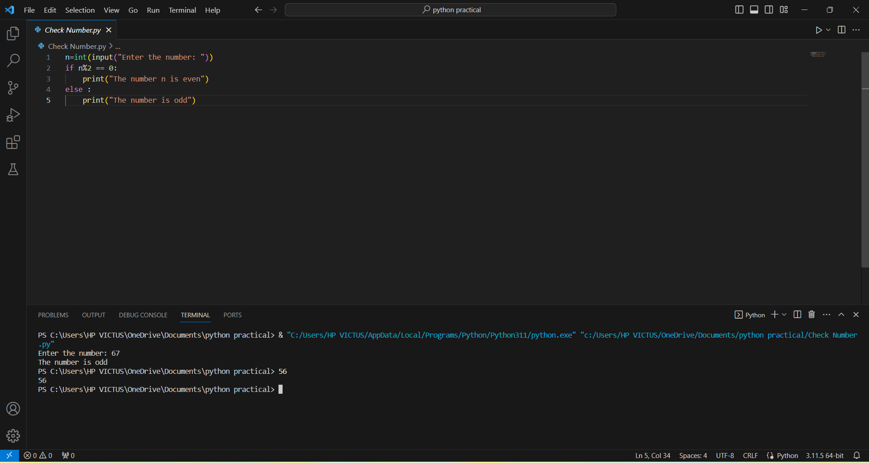

**Program 6: ………………..Title of program………..**

**Solution:**

n = int(input("Enter the number : "))

sum = 0

order = len(str(n))

temp = n

while temp > 0:

digit = temp % 10

sum += digit**order

temp //= 10

if n == sum :

print("The number is Armstrong number")

else :

print("The number is not Armstrong number")

**Output:**

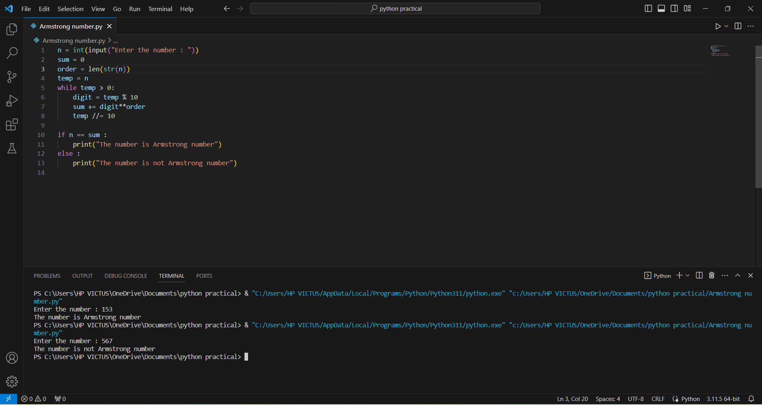

**Program 7: ………………..Title of program………..**

**Solution:**

**Output:**

**Program 8: ………………..Title of program………..**

**Solution:**

**Output:**