 **FLEXFORCE_ONDEMAND**

**URL-**[**https://flexforceondemand.com**](https://flexforceondemand.com)

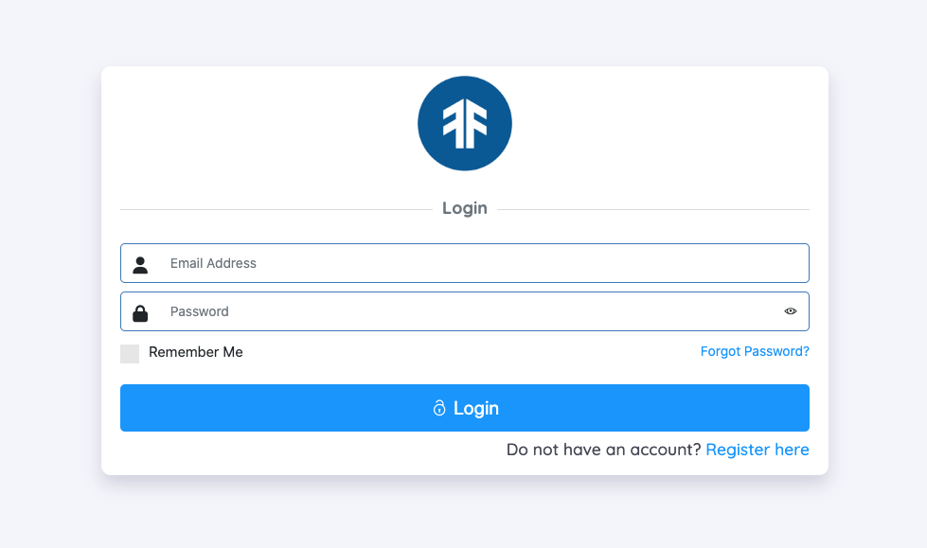

**LOG-IN:- Flexforce has types of login - (A). Company Login  
 (B). Branch Login**

**(C). Client  
 (D). User Login-** We have three types of users which will login from the same panel or url

**1**. Branch Manager  
 2. Client Manager  
 3. Screen Agent

**1. Branch Manager’s work-** Branch manager will login to the branch and he will manage the all activity of shifts and able to take any action for shift and associates the branch manager can handle multi branches for the same company so he can follow the steps-

1. Login to Branch  
2. He can add associates for all branches and able to take all actions for the associate like (Add, Edit,Department,branch allotment)  
3. He can add clients for the branch.  
4. He can switch to another branch without logout but the branch must be assigned for the manager.

5. He can create assignments for the branches.

6. He can invites associate for the assignment

7. He can invite more associates for the assignment if needed.

8. He can make associate check-in, clock-in,clock-out.

➤**Check-in**>On which time associates reached work. <https://prnt.sc/FxfrRvsaBB6_>

➤**Clock-in**> On which time the associate starts the work.<https://prnt.sc/3PYp1gS1U_S2>

➤**Clock-out**> Temporary break from work.<https://prnt.sc/JTvbbQAsAjBu>

9. He can take actions on the shift like - Absent, Released from the assignment, Return to agency

➤ **Mark absent**- When the associate is not available for the work without inform will be marked as

absent <https://prnt.sc/BmzNrULhMJCO>

➤**Released From the Assignment**- associate can be released from the assignment <https://prnt.sc/RDrF0AILdNn0>

➤**Return to agency**- If the associate has no consistency on the work than the associate will be return to the

agency.<https://prnt.sc/PUjb61Q6s7X0>

10. Has access to the calendar view.<https://prnt.sc/Wxd8Uq3VCjt7>

**2. Client’s Manager Work-**  Client manager will login to the Client and he will manage the all activity of shifts and able to take any action that are assigned in the client manager roles he can follow the steps-

1. Login to client panel
2. He can be assigned to multiple clients for that location and location must be assigned for the client manager.
3. Has access to the calendar view.
4. He can create assignments for the client.
5. He can invite the associates for the assignment.

6. He can make associate check-in, clock-in,clock-out.

7. He can take actions for the shift according to the client manager roles.

**3. Screen Agent’s work-** Screen agent has access to the applicant module he will list the all applicants and schedule the

interview for the applicant and completing the screening and on-boarding associates.

**4. Assignments-** Assignment types **- (1). On-going  
 (2). On-demand**

➤ **On-Demand-** This is for a limited day's assignment. It has an end date and the client can change the setting and can set the on-demand days limit.

➤**On-Going-** This type of assignment does not have any end date, it is an endless assignment and in the initial the shifts will be created for 21 days after that every day one shift will be auto created.

**Create Assignment**- Client, Company, Branch manager and client manager can create the assignments and following these steps-  
  
1. Location of the client must be added for the client with the department.

2. Associates must be added in the branch within 25 miles radius with the same department.

3. Associates must be available for the Assignment.

4. Associate can not accept any assignment if he is working on another shift at the same time.

For demonstration purposes click on the link-

<https://www.dropbox.com/scl/fi/ile0ap40wsre1yznd4puq/Add-assignment-by-auto-login-to-branch.mp4?rlkey=k9wyeaiyxuhukyc8wary9acf3&dl=1>

**Associate panel-**  Associate can login from the same login panel.

1. Associate received the invitation on the panel.
2. Associates can accept or decline the invitation.
3. Associates can take action like time-off, call-out and withdrawal from the assignment.

**➤Time-off** - This is planned leave and associates can take multiple leave in the bundle with the approval.

➤**Call-ou**t- This is single day leave in which the associate can take leave without approval.

**➤Withdrawal-**  Associate can withdraw from the assignment.

**Branch Manager-** Branch manager will be added by the company and branch manager will login to the branch.

**Click on the link for download demo of Branch manager-**

[**https://www.dropbox.com/s/2vpalib7r99jw60/Add%20Branch%20manager.mp4?dl=1**](https://www.dropbox.com/s/2vpalib7r99jw60/Add%20Branch%20manager.mp4?dl=1)

**Client Manager-** Client manager will be created by the company and will login into a separate panel.

<https://www.dropbox.com/s/ien4tiv429rvz0l/Add%20client%20manager.mp4?dl=1>

**Applicant-**  It will be used for the hiring process.

Steps- 1. We need to create assignments for hiring.

2. We will post requirements on the job portal.

3. All users will apply for the job.

**Click on the link for download demo of applicants-** <https://www.dropbox.com/s/t1kyphb41yqcwhu/Applicant%20external%20registration%20.mp4?dl=1>

**Associate-**  Internal users of flexforce and they are temp work force.

➤ We can add associates in any branch for the same company.

➤ Associates must be in the 25 mile radius from the work location.

**Click on the link for download demo of associates-**

[**https://www.dropbox.com/scl/fi/mdw5pqknjd4iwdrz7vb6e/add-new-associats-from-company-panel-and-branch-panel.mp4?rlkey=8tx7o96rinngi3kj43zd7ewck&dl=1**](https://www.dropbox.com/scl/fi/mdw5pqknjd4iwdrz7vb6e/add-new-associats-from-company-panel-and-branch-panel.mp4?rlkey=8tx7o96rinngi3kj43zd7ewck&dl=1)

**Assign client manager to Client-** Company or branch manager will create the manager and will assign to the client by following steps-

1. When The Client manager is created he will assign to the branches.
2. After being assigned the branch manager will assign to the client.
3. A client manager can be assigned to multiple clients and locations.
4. Where to Assign- <https://prnt.sc/kzseaQmMWWov>

**Types of Company-** 1. Bullhorn  
 2. Docusign

3. Default

1. **Bullhorn**- When the company type is bullhorn the all associates will be assigned for bullhorn

**Steps -**  ➤ Superadmin will decide the type according to requirements.

➤ Now the company will decide and add the documents from the document setting.

➤ Company will decide the expiry days for the documents.

2. **Docusign-** When the company type is Docusign the all Documents will be uploaded by the company or associates and the

associates will sign on the docs by this service.

**Steps**-

➤ Company will upload the templates for the docs.

➤ Associate will download from the mail and read then sign on the docs for varifications.

➤ Company will decide the expiry days for the documents.