**ABSTRACT**

‘**Aisha-The Virtual Assistant**’ is an android app that works as an intelligent personal assistant and helps you do things you do every day. It is a multi-functional application that provides a single window environment to perform wide range of tasks using voice commands as well as it can chat with you when you want. It can take a commands as speech to text to search information on the Internet, it can play the songs you want to hear and play videos which you want, it can set alarms, Open applications like camera, gallery, memo, whatsapp and much more.

It is daily use application can be used by every user of any age. This app is very useful to handicapped people like people with vision impairment, who don’t have hands or people who cannot operate mobile as whole application can work only on voice recognition. This app is more than just an app, it is also friend of yours. You can chat with her.

This is a general application which can be extended as per our need as in home automation, Farm automation etc. it can be extended and used in robotics to have your robot assistant. It can be inherited as per other use in robotics or anywhere where work can be done by using commands.

|  |  |
| --- | --- |
| 1.Introduction  1.1 Existing techniques  1.2 Proposed system  1.3 Features of proposed system | 3 |
| 2. Software Requirement Specification  2.1 Introduction  2.1.1 Purpose  2.1.2 Scope  2.1.3 Developer’s Responsibilities overview  2.2 Overall Description  2.2.1 Product functions  2.2.2 User Characteristics  2.2.3 Assumptions and Dependencies  2.2.4 Design Constraints | 4 |
| 3.System Design  3.1 Sequence diagram  3.2 Use Case Diagram  3.3 Activity Diagram | 5 |
| 4. Technical Specifications  4.1 Used programming languages  4.2 Used software | 8 |
| 5.Software Implementation  5.1 Problem statement  5.2 System architecture | 11 |
| 6. Result Snapshot | 12 |
| 7. Conclusion and future work  8.1 Conclusion   * 1. Future work | 20 |
| 8. References | 21 |

**CONTENTS**

**1 .Introduction**

* 1. **Existing Techniques**

Today in market we have apps like Apple's Siri, Google's Google Now, Amazon Echo, Microsoft's Cortana, Braina (application developed by Brainasoft for Microsoft Windows)

**1.2 Proposed System**

This app is based on android operating system. In this app we have created a virtual personality named “Aisha”. She can chat with you. We can open web browser, contact, gallery, message etc. set alarm, play songs just by giving voice command

**1.3 Features of proposed system**

1. Speech To Text & Text To Speech
2. Chat as a friend
3. Open applications like web browser, contact, gallery, message etc.
4. Perform tasks like set alarm, play songs, web search etc.

### 2. Software Requirement Specification

#### Introduction

**2.1.1 Purpose**

The purpose of this system is to work as intelligent virtual assistant.

**2.1.2 Scope**

The system will be designed for use as long as the hardware and operating systems

Specified in this document remain available.

**2.1.3 Developer’s Responsibilities overview**

The developer is responsible for-

1. Developing the system.
2. Installing it on system
   1. **Overall Description**

**2.2.1 Product Functions**

Functionalities required:

1. Install the application on the mobile.
2. Internet connection for speech to text

**2.2.2 User Characteristics**

The user is required to know basic knowledge of android cell phones.

* + 1. **Assumptions and Dependencies**

1. The user must have android environment.
2. User must have internet connection(For some functionalities)

**2.2.4 Design Constraints**

1. Software Constraints
   1. The cell phone is to run under Android.

**3. System Design**

**3.1 Sequence Diagram**

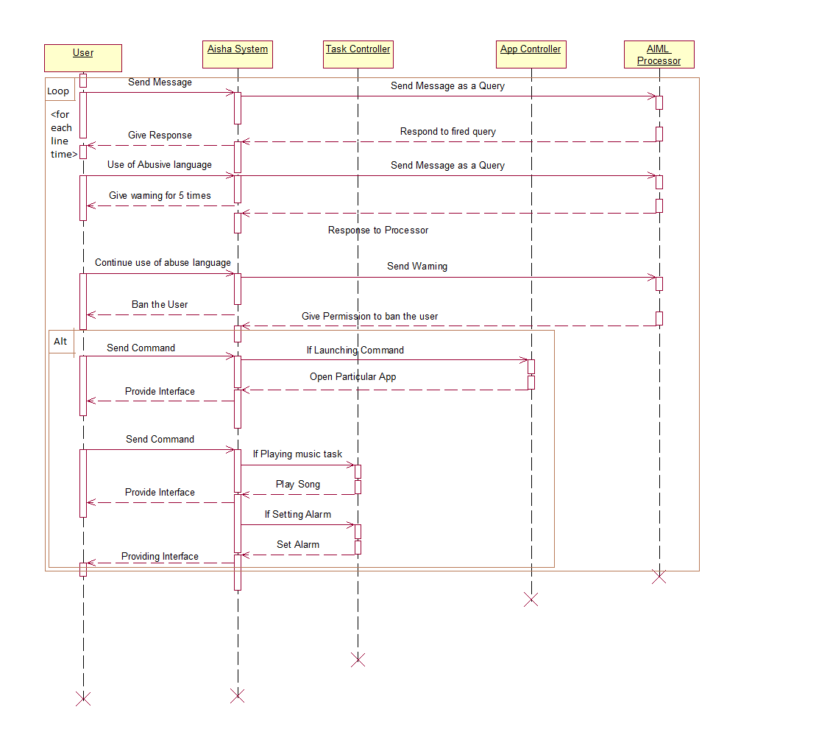

*Figure 5.1: sequence diagram for admin*

**3.2 Use case Diagram**



*Figure 5.2: use case diagram*

**3.3 Activity Diagram**

*Figure 5.3: Activity diagram*

### 4. Technical Specification

### 4.1 Used programming languages

### Java-

Java is a set of several computer software and specifications developed by Sun Microsystems later acquired by Oracle Corporation that provides a system for developing application software and deploying it in a cross-platform computing environment. Java is used in a wide variety of computing platform from embedded devices and mobile phones to enterprise servers and supercomputers. While less common, Java applets run in secure, sandboxed environments to provide many features of native applications and can be embedded in HTML pages.

Writing in the Java programming language is the primary way to produce code that will be deployed as byte code in a Java Virtual Machine (JVM); byte code compilers are also available for other languages, including Ada, JavaScript, Python, and Ruby. In addition, several languages have been designed to run natively on the JVM, including Scale, Closure and Groovy. Java syntax borrows heavily from C and C++, but object-oriented features are modeled after Smalltalk and Objective. Java eschews certain low-level constructs such as pointers and has a very simple memory model where every object is allocated on the heap and all variables of object types are references. Memory management is handled through integrated automatic garbage collection performed by the JVM.

On November 13, 2006, Sun Microsystems made the bulk of its implementation of Java available under the GNU General Public License (GPL).

**Android-**

Android is a mobile operating system (OS) based on Linux Kernel and currently developed by Google. With a user interface based on direct manipulation, Android is designed primarily for touchscreen mobile devices such as smartphones and tablet computers, with specialized user interfaces for televisions (Android TV), cars (Android Auto), and wrist watches (Android Wear). The OS uses touch inputs that loosely correspond to real-world actions, like swiping, tapping, pinching and reverse pinching to manipulate on-screen objects, and a virtual keyboard. Despite being primarily designed for touchscreen input, it also has been used in game consoles, digital cameras, regular PCs (e.g. the HP Slate21) and other electronics.

**AIML -**

AIML (Artificial Intelligence Markup Language) is an XML-compliant language that's easy to learn, and makes it possible for you to begin customizing a chatbot or creating one from scratch within minutes.The AIML was developed by Richard Wallace.

The AIML set was released under the GNU GPL, and therefore most AIML interpreters are offered under a free or open source license. Free AIML sets in several languages have been developed and made available by the user community. There are AIML interpreters available in Java, Ruby, Python, C++, C#, Pascal, and other languages. A semi-formal specification and a W3C XML Schema for AIML are available.

The most important units of AIML are:

* < aiml >: the tag that begins and ends an AIML document
* <category>: the tag that marks a "unit of knowledge" in an Alicebot’ s knowledge base
* <pattern>: used to contain a simple pattern that matches what a user may say or type to an Alicebot
* <template>: contains the response to a user input

There are also 20 or so additional more tags often found in AIML files, and it's possible to create your own so-called "custom predicates".

**4.2 Used software**

**Eclipse-**

In computer programming, Eclipse is an integrated development environment (IDE). It contains a base workspace and an extensible plug-in system for customizing the environment. Written mostly in Java, Eclipse can be used to develop applications. By means of various plug-ins, Eclipse can be used to develop applications in other programming languages: Ada, ABAP, C, C++, COBOL, FORTRAN, Haskell, JavaScript, Lasso, Natural, Perl, PHP, Prolog, Python, R, Ruby, Scale, Closure, Groovy, Scheme, and Erlang. It can also be used to develop packages for the software Mathematics. Development environments include the Eclipse Java Development tools (JDT) for Java and Scale, Eclipse CDT for C/C++ and Eclipse PDT for PHP, among others. The initial codebase originated from IBM Visual Age. The Eclipse Software Development Kit (SDK), which includes the Java development tools, is meant for Java developers. Users can extend its abilities by installing plug-ins written for the Eclipse Platform, such as development toolkits for other programming languages, and can write and contribute their own plug-in modules.

**Genymotion-**

Genymotion is a relatively fast Android emulator which comes with pre-configured Android (x86 with OpenGL hardware acceleration) images, suitable for application testing. The project has evolved from the old Android VM and comes with a new player design and installer.

Genymotion Features:

* Easily download and run pre-configured virtual images: covering a range of Android versions from 2.x onwards, and various phone and tablet screen sizes.
* Networking: Ethernet (emulates WiFi connection)
* GPS (with configurable coordinates) and battery (with configurable battery levels) emulation widgets.
* Display: OpenGL hardware acceleration, multiscreen, full screen display
* Genymotion shell which allows you to interact with your VM using a command line
* ADB support
* Eclipse and Android Studio plugins
* Supports Linux, Windows and Mac.
* "Drag & Drop" APK installs
* "Drag & Drop" Zip support for system updates/patches

**5. Software Implementation**

#### 5.1 Problem Statement

Create an application for Android Mobile, with all the specifications and features mentioned earlier.

#### 5.2 System Architecture

MainActivity.java is the main class for running application. ChatMessage.java and ChatArrayAdapter.java classes are used to display conversation between user and system i.e. virtual personality Aisha. FetchSong.java is used to search every song present in mobile and play it. Music.java is another main activity used display all the list of songs searched by system according to users input. Same way FetchVideo.java and OpenVideo.java works. Browser.java is used when user want to search something on web.

**6. Result Snapshot**

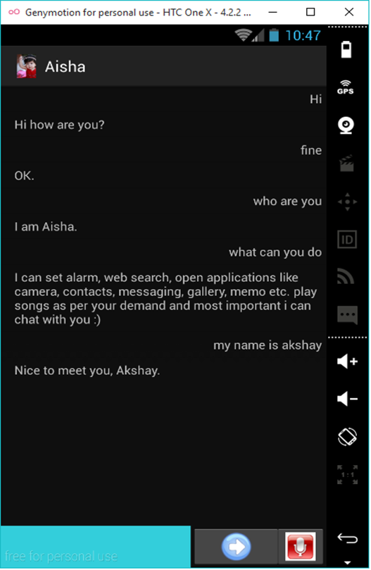

**6.1 Chatting session**

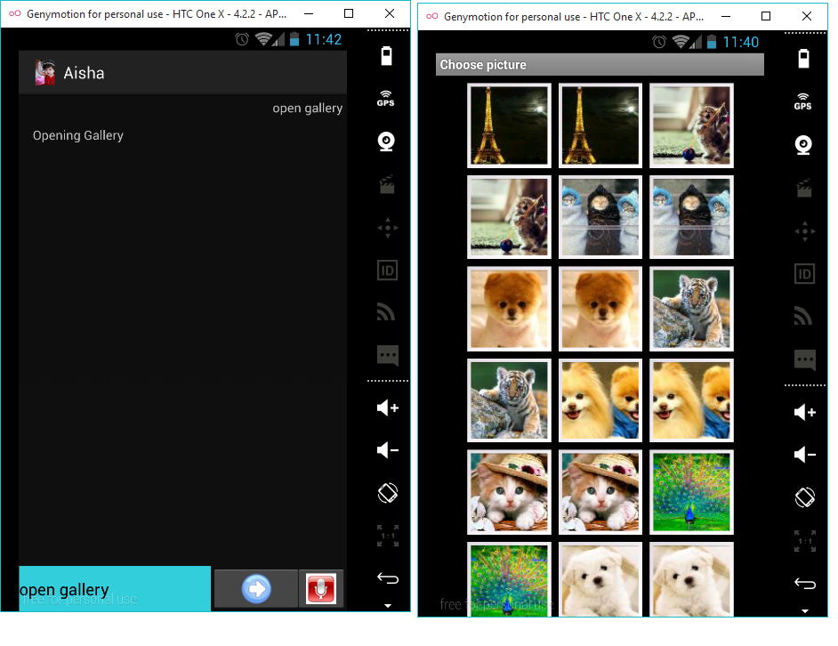

**6.2 opening Gallery**

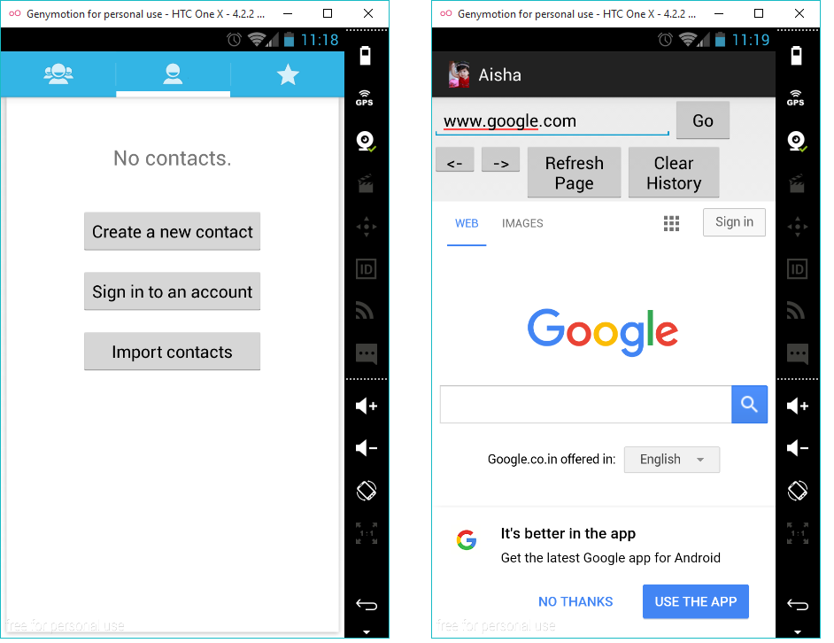

**6.3 Opening contacts and Web Browser**

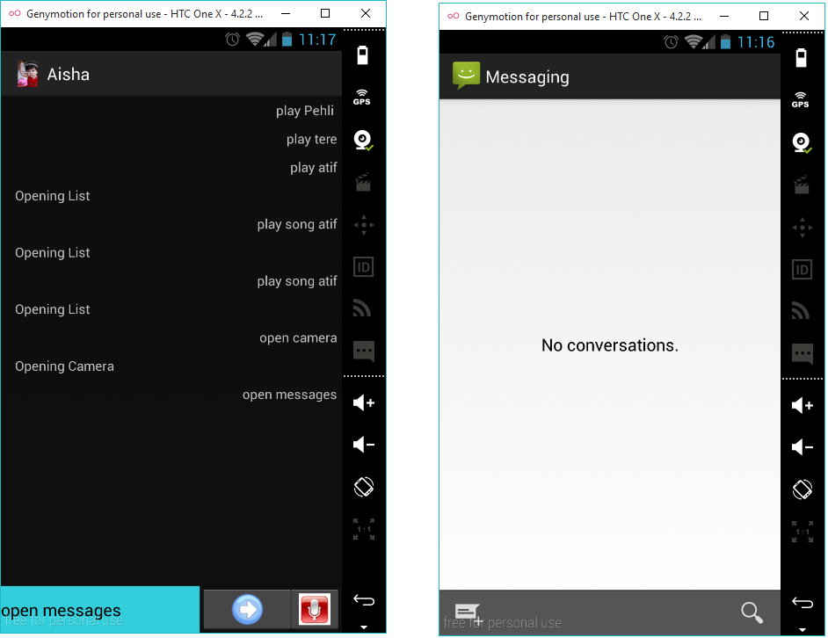

**6.4 opening message**

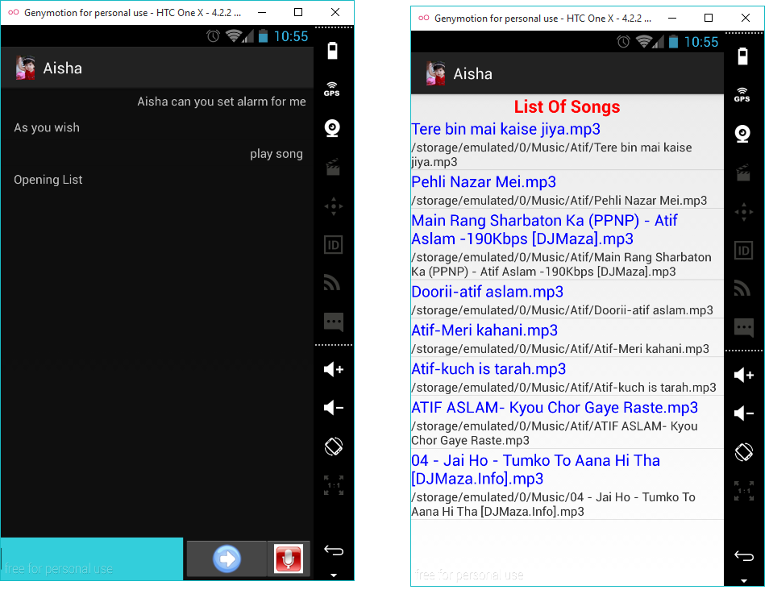

**6.6 Opening List of Songs**

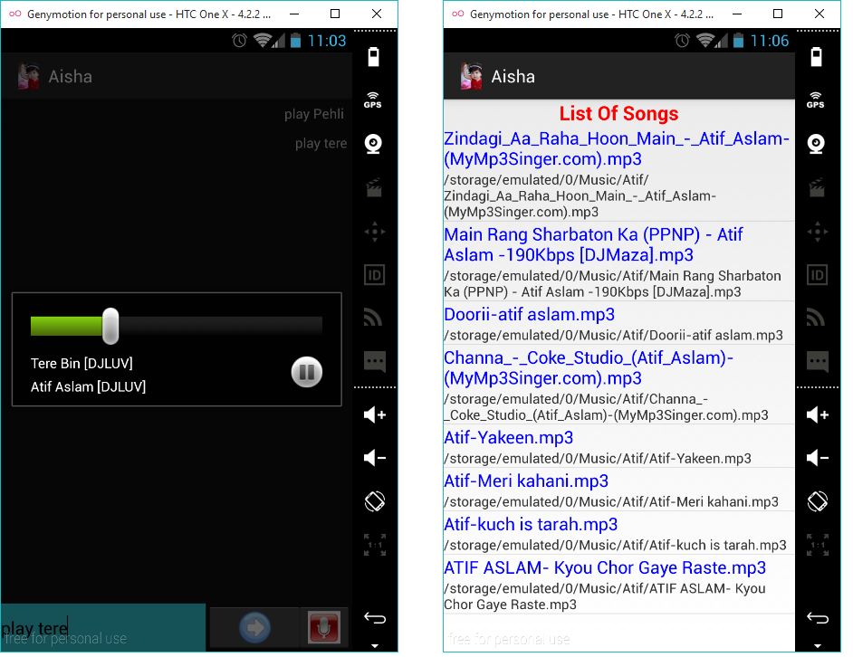

**6.7 Playing Songs**

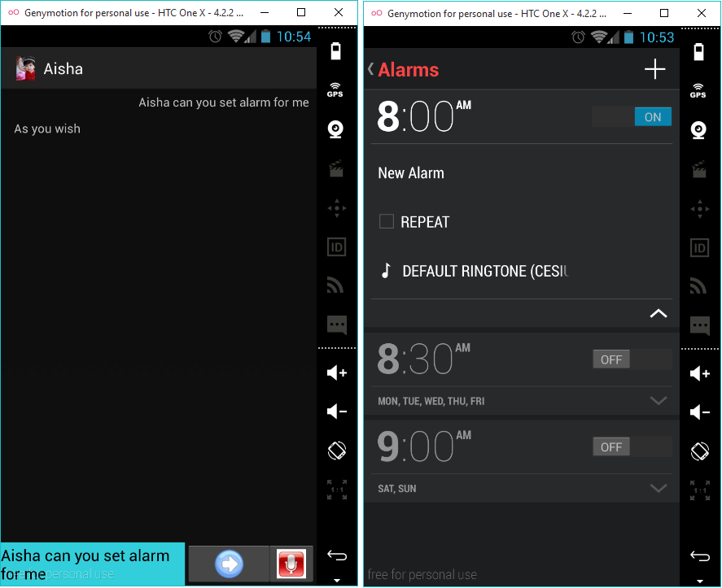

**6.8 Set alarm**

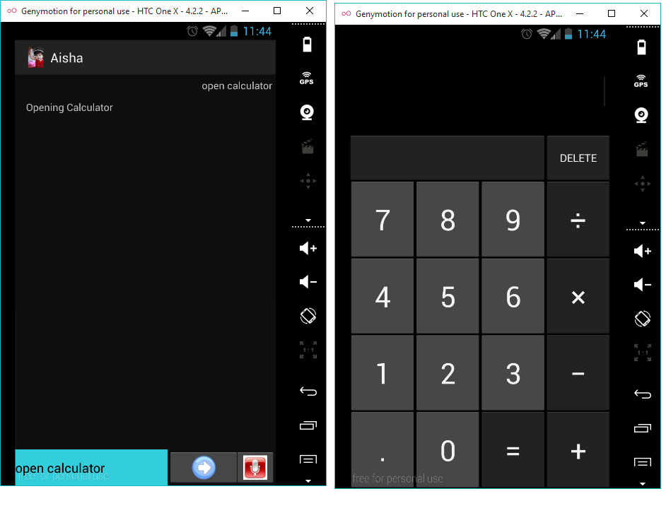

**6.9 Opening Calculator**

### 7. Conclusion and Future Work

**7.1 Conclusion**

So this project is used to set the discount according to different products. This app is useful for the people who want their own assistant. Using this app they can play the songs and videos , it can set alarms, Open applications like camera, gallery, messages, Contacts, Web Browser, and all other installed applications like whatsapp, facebook etc, also can Chat with you as a friend.

**7.2 Future Work**

1. Adding more functionalities like full control of mobile.
2. Making application work in background
3. Enhancing Aisha’s current database.

**8. References**

* www.alicebot.org
* www.tutorialspoint.com/aiml
* developer.android.com
* alice.pandorabots.com