Datastructures And Algorithms
CS 202
Assignment-1 Report
Sorting Algorithms:
1) Insertion Sort:
T(n) = O(n^2);
S(n) = O(1)
PseudoCode:
for j = 2 to n
key = A [j]
j = i – 1
while i > 0 and A[i] > key
A[i+1] = A[i]
i = i – 1
A[j+1] = key
Remarks:
Insertion sort is based on the idea that one element from the input elements is consumed in each iteration to find its correct position. In class it was demonstrated with the example of cards picked in the sorted order.

2) Merge Sort:
T(n) = O(nlogn)
S(n) = O(n)
PseudoCode:
Merge (A, p, q, r):
- n1= q – p +1
n2= r – q
let L [1.. n1+ 1 ] and L [1.. n2+ 1 ] be new arrays
for i=1 to n1
L[ i ] = A [ p + i -1]
for j=1 to n2
R[ j ]= A[ q + j ]
L [n1+ 1 ] = infinity
R [n2+ 1 ] = infinity
i = 1
j = 1
for k = p to r
if L[ i ]<R [ j ]
A[ k ] = L[ i ]
i = i + 1
else A[ k ] = R [ j ]
j = j + 1

MergeSort(A,low,high):
if low<high:
mid = (low+high)/2
MergeSort(A,low,mid)
MergeSort(A,mid+1,high)
Merge(A,low,mid,high)
Remark:
It is based on divide and conquer strategy.
3) Quick Sort:
T(n)(worst) = O(n^2), average = O(nlogn)
S(n) = O(1)
PseudoCode:
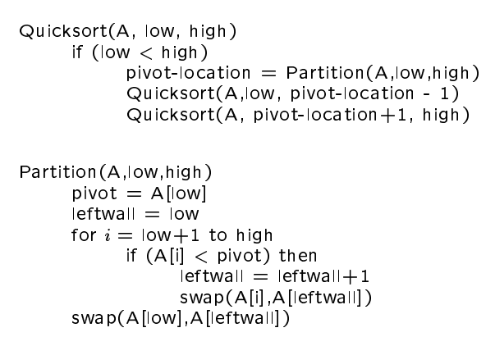

Remark:
It is also based on divide and conquer strategy.

4) Heap Sort:
T(n) = O(nlogn)
S(n) = O(n)
pseudoCode:
Heapsort(A)
BuildHeap(A)
for i <- length(A) downto 2 {
exchange A[1] <-> A[i]
heapsize <- heapsize -1
Heapify(A, 1)
BuildHeap(A)
heapsize <- length(A)
for i <- floor( length/2 ) downto 1
Heapify(A, i)
Heapify(A, i)
le <- left(i)
ri <- right(i)
if (le<=heapsize) and (A[le]>A[i])
largest <- le
else
largest <- i
if (ri<=heapsize) and (A[ri]>A[largest])
largest <- ri
if (largest != i) {
exchange A[i] <-> A[largest]
Heapify(A, largest)

Remark:
The children of each node is smaller then itself. Root is the max value of the array. Balance factor = {1,0}

