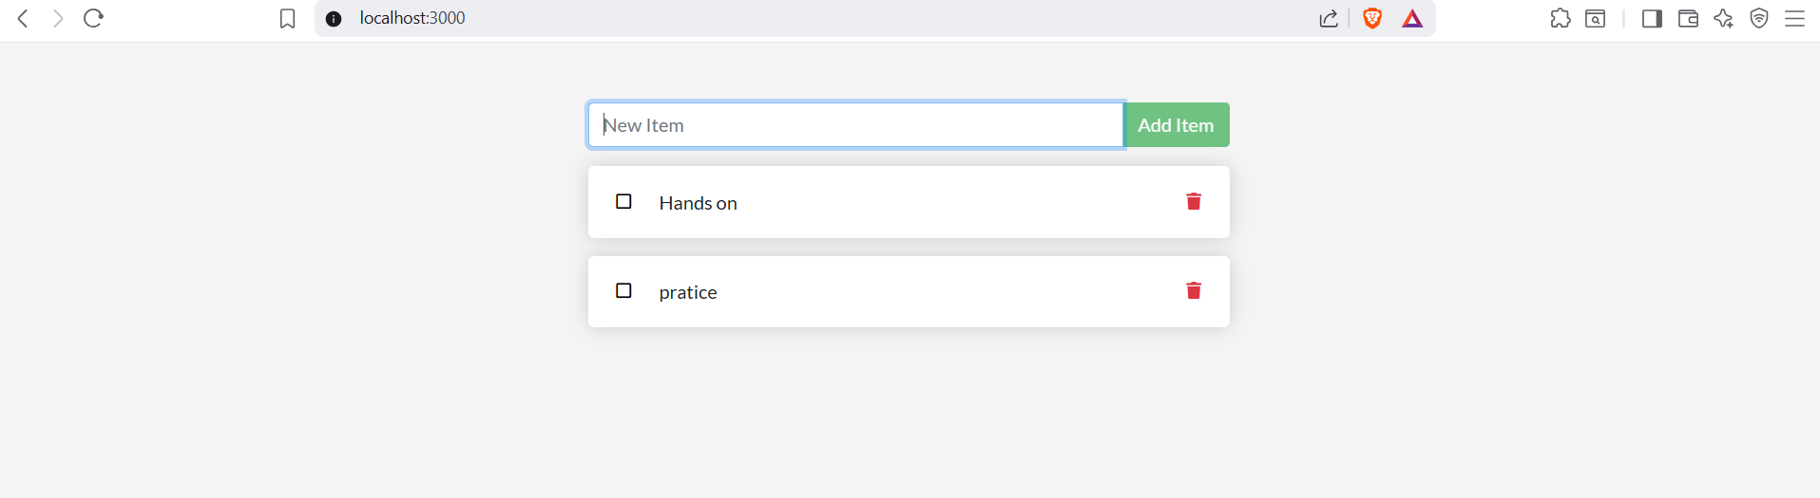

**Update the application**

Update the Source Code:

Open the file **src/static/js/app.js** in a text editor.

change the text from No items yet! Add one above! to You have no todo items yet! Add one above!.

Build the New Image:

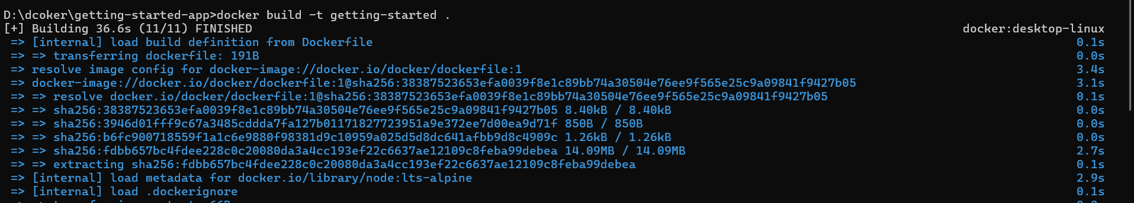

Stop and Remove the Old Container:





Run the Updated Application:

docker run -dp 127.0.0.1:3000:3000 getting-started



**Share the application**

Create a Repository on Docker Hub

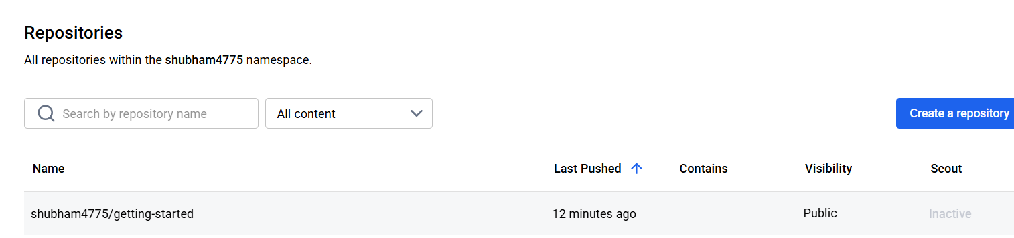

Sign In and Tag Your Image

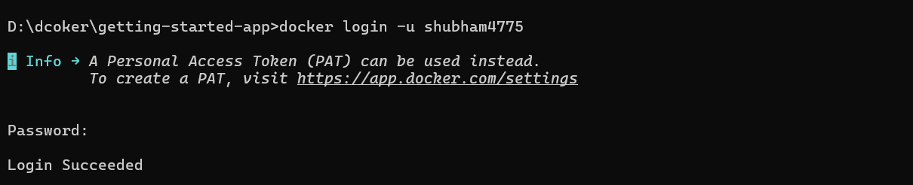

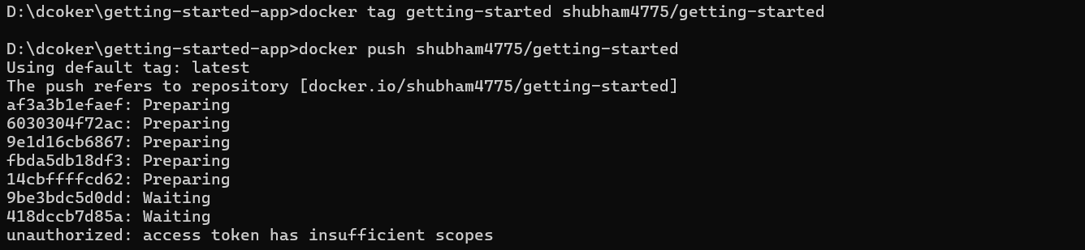

Push the Image to Docker Hub

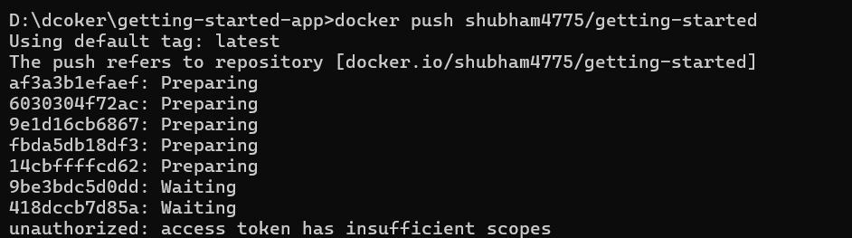

Run the Image on a New Instance



**Persist the DB**

The container filesystem:

**docker run --rm alpine touch greeting.txt**

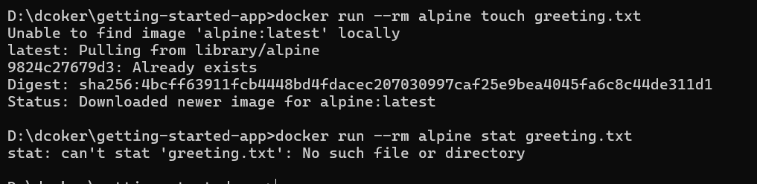

Create a Docker Volume



Stop the Old Container

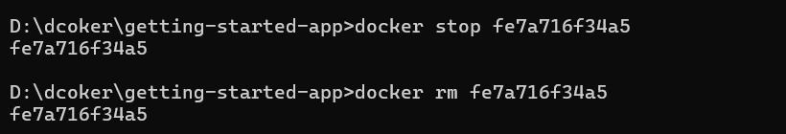

Run a New Container with the Volume



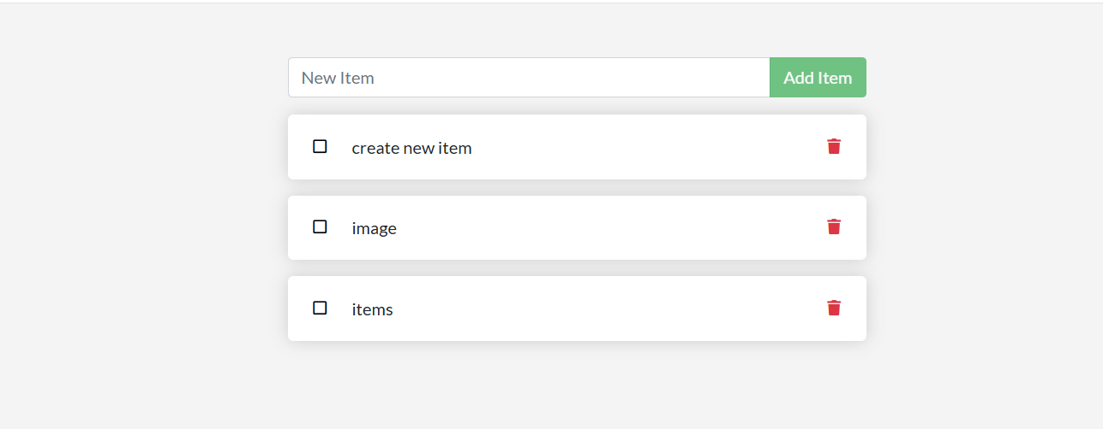

Verify That the Data Persists

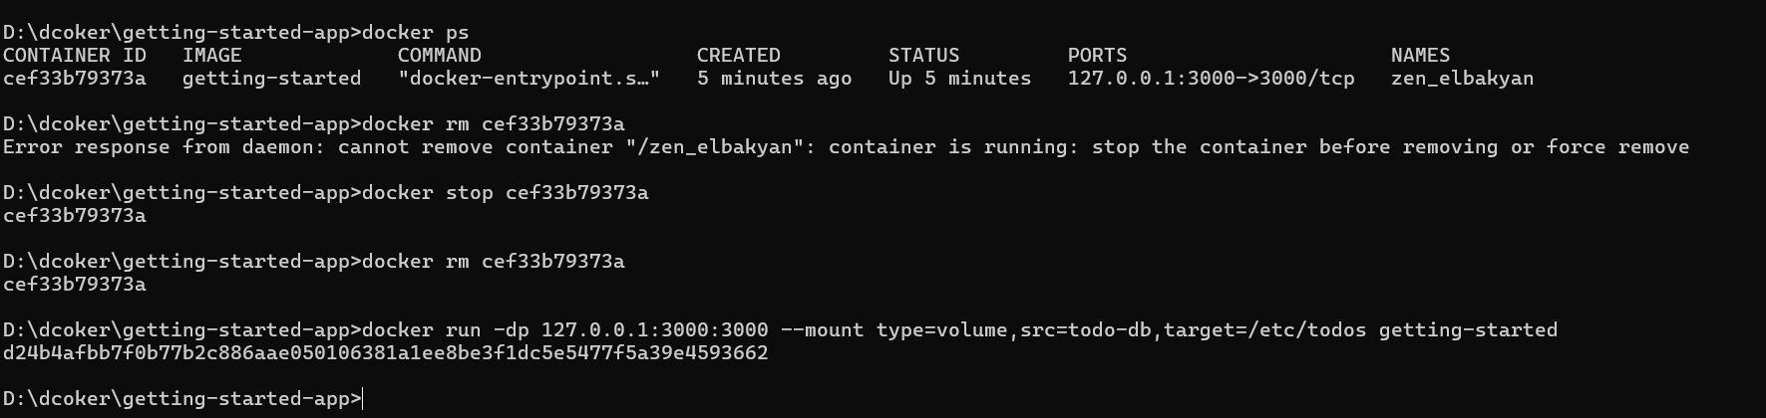

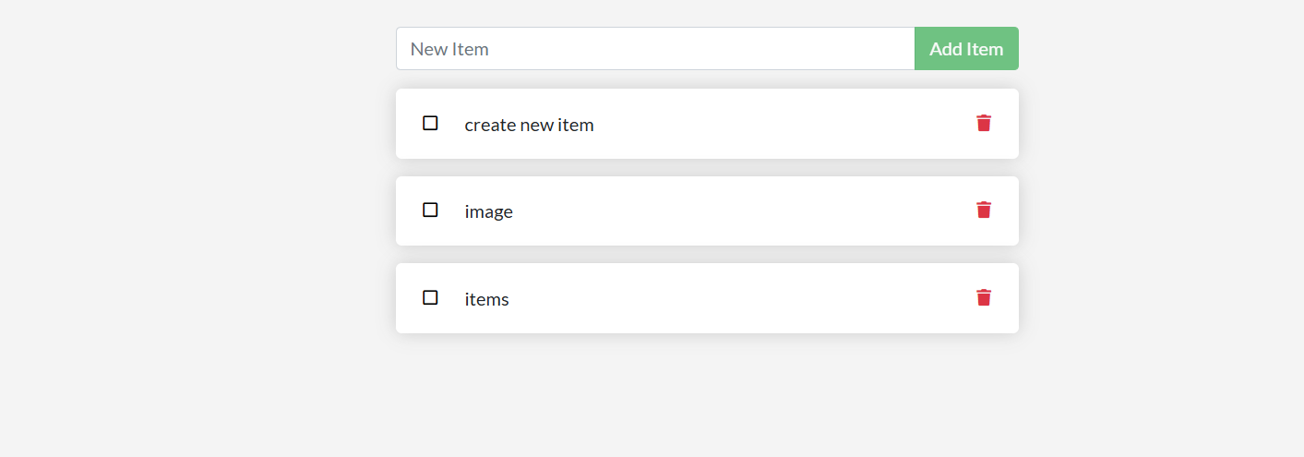

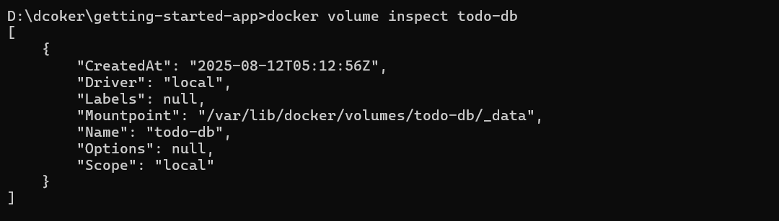

**Use bind mounts**

Trying out bind mounts:

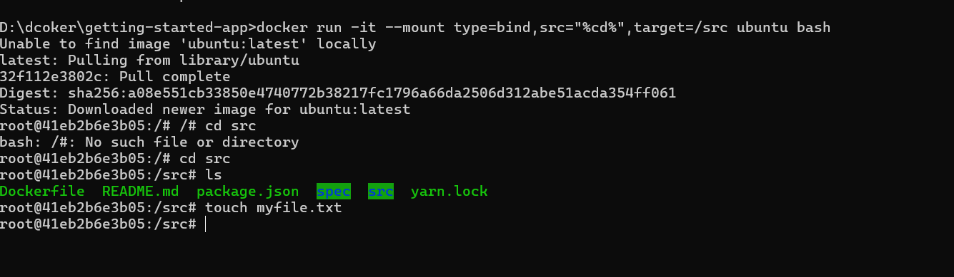

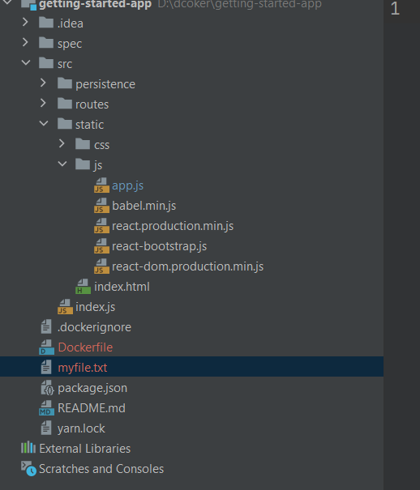

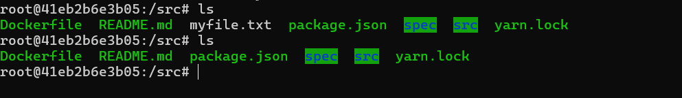

Development containers:

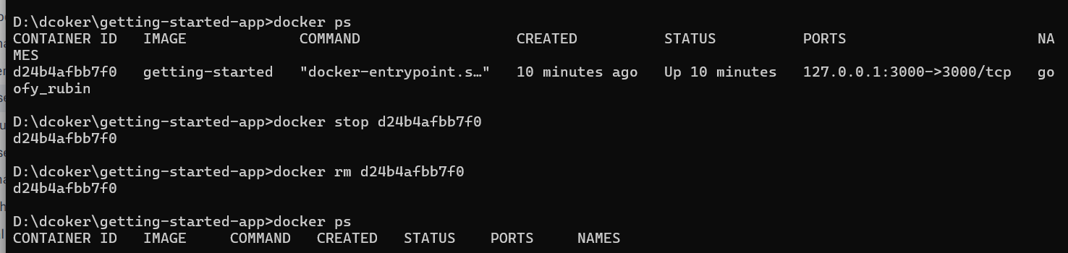

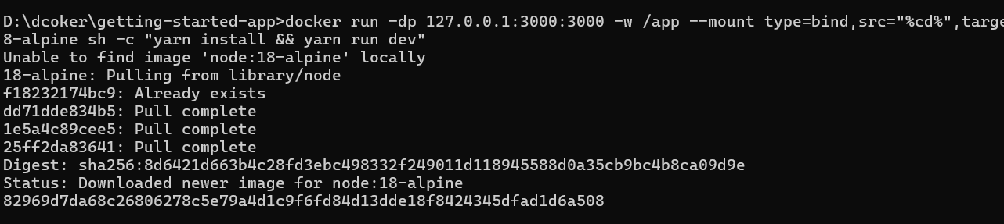

Logs:

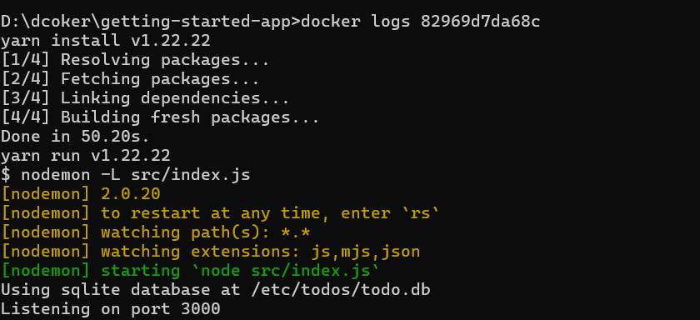

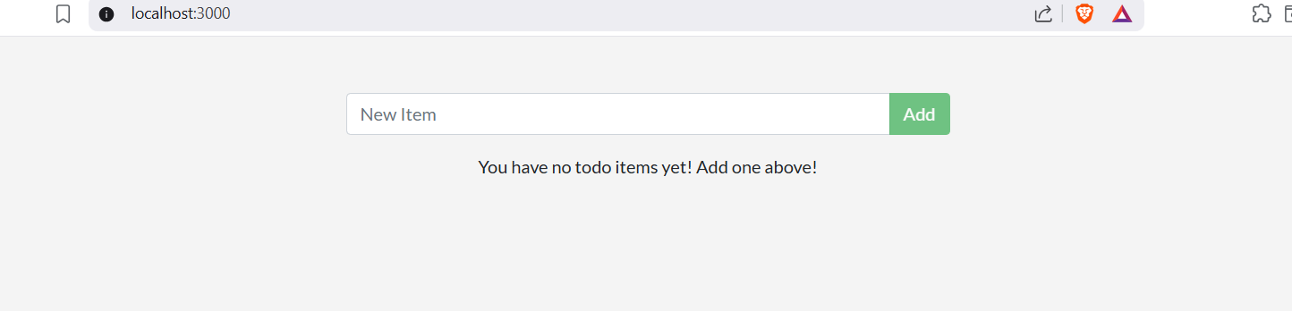

**Multi container apps :**

Start mysql

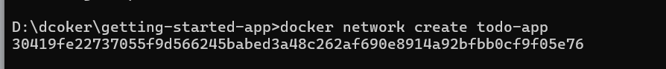

Run mysql :

docker run -d --network todo-app --network-alias mysql -v todo-mysql-data:/var/lib/mysql -e MYSQL_ROOT_PASSWORD=secret -e MYSQL_DATABASE=todos mysql:8.0



Verify the database connection:

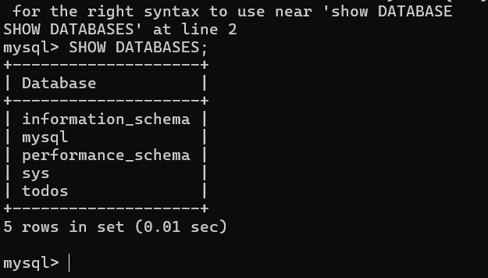

Connect to MySQL:



Added some items

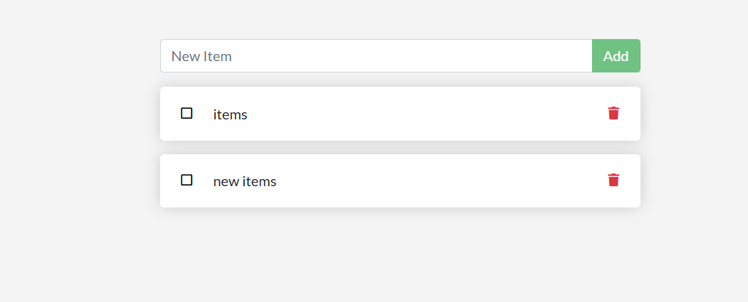

DB items added in table   
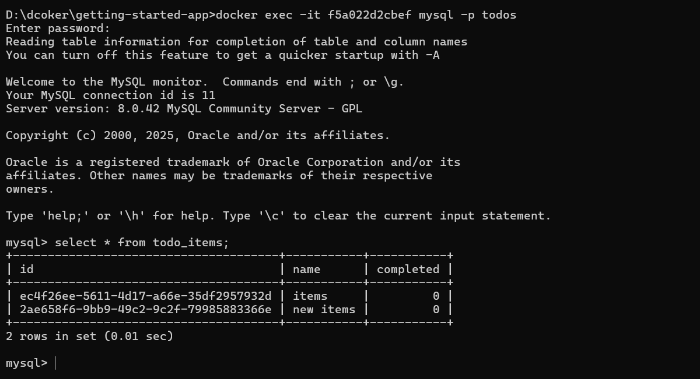

**Use Docker Compose**

Create compose.yaml file in application

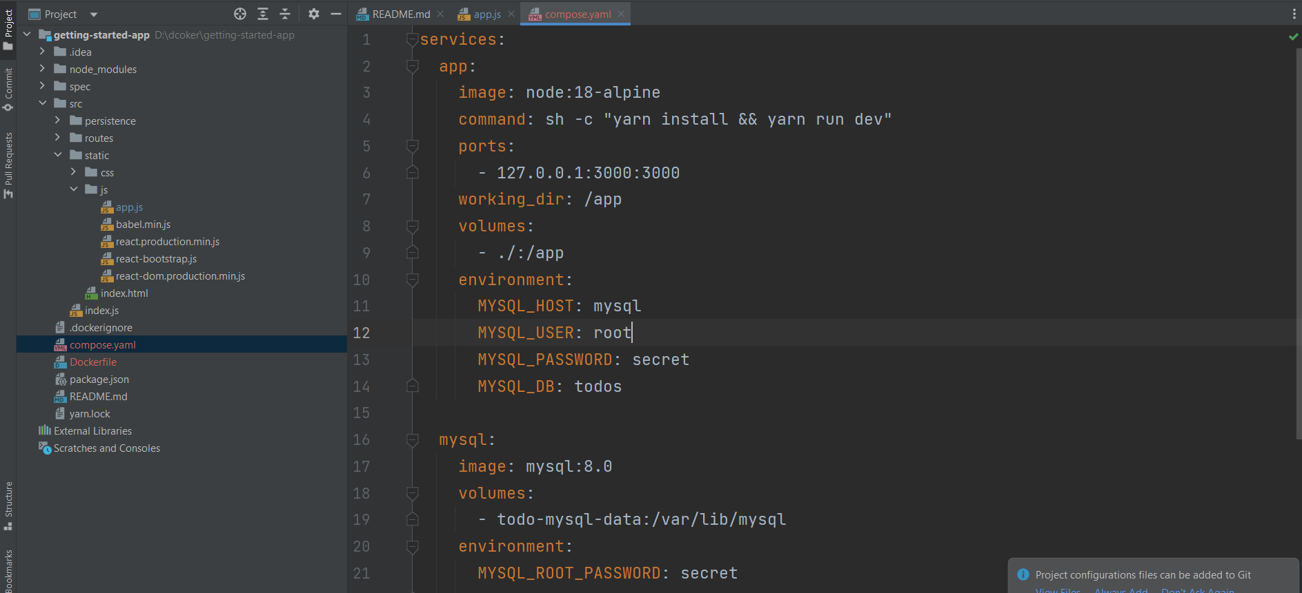

Running the application



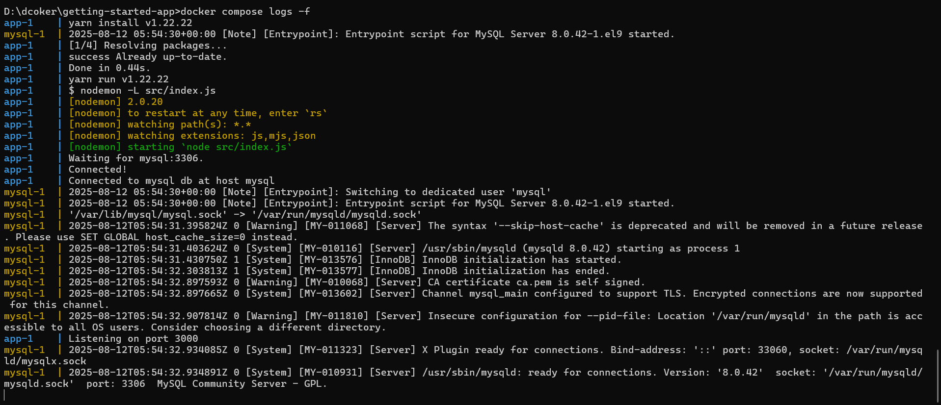

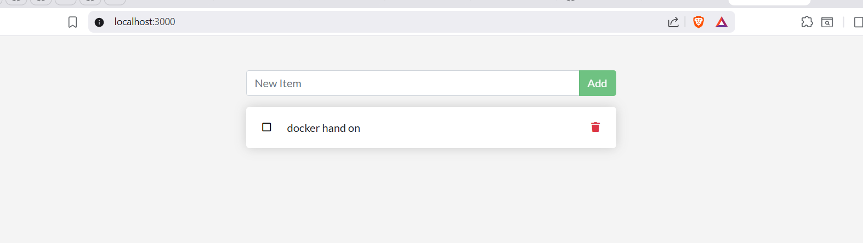

Stopping the docker compose



**Image-building best practices**

Image Layering

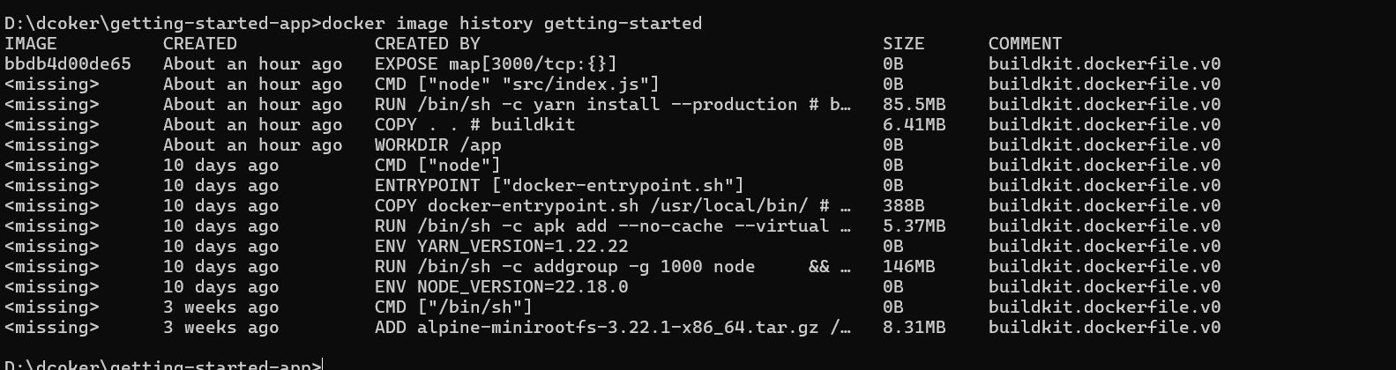

Layer cashing

Updated dockerfile and build new image

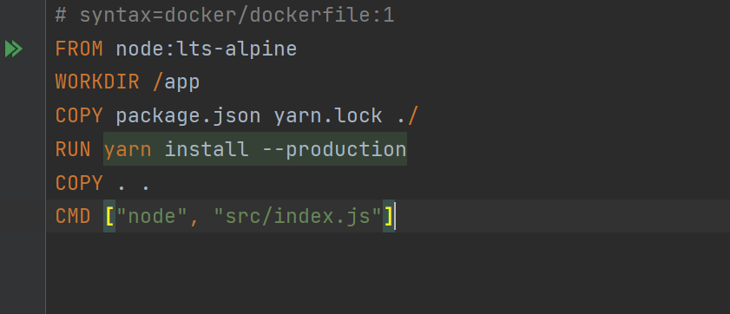

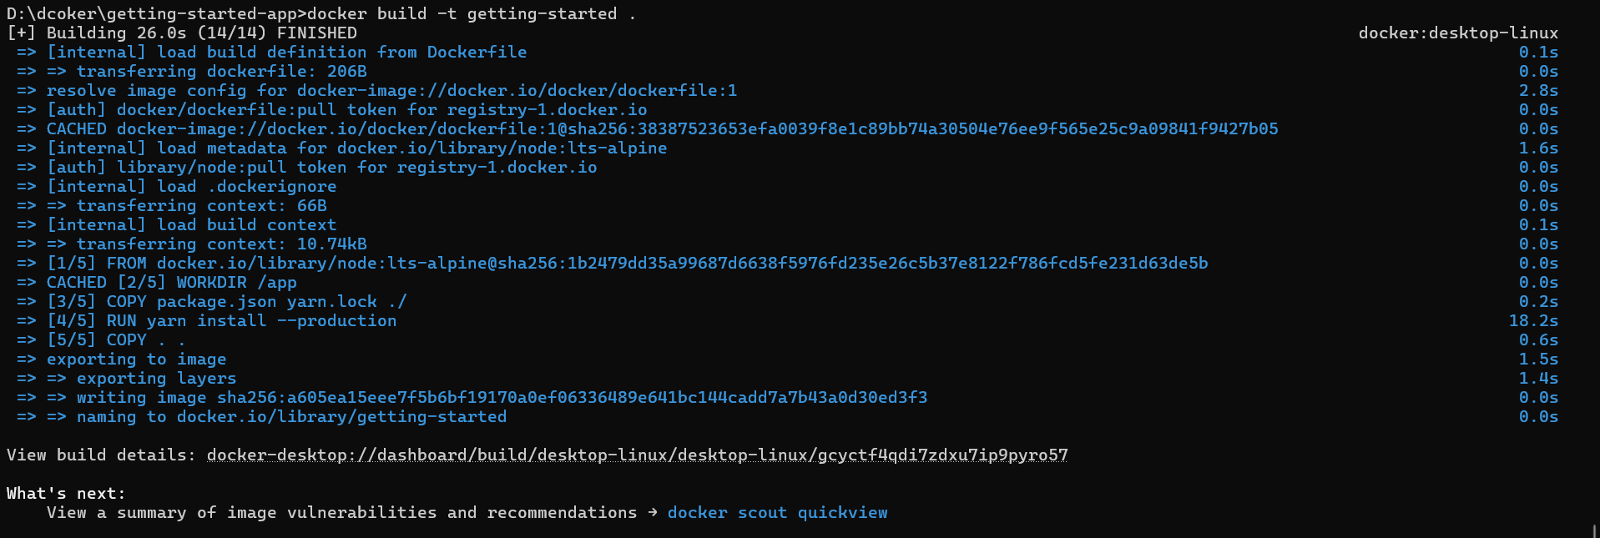

Updated the title in index.html  
