 Department of Information Technology
Semester | T.E. Semester V
Subject | Operating System
Subject Professor In-charge | Prof. Harshali Rambade
Laboratory | L05B

Student Name | Chetana P. Tambe
Roll Number | 12101A0022
Grade and Subject Teacher’s Signature

Experiment No | 4
Aim | Write a program to implement Simulation of Round Robin scheduling algorithm with priority
Resources / Apparatus Required | Hardware:  Computer System | Software:  Java
Objectives  (Skill Set / Knowledge Tested / Imparted) | To learn that Round Robin with Priority reduces the problem of starvation as the processes with less remaining CPU burst time are assigned with the higher priorities and are executed first.
Theory of Operation | The proposed Priority based Round-Robin CPU Scheduling algorithm is based on the integration of round-robin and priority scheduling algorithm. It retains the advantage of round robin in reducing starvation and also integrates the advantage of priority scheduling. The proposed algorithm also implements the concept of ageing by assigning new priorities to the processes. Existing round robin CPU scheduling algorithm cannot be implemented in real time operating system due to their high context switch rates, large waiting time, large response time, large turnaround time and less throughput. The proposed algorithm improves all the drawbacks of round robin CPU scheduling algorithm.  Case:  Consider five processes viz. A, B, C, D and E with given CPU burst time and associated priorities. Let the time quantum is 5 ms.  Table for Input component for the processors  Priority based Round Robin CPU scheduling consists of two rounds:  Round 1: Process with the highest priority is executed first for the time equal to given time quantum i.e. 5ms. In the same manner other processes are executed according to their priorities for single time quantum. Eg: The sequence of execution for above case is:  Table for Executed CPU burst for first round  Round 2: This round includes the changing of process’s priorities according to the remaining CPU Burst Time. The process with least remaining CPU Burst Time is assigned highest priority. The new assigned priorities are as follows:  Table for Remaining CPU burst for second round & new assigned priorities  Now the processes are executed according to the new priority assigned without taking consideration of time quantum.  Gantt chart:  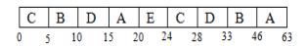  Number of context switches: 8  Average waiting Time: 26.200001 ms  Average Turnaround Time: 38.800000 ms
  Process Name | CPU Burst Time (ms) | Priority
  A | 22 | 4
  B | 18 | 2
  C | 9 | 1
  D | 10 | 3
  E | 4 | 5
  S.No | Process | Executed Burst | Priority
  1 | C | 5 | 1
  2 | B | 5 | 2
  3 | D | 5 | 3
  4 | A | 5 | 4
  5 | E | 4 | 5
  S.No | Process | Remaining Burst | Priority
  1 | C | 4 | 1
  2 | D | 5 | 2
  3 | B | 13 | 3
  4 | A | 17 | 4
Code/ Experiment performed | import java.util.*;  class process1  {  public static void main(String args[])throws Exception  {  Scanner sc=new Scanner(System.in);  int bur[],rem[],wai[],ta[],p[],p1[];  int size=0,q,b=0,t=0,flag=0,temp=0;  System.out.print("Enter the no of process:");  size=sc.nextInt();  bur=new int[size];  wai=new int[size];  ta=new int[size];  p=new int[size];  rem=new int[size];  p1=new int[size];  System.out.print("Enter burst time:");  for(int i=0;i<size;i++){  bur[i]=sc.nextInt();  }  System.out.print("Enter priority:");  for(int i=0;i<size;i++){  p[i]=sc.nextInt();  }  for(int i=0;i<size;i++){  p1[i]=i;  }  System.out.print("Enter quantum time:");  q=sc.nextInt();  for(int k=0;k<size;k++){  for(int l=k+1;l<size;l++){  if(p[k]>p[l]){  temp=p[k];  p[k]=p[l];  p[l]=temp;  temp=p1[k];  p1[k]=p1[l];  p1[l]=temp;  temp=bur[k];  bur[k]=bur[l];  bur[l]=temp;  }  }  }  for(int i=0;i<size;i++){  rem[i]=bur[i];  }  do{  flag=0;  for(int i=0;i<size;i++){  if(rem[i]>=q){  for(int j=0;j<size;j++){  if(j==i)  rem[i]=rem[i]-q;  else if(rem[j]>0)  wai[j]+=q;  }  }  else if(rem[i]>0){  for(int j=0;j<size;j++){  if(j==i)  rem[i]=0;  else if(rem[j]>0)  wai[j]+=rem[i];  } } }  for(int i=0;i<size;i++)  if(rem[i]>0)  flag=1;  }while(flag==1);  for(int i=0;i<size;i++)  ta[i]=wai[i]+bur[i];  System.out.println("\nProcess\tPriority\tBurst time\tWaiting time\tTurnaroundtime");  for(int i=0;i<size;i++){  System.out.println("P"+p1[i]+"\t"+p[i]+"\t\t"+bur[i]+"\t\t"+wai[i]+"\t\t"+ta[i]); b+=wai[i];  t+=ta[i];  }  System.out.println("Average waiting time:"+(b/size));  System.out.println("Average Turnaround time:"+(t/size));  }  }
Output/ Screenshots | 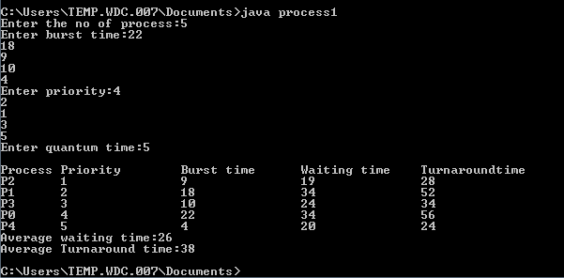
Conclusion | Thus Round Robin with priority is more efficient because it has less average waiting  time, average turnaround time and number of context switches as compared to simple round robin, in turn reducing the operating system overhead and hence dispatch latency.

