R Programming
Unit 1 - Assignment 1
Air Quality Analysis - Practical Assignment

Subject | R Programming
Unit | Unit 1 - Introduction to R
Assignment | Assignment 1 - Practical
MIS Number | 752562026

Task 1: Getting Started with RStudio
Open RStudio, create a new R Script file, and add the following header comments at the top. This is standard professional documentation practice.

# ===============================================================
# Project Title : Air Quality Analysis - Environmental Monitoring
# Student Name : Pawar Shubham Dilip
# Date : 29-03-2026
# Unit : Unit 1 - Introduction to R
# Description : Exploratory data analysis of airquality dataset
# to identify pollution patterns and risk periods.
# ================================================================

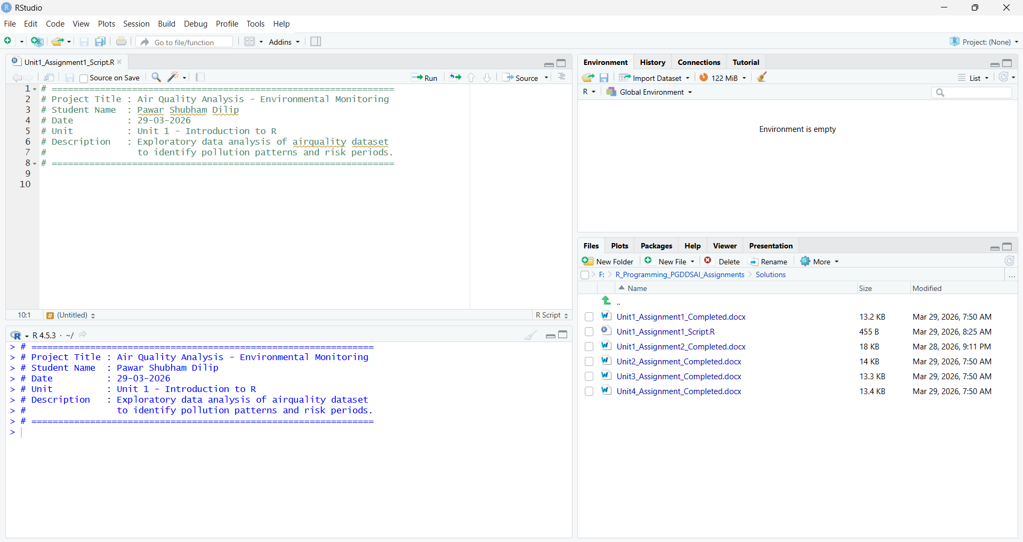
Task 2: Load and Explore the Dataset
Load the built-in airquality dataset and explore its structure. The dataset contains 153 observations of daily air quality measurements in New York.

# Load the built-in airquality dataset
data(airquality)

# Display the first 6 rows
head(airquality)
# Each row = one day of observation
# Columns: Ozone (ppb), Solar.R (lang), Wind (mph), Temp (°F), Month, Day

# View the dataset in tabular format (opens spreadsheet-like viewer in RStudio)
View(airquality)

# Summary statistics - min, max, mean, median, NA count for each column
summary(airquality)

# Column names
colnames(airquality)

# Structure of dataset - data types and sample values
str(airquality)

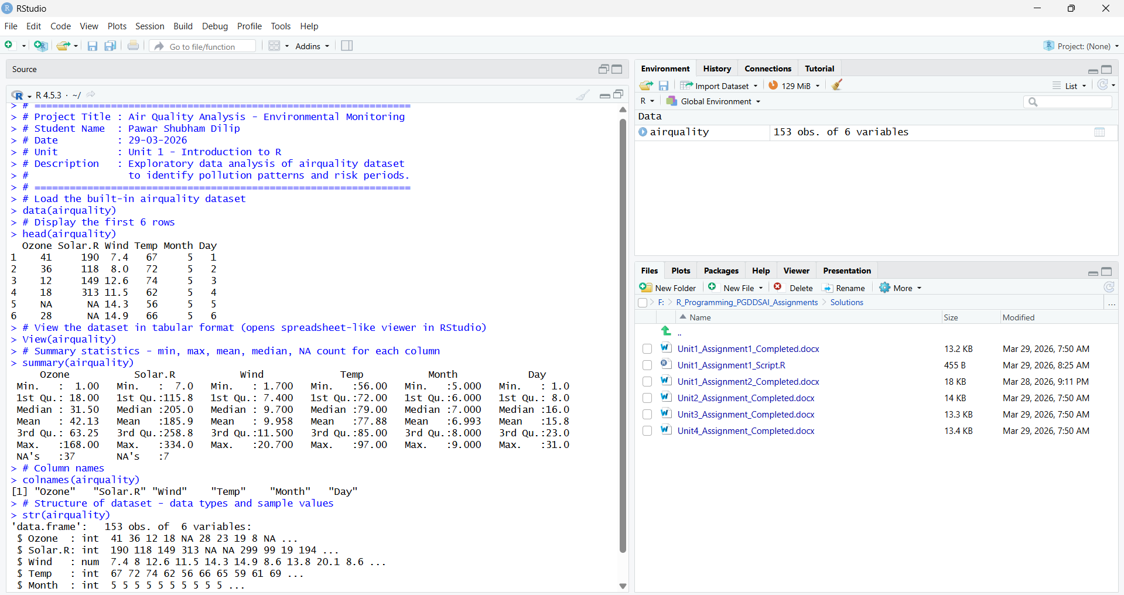

Task 3: Packages and Installation
Install and load the ggplot2 package for data visualization. Note: install.packages() downloads the package to disk (done once), while library() activates it for the current R session (done every session).

# STEP 1: Install the package (only once - downloads from CRAN)
# Run this line only the first time; comment it out after installation
install.packages("ggplot2")

# STEP 2: Load the package into the current session (every new session)
library(ggplot2)

# Verify the package is loaded
packageVersion("ggplot2") # Shows installed version

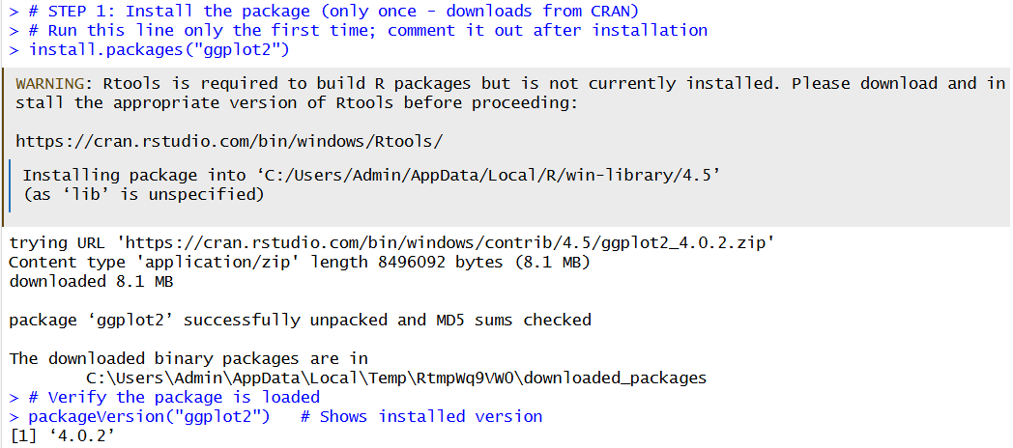

Task 4: Variables, Constants, and Strings
Define variables, constants (named by ALL_CAPS convention), and strings to store key analysis parameters.

# ── Variable: Store average temperature ──
avg_temp <- mean(airquality$Temp, na.rm = TRUE)
cat("Average Temperature (F):", round(avg_temp, 2), "\n")

# ── Constant: Safe ozone limit (defined by environmental standards) ──
SAFE_OZONE_LIMIT <- 70 # parts per billion (ppb) - EPA guideline

# ── String: Analysis context ──
CITY_NAME <- "New York"
ANALYSIS_YEAR <- "1973"
ANALYST_NAME <- "Environmental Data Analyst"

# Print all values
cat("City :", CITY_NAME, "\n")
cat("Analysis Year :", ANALYSIS_YEAR, "\n")
cat("Analyst :", ANALYST_NAME, "\n")
cat("Avg Temp (F) :", round(avg_temp, 2), "\n")
cat("Safe Ozone Lim:", SAFE_OZONE_LIMIT, "ppb\n")

# Check data type of each
class(avg_temp) # "numeric"
class(SAFE_OZONE_LIMIT) # "numeric"
class(CITY_NAME) # "character"

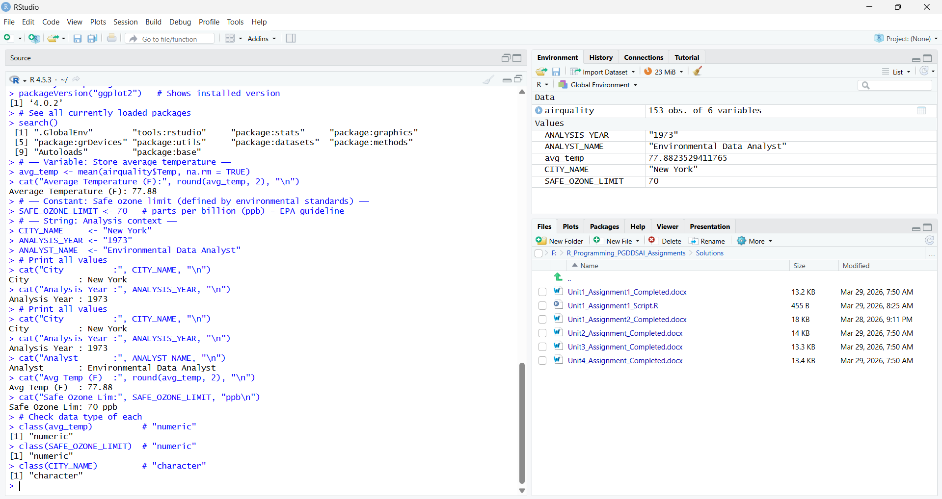

Task 5: Operators and Logical Conditions
Use logical operators and relational comparisons to identify safe vs. unsafe pollution days based on the defined ozone threshold.

# Remove rows with NA ozone values for this analysis
ozone_clean <- airquality$Ozone[!is.na(airquality$Ozone)]

# Identify days where ozone > safe limit (logical vector)
unsafe_days_logical <- ozone_clean > SAFE_OZONE_LIMIT

# Count unsafe and safe days
num_unsafe <- sum(unsafe_days_logical)
num_safe <- sum(!unsafe_days_logical)
total_days <- length(ozone_clean)

cat("Total days with ozone data:", total_days, "\n")
cat("Unsafe days (Ozone > 70 ppb):", num_unsafe, "\n")
cat("Safe days (Ozone <= 70 ppb):", num_safe, "\n")

# Calculate percentage
pct_unsafe <- round((num_unsafe / total_days) * 100, 1)
cat("Percentage of unsafe days :", pct_unsafe, "%\n")

# Show which rows in the original dataframe are unsafe
unsafe_records <- airquality[!is.na(airquality$Ozone) & airquality$Ozone > SAFE_OZONE_LIMIT, ]
cat("\nUnsafe day records (first 5):\n")
print(head(unsafe_records, 5))

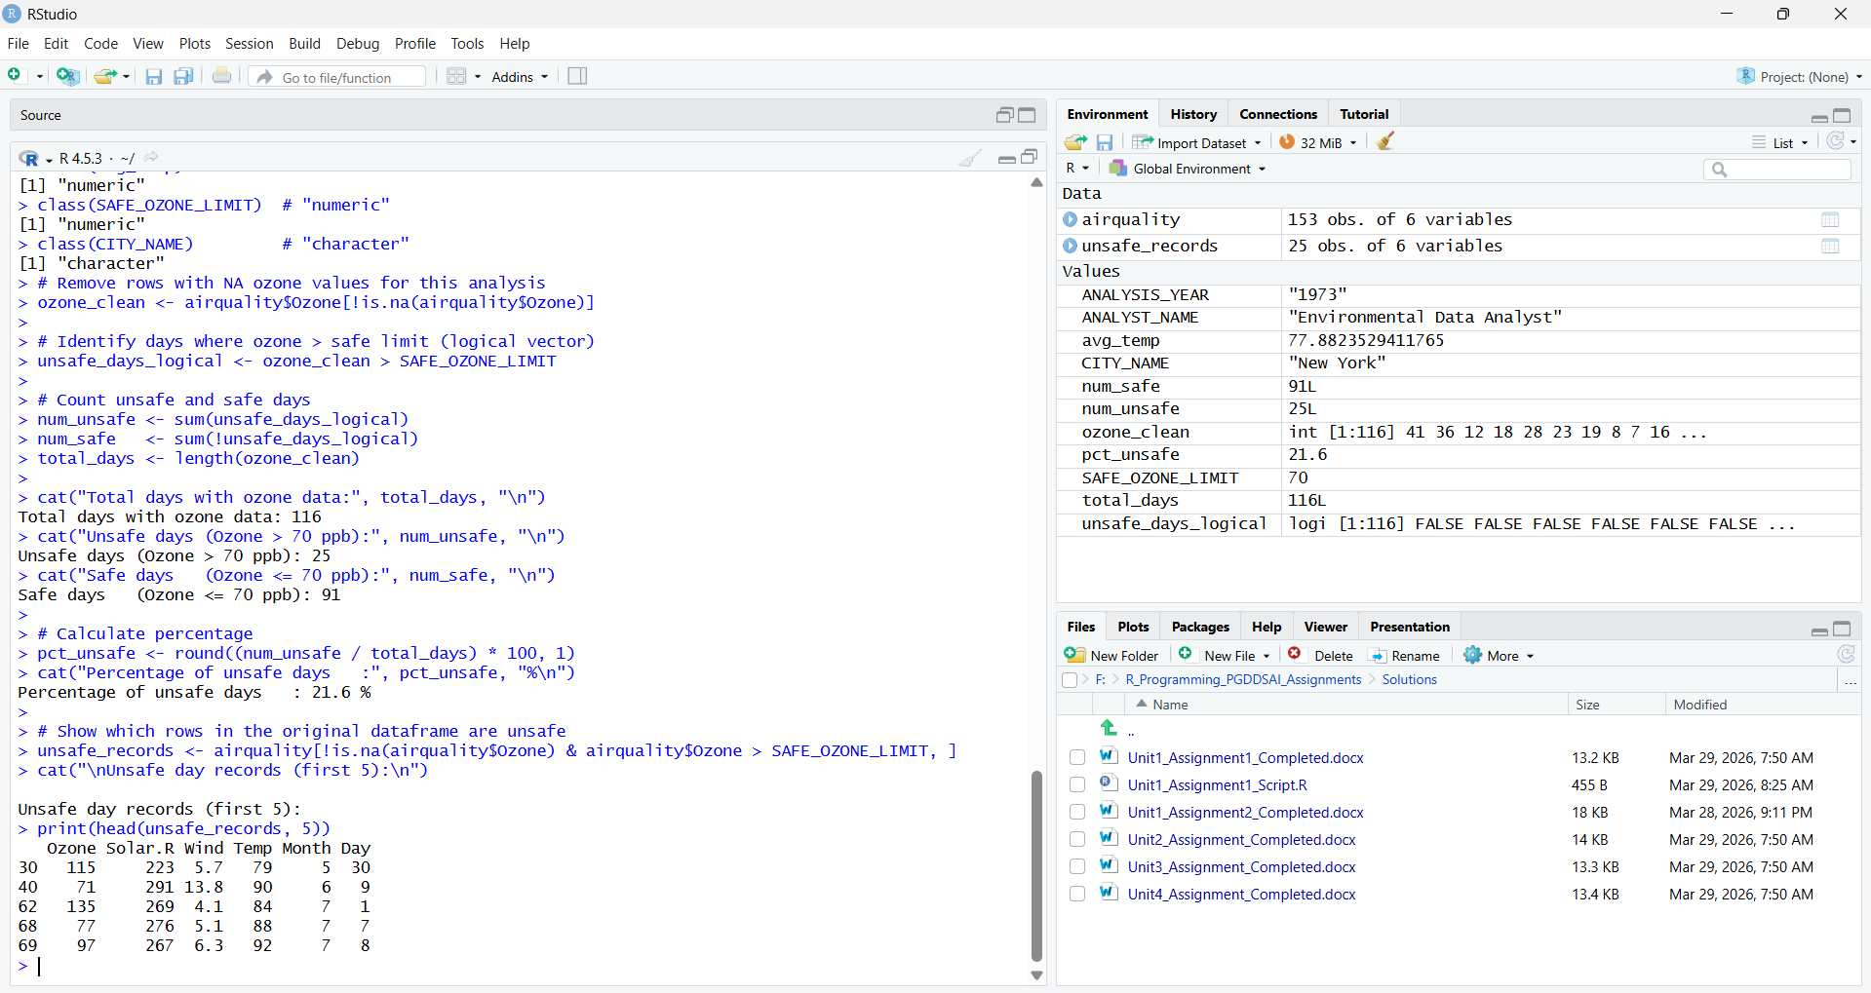
Task 6: Data Visualization
Create a professional scatter plot using ggplot2 showing the relationship between Temperature and Ozone levels. This visualization is suitable for presenting to environmental regulators.

library(ggplot2)

# Remove rows with NA in Ozone or Temp for clean plotting
aq_clean <- airquality[!is.na(airquality$Ozone) & !is.na(airquality$Temp), ]

# Create scatter plot
ggplot(aq_clean, aes(x = Temp, y = Ozone)) +
geom_point(aes(color = Ozone > SAFE_OZONE_LIMIT), size = 3, alpha = 0.7) +
scale_color_manual(
values = c("FALSE" = "steelblue", "TRUE" = "firebrick"),
labels = c("FALSE" = "Safe (<=70 ppb)", "TRUE" = "Unsafe (>70 ppb)")
) +
geom_hline(yintercept = SAFE_OZONE_LIMIT, linetype = "dashed",
color = "orange", linewidth = 1) +
geom_smooth(method = "lm", se = TRUE, color = "darkgreen", linetype = "solid") +
labs(
title = "Temperature vs Ozone Levels - New York (1973)",
subtitle = "Orange dashed line = Safe Ozone Limit (70 ppb)",
x = "Temperature (degrees Fahrenheit)",
y = "Ozone Level (ppb)",
color = "Air Quality Status"
) +
theme_minimal(base_size = 13) +
theme(
plot.title = element_text(face = "bold"),
plot.subtitle = element_text(color = "gray40")
)

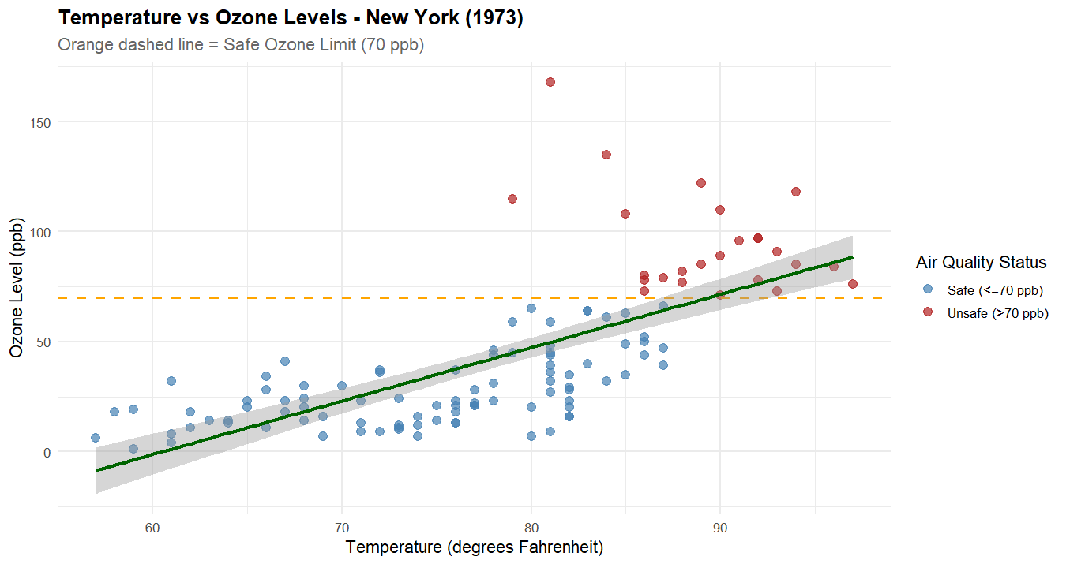

Task 7: Business Interpretation
The following comments in the R script provide a business-level interpretation of the findings:

# ── Business Interpretation ──

# 1. TEMPERATURE-OZONE RELATIONSHIP:
# There is a clear positive correlation between temperature and ozone levels.
# As temperatures rise (particularly above 80°F), ozone concentrations
# tend to increase significantly. This is consistent with the known chemistry
# of ground-level ozone formation, which is accelerated by sunlight and heat.

# 2. HIGH-POLLUTION DAYS:
# Pollution levels are consistently higher on hot summer days (July-August).
# Days with temperatures above 85°F show the highest frequency of ozone
# readings exceeding the safe limit of 70 ppb.

# 3. PRECAUTIONARY RECOMMENDATIONS:
# - Issue public health advisories on days when the forecast temperature
# exceeds 85°F, warning vulnerable populations (elderly, children,
# asthma patients) to limit outdoor activities.
# - Set up automated alerts when ozone levels approach 60 ppb
# (buffer below the 70 ppb threshold) to allow advance warning.
# - Consider vehicle emission controls and industrial activity restrictions
# during peak summer heat waves.

End of Assignment 1
R Programming - Unit 1 | Environmental Monitoring with airquality Dataset

