R Programming
Unit 3 - Assignment
Basic Grocery Store Analysis

Subject | R Programming
Unit | Unit 3 - Control Structures & Functions
Assignment | Basic Grocery Store Analysis
Name | Pawar Shubham Dilip
MIS No | 752562026
Dataset Creation
Create the grocery store customer dataset as a data frame with the required columns.
# ── Grocery Store Customer Dataset ──
customer_data <- data.frame(
CustomerID = c(101, 102, 103, 104, 105, 106, 107, 108),
AmountSpent = c(2500, 1800, 500, 3200, 950, 1500, 2100, 800),
Visits = c(5, 3, 1, 7, 2, 4, 6, 2),
Membership = c("Gold", "Silver", "Bronze", "Gold",
"Bronze", "Silver", "Gold", "Bronze"))
# View the dataset
print(customer_data)
str(customer_data)

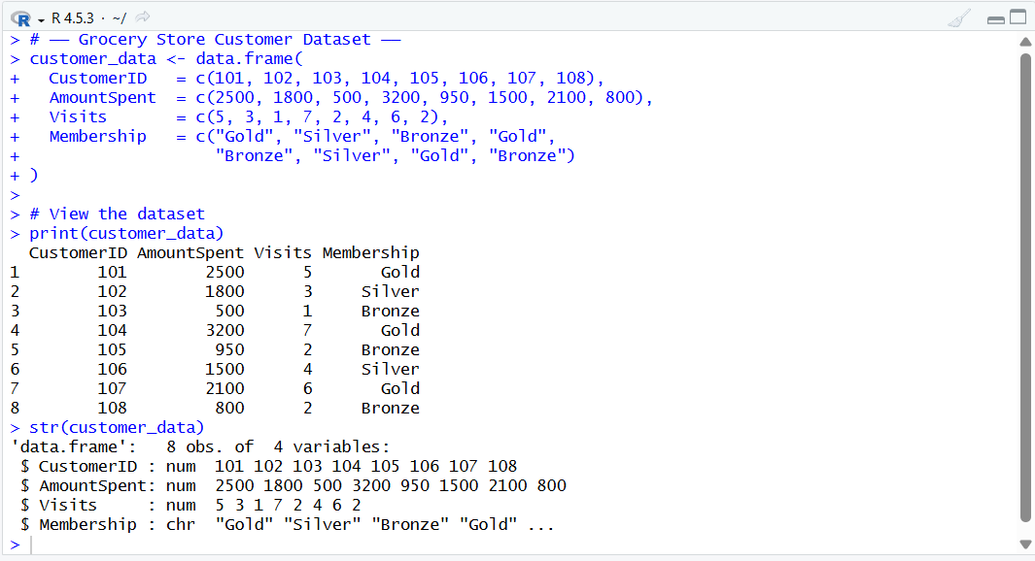

Task 1: Using Conditions - Category Column
Add a new column 'Category' based on the amount spent, using ifelse() for vectorised conditional logic.

# Task 1: Create Category column using nested ifelse()
# ifelse(test, yes, no) - vectorised, works on entire column at once
customer_data$Category <- ifelse(
customer_data$AmountSpent > 2000, "High",
ifelse(
customer_data$AmountSpent >= 1000, "Medium",
"Low"
)
)

# Display updated dataset
print(customer_data[ , c("CustomerID", "AmountSpent", "Category")])

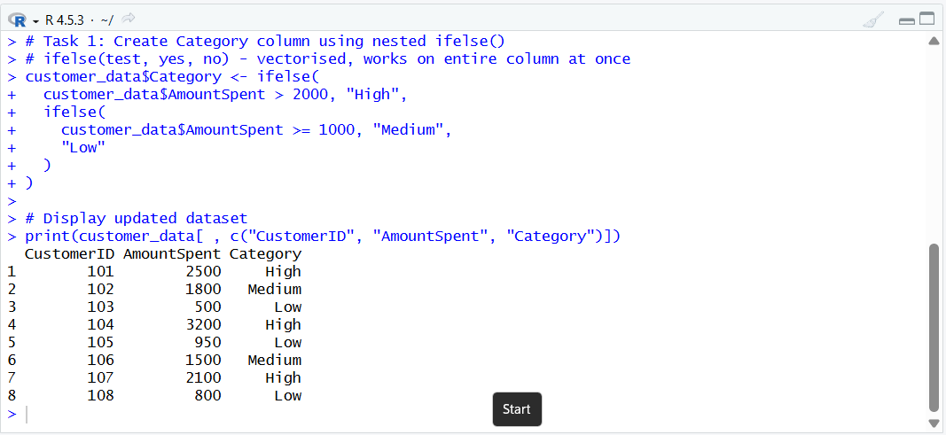

Task 2: Using Loop
Use a for loop to iterate through each row and print the Customer ID along with their spending category.

# Task 2: Loop through each customer and print ID + Category
cat("\n=== Customer Category Report ===\n")

for (i in 1:nrow(customer_data)) {
cat("Customer ID:", customer_data$CustomerID[i],
"| Category:", customer_data$Category[i], "\n")
}

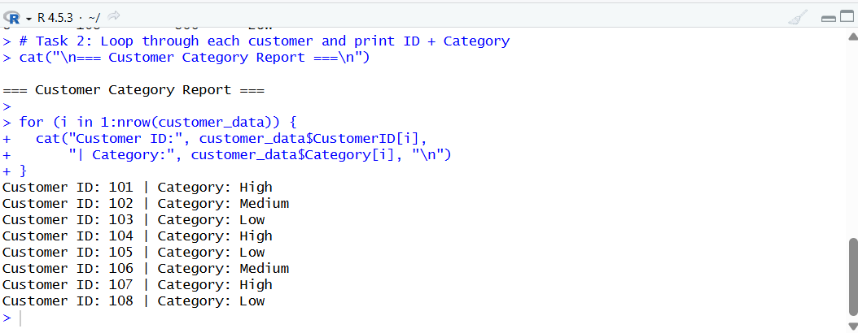

Task 3: Control Functions - next and break
Use next to skip customers with fewer than 3 visits, and break to stop execution if a negative amount is found.

# Task 3: Control flow with next (skip) and break (stop)
cat("\n=== Filtered Customer Report (Visits >= 3) ===\n")
for (i in 1:nrow(customer_data)) {

# STOP: break if any amount is negative (data integrity check)
if (customer_data$AmountSpent[i] < 0) {
cat("ERROR: Negative amount found for Customer",
customer_data$CustomerID[i], "- Stopping.\n")
break
}

# SKIP: next if visits < 3 (not enough engagement)
if (customer_data$Visits[i] < 3) {
cat("Skipping Customer", customer_data$CustomerID[i],
"(only", customer_data$Visits[i], "visit(s))\n")
next
}

# Process eligible customers
cat("Customer:", customer_data$CustomerID[i],
"| Visits:", customer_data$Visits[i],
"| Amount: Rs.", customer_data$AmountSpent[i], "\n")
}

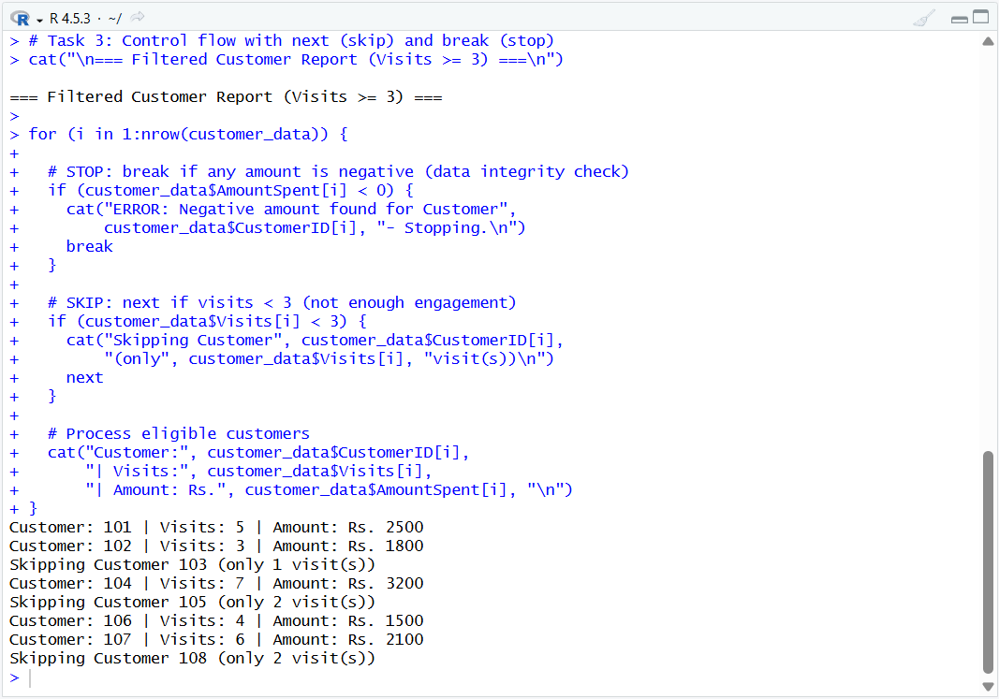

Task 4: Apply Family Functions
Use sapply() to compute average and maximum amount spent from the dataset. The apply family is preferred over loops for cleaner, faster vector operations.

# Task 4: Apply family functions

# sapply() applies a function to a vector and returns a simplified result
# Here we use it on a single-column numeric vector

amount_vector <- customer_data$AmountSpent

# Average amount spent
avg_amount <- sapply(list(avg = amount_vector), mean)
cat("Average Amount Spent: Rs.", round(avg_amount, 2), "\n")

# Maximum amount spent
max_amount <- sapply(list(max = amount_vector), max)
cat("Maximum Amount Spent: Rs.", max_amount, "\n")
# Alternative: Using apply() on a matrix column
marks_matrix <- as.matrix(customer_data$AmountSpent)
cat("Mean via apply():", apply(marks_matrix, 2, mean), "\n")
cat("Max via apply():", apply(marks_matrix, 2, max), "\n")

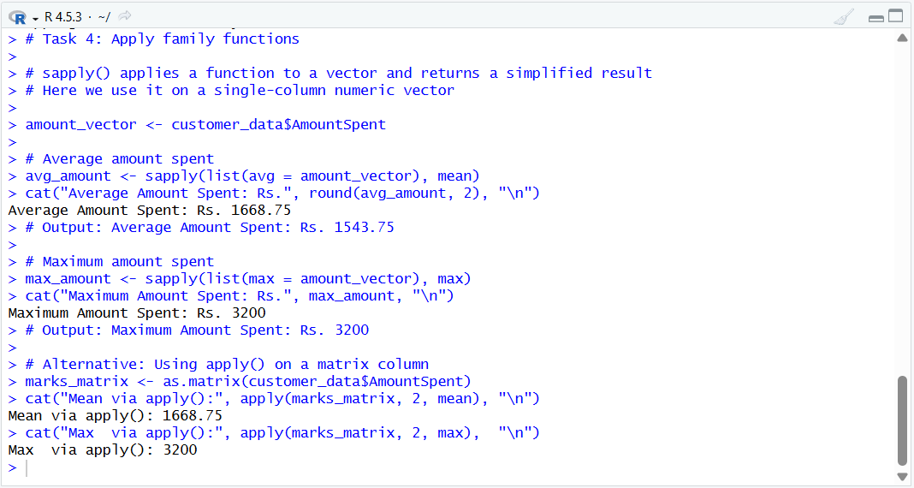

Task 5: Functions with Default Argument
Create a discount calculation function with a default membership parameter set to 'Bronze'.

# Task 5: Function with default argument
calculate_discount <- function(amount, membership = "Bronze") {
# Define discount rates per membership tier
rate <- switch(membership,
"Gold" = 0.20, # 20%
"Silver" = 0.10, # 10%
"Bronze" = 0.05, # 5% (also the default)
stop("Unknown membership type: ", membership)
)
discount_amount <- amount * rate
final_price <- amount - discount_amount

cat("Membership :", membership, "\n")
cat("Amount : Rs.", amount, "\n")
cat("Discount(%): ", rate * 100, "%\n")
cat("Discount : Rs.", discount_amount, "\n")
cat("Final Price: Rs.", final_price, "\n\n")

return(final_price)
}

# Test with specific memberships
calculate_discount(2500, "Gold") # 20% off
calculate_discount(1800, "Silver") # 10% off
calculate_discount(500) # Default: Bronze, 5% off

# Apply to entire dataset
customer_data$FinalPrice <- mapply(calculate_discount,
customer_data$AmountSpent,
customer_data$Membership)

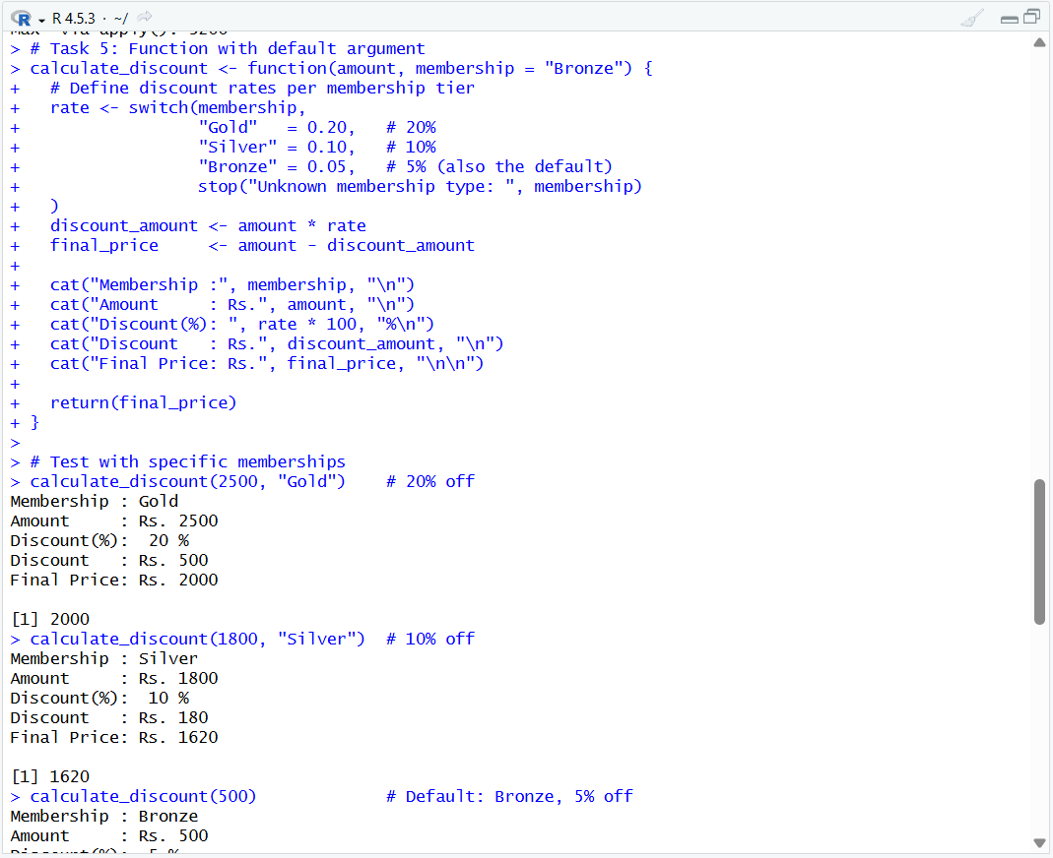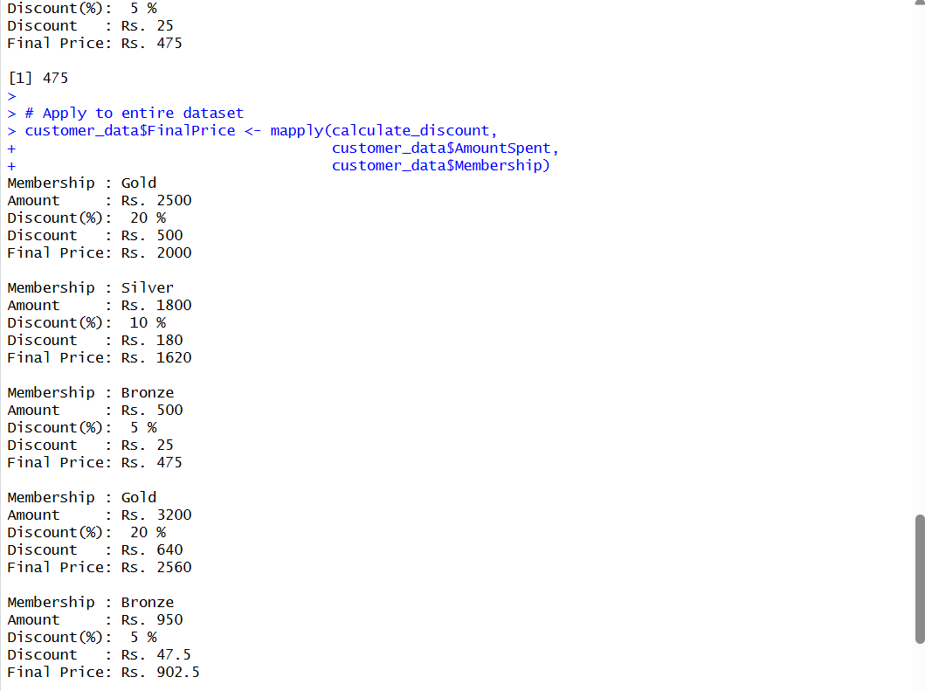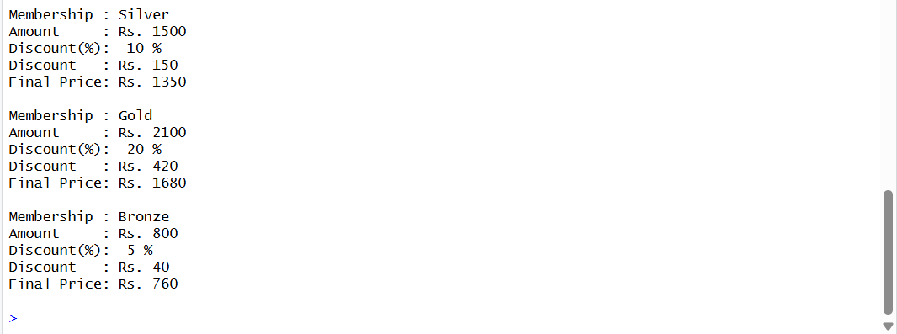

Task 6: Lazy Evaluation
Demonstrate lazy evaluation in R - function arguments are not evaluated until they are actually needed inside the function body.

# Task 6: Lazy Evaluation
# R uses lazy evaluation: arguments are only computed when first accessed.
# If an argument is never used, it is never evaluated - no error occurs.

lazy_discount <- function(amount, membership, verbose = FALSE) {
# 'verbose' parameter is lazy - only evaluated if needed

rate <- switch(membership,
"Gold" = 0.20, "Silver" = 0.10, "Bronze" = 0.05
)

# Discount is calculated ONLY when this line is reached
# If we returned early before this, 'rate' would never be used
discount <- amount * rate

# 'verbose' argument is only evaluated here, not at function call time
if (verbose) {
cat("[Verbose] Rate applied:", rate * 100, "% on Rs.", amount, "\n")
}

return(amount - discount)
}

# Without verbose: discount logic runs, verbose block is skipped
result1 <- lazy_discount(2500, "Gold")
cat("Result (no verbose):", result1, "\n")

# With verbose: discount logic runs AND verbose block executes
result2 <- lazy_discount(2500, "Gold", verbose = TRUE)
cat("Result (verbose):", result2, "\n")
# [Verbose] Rate applied: 20 % on Rs. 2500

# Lazy evaluation demo: unused argument causes no error
f <- function(x, y) x + 1 # y is never used
f(5) # Works fine - R never evaluates the missing y

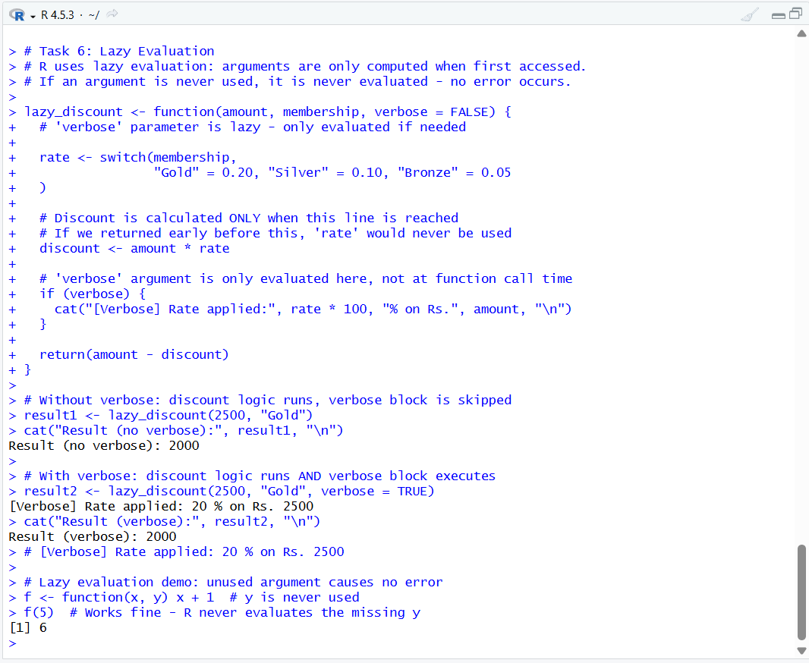

Task 7: Objects and Classes
Create a list representing one customer and assign it the class 'Customer', demonstrating R's S3 object system.

# Task 7: Objects and Classes (S3 system)

# Create a list for Customer 101
customer_obj <- list(
id = 101,
name = "Rahul Sharma",
amount = 2500,
visits = 5,
membership = "Gold",
category = "High"
)

# Assign a class to the list - now it is a 'Customer' object
class(customer_obj) <- "Customer"

# Check the class
cat("Object class:", class(customer_obj), "\n")
# Output: Object class: Customer

# Define a custom print method for the Customer class
print.Customer <- function(obj) {
cat("========== Customer Profile ==========\n")
cat("ID :", obj$id, "\n")
cat("Name :", obj$name, "\n")
cat("Membership:", obj$membership, "\n")
cat("Amount : Rs.", obj$amount, "\n")
cat("Visits :", obj$visits, "\n")
cat("Category :", obj$category, "\n")
cat("======================================\n")
}

# Calling print() will now use our custom method
print(customer_obj)

# Check structure
str(customer_obj)
is.list(customer_obj)
inherits(customer_obj, "Customer")

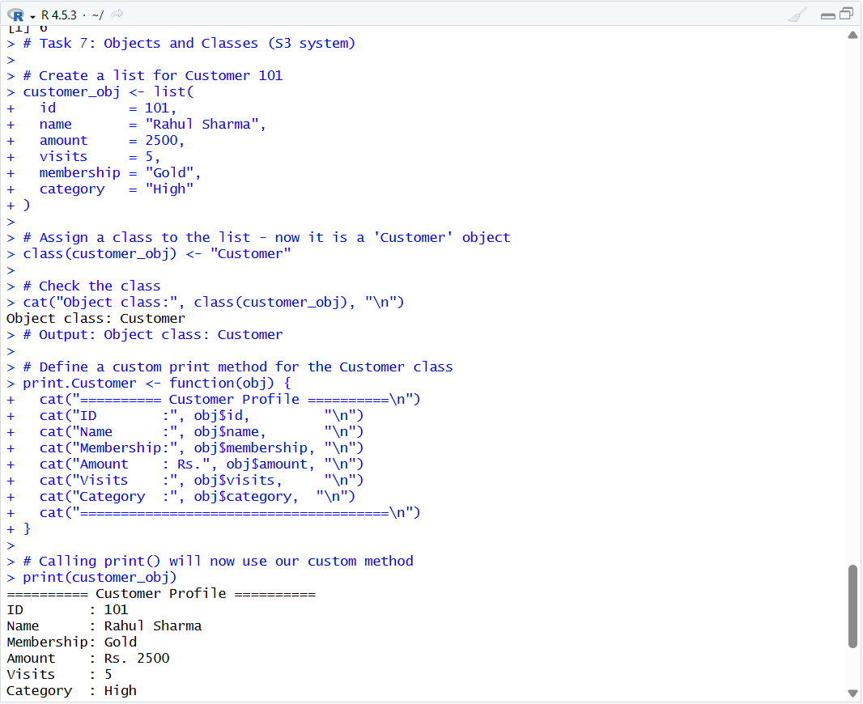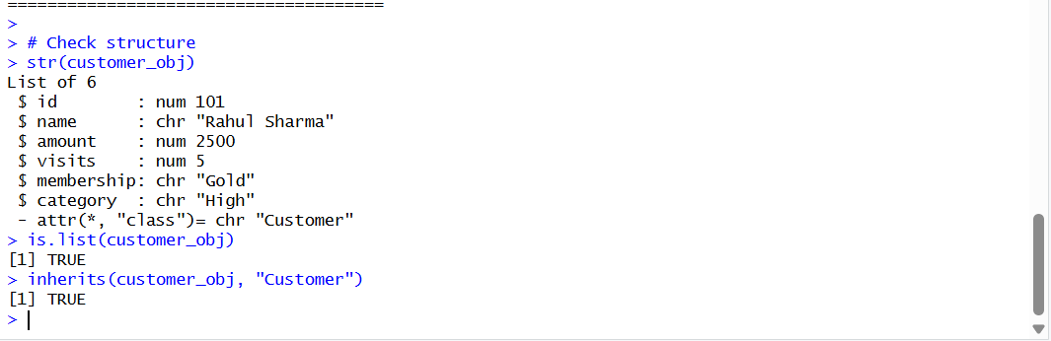

Task 8: Debugging
Demonstrate a common R error, identify the bug, and show the corrected version with explanation.

# Task 8: Debugging

# ── BUGGY FUNCTION (contains an error) ──
calculate_total_buggy <- function(prices) {
total <- sum(price) # BUG: 'price' should be 'prices' (wrong variable name)
return(total)
}

# Calling the buggy function produces an error:
# calculate_total_buggy(c(100, 200, 300))
# Error in calculate_total_buggy(c(100, 200, 300)) :
# object 'price' not found

# ── DEBUGGING STEPS ──
# Step 1: Read the error message carefully - 'price' not found
# Step 2: Check the function body - parameter name is 'prices'
# Step 3: The bug is a typo: sum(price) should be sum(prices)

# ── CORRECTED FUNCTION ──
calculate_total_fixed <- function(prices) {
total <- sum(prices) # FIXED: correct variable name
return(total)
}

# Test corrected function
result <- calculate_total_fixed(c(100, 200, 300))
cat("Total price: Rs.", result, "\n")

# ── Additional Debugging Tools ──
# traceback() - shows call stack after an error
# debug(fn) - step through function line by line
# browser() - insert inside function to pause and inspect
# print() / cat() - add diagnostic output at key points

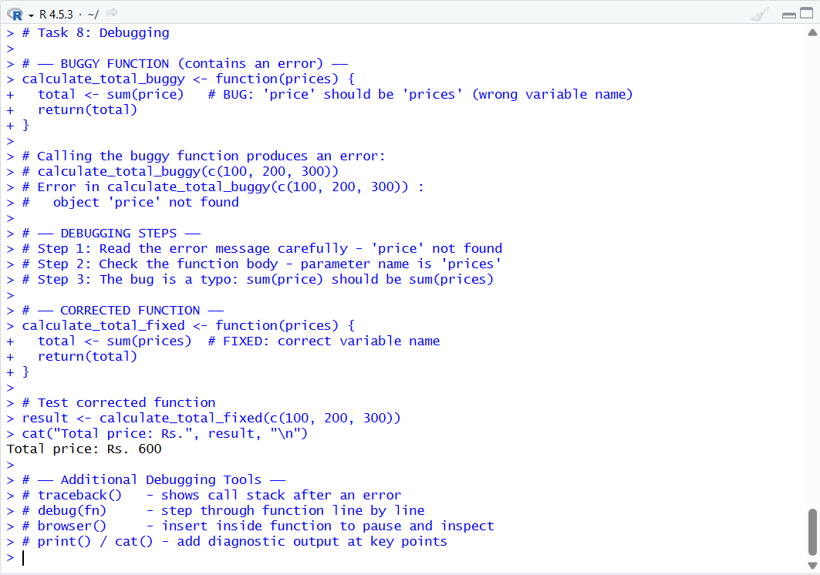

End of Assignment
R Programming - Unit 3 | Control Structures, Functions & OOP

