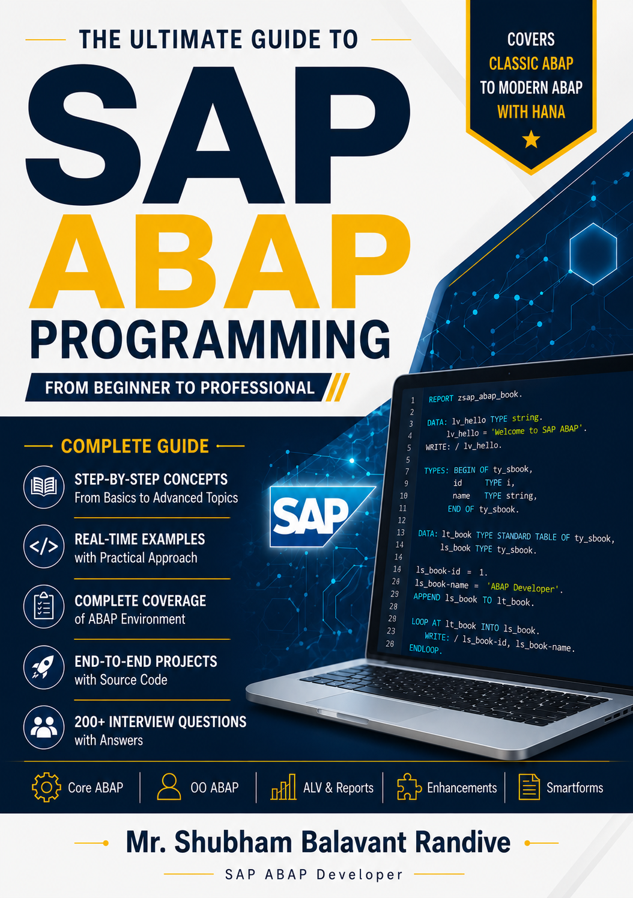

SAP
ABAP
Programming

By
Mr. Shubham Randive

Copyright © 2026 Shubham Balavant Randive

All rights reserved.

No part of this publication may be reproduced, distributed, stored in a retrieval system, or transmitted in any form or by any means, electronic, mechanical, photocopying, recording, or otherwise, without prior written permission of the author.

This book is intended for educational and informational purposes only. The author assumes no responsibility for errors or omissions or for damages resulting from the use of the information contained herein.

Book Title:
The ultimate guide to SAP ABAP Programming

Author
Mr. Shubham Balavant Randive
First Edition: 2026

DEDICATION

This book is dedicated to my parents, mamas, teachers, mentors, and all SAP learners who continuously strive to improve their knowledge and build successful careers in the SAP ecosystem.

AUTHOR'S NOTE
Dear Readers,
This book has been written with the objective of providing a complete learning path for SAP ABAP beginners. It covers concepts from basic ABAP programming to advanced topics, real-time projects, and interview preparation.

The examples, screenshots, and project implementations included in this book are designed to help readers gain practical experience and confidence in SAP ABAP development.

I hope this book becomes a valuable resource in your SAP learning journey.

Best Wishes,
Mr. Shubham Balavant Randive

PREFACE

SAP ABAP is one of the most important programming languages used in SAP ERP systems. This book provides a structured approach to learning SAP ABAP from fundamental concepts to advanced development techniques.
Readers will learn Data Dictionary, Internal Tables, Open SQL, Reports, ALV, SmartForms, OOPs ABAP, BAPI, RFC, Enhancements, Module Pool Programming, Performance Tuning, and Real-Time Projects.

HOW TO USE THIS BOOK
- Read chapters sequentially.
- Practice all examples in the SAP system.
- Complete exercises and project implementations.
- Review interview questions after each major topic.
- Build the real-time projects provided in the final sections.

INTRODUCTION
Welcome to SAP ABAP Complete Guide.

This book provides a comprehensive roadmap to mastering SAP ABAP development. Whether you are a student, fresher, consultant, or developer, this guide will help you understand SAP concepts and implement real-world business solutions.

The book combines theoretical concepts, practical examples, real-time projects, and interview preparation material to ensure a complete learning experience.

Let's begin the journey into SAP ABAP development.

A MESSAGE TO EVERY SAP ABAP LEARNER
Dear Reader,
Welcome to your SAP ABAP learning journey.
Before you begin reading this book, remember one important thing:
“Every expert was once a beginner.”
SAP ABAP is not just a programming language; it is a skill that has helped thousands of professionals build successful careers, solve real business problems, and contribute to organizations across the world.
There may be moments when a concept feels difficult, a program does not work as expected, or an error takes hours to resolve. These moments are not obstacles—they are opportunities to grow.
Learning SAP ABAP is a journey of patience, practice, and persistence.
As you move through this book:
Learn with curiosity.
Practice with consistency.
Build with confidence.
Never be afraid of making mistakes.
Remember:
Success in SAP is not achieved by reading alone.
Success is achieved by understanding, practicing, and applying knowledge.
Believe in yourself.
Stay committed to your learning.
Keep moving forward.
One day, the concepts that seem difficult today will become the skills that define your career.
Your SAP journey starts now.
Wishing you success, growth, and continuous learning.

Mr. Shubham Balavant Randive
Author

Book Roadmap

Sr. No | Chapter Title | Page No
SAP Overview and Introduction
1 | Introduction to SAP
2 | Introduction to ERP
3 | SAP Fundamentals
5
6
7
8
9
10
11
14
15
16
17
18
19
20
21
22
23
24

Introduction to SAP

SAP stands for Systems, Applications, and Products in Data Processing. It is one of the world's leading Enterprise Resource Planning (ERP) software solutions used by organizations to manage business operations and customer relations efficiently.
SAP integrates various business functions such as Finance, Human Resources, Sales, Procurement, Production, and Inventory Management into a single centralized system. This integration enables organizations to share data across departments, improve decision-making, reduce redundancy, and increase operational efficiency.
Today, SAP solutions are used by thousands of organizations worldwide, ranging from small businesses to multinational corporations.

  - History and Evolution of SAP
The journey of SAP began in 1972 in Germany when five former IBM engineers decided to develop a standardized business software solution that could process data in real time.
Founders of SAP
The company was founded by:
• Dietmar Hopp • Hans-Werner Hector
• Hasso Plattner • Klaus Tschira
• Claus Wellen Reuther

These five engineers shared a vision of creating integrated business software that would help organizations manage their operations more effectively.

The Beginning (1972)
SAP was founded in Mannheim, Germany, under the name:
System Analysis Program Development
The company initially focused on developing software solutions that could process business transactions in real time rather than using traditional batch processing methods.
This innovation was revolutionary because businesses could now access updated information immediately after transactions were recorded.

SAP R/1 (1973)
The first SAP product was called SAP R/1.
Key Features:
• Single-tier architecture
• Real-time data processing
• Financial accounting functionality
• Centralized data storage
The letter "R" represented Real-Time Data Processing.

SAP R/2 (1979)
SAP introduced SAP R/2, which operated on mainframe systems.
Key Features:
• Two-tier architecture
• Improved scalability
• Support for large enterprises
• Integration of multiple business functions
R/2 became popular among large organizations because it allowed different departments to work within a common system.

SAP R/3 (1992)
One of the most significant milestones in SAP history was the launch of SAP R/3.
Key Features:
• Three-tier architecture
• Client-server technology
• Graphical User Interface (GUI)
• Modular structure
• Improved flexibility
SAP R/3 became the most successful ERP system globally and helped establish SAP as a market leader.
The three layers of SAP R/3 are:
- Presentation Layer
- Application Layer
- Database Layer

  - Why was SAP developed?
Before SAP was developed, companies used separate systems for each department.
For example:
- Finance maintained its own records.
- Sales maintained separate records.
- Inventory maintained separate records.
- Human Resources maintained separate records.
Because these systems were not connected, the same information had to be entered multiple times. This led to:
- Duplicate data
- Data inconsistencies
- Communication gaps between departments
- Slow business processes
- Difficulty in generating reports

Real-Life Example
Suppose a customer place an order.
Without SAP:
- Sales records the order.
- Inventory separately checks stock.
- Finance separately creates the invoice.
- Accounts separately records payment.
Each department maintains its own data, increasing the chances of errors and delays.
With SAP:
- Sales enters the order once.
- Inventory is updated automatically.
- Finance receives the information automatically.
- Billing and payment processes are integrated.
All departments work on the same data in real time.

SAP was developed to
- Integrate all business departments into a single system.
- Eliminate duplicate data entry.
- Provide real-time information.
- Improve communication between departments.
- Increase business efficiency.
- Support better decision-making.
- Automate business processes.
- Reduce operational costs

Features of SAP
- Real time data processing
Data processing without any delay.

- Scalability
SAP can grow with business needs, and suitable for small, medium and large companies.

- Centralized database
SAP stores data in one centralized database place

- Reporting and Analytics
SAP generates real-time reports.

- Security and Authorization
SAP provides user-based access. Unauthorized person can’t access the SAP GUI.

- Multi-lingual supports
SAP supports 40+ languages like English, German, French, Spanish, Italian, Dutch and may more.

Introduction to ERP
ERP stands for Enterprise Resource Planning. It is a software system that helps organizations manage and integrate their business processes through a single centralized platform.
An ERP system allows different departments such as Finance, Human Resources, Sales, Procurement, Production, and Inventory Management to work together using the same database and real-time information.
Instead of maintaining separate systems for each department, ERP brings all business operations into one integrated system, ensuring better communication, efficiency, and decision-making.
In simple words, ERP acts as the backbone of an organization by connecting people, processes, and data.

Need for ERP
As businesses grow, managing operations manually or through separate software becomes difficult. Different departments often maintain their own records, leading to duplication, errors, and delays.
Organizations require ERP systems because they help:
• Integrate all business functions into one system.
• Eliminate duplicate data entry.
• Improve communication between departments.
• Provide real-time business information.
• Automate routine business processes.
• Increase operational efficiency.
• Improve decision-making through accurate reporting.
• Reduce operational costs.
• Enhance customer satisfaction.
• Support business growth and scalability.
Without ERP, organizations may face difficulties in coordinating activities across departments, resulting in inefficiencies and inaccurate information.

Benefits of ERP
ERP systems provide numerous advantages that help organizations improve their overall performance.
1. Centralized Data Management
All business information is stored in a single database, ensuring consistency and accuracy.
2. Improved Efficiency
Business processes become faster and more streamlined through automation.
3. Real-Time Information
Users can access updated information immediately after transactions occur.
4. Better Decision-Making
Accurate reports and analytics help management make informed decisions.
5. Reduced Operational Costs
Automation reduces manual work and minimizes errors.
6. Increased Productivity
Employees spend less time on repetitive tasks and more time on value-added activities.
7. Enhanced Collaboration
Departments can easily share information and work together effectively.

Traditional System vs ERP System
Before ERP systems were introduced, organizations used separate software applications for different departments. These independent systems often created communication gaps and data inconsistencies.

Traditional System
In a traditional environment:
• Each department maintains its own database.
• Data is entered multiple times.
• Information sharing is difficult.
• Reports are generated manually.
• Higher chances of errors and inconsistencies.
• Business processes are slower.

ERP System
In an ERP environment:
• All departments share a common database.
• Data is entered only once.
• Real-time information is available.
• Processes are integrated and automated.
• Reporting becomes faster and more accurate.
• Business operations become more efficient.

Comparison Between Traditional System and ERP System

Feature | Traditional System | ERP System
Database | Separate Databases | Centralized Database
Data Entry | Multiple Times | Singal Entry
Information Sharing | Difficult | Easy
Reporting | Manual | Automated
Accuracy | Lower | Higer
Process Integration | Limited | Fully Integrated
Decision Making | Slow | Faster
Productivity | Lower | Higher

SAP as an ERP solution
SAP is one of the world's leading ERP software providers. It offers a comprehensive suite of applications that help organizations manage their business processes efficiently.
SAP integrates various business functions into a single system, enabling seamless communication and real-time data sharing across departments.

Why Organizations Choose SAP
• Industry-leading ERP solution.
• Highly scalable and reliable.
• Supports global business operations.
• Advanced reporting and analytics.
• Cloud and on-premises deployment options.
• Continuous innovation through SAP HANA and SAP S/4HANA.

SAP Fundamentals
SAP R/3 Architecture
SAP R/3 Architecture is the three-tier client-server architecture used by SAP systems to process business transactions efficiently. The term R/3 stands for:
- R – Real-time data processing
- 3 layers (Presentation Layer, Application Layer, and Database Layer)
This architecture separates user interaction, business logic, and data storage into different layers, making the system scalable, secure, and easy to maintain.

Components of SAP R/3 Architecture
SAP R/3 consists of the following three layers:
1. Presentation Layer
The Presentation Layer is the interface through which users interact with the SAP system.
Functions
- Displays SAP screens to users.
- Accepts user input.
- Sends requests to the Application Layer.
- Displays processed results received from the Application Layer.
Examples
- SAP GUI (Graphical User Interface)
- SAP Business Client
- Web Browser (for web-based SAP applications)

Real-Life Example
When a user enters a material number in SAP and clicks the Display button, the request is sent from the Presentation Layer to the Application Layer for processing.

2. Application Layer
The Application Layer is the heart of the SAP system. It contains all business logic and processing functions.
Functions:
- Processes user requests.
- Executes ABAP programs.
- Performs calculations and validations.
- Manages communication between the Presentation Layer and Database Layer.
- Handles workload distribution among multiple application servers.
Components:
- Work Processes
- Dispatcher
- Gateway
- Message Server
- Enqueue Server

Real-Life Example
When a user creates a Purchase Order, the Application Layer validates the entered data, checks business rules, and processes the transaction before saving it to the database.

3. Database Layer
The Database Layer stores all SAP data permanently.
Functions:
- Stores master data, transaction data, and configuration data.
- Retrieves requested data.
- Ensures data consistency and integrity.
- Handles backup and recovery operations.
Examples
- SAP HANA
- Oracle Database
- Microsoft SQL Server
- IBM DB2
Real-Life Example
When a user displays customer information, the required data is fetched from the database and sent back through the Application Layer to the Presentation Layer.

Digram