Inventory Management System
[Button Logic]
SCREEN 100 - MAIN MENU
Screen Number: 100
Screen Title:
INVENTORY MANAGEMENT SYSTEM
Screen Layout
********************************************************
INVENTORY MANAGEMENT SYSTEM
********************************************************
[ MATERIAL MASTER ]
[ STOCK INWARD ]
[ STOCK OUTWARD ]
[ STOCK REPORT ]
[ EXIT ]
********************************************************
Screen Elements
Push Button : Material Master -> Function Code MAT
Push Button : Stock Inward -> Function Code INW
Push Button : Stock Outward -> Function Code OUT
Push Button : Stock Report -> Function Code REP
Push Button : Exit -> Function Code EXIT

NAVIGATION FLOW
Screen 100 (Main Menu)
|
+--> Screen 200 : Material Master
+--> Screen 300 : Stock Inward
+--> Screen 400 : Stock Outward
+--> Screen 500 : Stock Report
PBO LOGIC
PROCESS BEFORE OUTPUT.
MODULE STATUS_0100.
MODULE STATUS_0100 OUTPUT.
SET PF-STATUS 'ZINV'.
ENDMODULE.
PAI LOGIC
PROCESS AFTER INPUT.
MODULE USER_COMMAND_0100.
MODULE USER_COMMAND_0100 INPUT.
CASE SY-UCOMM.
WHEN 'MAT'.
CALL SCREEN 200.
WHEN 'INW'.
CALL SCREEN 300.
WHEN 'OUT'.
CALL SCREEN 400.
WHEN 'REP'.
CALL SCREEN 500.
WHEN 'EXIT'.
LEAVE PROGRAM.
ENDCASE.
ENDMODULE.
COMPLETE APPLICATION FLOW
START
|
Screen 100 (Main Menu)
|
+--> Screen 200 (Material Master)
+--> Screen 300 (Stock Inward)
+--> Screen 400 (Stock Outward)
|
+--> Screen 500 (Stock Report)
|
END
Inward Flow

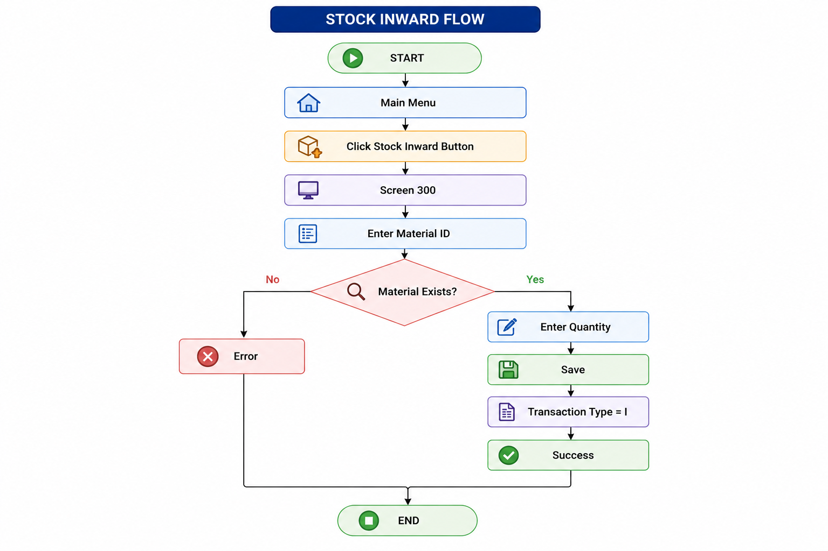

Outward Flow
