Task 1: Implicit Enhancement
Question 1
Create an Implicit Enhancement in the standard transaction MM01.
Requirement:
- When a material is created, display the message:
"Material creation started successfully."
- Do not modify the SAP standard program.
- Use an Implicit Enhancement only.

Process : Firstly go inside the ‘MM01’ T-code then apply the debugger with ‘/h’ T-code then go inside the MM01 program and also go inside the very first FM and create the Enhancement with the help of ENHANCEMENT-SECTION and write my logic there.

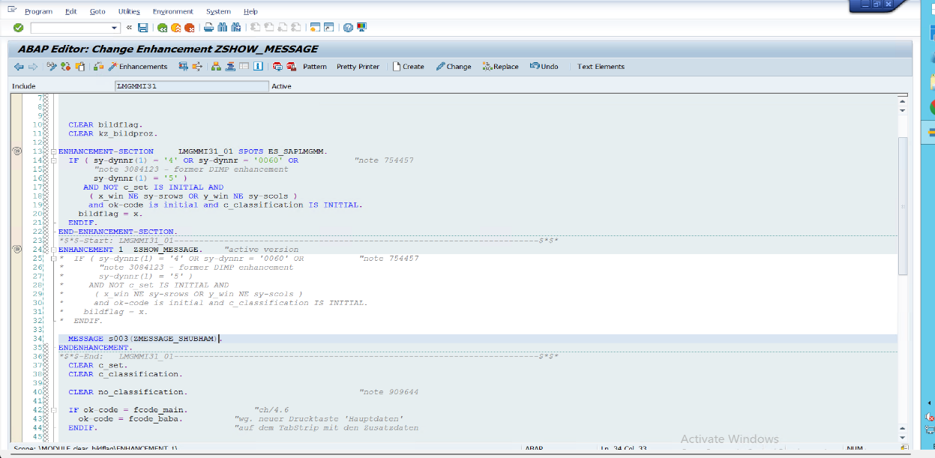

- 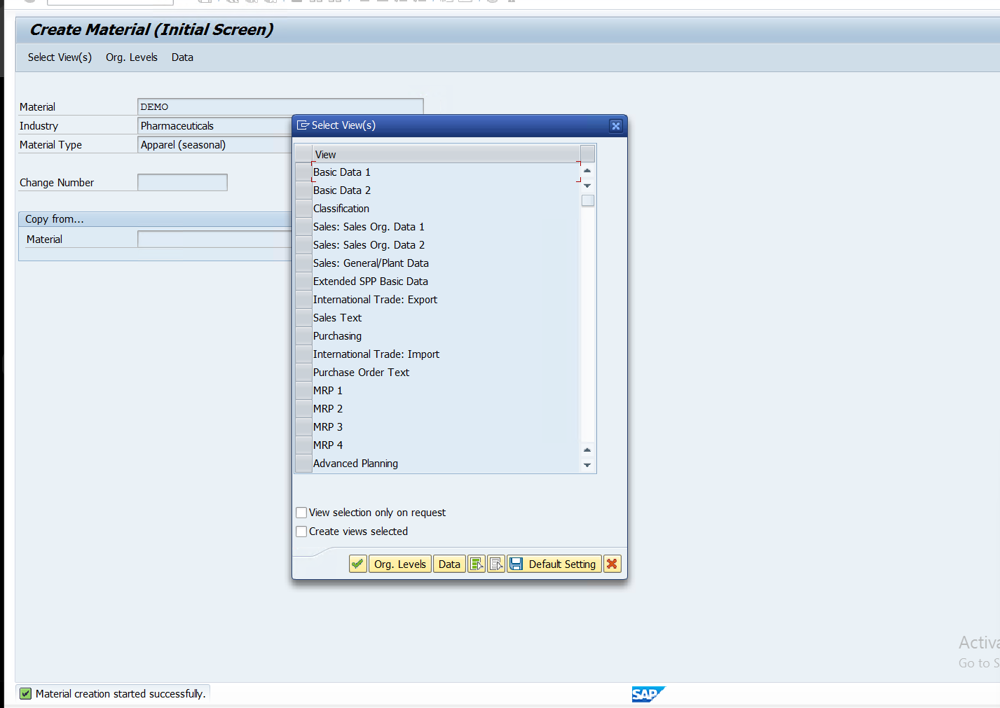

Question 2
In the VA01 (Create Sales Order) transaction:
Requirement:
- Before saving the sales order, check whether the order value is greater than ₹1,00,000.
- If yes, display:
Manager Approval Required
- Implement the logic using an Implicit Enhancement.

